**PRACTICAL: 01**

**AIM: Create “Hello World” application. That will display “Hello World How are you?” in the middle of the screen in the green color with yellow background.**

**Source Code:**

**Main.dart**

// this package is used for the material design

import 'package:flutter/material.dart';

void main() => runApp(MyApp());

class MyApp extends StatelessWidget {

@override

Widget build(BuildContext context) {

return MaterialApp(

home: Scaffold(

backgroundColor: Colors.yellow,

body: SafeArea(

child: Center(

child: (Text('Hello World How are you?', style:TextStyle(color: Colors.green, fontSize: 30)))

)

)

)

);

}

}

**Output:**

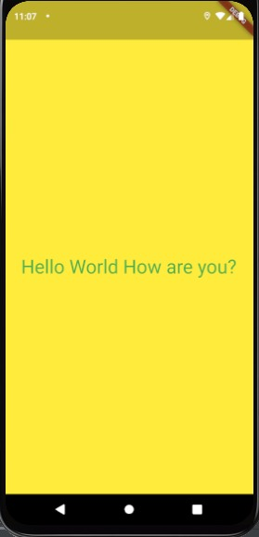

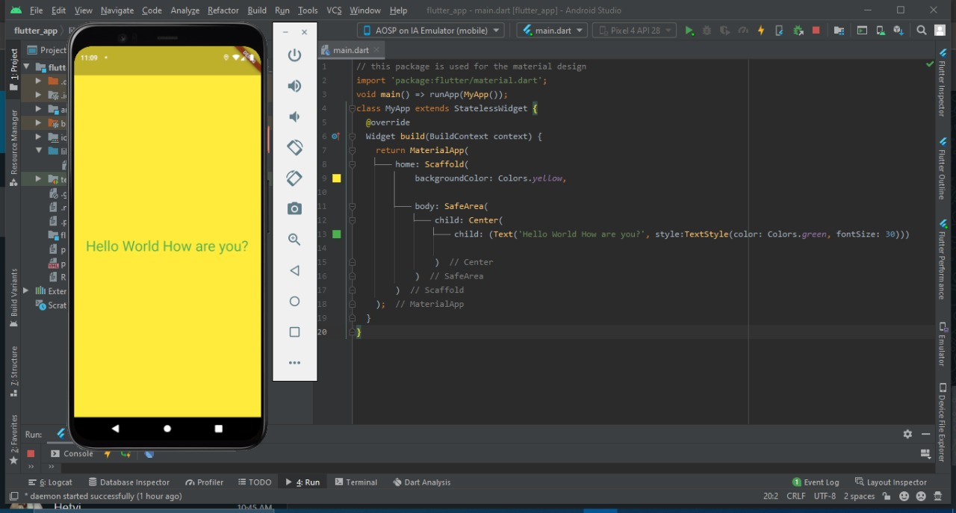

**Conclusion:**

Here, in this practical I learned about the basic functionality of flutter and how to run flutter in android and how to code it.