**PRACTICAL:02**

**AIM: Create an android application to calculate sum of two numbers and gives result in Toast Message. Develop an app with proper UI/UX.**

**Source Code in flutter:**

import 'dart:ui';

import 'package:flutter/material.dart';

void main() {

runApp(

MaterialApp(

debugShowCheckedModeBanner: false,

title: "My App",

home: Scaffold(

resizeToAvoidBottomPadding: false,

appBar: AppBar(title: Text("First Screen",),),

body: Calc()

)

)

);

}

class Calc extends StatefulWidget{

@override

State<StatefulWidget> createState(){

return CalcState();

}

}

class CalcState extends State<Calc>{

TextEditingController fNum = TextEditingController();

TextEditingController sNum = TextEditingController();

@override

Widget build(BuildContext context) {

return Container(

margin: EdgeInsets.all(20.0),

child: Column(

children: <Widget>[

TextField(

keyboardType: TextInputType.number,

controller: fNum,

decoration: InputDecoration(

labelText: "First number",

border: OutlineInputBorder(

borderRadius: BorderRadius.circular(1.0)

)

),

),

Padding(

padding: EdgeInsets.only(top: 10.0),

child: TextField(

keyboardType: TextInputType.number,

controller: sNum,

decoration: InputDecoration(

labelText: "Second number",

border: OutlineInputBorder(

borderRadius: BorderRadius.circular(1.0)

)

),

)

),

Padding(

padding: EdgeInsets.only(top: 10.0),

child: RaisedButton(

color: Colors.purpleAccent,

child: Text(

"Calculate",

style: TextStyle(color: Colors.black)

),

onPressed: (){

add(context);

},

),

)

],

),

);

}

void add(BuildContext context){

double fnum = double.parse(fNum.text);

double snum = double.parse(sNum.text);

double sum = fnum + snum;

var alertDialog = AlertDialog(

content: Text("Sum is: $sum"),

);

showDialog(context: context,

builder: (BuildContext context){

return alertDialog;

}

);

}

}

**Output:**

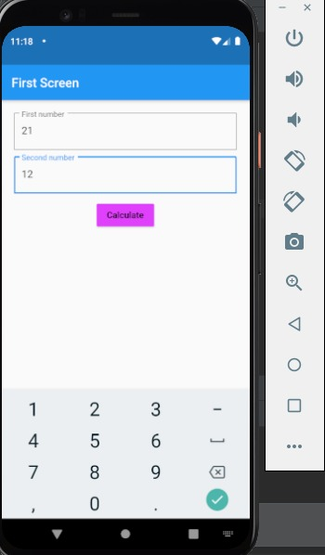 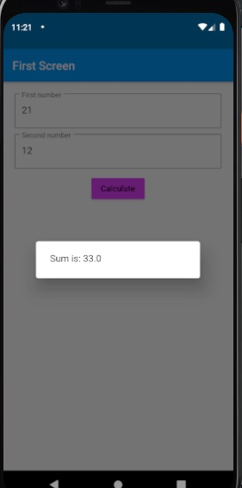

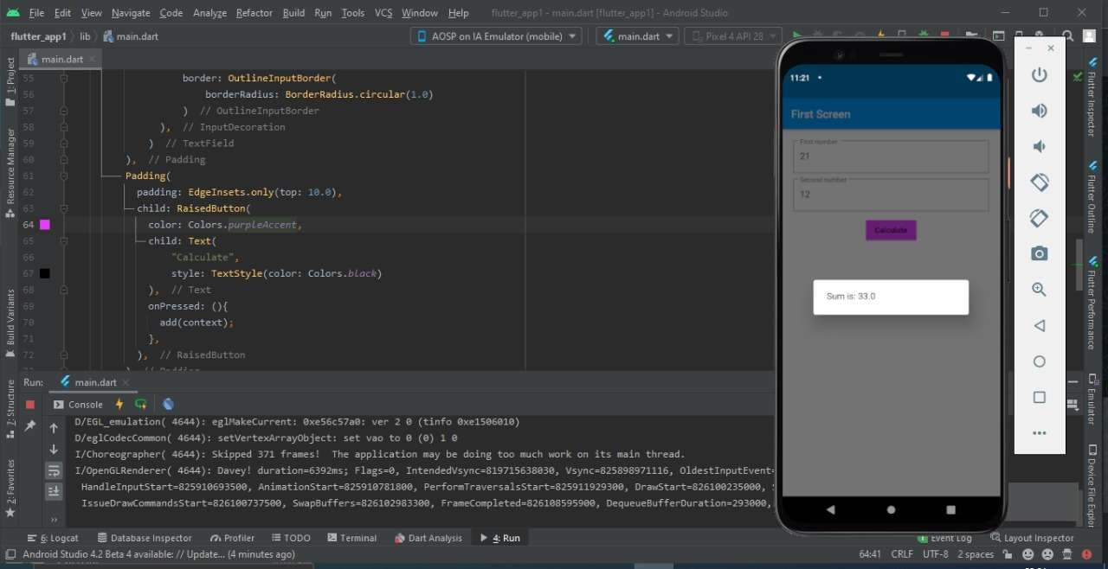

**Source code in android studio:**

**MainActivity.java/.dart/.js**

package com.example.mycalculator;  
import android.os.Bundle;  
import android.view.View;  
import android.widget.Button;  
import android.widget.EditText;  
import android.widget.Toast;  
import androidx.appcompat.app.AppCompatActivity;  
public class MainActivity extends AppCompatActivity {  
 EditText number1;  
 EditText number2;  
 Button add;  
 @Override  
 protected void onCreate(Bundle savedInstanceState) {  
 super.onCreate(savedInstanceState);  
 setContentView(R.layout.*activity_main*);  
 number1=findViewById(R.id.*edt1*);  
 number2=findViewById(R.id.*edt2*);  
 add=findViewById(R.id.*addbtn*);  
 add.setOnClickListener(new View.OnClickListener() {  
 @Override  
 public void onClick(View v) {  
 double num1=Double.*parseDouble*(number1.getText().toString());  
 double num2=Double.*parseDouble*(number2.getText().toString());  
 double add= num1+num2;  
 Toast.*makeText*(getApplicationContext(),String.*valueOf*(add),  
 Toast.*LENGTH_LONG*).show();  
 }  
 });  
 }  
}

**Layout File/s:**

**activity_main.xml/view/**

<?xml version="1.0" encoding="utf-8"?>  
<androidx.constraintlayout.widget.ConstraintLayout xmlns:android="http://schemas.android.com/apk/res/android"  
 xmlns:app="http://schemas.android.com/apk/res-auto"  
 xmlns:tools="http://schemas.android.com/tools"  
 android:layout_width="match_parent"  
 android:layout_height="match_parent"  
 tools:context=".MainActivity"  
 android:background="@color/teal_200">  
  
 <TextView  
 android:id="@+id/tv1"  
 android:layout_width="103dp"  
 android:layout_height="23dp"  
 android:layout_marginStart="34dp"  
 android:layout_marginLeft="34dp"  
 android:layout_marginTop="186dp"  
 android:layout_marginEnd="45dp"  
 android:layout_marginRight="45dp"  
 android:text="@string/tv1"  
 app:layout_constraintEnd_toStartOf="@+id/edt1"  
 app:layout_constraintStart_toStartOf="parent"  
 app:layout_constraintTop_toTopOf="parent" />  
  
 <TextView  
 android:id="@+id/tv2"  
 android:layout_width="103dp"  
 android:layout_height="23dp"  
 android:layout_marginStart="34dp"  
 android:layout_marginLeft="34dp"  
 android:layout_marginTop="73dp"  
 android:layout_marginRight="45dp"  
 android:layout_marginBottom="427dp"  
 android:text="@string/tv2"  
 app:layout_constraintBottom_toBottomOf="parent"  
 app:layout_constraintStart_toStartOf="parent"  
 app:layout_constraintTop_toBottomOf="@+id/tv1" />  
 <EditText  
 android:id="@+id/edt1"  
 android:layout_width="wrap_content"  
 android:layout_height="wrap_content"  
 android:layout_marginTop="164dp"  
 android:layout_marginEnd="16dp"  
 android:ems="10"  
 android:inputType="text"  
 android:importantForAutofill="no"  
 tools:ignore="LabelFor"  
 app:layout_constraintEnd_toEndOf="parent"  
 app:layout_constraintTop_toTopOf="parent"  
 android:layout_marginRight="16dp" />  
 <EditText  
 android:id="@+id/edt2"  
 android:layout_width="wrap_content"  
 android:layout_height="wrap_content"  
 android:layout_marginStart="45dp"  
 android:layout_marginTop="50dp"  
 android:layout_marginEnd="16dp"  
 android:layout_marginBottom="427dp"  
 android:ems="10"  
 android:inputType="text"  
 android:importantForAutofill="no"  
 tools:ignore="LabelFor"  
 app:layout_constraintBottom_toBottomOf="parent"  
 app:layout_constraintEnd_toEndOf="parent"  
 app:layout_constraintStart_toEndOf="@+id/tv2"  
 app:layout_constraintTop_toBottomOf="@+id/edt1"  
 android:layout_marginLeft="45dp"  
 android:layout_marginRight="16dp" />  
  
 <Button  
 android:id="@+id/addbtn"  
 android:layout_width="wrap_content"  
 android:layout_height="wrap_content"  
 android:layout_marginStart="166dp"  
 android:layout_marginLeft="166dp"  
 android:layout_marginEnd="157dp"  
 android:layout_marginRight="157dp"  
 android:layout_marginBottom="269dp"  
 android:text="@string/addbtn"  
 app:layout_constraintBottom_toBottomOf="parent"  
 app:layout_constraintEnd_toEndOf="parent"  
 app:layout_constraintStart_toStartOf="parent"  
 app:rippleColor="#F487AC" />  
  
  
</androidx.constraintlayout.widget.ConstraintLayout>

**Output:**

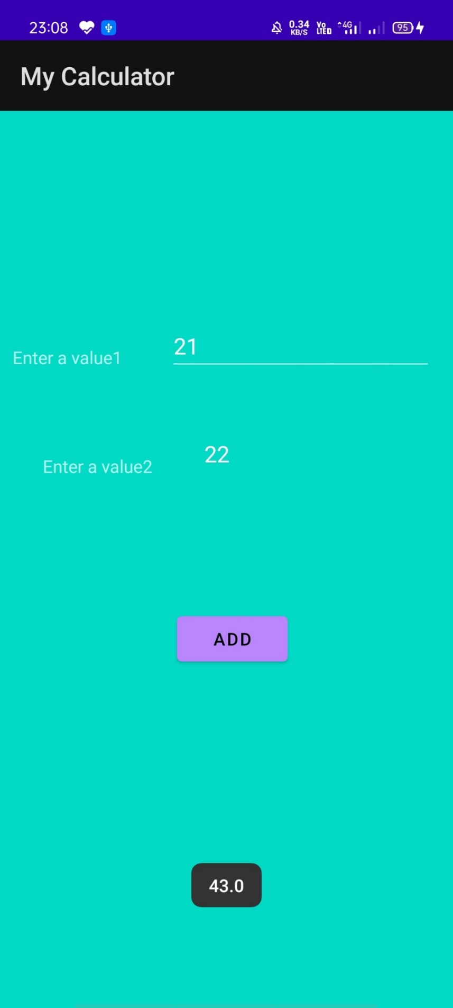 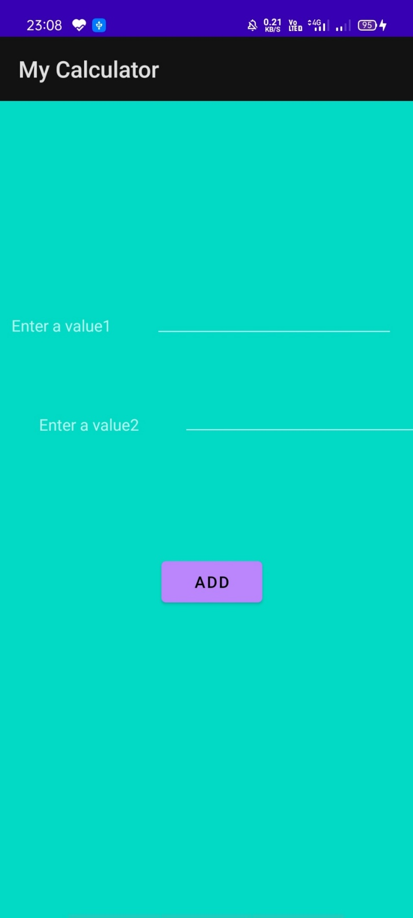

**Learning Outcome:**  We have learned about the how to calculate the sum for android application which display the answer of given operation.