**PRACTICAL:03**

**AIM: Create a temperature converter Application. (Fahrenheit-Celsius)**

**Source Code :**

**Main.dart:**

import 'package:flutter/material.dart';

import 'temperature.dart';

void main() {

  runApp(MyApp());

}  
class MyApp extends StatelessWidget {

  @override

  Widget build(BuildContext context) {

    return MaterialApp(

      title: 'Temperature Converter',

      theme: ThemeData(

        primarySwatch: Colors.*blue*,

      ),

      home: MyHomePage(title: 'Temperature Converter'),

      debugShowCheckedModeBanner: false,

    );

  }

}

class MyHomePage extends StatefulWidget {

  MyHomePage({Key key, this.title}) : super(key: key);

  final String title;

  @override

  _MyHomePageState createState() => _MyHomePageState();

}

class _MyHomePageState extends State<MyHomePage> {

  Model _m = Model();

  String _textTemp = "Enter a temp";

  bool _isSwitched = true;

  void _updateTemp() {

    setState(() {

      _textTemp = _m.convertS();

    });

  }

  void _updateSwitch(bool value) {

    setState(() {

      _isSwitched = value;

      _m.toggle();

      _textTemp = _m.convertS();

    });

  }

  @override

  Widget build(BuildContext context) {

    return Scaffold(

      appBar: AppBar(

        title: Text(widget.title),

      ),

      body: Center(

        child: Column(

          mainAxisAlignment: MainAxisAlignment.center,

          children: <Widget>[

            Text(

              _textTemp,

              style: TextStyle(fontSize: 30),

            ),

            Container(

              child: TextField(

                style: TextStyle(fontSize: 30),

                keyboardType: TextInputType.*number*,

                textAlign: TextAlign.right,

                decoration: InputDecoration(

                  border: OutlineInputBorder(),

                  labelText: 'Input Temp',

                ),

                onChanged: (text) {

                  _m.setTemp((double.*tryParse*(text) ?? -500.0));

                  _updateTemp();

                },

              ),

              padding: EdgeInsets.all(50),

              width: 400,

            ),

            Row(mainAxisAlignment: MainAxisAlignment.center, children: <Widget>[

              Text(

                '°C',

                style: TextStyle(fontSize: 25),

              ),

              Switch(

                value: _isSwitched,

                onChanged: (value) {

                  _updateSwitch(value);

                },

              ),

              Text(

                '°F',

                style: TextStyle(fontSize: 25),

              )

            ]),

          ],

        ),

      ),

    );

  }

}

**Temperature.dart**

class Model {

  double temp;

  String mode;

  Model() {

    temp = 32;

    mode = "°F";

  }

  void setTemp(double t) {

    temp = t;

  }

  void toggle() {

    if (mode == "°F") {

      mode = "°C";

    } else {

      mode = "°F";

    }

  }

  double convert() {

    if (temp <= -500) {

      return -500;

    }

    if (mode == "°F") {

      return (temp - 32) * 5 / 9;

    } else {

      return temp / 5 * 9 + 32;

    }

  }

  String convertS() {

    return convert().toStringAsFixed(1) + (mode == "°F" ? "°C" : "°F");

  }

}

**Output:**

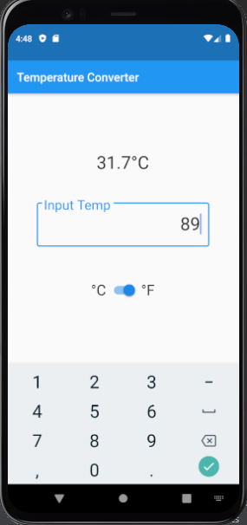

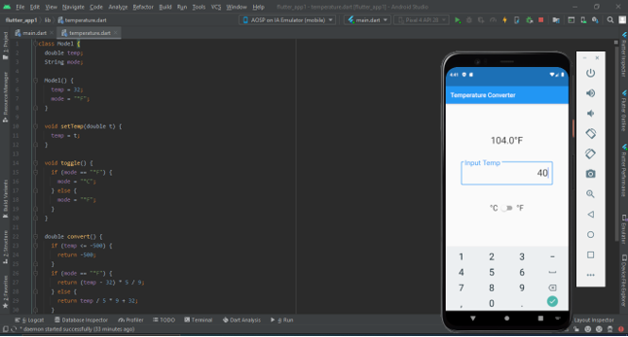

**Learning Outcome:**  We have learned about the how to convert the temperature from Celsius to Fahrenheit and vice versa, there is also a method name chronometer which gives us a run-time feedback which is also important method which I learned in this practical.