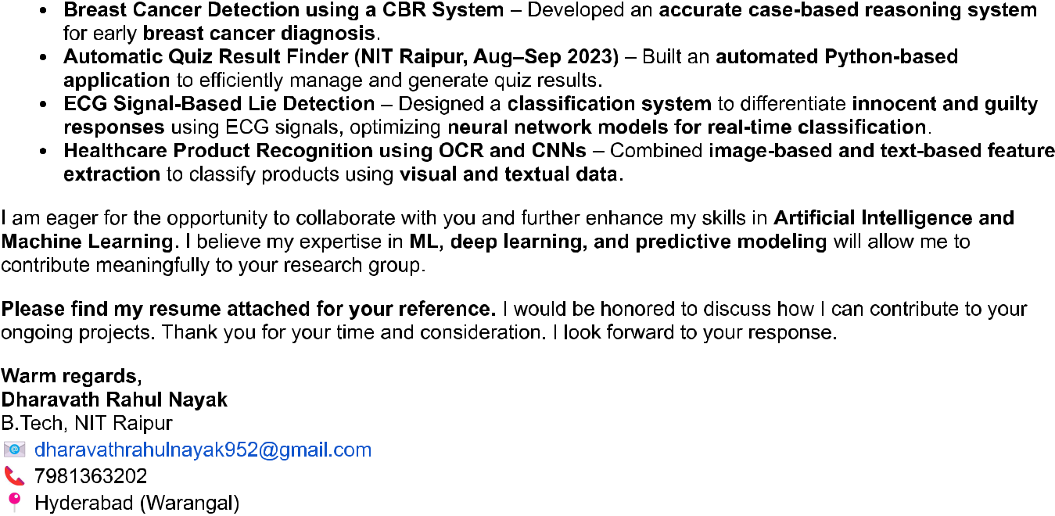

NATIONAL INSTITUTE OF TECHNOLOGY ,RAIPUR mail- Request for review of my summer internship Applicationn -NIT warangal

Warm Regards,

Riya Kasaudhan

B.tech ,NIT Raipur

[Riyakasaudhan26@gmail.com](mailto:Riyakasaudhan26@gmail.com)

8299351337

Projects:

To Develop a software for face recognition for Robonova AI3 using python programming language

Skills :

Languages:C++,Web Development (frontend Development), React ,Python Programming

Developer Tools:MATLAB,Odroid C2,Raspberry PI4

Soft Skills:Communication,Leadership,Time Management ,

Areas of Interest:Data Structure and Algorithm and machine learning

Supervisors Training Centre Northern Railways-Vocational Intern at Lucknow-

To developed a new software Odroid C2 for face recognition of smart Robot(Robonova AI3) and its implementation in hardware

-Primarily focused on working of 17 Servo motor,UART channels,MR-3024 Motor Controller of Robonova AI 3

Developers used for introducing new software are RASPBERRY PI4,Open source computer vision libraries

I hope this email finds you well. My name is Riya Kasaudhan and I am a B.tech student in Electronics and telecommunication Engineering at NIT Raipur ,currently maintaining a CGPA of 8.42. I am from Uttar Pradesh and deeply interested in contributing to research under your guidance as part of the Summer Internship Program at NIT Warangal.

I have extensive experience in Machine Learning ,gained through multiple internship and projects.

Riya Kasaudhan < rkasaudhan086.btech2022@ece.nitrr.ac.in>

rkasaudhan086.btech2022@ece.nitrr.ac.in

Request for review of My Summer Internship Application -NIT Warangal