**Power Line Carrier Communication**

A

Summer Internship (II) Report

Submitted By

**Riya Kasaudhan (22116086)**

*Submitted in the partial fulfillment of the requirements for the subject*

*Summer Internship (II) in VII semester*

*of*

**Bachelor of Technology**

in

**Electronics & Communication Engineering**

to the

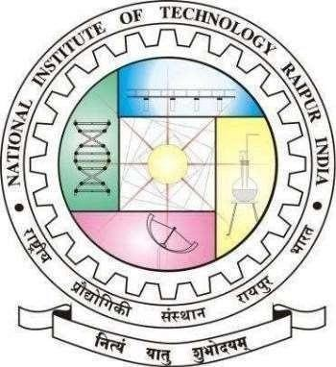

**Department of Electronics and Communications**

**National Institute of Technology Raipur**

**G. E. Road, Raipur-492010(C.G.)**

**September 26th, 2025**

|  |
| --- |
| **NATIONAL INSTITUTE OF TECHNOLOGY RAIPUR** |

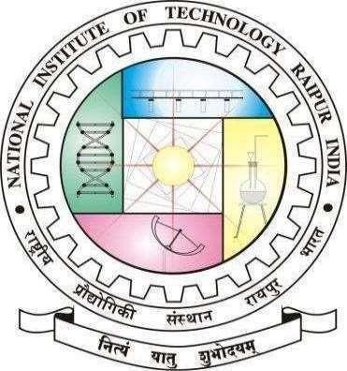

# Certificate by the Examiner

This is to certify that the Summer Internship(II) work entitled “**Power Line Carrier Communication**” is the bona-fide work done by **Riya Kasaudhan (22116086)** under our guidance and supervision. This report is submitted following the completion of Summer Internship(II) during the academic session of January-May 2025.

**Examiner 1**

**Name: Date:**

**Examiner 2**

**Name: Date:**

II

|  |
| --- |
| **NATIONAL INSTITUTE OF TECHNOLOGY RAIPUR** |



# Declaration

I certify that

1. The work contained in this report is original and has been done by me during the summer vacation.
2. The work has not been submitted to any other institute for any degree or diploma.
3. I have followed the guidelines provided by the Institute in writing the report.
4. Whenever I have used materials (data, theoretical analysis, and text) from other sources, I have given due credit to them in the text of the report and giving their details in the references.

**(Signature)**

**Riya Kasaudhan**

**Roll No.: 22116086**

**B.Tech (Semester: VII)**

**Dept. of ECE**

III

# Abstract

This abstract summarizes a four-week vocational training on Power Line Carrier Communication (PLCC) completed at **Uttar Pradesh Power Corporation Limited** (UPPCL), at 220 K.V. Substation Hardoi Road Lucknow under Executive Engineer, Electy. Transmission Division-I, Room No. 115, Pareshan Bhawan, Vibhuti Khand-2, Gomti Nagar, Lucknow in Electronics & Communication Engg. branch w.e.f. 05-06-2025 to 04-07-2025.The training provided hands- on exposure to high-voltage substation communication systems, focusing on PLCC fundamentals, channel allocation, coupling capacitors and line traps, protection signaling, and SCADA telemetry integration at a 220 kV substation. Practical activities included observing live communication link switching, verifying earthing and noise-mitigation procedures for carrier equipment, recording 24-hour channel performance, and analyzing disturbance records related to PLCC-based protection signaling. Key learnings encompassed coordination between numerical relays and PLCC teleprotection, adherence to IEC/IEEE safety and communication standards, and routine maintenance of carrier sets, reinforcing readiness for modern substation automation and reliable grid operations at UPPCL, Lucknow.

**Index Terms**— **Uttar Pradesh Power Corporation Limited** (UPPCL), electrical substation, gas-insulated substation (GIS), IEC 61850, IEEE Std 80, SCADA, numerical relays, smart grid, transformer efficiency, predictive maintenance.

**(Signature)**

**Riya Kasaudhan**

**Roll No.: 22116086**

**B.Tech (Semester: VII)**

**Dept. of ECE**

# Acknowledgement

1

I would like to express my sincere gratitude to our faculty incharge training & placement and internship: **Dr. Anshul Gupta & Dr.Ajay Singh Raghuvanshi**, Assistant Professor, NIT Raipur for his precious guidance and kind co-operation at every step of this training/internship work. I/we consider myself fortunate to have obtained his friendly and valuable advice during my work.

My sincere thanks to **Dr. Bijayananda Patnaik**, Head of the Department, ECE, NIT Raipur for giving me permission to carry out this training/internship.

I am thankful to all the teaching and non-teaching faculty members of ECE department, NIT Raipur for helping me during this project.

I appreciate the help extended by all the team members of **Uttar Pradesh Power Corporation Limited (UPPCL)** for helping during training/internship period.

Finally, I am very thankful to my family members and friends for their great moral support.

**(Signature)**

**Riya Kasaudhan**

**Roll No.: 22116086**

**B.Tech (Semester: VII)**

**Dept. of ECE**

2

**ORGANIZATION PROFILE**

**Name of Organization: Uttar Pradesh Power Corporation Limited** (UPPCL).

**About the Organization:** Uttar Pradesh Power Corporation Limited (UPPCL) is the state organization responsible for managing electricity in Uttar Pradesh. It handles the transmission and distribution of power across the state, ensuring a reliable supply to households, industries, and businesses.

**Mandate and Functions:**

* **Transmission Network:** Design, construction, operation, and maintenance of the Extra High Voltage (EHV) grid comprising 400 kV, 220 kV, and 132 kV transmission lines and associated substations.
* **System Coordination:** Real-time load dispatch and coordination with state generating stations, central sector utilities, and distribution companies to ensure secure and economical power flow.
* **Grid Expansion:** Planning and implementation of new transmission corridors to meet the growing demand of industrial, commercial, and rural consumers.
* **Billing & Revenue Collection** – Issues electricity bills, collects payments, and manages consumer accounts.
* **Regulatory Compliance Key Infrastructure (as of 2025):**
* **EHV Network Length:** ~12,000 circuit-kilometres of 400 kV/220 kV/132 kV lines.
* **Environmental Regulations** – Ensuring sustainable practices, waste management, and emission control.
* **System Availability:** Consistently above 99% in recent annual performance reports.

**Relevance to Internship:**

The internship was carried out at the 220 kV Substation of Uttar Pradesh Power Corporation

Limited (UPPCL), providing exposure to live operation of transformers, switchgear,

protection relays, and SCADA-based control under the supervision of UPPCL

**INDEX**

* INTRODUCTION TO POWER LINE CARRIER COMMUNICATION
* ABSTRACT:
* FREQUENCY RANGE OF PLCC
* ADVANTAGES OF PLCC
* TECHNICAL SPECIFICATIONS 650W COUPLING DEVICE
  1. 650W LMU
  2. DRAIN COIL
  3. EARTH SWITCH
  4. LIGHTNING ARRESTER
* LMU FUNCTION
* LMU Functional Blocks
* DESCRIPTION OF LINE DIAGRAM OF PLCC
  1. COUPLING FILTER(CF)
  2. BALANCING TRANSFORMER
  3. MATCHING TRANSFORMER
  4. EARTH SWITCH
  5. DRAIN COIL
  6. LIGHTING ARRESTER(LA)

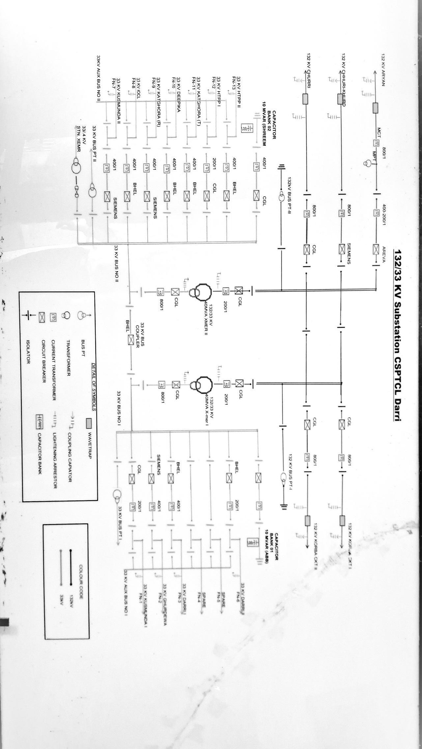

**INTRODUCTION TO POWER LINE CARRIER COMMUNICATION**

**ABSTRACT:**

|  |
| --- |
| POWER LINE CARRIER COMMUNICATION   * IN PLCC EHV POWER LINE IS USED FOR POWERSYSTEM COMMUNICATIONS. * THE PLCC HF SIGNALS(30-500Khz) IS COUPLED TO THE EHV POWER LINE THROUGH COUPLING CAPACITOR. * IT IS USED FOR SPEECH AND DATA TRANSFERING IT IS USED FOR THE LINE PROTECTION * HIGHLY RELIABLE COMMUNICATION SYSTEM * MAINTANCE FREE * LESS INSTALLATION COST * NO RUNNING EXPENDITURE |

**FREQUENCY RANGE OF PLCC**

The frequency range of PLCC for communication is 50kHz-500kHz. PLCC works only on high voltage(H.V) line.

EG:- 400kV,220kV,132kV &33kV line.

**ADVANTAGES OF PLCC**

Its transmissions as that of the power line themselves Whereas telephone lines are much weaker

-mechanically. PLCC is not subjected to any variation from atmosphere, Which is always the case high frequency and microwave System. Direct interfacing to power system service protection.

**TECHNICAL SPECIFICATIONS 650W COUPLING DEVICE**

1. **650W LMU**

|  |
| --- |
| Pass band(s) (35-50)/(50-90)(90-500kHz) |
| Coupling Capacitor 4400pf |
| Composite Loss <2dB |
| Return Loss >12dB |
| Equipment Side Impedance 75/125/150ohm |
| Line Side Impedance 600 phase to phase |
| Peak Envelop Power 650 watts |
| Isolation between primary & secondary Power frequency  test voltage 5kV rms |
| Balancing Transformer 5kV AC rms for 1min |
| Matching Transformer 5kV AC rms for 1min |
| Impulse Withstand Level 10kV peak |

1. **DRAIN COIL**

|  |
| --- |
| Rated inductance 40mH±5% |
| Continuous current rating 1Amps |
| Short time current 50 Amps for |
| Rating 0.2secs |

1. **EARTH SWITCH**

|  |
| --- |
| Insulation withstand voltage 10kVAC |
| Rated current 400Amps |

1. **LIGHTNING ARRESTER**

|  |
| --- |
| Rated voltage 0.8kV |
| Power frequency spark voltage  >1.2kV |
| Nominal discharge current 5kV |

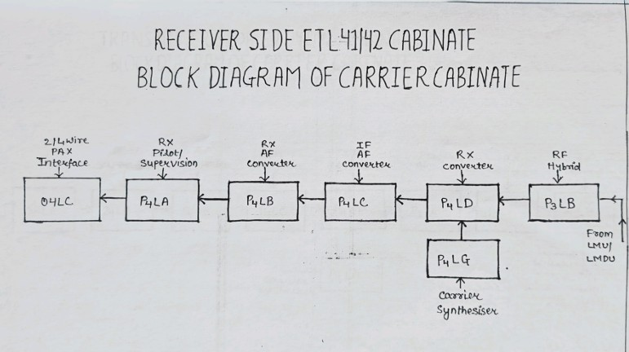

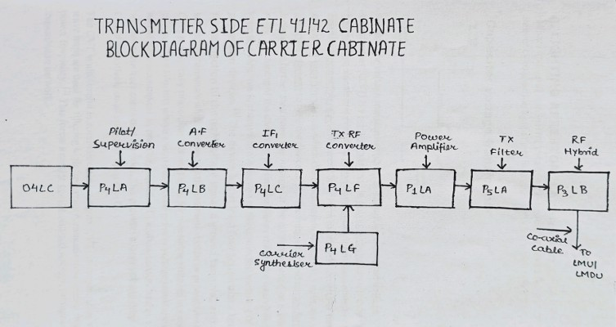

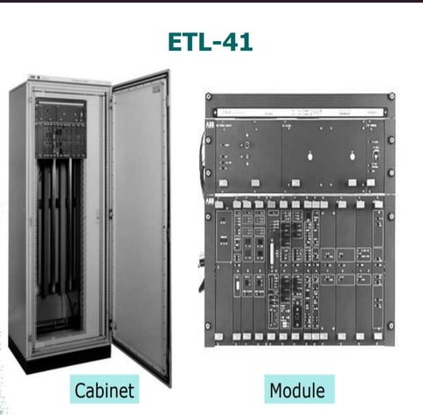

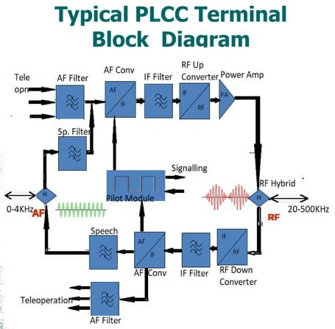

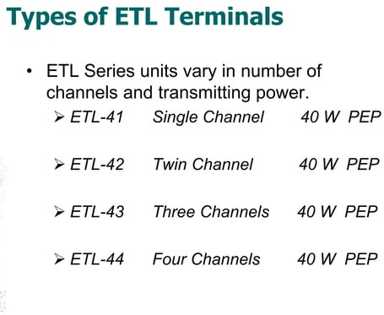

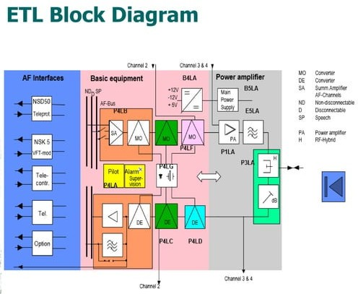

**LMU FUNCTION**

**LMU=**impedance matching transformer +high voltage protection

* To prevent dangerous potential on the PLCC connection.
* To match PLCC set & transmission LIne

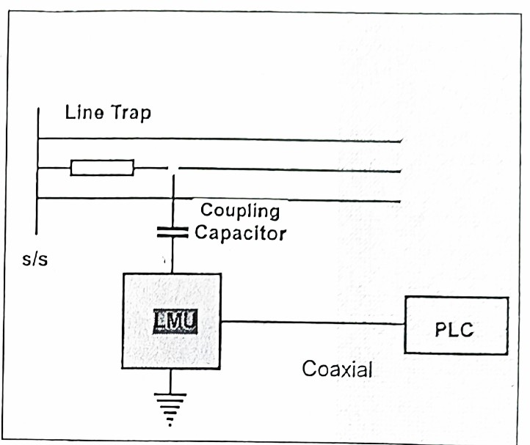

**LMU Functional Blocks**

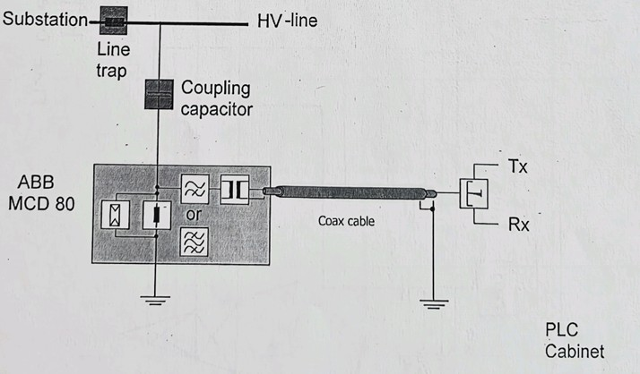

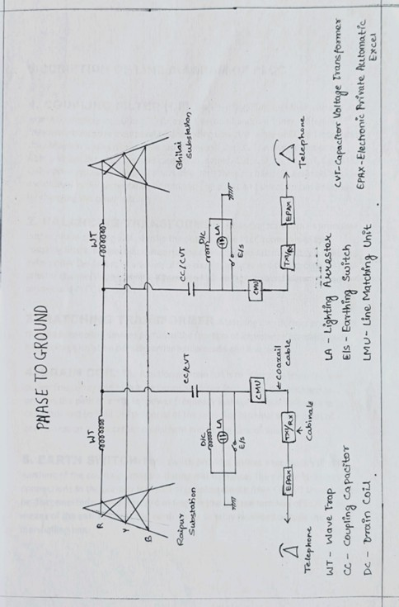

**DESCRIPTION OF LINE DIAGRAM OF PLCC**

* 1. **COUPLING FILTER(CF):** The coupling filter, together with the external coupling capacitor(cc) forms a t section bandpass tuner, Different frequency bands are incorporated depending upon the value of cc and it ensures the optimum tuning of available capacitance of the cc . The basic element of filter unit are the inductors and capacitors namely LS1, LS2, Lp, Cs, Cp1, Cp2 AND Cp3 whose typical values are factory selected. The pass band (S) available is mentioned in the technical

specifications / The pass band selection can be done by changing the tuner settings.

* 1. **BALANCING TRANSFORMER,** Balancing transformer provides better phase splitting and couples the output of the PLCC terminals to the coupling filters.

Meanwhile it ensures the carrier signals are in healthy conditions even under the failure of any one of the coupled phases and thus provides greater channel dependability. It provides high voltage isolation between each phases and PLCC terminals.

* 1. **MATCHING TRANSFORMER:** Matching transformer provided in the phase coupling devices performs the function of impedance matching and high voltage isolation between carrier equipment s and line side.
  2. **EARTH SWITCH:** Earth switch provides ensues a temporary directly earthing of the coupling capacitor during maintainance. The carrier frequency connections to

the primary terminal of coupling device from CC/CVT should never be disconnected without first grounding the low voltage terminal of CC/CVT by means of the earth switch. The earth s/w is suitably mounted outside the marshalling box.

* 1. **DRAIN COIL :**The function of drain coil is to offer zero impedance at power frequency and high impedance at Carrier frequency. It is designed to provide the path to earth for power frequency leakage current through the capacitor and so limit the potencial of the capacitor terminal at the point of concentration to the carrier equipment and taking care of safety.
  2. **LIGHTING ARRESTER(LA) :** A non-linear type LA is connected primary and earth terminal for protecting the coupling device the carrier frequency connection

against any high spike voltages, which may occur.

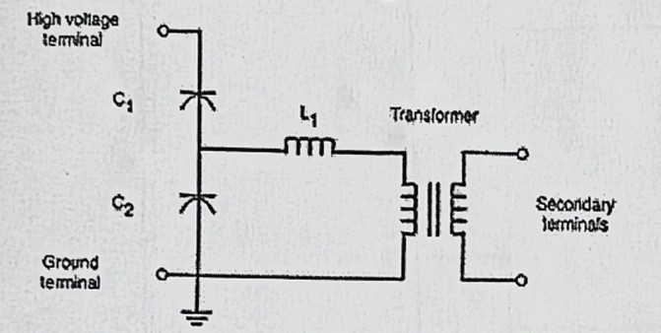**CAPACITOR VOLTAGE TRANSFORMER**

A **capacitor voltage transformer** (CVT), or **capacitance coupled voltage transformer** (CCVT) is a transformer used in power systems to step down extra high voltage signals and provide a low voltage signal, for measurement or to operate a protective relay. In its most basic form the device consists of three parts: two capacitors across which the transmission line signal is split, an inductive element to tune the device to the line frequency and a transformer to isolate and further step down the voltage for the instrumentation or protective relay. The tuning of the divider to the line frequency makes the overall division ratio less sensitive to changes in the burden of the connected metering or protection devices. The device has at least four terminals : a terminal for connection to

the high voltage signal, a ground terminal , and two secondary terminals which connect to the instrumentation or protective relay . CVTs are typically single-phase devices used for measuring voltages in excess of one hundred kilovolts where the use of wound primary voltage transformers smaller capacitors connected in series. This provides a large voltage drop across C1 and relatively small voltage drop across c2.

The CVT is also useful in communication systems. CVTs in combination with wave traps are used for filtering high frequency communication signal from power frequency. This forms a carrier communication network throughout the transmission network.

KEY LEARNINGS AND SKILLS ACQUIRED

* The Summer Internship (I) at Chhattisgarh State Power Transmission Company Limited (CSPTCL), Raipur provided an in-depth, hands-on understanding of high-voltage substation engineering. The following technical and professional competencies were developed:

Technical Knowledge:

Comprehensive Substation Design and Operation:

* Gained practical insight into the layout of a 220 kV/132 kV Gas-Insulated
* Substation (GIS), including double-bus configurations, transfer bus arrangements, and sectionalizing practices.
* Learned the complete operational sequence for energizing and de-energizing feeders, switching procedures, and lock-out/tag-out (LOTO) safety measures.

1.2. Standards and Regulatory Framework:

* Became familiar with international and national standards governing substation design and safety, such as IEC 61850 (substation automation and communication), IEEE Std 80 (grounding), IEEE C37 series (circuit breakers and relays), and
* Central Electricity Authority (CEA) Safety Regulations.
* Understood how compliance with these standards ensures reliability,interoperability, and personnel safety.
* 6.1.3. Modern Automation and SCADA Systems:

Acquired working knowledge of Supervisory Control and Data Acquisition (SCADA) platforms, including real-time parameter monitoring, alarm categorization, and event logging.

* Observed integration of Intelligent Electronic Devices (IEDs) and process-bus communication using IEC 61850 GOOSE messaging.
* Learned the basics of predictive-maintenance analytics using disturbance and event records.

6.1.4. Protection and Control:

* Studied the coordination of numerical relays (distance, differential, over-current/earth-fault) and their settings for selective fault clearance
* Analyzed disturbance records to verify breaker clearing times and relay performance.

6.2. Practical and Analytical Skills:

* 6.2.1. Field Measurement &amp; Data Analysis:
* Measured and plotted voltage/current profiles for both 220 kV and 132 kV buses, and calculated real-time transformer efficiency (&gt;98 %Reviewed breaker operation counters to schedule preventive maintenance.

6.2.2. Safety and Risk Awareness:

* Underwent formal high-voltage safety training, including the use of personal protective equipment (PPE), step-and-touch potential considerations, and emergency response protocols.

6.2.3. Documentation and Reporting:

* Maintained detailed daily logs of observations, test data, and system events, preparing concise reports for engineers and the faculty mentor.

6.3. Professional Competencies:

6.3.1. Team Collaboration:

* Worked closely with CSPTCL engineers during live operations and maintenance, enhancing communication and teamwork abilities.

6.3.2. Problem-Solving:

* Participated in troubleshooting minor SCADA communication alarms,developing diagnostic approaches under supervision.

6.3.3. Time Management:

* Balanced field activities, data analysis, and report preparation within a structured internship schedule.

RESULTS AND DISCUSSION

7.1. Impact on Grid Reliability:

* Reduced outage duration and frequency when substations use automatic fault isolation.
* More consistent voltage profiles, fewer voltage drops.
* 7.2. Efficiency and Loss Reduction:
* Higher voltage transmission and proper transformer sizing reduce I²R losses.
* Digital substations reduce maintenance and parasitic losses.
* 7.3. Economic and Environmental Benefits:
* Though GIS and smart upgrades require high upfront cost, over life-cycle these can be offset by lower maintenance and land costs.
* Environmental: lower emissions via better efficiency, support for renewables;
* SF₆ environmental concerns to be managed.

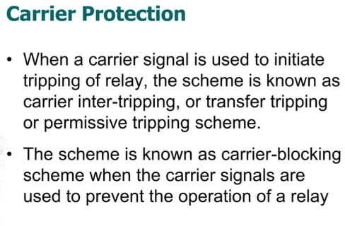

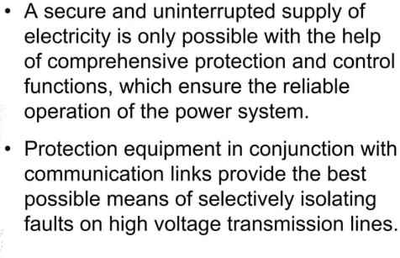

REFERENCES

[1]. A. Altaher, “The Role of Modern Substation Automation Systems in Smart Grid Evolution,” IEEE

Smart Grid Bulletin, August 2021.

[2]. IEEE Guide for Gas-Insulated Substations Rated Above 52 kV, IEEE Std. C37.122.1-2014.

[3]. Donald Parnell, “An Introduction to Gas Insulated Electrical Substations,” CED Engineering.

[4]. IEEE Guide for Specifications for High-Voltage Gas-Insulated Substations Rated 52 kV and

Above, IEEE Std. C37.123-2023.

[5]. TA Rajaperumal et al., “Transforming the electrical grid: the role of AI in advancing …,” Energy

Informatics, 2025.IEC 61850 Standard for Communication Networks and Systems in Substations.

[6]. IEEE Std 80-2013: Guide for Safety in AC Substation Grounding.

[7]. Central Electricity Authority, “Indian Power Grid Reports,” 2024.

[8]. Long, S., Mark McAllister, and Liang Shen. &quot;The resonant cylindrical dielectric cavity antenna.&quot;

IEEE Transactions on Antennas and Propagation 31, no. 3 (1983): 406-412.

[9]. McAllister, M. C., G. L. Conway, and S. A. Long. &quot;Rectangular dielectric-resonator antenna,

Electron Letter.&quot; (1983): 218-219.