**Screenshots**

<https://github.com/SarigaMallika/Web-project/upload/master>

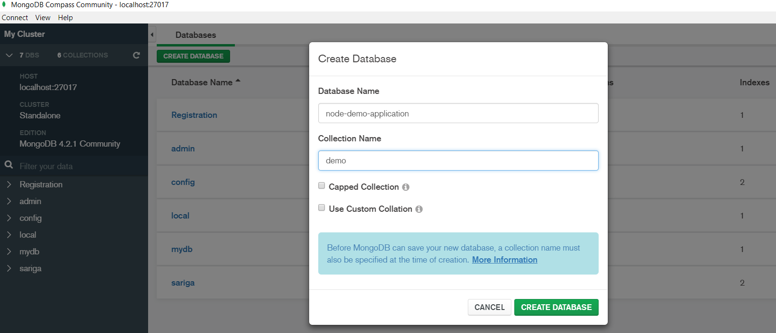

Fig1:Creating database

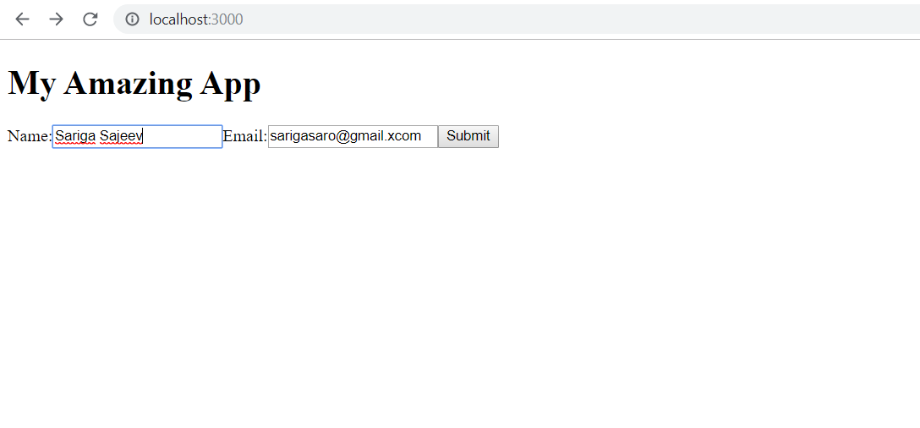

Fig2:Entering name and email to the web page

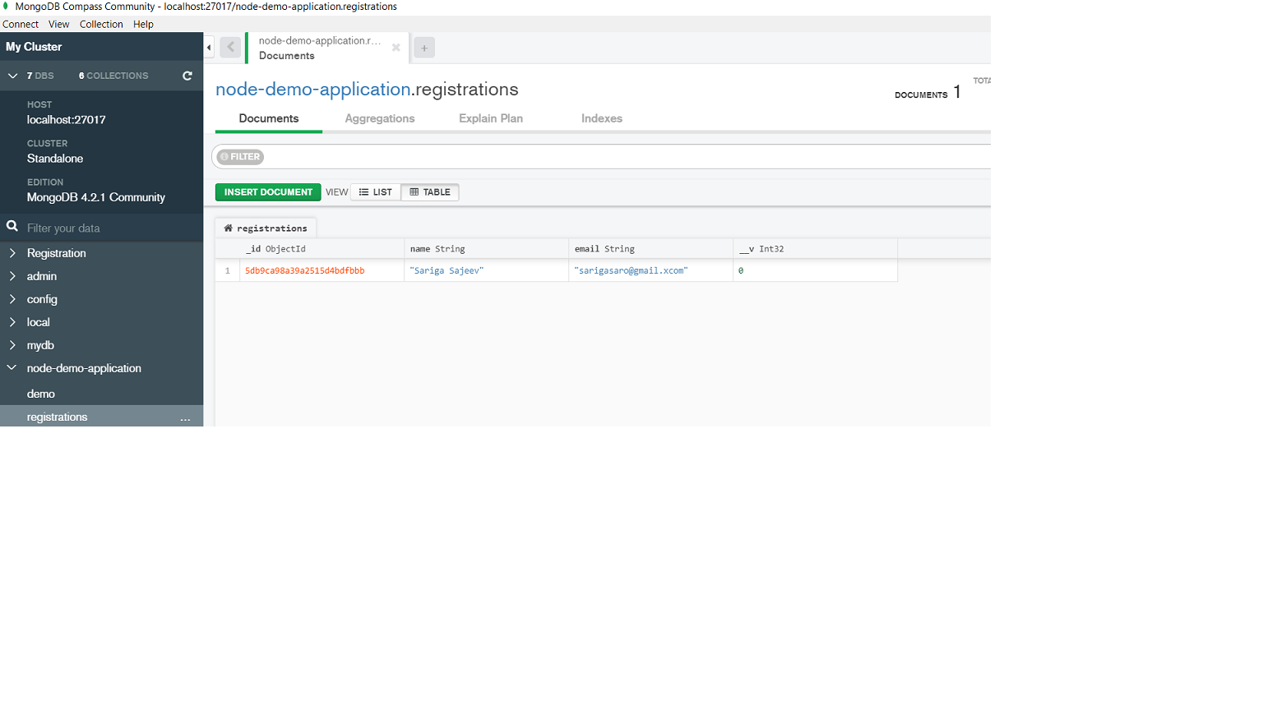

Fig3:Entered name and email id will be saved on the created database