

**University Alumni Management System**

**Software Requirement Specification (SRS) Document**

**Sprint 2 Implementation**

**Project Timeline: 07.09.2022 to 25.09.2022**

**INDEX**

1. Introduction

1.1 Purpose -------------------------------------------------- 3

1.2 Intended audience -------------------------------------------------- 3

1.3 Intended use -------------------------------------------------- 3

1.4 Scope -------------------------------------------------- 3

2. Overall description -------------------------------------------------- 4

2.1 Assumptions and dependency -------------------------------------------------- 4

3. System feature and requirements -------------------------------------------------- 4

3.1 Functionality -------------------------------------------------- 4

3.1.1 Alumni Module --------------------------------------------------- 4

3.1.1.1 alumni get data function -------------------------------------------5

3.1.1.2 Alumni Login function -------------------------------------------5

3.1.1.3 Edit details function -------------------------------------------5

3.1.1.4 Create posts function --------------------------------------------5

3.1.1.5 view posts function --------------------------------------------5

3.1.1.6 view profile function -------------------------------------------5

3.1.2 Student Module -------------------------------------------------- 5

3.1.2.1 Student get data function -----------------------------------------5

3.1.2.2 Student Login function -----------------------------------------5

3.1.2.3 View profile function ----------------------------------------5

3.1.2.4 Edit Info function ---------------------------------------- 5

3.1.2.5 View Alumni Details function ------------------------------------6

3.1.2.6Job post function -----------------------------------------6

3.1.2.7ask for Connect function -----------------------------------------6

3.1.3 Admin Module -----------------------------------------------6

3.1.3.1 Edit Alumni function -----------------------------------------6

3.1.3.2 Delete_alumni_details function -------------------------------6

3.1.3.3Report Non placed student function ------------------------------6

3.1.3.4 List of Connects function ---------------------------------6

3.1.3.5 Connect Session function ----------------------------------------6

3.1.3.6 Completed connect Report function -------------------------------6

3.1.3.7 Connect Delete function ---------------------------------6

3.2 System requirement -------------------------------------------------- 7

3.2.1 Tools to be used -------------------------------------------------- 7

3.3 System feature ------------------------------------------------- 7

4. DataFlow Diagram

4.1 DFD level 0 ------------------------------------------------ 8

4.2 DFD level 1 ------------------------------------------------ 9

### 

### 

### 

## **1.** **Introduction:**

The introduction of the software requirement specification provides an overview of the entire software. The entire SRS with overview description purpose, scope, tools used and basic description. The aim of this document is to gather, analyze and give an in-depth insight into the complete University Alumni Management System by defining the problem statement in detail. The detailed requirements of the University Alumni Management System is provided in this document.

**1.1** **Purpose**: **-**The purpose of this document is to show the requirements for the University Alumni Management System , which helps the college or university to keep track of the alumni students, by doing this it will help the students who are currently in that college or university to know about the job applications in the same field and to know about the technology which is in trend. This portal helps to connect students to alumni and help to build their career.

**1.2** **Intended Audience: -**This document is intended to be read by, Client.

**1.3** **Intended Use: -**

* Development Team
* Maintenance Team
* Clients

Since this a general-Purpose Software any one can access it.

**1.4** **Scope: -**This project aims to create the development of an University Alumni Management application in which administrators,students and alumni will be able to continuously communicate with each other.This provide access to the student to access alumni information and posts, which will help students in their career.

**2. Overall Description: -**

It is an University Alumni Management portal which consists of three modules such as Admin, Student and Alumni.The Alumni can register the portal using the details like University Register number, Name, Current Designation and Department, domain he is working on,Years of Experience and salary. After Registered on that portal, he can login using the Register no and password and post the available new job updates ,technical advice and materials so that the students can know about the jobs related to their field and can easily access it.The Alumni can also modify, delete,view his Present Information like company name,designation,salary,domain,location .The Student can also Register in the portal by entering the Registration number ,If he is registered he can view the all the details of alumnis and the post that alumni had posted.The student can update his own details like telephone number,email id in the Student Database .If he enters his department he can view the details of alumnis working in that only not in any other department.If he selects the option called current job offers a list of job offers will get displayed to the student and student can access it.Admin can login to the portal using a password and he can add,modify,delete and view the Records in both the Alumni and Student Database.CSE, EEE, ECE, MECH, CIVIL department students who have not placed in a company so that the Admin can enter the department and see which a student and alumni belongs to that department so he can arrange a connect with Students and Alumni in the same department and also Admin will generate a list of all scheduled connects and all connects which already carried out,once the connect is over the record wil get deleted from the file.

**2.1 Assumptions and Dependency: -**

* System should have Ubuntu Linux installed.
* · System should have either 4GB or more RAM.
* The service is used preferably on a desktop or laptop.

**3.System Features and Requirements: -**

**3.1 Functionality: -**

**3.1.1 Alumni Module:** An Alumni can first register by entering his personal and professional details, once registered the alumni can login to his page and post the job related contents for the other users to see.

**3.1.1.1 UAM_01-> alumni_get_data() ->** It will register the new alumni using a unique university registration number. Alumni can enter the details like name, address, telephone no., email id, department, company, years of experience and the salary

**3.1.1.2 UAM_02-> Alumni_Login() ->** After Registration is doneAlumni can enter the username and password to login to the Alumni portal.

**3.1.1.3 UAM_03-> Edit_details() ->** After entering username and password, alumni can update their details like salary, designation, technology, company,location,years of experience.

**3.1.1.4 UAM_05-> Create_posts() ->** After login, alumni can create the Job post /Materials/Information.

**3.1.1.5 UAM_06-> view_posts() ->** Alumni can view the post for job profile, technical advice/materials.

**3.1.1.6 UAM_04-> view_Profile() ->** Alumni can view their profile through this function.

**3.1.2 Student Module:** A student can register into the portal. If the student already has his login credentials then he can go into the portal and view all the information posted by alumni like job updates/technical advice/materials. Also can view their own department alumni details. Students can also edit their information like telephone number and email.

**3.1.2.1 UAM_07 -> student_get_data() :**function will register the new student into the portal by his unique university register number.

**3.1.2.2 UAM_08 -> Student_Login() :** If a student has already registered into the portal, they can login into the portal by giving their credentials like register number and password.

**3.1.2.3 UAM_09 -> view_profile()** : After the login is successful, the student can view his/her profile.

**3.1.2.4 UAM_10 ->** **Edit_Info()** : Students can also edit and update their details in the student database like telephone number, email id, etc. by using the edit info function.

**3.1.2.5 UAM_11 -> View_Alumni_Details() :**  Students can view the details of alumni.

**3.1.2.6 UAM_12 -> Job_posts() :** Students can also see the current job offers, a list of which will be displayed.

**3.1.2.7 UAM_13 -> ask_for_Connect() :** Students can ask for a connect with alumni.

**3.1.3 Admin Module:** Admin can login using a password and can modify , delete, view records of Alumni database and as well student database too and prepare the Report for non placed students . He can also enter a domain and see which aluminis and students belong to that department. Generates the Report for Completed Connect and Report for Scheduled connect.Once the connect is the Records will get deleted from the file.

**3.1.3.1 UAM_14 ->Edit_Alumni()** : Admin can login by giving the password and can edit the alumni details.

**3.1.3.2 UAM_15 ->Delete_Alumni_Details()** : Admin can login by giving the password and can delete the student details.

**3.1.3.3 UAM_16 -> Report_Nonplaced_student() :** Admin will Generate the Report for the students who have not placed in any company.

**3.1.3.4 UAM_17 -> List_of_connects() :** It contains all the list of scheduled and completed connects

**3.1.3.5 UAM_18-> Connect_Session() :** Admin Generates a Report of all scheduled Connects between the Student and Alumni.

**3.1.3.6 UAM_19 ->Completed _connect_Report() :** Admin will generate the Report For the Connect that is already completed between student and alumni.

**3.1.3.7 UAM_20 ->Connect_Delete() :** Once the Connect is over the Record for Connect will get deleted from the file.

**3.2 System Requirements: -**

### **3.2.1. Tools to be used:**

* Pthread Library
* CPP Unit
* Valgrind
* GCOV
* GPROF
* Splint
* Cloud System
* IP Address : 35.193.134.250

### **3.3 System Features: -**

### Supportability:The system is easy to use.

* Design Constraints: The system is built using only C++ language.
* Reliability & Availability**:** The system is available 24/7 that is whenever the user would like to use the system, they can use it up to its functionalities.

### Performance: The system will work on the user’s terminal**.**

**4. DataFlow Diagram:**

**4.1 DFD Level 0 -**

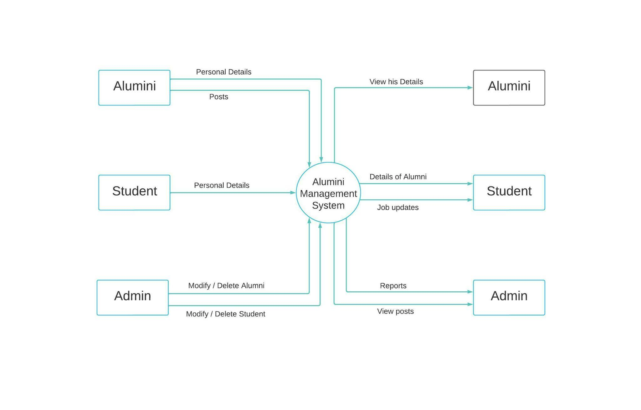

**4.1 DFD Level 1 -**

