RSA Implementation Using FPGA

Nitin Singh
Department Of Electronics and Communication
JSS Academy Of Technical Education, Noida
20ec094@jssaten.ac.in

Riya Sharma
Department Of Electronics And Communication
JSS Academy Of Technical Education, Noida
20ec028@jssaten.ac.in

Ms. Rajeshwari Bhat
Assistant Professor
Department Of Electronics And Communication
JSS Academy Of Technical Education, Noida
rajeshwaribhat2@jssaten.ac.in

Nisha Chauhan
Department Of Electronics And Communication
JSS Academy Of Technical Education, Noida
20ec155@jssaten.ac.in

Abstract— In this work, the cryptographic technique known as RSA is designed and implemented, with the goal of becoming a standard in secure communication systems. The basic idea of this algorithm is to create a confidential communication channel in between two parties (sender, and receiver). Verilog is used to code each module or block, and the Xilinx ISE_14.7 Design Suite is used to synthesize and simulate the code. A trade-off between speed, power, and space is offered, and the design is geared toward speed. FPGA is used as hardware to increase the speed and make the algorithm more secure. Our goal is to demonstrate, as a significant practical outcome, that the RSA algorithm can be implemented at secure bit lengths on a single piece of commercial hardware—FPGA and the study covers the design, optimization, and challenges of implementing RSA modules on FPGA, emphasizing modular exponentiation, key generation, and data handling.
Keywords—Cryptography, Encryption, Decryption, RSA, Security, Verilog, FPGA.

Introduction
In light of the recent explosion in electronic data communications and emerging technologies, it is critical to create new and improved methods for ensuring the security and safety of transferred data. Data that needs to be encrypted and shielded from outside access can be in the form of text, images, audio, or video. Cryptography is the art of keeping messages safe. The use of cryptography is essential to data security. In 1978, Adi Shamir, Leonard Adleman, and Ron Rivest presented the RSA algorithm. It's an extremely secure and high-quality public key cryptography algorithm [1]. It is a means of creating digital signatures and exchanging sensitive data, such as keys. However, the RSA algorithm's effort places computational demands, particularly when processing very big integers, which are often thousands of bits long [2]. These computational complexities pose challenges, especially when they need to be executed quickly and efficiently. Due to these challenges, integrating hardware acceleration has emerged as a compelling solution to improve the performance of RSA-based cryptographic systems in response to these demands, researchers and engineers have explored new ways to implement RSA algorithms using Field-Programmable Gate Arrays (FPGAs). FPGAs offer a unique blend of flexibility and performance, enabling hardware realization of complex cryptographic applications. Its enduring popularity can be attributed to its superior cryptographic properties, which ensure a degree of security that is considered paramount in the modern environment of communication and data processing

STEPS OF SECURE COMMUNICATION (DATA TRANSFER)
The RSA algorithm is an asymmetric encryption algorithm that uses two separate keys that are linked together: a public key and a private key. Commonly used for encryption, the public key is the one that is widely known. Exclusively the private key can be used to decrypt messages encrypted using the public key [3]. Using the following procedures, the keys are generated:

1. Encryption
1.1 Key Generation (Public Key)
2. Data Transfer
3. Decryption
3.1 Key Generation (Private Key)

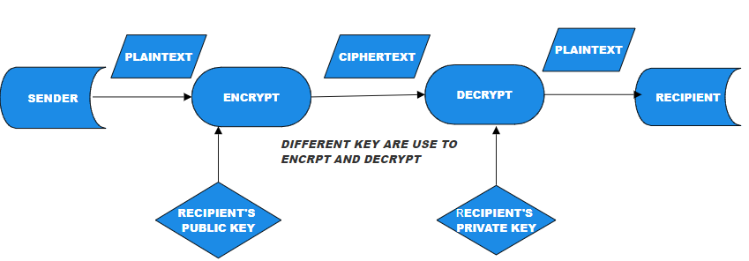

Fig 1.0 Work-Flow Of RSA

III.ENCRYPTION
Information is rendered incomprehensible to unauthorized users by the process of encryption, which converts plaintext into ciphertext. Encryption is essential for maintaining confidentiality, integrity, and authenticity since it prevents unwanted access and manipulation of sensitive data. Encryption, which is widely used in digital communication and storage, is essential to cybersecurity because it provides a strong barrier against illegal access and data compromise. The foundation of contemporary cryptography, the RSA algorithm, employs a distinct method of encryption. RSA employs two separate keys: a public key for encryption and a private key for decryption, in contrast to symmetric key methods. The encryption procedure is made even simpler by the addition of complexity and security provided by this dual-key gadget. The first step in the RSA encryption process is to choose a public key, which is usually two large prime numbers. These primes help generate a public key, which is used explicitly for everyone. The public key, with its associated parameter, forms the basis for plaintext encryption [4].Once the public key is obtained, the encryption process proceeds by dividing the plain text into smaller chunks. Each block goes through modular exponentiation, a basic step that uses arithmetic operations to raise plaintext to public exponent powers, followed by a modulo of public parameters.[5]This modular exponentiation operation generates ciphertext, and converts plaintext to signified characters if it is a random sequence[6].
KEY GENERATION
This technique includes deciding on appropriate high numbers, computing modular mathematics, and figuring out the public and private key additives [7]. Here, we complex the key generation technique, highlighting its importance and underlying theoretical standards.

- Choose the prime numbers p and q, two different huge random numbers.
- 2. Type in n = p*q. The modulus is equal to n for both the public and private keys.
- Determine the Euler's function by computing ϕ (n) = (p −1) (q −1).
- Select an integer e so that 1<e< ϕ (n); e and ϕ
- (n) share only one factor, which is 1 because e and ϕ (n) are co-primes; e is revealed as the public key's exponent.
- Find d such that ed ≡ 1 (mod φ(n)), or the congruence relation de ≡ 1 (mod ϕ (n)).

e is primarily understood as e=2^16 +1 = 65537. Certain applications opt for lesser values, such as e= 3, 5, 17, or 257 [8]. This is what we do to speed up encryption. The public key is composed of the modulus (n) and the public exponent (e). The private key is composed of the modulus (n) and private exponent (d).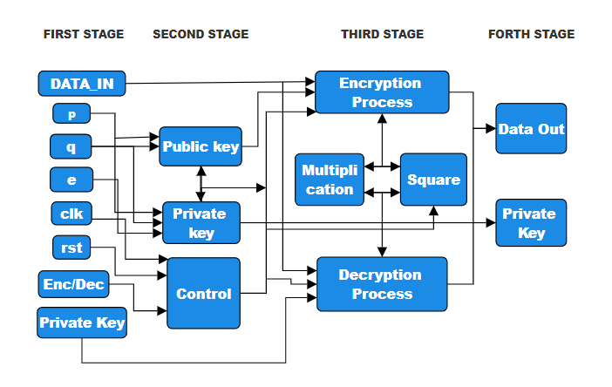
Fig 1.1 Key Generation
DIVIDER 16 BITS
The DIVIDER 16 BITS in the context of the RSA algorithm plays a crucial role in breaking down the intricate cryptographic processes into manageable components. In the realm of hardware-based RSA implementations on FPGAs, the DIVIDER 16 BITS stands as a fundamental arithmetic unit responsible for performing the division operation on binary data with a precision of 16 bits. To comprehend its significance, let's delve into the logical underpinnings and operational intricacies of this pivotal component.
The division process involves dividing a larger binary number (dividend) by a smaller binary number (divisor) to obtain a quotient and a remainder. The 16-bit divider performs this operation on binary data of 16 bits each. The result of the division is typically a quotient and a remainder, both represented as 16-bit binary numbers. Here 16-bit divider is utilized in RSA cryptography (using FPGA) as:

Encryption:
Prime numbers are generated. The 16-bit divider could be used to check and ensure that the generated numbers are prime.
During the encryption process, the plaintext is typically raised to the power of the public exponent modulo the public modulus (n). The modular exponentiation involves multiple modular multiplications, where a 16-bit divider might be used to handle smaller chunks of the data efficiently.
Decryption:
In RSA decryption, the ciphertext is raised to the power of the private exponent modulo n. Similar to encryption, modular arithmetic with a 16-bit divider could be employed in this process.

DIVIDER 32 BITS
A 32-bit divider [9] is used in RSA cryptography as a component of the modular exponentiation process, which is an essential RSA algorithm operation. Raising a base number to the power of an exponent and calculating the result modulo a modulus are the steps involved in modular exponentiation. The formula for this operation is (c ≡ m ^ e) mod n, where n is the modulus, e is the public exponent, m is the plaintext, and c is the ciphertext. Here 32bit divider is utilized in RSA cryptography (using FPGA) as:

Modular Exponentiation:
The modular exponentiation operation in RSA requires multiple modular multiplications and divisions.
A 32-bit divider is used to efficiently compute the modular divisions within the RSA algorithm.
FPGA Implementation:
FPGAs are programmable hardware devices that can be configured to implement specific digital logic circuits.
The modular exponentiation operation, including the 32-bit divider, is implemented in hardware on the FPGA.

Security Considerations:

Implementing RSA on an FPGA requires attention to security considerations, such as protection against side-channel attacks.

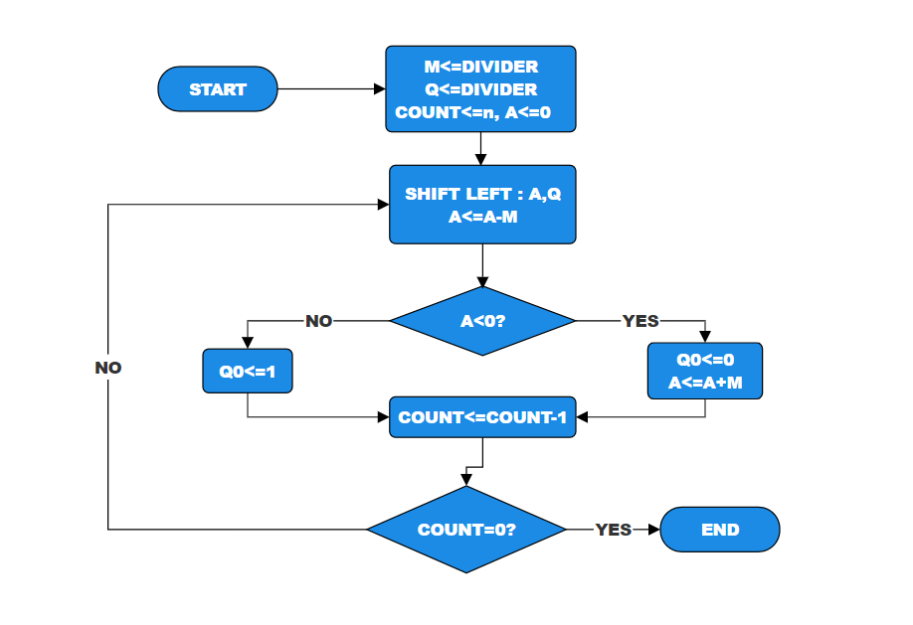

Fig 1.3 32-Bit Divider Architecture

MODULAR MULTIPLIER
A key element in accomplishing effective modular exponentiation is the modular multiplier [10]. The creation of RSA keys and the encryption and decryption procedures both depend on this action.
The modular multiplier is important because it makes sure that every multiplication operation is carried out modulo n in the modular exponentiation equation, where "m" is the plaintext, "e" is the exponent, and "n" is the modulus.
Efficient Multiplication:
The modular multiplier performs the multiplication of two numbers, typically the base m and the result from the previous modular multiplication step. This operation is conducted to minimize computational complexity.
Modular Reduction:
After multiplication, the result undergoes modular reduction by taking the remainder when divided by the modulus n. This step prevents numerical overflow and keeps the result within the appropriate range [0, n−1].
Iterative Process:
Starting with the least significant bit (LSB) and working its way up to the most significant bit (MSB), the modular multiplier loops over each bit of the exponent e. The outcome is totaled at each stage.
Impact on RSA Performance:
The efficiency of the modular multiplier directly influences the overall performance of RSA cryptography [11].
Key generation and encryption/decryption processes rely heavily on modular exponentiation, making the modular multiplier a critical factor.

DECRYPTION
Decryption in the RSA algorithm is a key process that ensures secure communication by converting the ciphertext back to the original plaintext with the help of the recipient’s private key. This policy is especially important where privacy is paramount, such as the transmission of sensitive information over insecure networks. Understanding the theoretical basis of RSA decryption provides insight into its mathematical foundation and the security guarantee it offers[12].

The process of converting encrypted data, or ciphertext, back into plaintext, or its original, readable form, is called decryption. The RSA algorithm uses two keys—a public key for encryption and a private key for decryption—and is based on the mathematical characteristics of big prime numbers. d.
Here's a step-by-step explanation of the decryption process RSA:
Ciphertext Reception:
The recipient receives the ciphertext ‘C’ transmitted securely over a communication channel. This ciphertext is now safe and unrecognizable by any third party or any intruder [13]. Thus, the result of encrypting the original plaintext message using the recipient's public key.
Private Key Usage:
The recipient employs their private key ‘d’ for decryption. The private key is generated as part of the RSA key generation process and possesses the necessary mathematical properties for reversing the encryption process.
Modular Exponentiation:
Modular exponentiation is carried out by the recipient by elevating the ciphertext c to the power of the private key 'd' modulo 'n'. The original plaintext message is effectively recovered from the ciphertext through the use of modular arithmetic's exponentiation mathematical property.
Result Validation:
After modular exponentiation, the recipient obtains the decrypted plaintext message [14]. It is crucial to validate the correctness of the decryption process by ensuring that the recovered plaintext matches the original message [15] sent by the sender.

V. RESULTS
ENCRYPTION
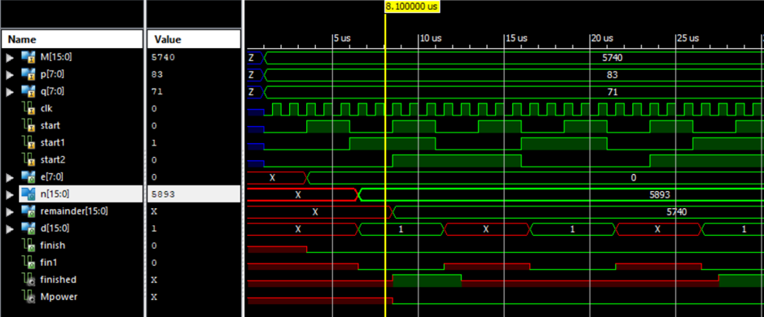

KEY GENERATION
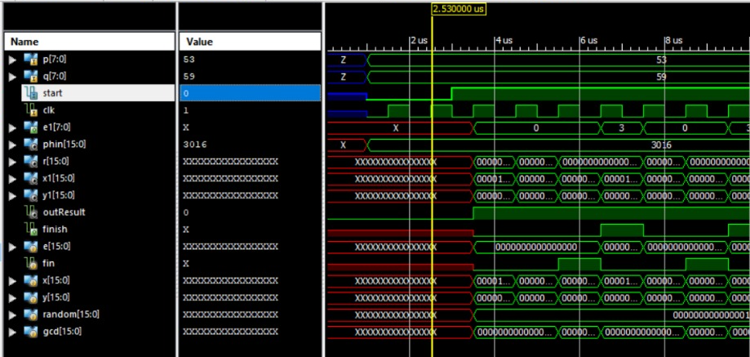

16-BIT DIVIDER
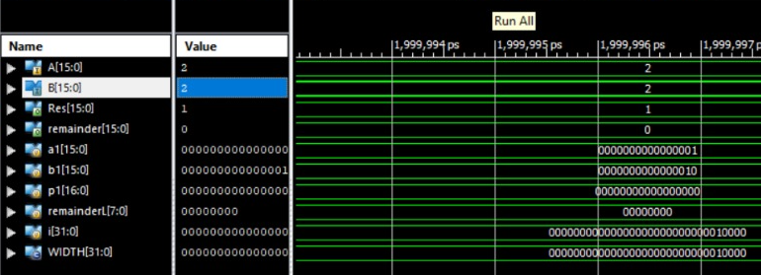

32-BIT DIVIDER
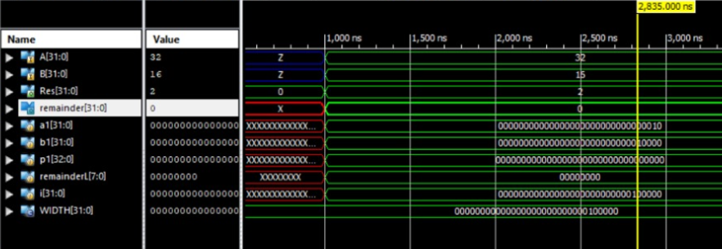

DECRYPTION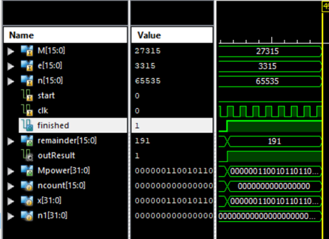

VI . References

- Cetin Kaya Koc, High-speed RSA algorithm, RSA laboratories, version 2, 1994
- Perovic N.S; Popovic-Bozovic: "FPGA implementation of RSA crypto algorithm using shift and carry algorithm ", IEEE
- Sushanta Kumar Sahu, ManoranjanPradhan, “FPGA Implementation of RSA Encryption System”, International Journal of Computer Applications (0975 – 8887), Volume 19– No.9, April (2011)
- Lin X Sun L and Qu H, 2017 An efficient RSA-based certificateless public key encryption scheme.
- https://www.slideshare.net/ijcncs/cryptosystem-an-implementation-of-rsa-using-verilog
- Ramzi A. Haraty, N . EI -Kassar and Bilal Shibaro, "A Comparative Study of RSA Based Digital Signature Algorithms ", Journal of Mathematics and Statistics ( 1 ) : 3 54-3 5 9, 2006
- Meng X and Zheng X, 2015 Cryptanalysis of RSA with a small parameter revisited Inf. Process. Lett. 115, 11 p. 858–862.
- Modular Arithmetic for RSA Cryptography. [Courtesy:http://gtk.hopto.org:8089/MODULARRSA.pdf]
- https://www.irjet.net/archives/V7/i9/IRJET-V7I9160.pdf
- D. Boneh and H. Shacham, “Fast Variants of RSA”, CryptoBytes, Vol. 5, No. 1, pp. 1-9, 2002
- Mohammad El-Hahidy, Danilo G. and Sevin J. K., "High performance Implementation of public key block cipher-MQQ, for FPGA Platforms", (2004), eprint.iacr.org/2008/339.pdf
- G. C. Kessler, An Overview of Cryptography, Boca Raton: Auerbach Publications,2017.
- Sushanta Kumar Sahu, ManoranjanPradhan, "FPGA Implementation of RSA Encryption System", International Journal of Computer Applications (0975-8887), Volume 19- No.9, April (2011)
- Symeon (Simos) Xenitellis, “A guide to PKIs and Open– source Implementations”, The Open–source PKI Book
- Md. AI i -AI-Mamun, Mohammad Motaharul I slam, S . M. Mashihure Romman and A.H. Salah Uddin Ahmad, " Performance Evaluation of Several Efficient RSA Variants", IJC SN S International Journal of Computer Science and Network Security, 8No.7, July (2008).

