RSA Implementation Using FPGA

Nitin Singh
Department Of Electronics and Communication
Jss Academy Of Technical Education , Noida
20ec094@jssaten.ac.in

Riya Sharma
Department Of Electronics And Communication
Jss Academy Of Technical Education, Noida
20ec028@jssaten.ac.in

Mentor: Ms. Rajeshwari Bhatt
Assistant Professor
Department Of Electronics And Communication
Jss Academy Of Technical Education
Noida
rajeshwaribhat2@jssaten.ac.in

Nisha Chauhan
Department Of Electronics And Communication
Jss Academy Of Technical Education , Noida
20ec155@jssaten.ac.in

Abstract—This paper presents the design and implementation of a cryptographic technique, RSA that can be used as a standard in the secured communication system. The basic idea of this algorithm is to create a confidential communication channel in between two parties (sender, receiver). Each module(block) is coded using Verilog and the code is synthesized and simulated using Xilinx ISE_14.7 Design Suite. The design is optimized for speed and a tradeoff is presented between speed, power and space. FPGA is used as a hardware to increase the speed and make the algorithm more secured. As a major practical result, our aim is to show that it is possible to implement RSA algorithm at secure bit lengths on a single commercially available hardware, FPGA and the study covers the design, optimization, and challenges of implementing RSA modules on FPGA, emphasizing modular exponentiation, key generation and data handling.
Keywords—Cryptography, Encryption, Decryption, RSA, Security, Verilog, FPGA.

Introduction
With the recent explosion of emerging technologies and electronic data communications, it is very important to develop new and better ways to guarantee the safety and security of the data that is being transferred. The data that is to be secured and protected from any third party intrusion can be in the form of plain-text, image, audio or video. The art of keeping messages secure is termed as Cryptography. Cryptography plays a vital role in data security. The RSA algorithm was introduced in the year 1978 by Ron Rivest, Adi Shamir and Leonard Adleman. It’s a public key cryptographic algorithm that’s high quality and very secured [1]. It is used as a method to exchange important information like keys and producing digital signatures. However, the effort of the RSA algorithm poses computational demands, especially for its processing on very large integers, typically thousands of bits in length [2] These computational complexities pose challenges, especially when they need to be executed works quickly and efficiently. Due to these challenges, integrating hardware acceleration has emerged as a compelling solution to improve the performance of RSA-based cryptographic systems in response to these demands, researchers and engineers have explored new ways to implement RSA algorithms using Field-Programmable Gate Arrays (FPGAs). FPGAs offer a unique blend of flexibility and performance, enabling hardware realization of complex cryptographic applications. Its enduring popularity can be attributed to its superior cryptographic properties, which ensure a degree of security that is considered paramount in the modern environment of communication and data processing

STEPS OF SECURE CDOMMUNICATION (DATA TRANSFER)
RSA algorithm is a type of asymmetric encryption algorithm which involves two different keys which are linked to each other; a public key and a private key. The public key is known to everyone and is used to encrypt messages. Messages that are encrypted with public key can only be decrypted using the private key. The keys are generated by the following steps:

1.Encryption
1.1 Key Generation (Public Key)
2. Data Transfer
3. Decryption
3.1 Key Generation (Private Key)

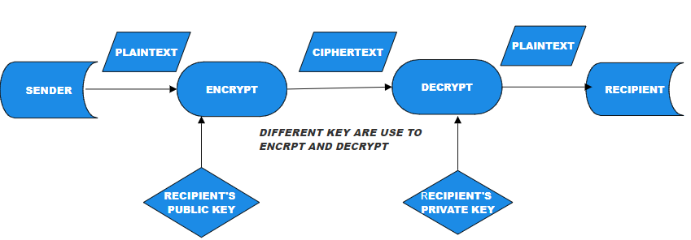

Fig 1.0 Work-Flow Of RSA
III.ENCRYPTION
Encryption is a process that transforms plaintext into ciphertext, rendering information unintelligible to unauthorized users Crucial in ensuring confidentiality, integrity, and authenticity, encryption safeguards sensitive data from unauthorized access and tampering. Widely adopted in digital communication and storage, encryption plays a pivotal role in cybersecurity, offering a robust defense against unauthorized intrusion and data compromise. The RSA algorithm, the cornerstone of modern cryptography, uses a unique approach to encryption. Unlike symmetric key algorithms, RSA uses two distinct keys: a public key for encryption and a private key for decryption. This dual-key device adds additional complexity and security, further simplifying the encryption process.
The first step in the RSA encryption process is to choose a public key, which is usually two large prime numbers. These primes help generate a public key, which is used explicitly for everyone. The public key, with its associated parameter, forms the basis for plaintext encryption.
Once the public key is obtained, the encryption process proceeds by dividing the plain text into smaller chunks. Each block goes through modular exponentiation, a basic step that uses arithmetic operations to raise plaintext to public exponent powers, followed by a modulo of public parameters This modular exponentiation operation generates ciphertext, and converts plaintext to signified characters if it is a random sequence.

KEY GENERATION
This technique includes deciding on appropriate high numbers, computing modular mathematics, and figuring out the public and private key additives. Here , we complex on the key generation technique, highlighting its importance and underlying theoretical standards.

- Choose two distinct large random prime numbers p and q.
- Compute n = p*q. The number n is used as the modulus for both the public and private keys.
Compute the Euler’s function: ϕ (n) = (p −1) (q −1).
Choose an integer e such that 1<e< ϕ (n); e and ϕ
- (n) share no factors other than 1 (i.e. e and ϕ (n) are co primes); e is released as the public key exponent.
- Compute d for the congruence relation
de ≡ 1 (mod ϕ (n)); i.e. ed ≡ 1 (mod φ(n)).

Majorly public exponent, e is taken as e=2^16 +1 =65537. Some applications choose smaller values like e= 3, 5, 17 or 257 instead. We do this to make encryption faster. The public key consists of the modulus n and the public exponent e. The private key consists of the modulus n and private exponent d.
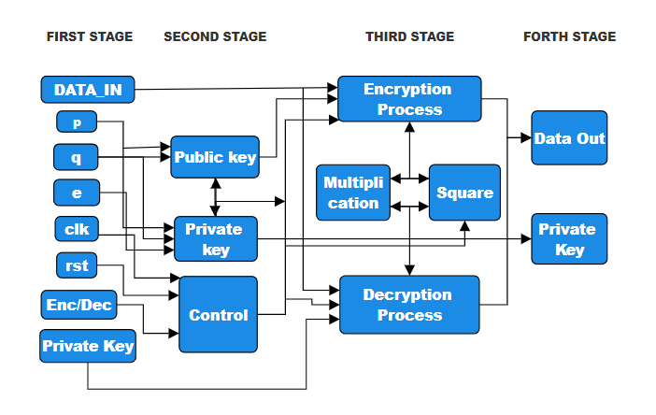
Fig 1.1 Key Generation

DIVIDER 16 BITS

The DIVIDER 16 BITS in the context of the RSA algorithm plays a crucial role in breaking down the intricate cryptographic processes into manageable components. In the realm of hardware-based RSA implementations on FPGAs, the DIVIDER 16 BITS stands as a fundamental arithmetic unit responsible for performing the division operation on binary data with a precision of 16 bits. To comprehend its significance, let's delve into the logical underpinnings and operational intricacies of this pivotal component.
The division process involves dividing a larger binary number (dividend) by a smaller binary number (divisor) to obtain a quotient and a remainder. The 16-bit divider performs this operation on binary data of 16 bits each. The result of the division is typically a quotient and a remainder, both represented as 16-bit binary numbers. Here 16-bit divider is utilized in RSA cryptography (using FPGA) as:

Key Generation:
In the key generation phase of RSA, prime numbers are generated. The 16-bit divider could be used to check and ensure that the generated numbers are prime.
Encryption:
During the encryption process, the plaintext is typically raised to the power of the public exponent modulo the public modulus (n). The modular exponentiation involves multiple modular multiplications, where a 16-bit divider might be used to handle smaller chunks of the data efficiently.
Decryption:
In RSA decryption, the ciphertext is raised to the power of the private exponent modulo n. Similar to encryption, modular arithmetic with a 16-bit divider could be employed in this process.

DIVIDER 32 BITS
In RSA cryptography, a 32-bit divider is employed as part of the modular exponentiation operation, which is a fundamental operation in the RSA algorithm. Modular exponentiation involves raising a base number to the power of an exponent and taking the result modulo a modulus. This operation is expressed as (c ≡ m ^ e) mod n, where c is the ciphertext, m is the plaintext, e is the public exponent, and n is the modulus. Here 32bit divider is utilized in RSA cryptography (using FPGA) as:

Modular Exponentiation:
The modular exponentiation operation in RSA requires multiple modular multiplications and divisions.
A 32-bit divider is used to efficiently compute the modular divisions within the RSA algorithm.
FPGA Implementation:
FPGAs are programmable hardware devices that can be configured to implement specific digital logic circuits.
The modular exponentiation operation, including the 32-bit divider, is implemented in hardware on the FPGA.

Security Considerations:

Implementing RSA on an FPGA requires attention to security considerations, such as protection against side-channel attacks.

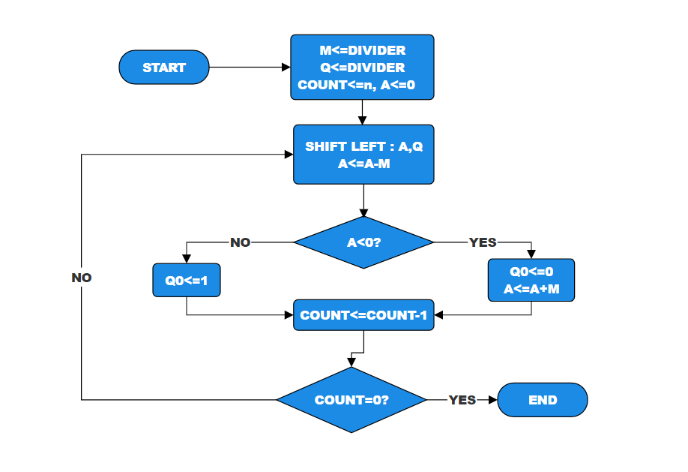
Fig 1.3 32-Bit Divider Architecture

MODULAR MULTIPLIER
Modular multiplier is a pivotal component in achieving efficient modular exponentiation. This operation is integral to both RSA key generation and the encryption/decryption processes. In the modular exponentiation equation
m is the plaintext, e is the exponent, and n is the modulus, the modular multiplier plays a crucial role by ensuring that each multiplication operation is performed modulo n.

Efficient Multiplication:
The modular multiplier performs multiplication of two numbers, typically the base m and the result from the previous modular multiplication step. This operation is conducted with the aim of minimizing computational complexity.
Modular Reduction:
After multiplication, the result undergoes modular reduction by taking the remainder when divided by the modulus n. This step prevents numerical overflow and keeps the result within the appropriate range [0, n−1].
Iterative Process:
The modular multiplier iterates over each bit of the exponent e, proceeding from the least significant bit (LSB) to the most significant bit (MSB). At each step, the result is accumulated.
Impact on RSA Performance:
The efficiency of the modular multiplier directly influences the overall performance of RSA cryptography.
Key generation and encryption/decryption processes rely heavily on modular exponentiation, making the modular multiplier a critical factor.

IV. DECRYPTION

Decryption in the RSA algorithm is a key process that ensures secure communication by converting the ciphertext back to the original plaintext. This policy is especially important where privacy is paramount, such as the transmission of sensitive information over insecure networks. Understanding the theoretical basis of RSA decryption provides insight into its mathematical foundation and the security guarantees it offers.

Decryption is the process of transforming encrypted data, known as ciphertext, back into its original and readable form, known as plaintext. The RSA algorithm relies on the mathematical properties of large prime numbers and involves a pair of keys: a public key for encryption and a private key for decryption.

Here's a step-by-step explanation of the decryption processin RSA:
Ciphertext Reception:
The recipient receives the ciphertext ‘C’ transmitted securely over a communication channel. This ciphertext is the result of encrypting the original plaintext message using the recipient's public key.
Private Key Usage:
The recipient employs their private key ‘d’ for decryption. The private key is generated as part of the RSA key generation process and possesses the necessary mathematical properties for reversing the encryption process.
Modular Exponentiation:
The recipient performs modular exponentiation by raising the ciphertext c to the power of the private key ‘d’ modulo ‘n’. This operation efficiently retrieves the original plaintext message from the ciphertext, leveraging the mathematical properties of exponentiation in modular arithmetic.
Result Validation:
After modular exponentiation, the recipient obtains the decrypted plaintext message. It is crucial to validate the correctness of the decryption process by ensuring that the recovered plaintext matches the original message sent by the sender.

V. RESULTS
ENCRYPTION
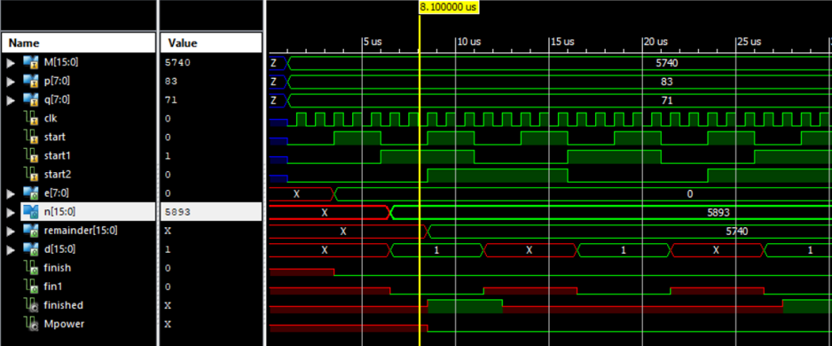

KEY GENRATION
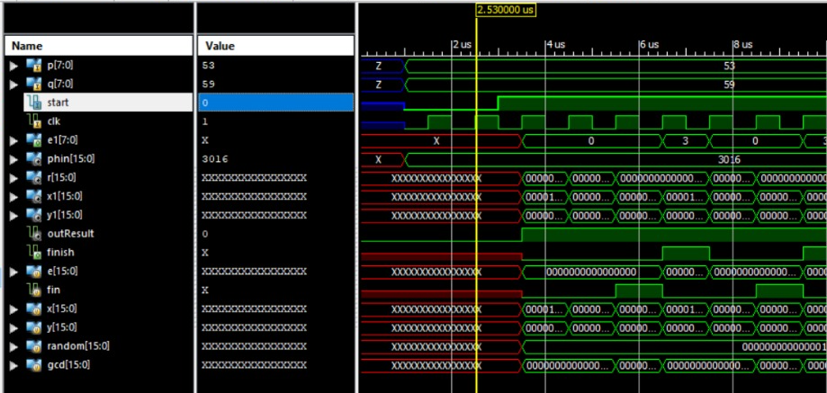

16-BIT DIVIDER
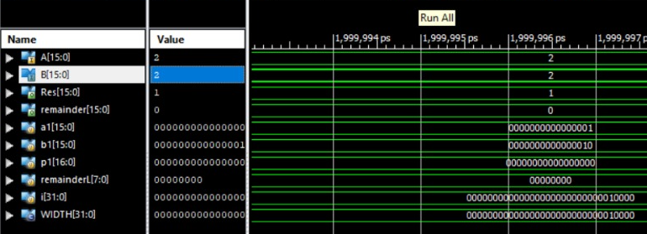

32-BIT DIVIDER
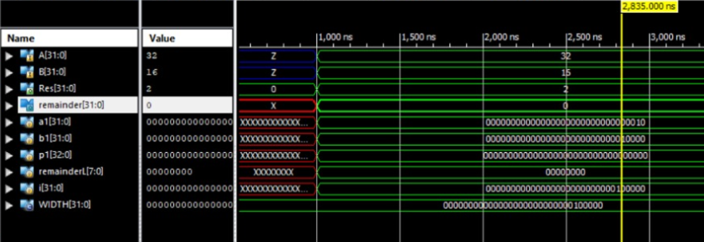

DECRYPTION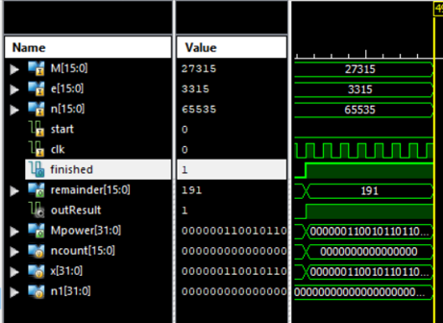

VI . References
The template will number citations consecutively within brackets [1]. The sentence punctuation follows the bracket [2]. Refer simply to the reference number, as in [3]—do not use “Ref. [3]” or “reference [3]” except at the beginning of a sentence: “Reference [3] was the first ...”
Number footnotes separately in superscripts. Place the actual footnote at the bottom of the column in which it was cited. Do not put footnotes in the abstract or reference list. Use letters for table footnotes.
Unless there are six authors or more give all authors’ names; do not use “et al.”. Papers that have not been
published, even if they have been submitted for publication, should be cited as “unpublished” [4]. Papers that have been accepted for publication should be cited as “in press” [5]. Capitalize only the first word in a paper title, except for proper nouns and element symbols.
For papers published in translation journals, please give the English citation first, followed by the original foreign-language citation [6].

[1] Cetin Kaya Koc, High speed RSA algorithm, RSA laboratories, version 2, 1994
[2] Perovic N.S; Popovic-Bozovic : “FPGA implementation of RSA crypto algorithm using shift and carry algorithm “,IEEE

