Deep Learning

Sequential Models

# Creating Sequential Model

Number of Layers

3

Number of Neurons in each layer

[9, 1, 1, 1, 1, 1, 1, 1, 1, 1, 1, 1, 1, 1, 1, 1, 1, 1, 1, 1, 1, 1, 1, 1, 1, 1, 1, 1, 1, 1, 1, 1, 1, 1, 1, 1, 1, 1, 1, 1, 1, 1, 1, 1, 1, 1, 1, 1, 1, 1]

Batch Size

10

Number of Epochs

100

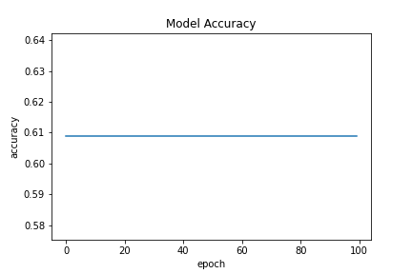

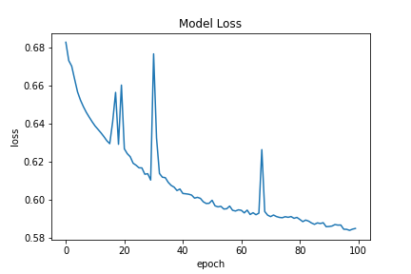

# Creating Sequential Model

Number of Layers

5

Number of Neurons in each layer

[9, 1, 1, 1, 1, 1, 1, 1, 1, 1, 1, 1, 1, 1, 1, 1, 1, 1, 1, 1, 1, 1, 1, 1, 1, 1, 1, 1, 1, 1, 1, 1, 1, 1, 1, 1, 1, 1, 1, 1, 1, 1, 1, 1, 1, 1, 1, 1, 1, 1]

Batch Size

10

Number of Epochs

100

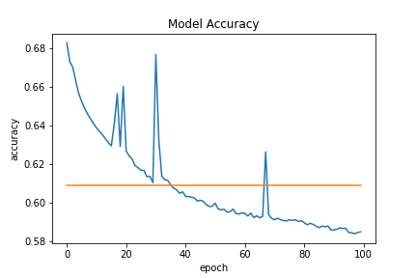

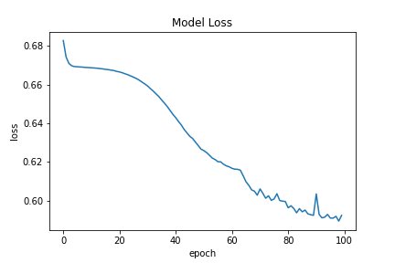

# Creating Sequential Model

Number of Layers

7

Number of Neurons in each layer

[9, 1, 1, 1, 1, 1, 1, 1, 1, 1, 1, 1, 1, 1, 1, 1, 1, 1, 1, 1, 1, 1, 1, 1, 1, 1, 1, 1, 1, 1, 1, 1, 1, 1, 1, 1, 1, 1, 1, 1, 1, 1, 1, 1, 1, 1, 1, 1, 1, 1]

Batch Size

10

Number of Epochs

100

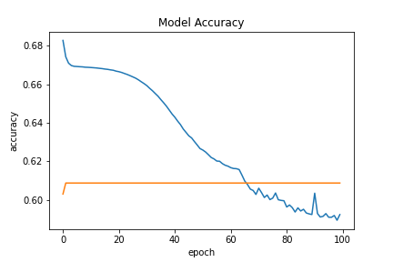

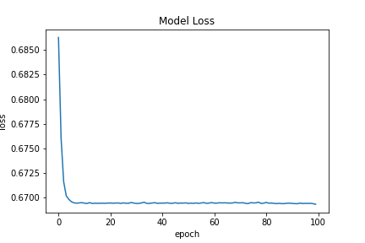

# Creating Sequential Model

Number of Layers

9

Number of Neurons in each layer

[9, 1, 1, 1, 1, 1, 1, 1, 1, 1, 1, 1, 1, 1, 1, 1, 1, 1, 1, 1, 1, 1, 1, 1, 1, 1, 1, 1, 1, 1, 1, 1, 1, 1, 1, 1, 1, 1, 1, 1, 1, 1, 1, 1, 1, 1, 1, 1, 1, 1]

Batch Size

10

Number of Epochs

100

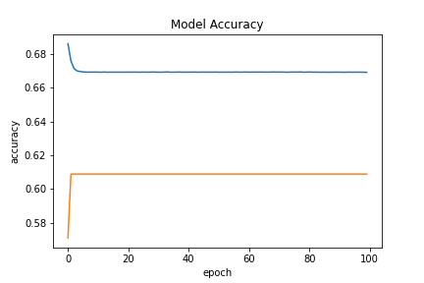

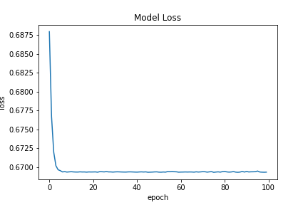

# Creating Sequential Model

Number of Layers

11

Number of Neurons in each layer

[9, 1, 1, 1, 1, 1, 1, 1, 1, 1, 1, 1, 1, 1, 1, 1, 1, 1, 1, 1, 1, 1, 1, 1, 1, 1, 1, 1, 1, 1, 1, 1, 1, 1, 1, 1, 1, 1, 1, 1, 1, 1, 1, 1, 1, 1, 1, 1, 1, 1]

Batch Size

10

Number of Epochs

100

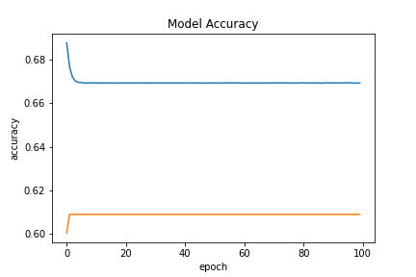

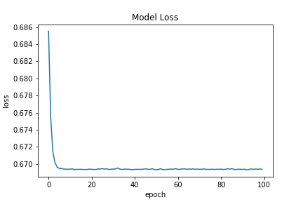

# Creating Sequential Model

Number of Layers

15

Number of Neurons in each layer

[9, 1, 1, 1, 1, 1, 1, 1, 1, 1, 1, 1, 1, 1, 1, 1, 1, 1, 1, 1, 1, 1, 1, 1, 1, 1, 1, 1, 1, 1, 1, 1, 1, 1, 1, 1, 1, 1, 1, 1, 1, 1, 1, 1, 1, 1, 1, 1, 1, 1]

Batch Size

10

Number of Epochs

100

# Creating Sequential Model

Number of Layers

3

Number of Neurons in each layer

[50, 1, 1]

Batch Size

5

Number of Epochs

100

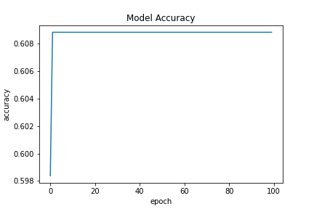

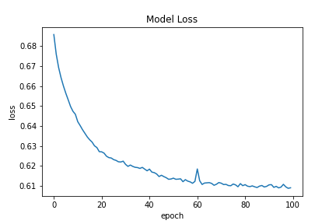

Best Model Results

Accuracy

0.6155303120613098

Loss

0.6340392827987671

Functional Models

Accuracy

0.6382575631141663

Loss

1776.8765869140625