# Machine Learning

Random Forest Classifier

Accuracy Score:

0.8333333333333334

Confusion Matrix

[[ 78 13]  
 [ 31 142]]



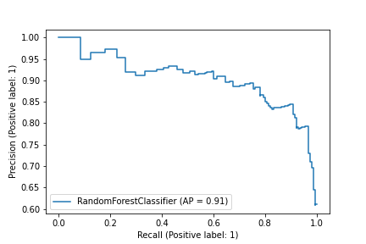

Sensitivity

0.8571428571428571

Specificty

0.8208092485549133

Precision

0.7155963302752294

Negative Predictive Value

0.9161290322580645

Mean Squared Error

0.408248290463863

Feature Importances

decomposition_energy

avg p valence electrons

exfoliation_energy_per_atom

Yang omega

energy_per_atom

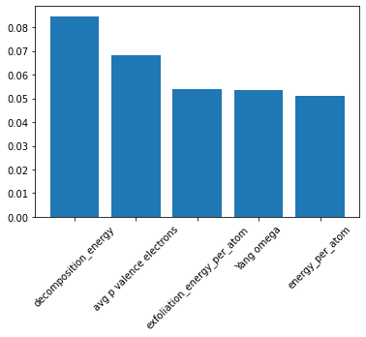

Support Vector Machines

Accuracy Score:

0.6628787878787878

Confusion Matrix

[[ 46 26]  
 [ 63 129]]



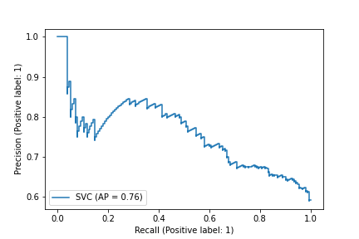

Sensitivity

0.6388888888888888

Specificty

0.671875

Precision

0.42201834862385323

Negative Predictive Value

0.832258064516129

Mean Squared Error

0.5806214017078704

KNeighbours Classifier

Accuracy Score:

0.6893939393939394

Confusion Matrix

[[ 61 34]  
 [ 48 121]]



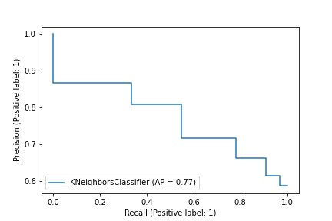

Sensitivity

0.6421052631578947

Specificty

0.7159763313609467

Precision

0.5596330275229358

Negative Predictive Value

0.7806451612903226

Mean Squared Error

0.5573204290227127

Decision Tree Classifier

Accuracy Score:

0.8068181818181818

Confusion Matrix

[[ 81 23]  
 [ 28 132]]



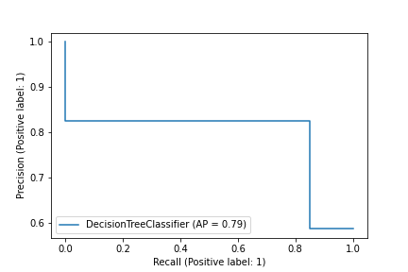

Sensitivity

0.7788461538461539

Specificty

0.825

Precision

0.7431192660550459

Negative Predictive Value

0.8516129032258064

Mean Squared Error

0.4395245364957663

Feature Importances

avg p valence electrons

decomposition_energy

energy_per_atom

number_of_magnetic_atoms

Yang omega

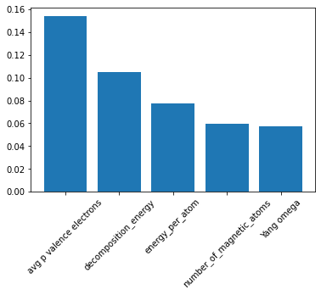

Gaussian NB

Accuracy Score:

0.5871212121212122

Confusion Matrix

[[ 0 0]  
 [109 155]]



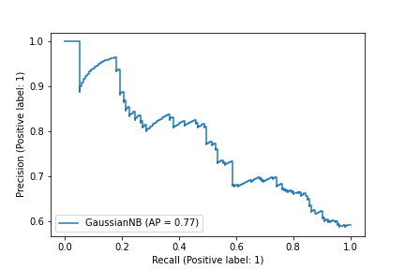

Sensitivity

nan

Specificty

0.5871212121212122

Precision

0.0

Negative Predictive Value

1.0

Mean Squared Error

0.642556447231516

Linear Discriminant Analysis

Accuracy Score:

0.8106060606060606

Confusion Matrix

[[ 84 25]  
 [ 25 130]]



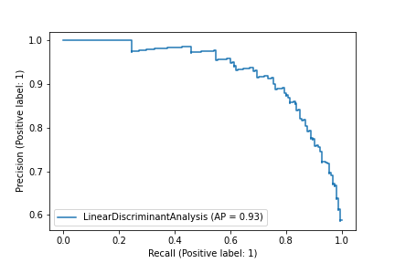

Sensitivity

0.7706422018348624

Specificty

0.8387096774193549

Precision

0.7706422018348624

Negative Predictive Value

0.8387096774193549

Mean Squared Error

0.4351941398892446

Ada Boost Classifier

Accuracy Score:

0.7651515151515151

Confusion Matrix

[[ 74 27]  
 [ 35 128]]



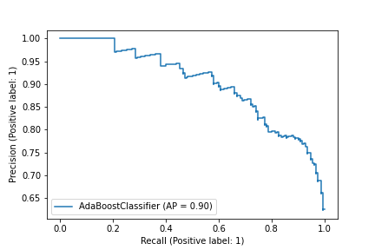

Sensitivity

0.7326732673267327

Specificty

0.7852760736196319

Precision

0.6788990825688074

Negative Predictive Value

0.8258064516129032

Mean Squared Error

0.4846116845975599

Feature Importances

decomposition_energy

sg_number

exfoliation_energy_per_atom

avg p valence electrons

band center

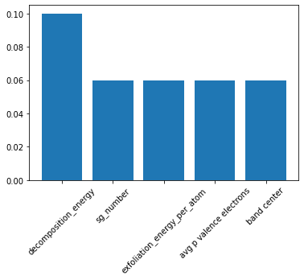

Gradient Boost Classifier

Accuracy Score:

0.7954545454545454

Confusion Matrix

[[ 75 20]  
 [ 34 135]]



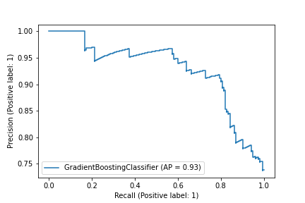

Sensitivity

0.7894736842105263

Specificty

0.7988165680473372

Precision

0.6880733944954128

Negative Predictive Value

0.8709677419354839

Mean Squared Error

0.45226701686664544

Feature Importances

avg p valence electrons

decomposition_energy

number_of_magnetic_atoms

energy_per_atom

band center

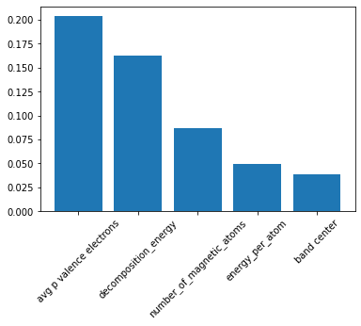

Random Forest Classifier

Accuracy Score:

0.8314393939393939

Confusion Matrix

[[142 39]  
 [ 50 297]]



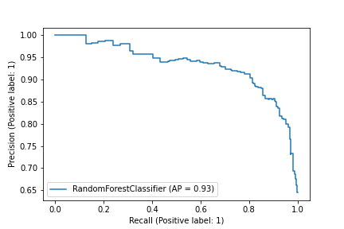

Sensitivity

0.7845303867403315

Specificty

0.8559077809798271

Precision

0.7395833333333334

Negative Predictive Value

0.8839285714285714

Mean Squared Error

0.4105613304496736

Feature Importances

decomposition_energy

avg p valence electrons

band center

energy_per_atom

Yang omega

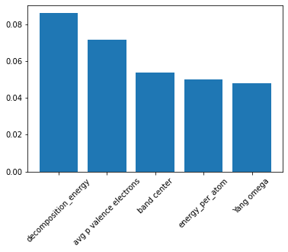

Support Vector Machines

Accuracy Score:

0.6818181818181818

Confusion Matrix

[[ 78 54]  
 [114 282]]



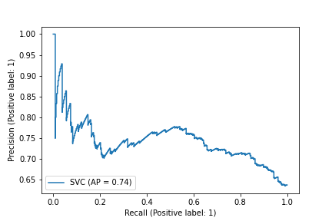

Sensitivity

0.5909090909090909

Specificty

0.7121212121212122

Precision

0.40625

Negative Predictive Value

0.8392857142857143

Mean Squared Error

0.5640760748177662

KNeighbours Classifier

Accuracy Score:

0.6515151515151515

Confusion Matrix

[[100 92]  
 [ 92 244]]



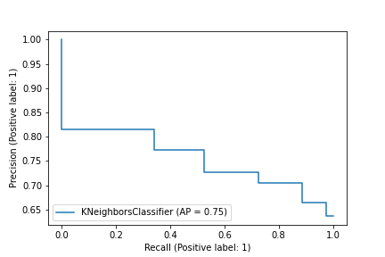

Sensitivity

0.5208333333333334

Specificty

0.7261904761904762

Precision

0.5208333333333334

Negative Predictive Value

0.7261904761904762

Mean Squared Error

0.5903260526902472

Decision Tree Classifier

Accuracy Score:

0.8106060606060606

Confusion Matrix

[[144 52]  
 [ 48 284]]



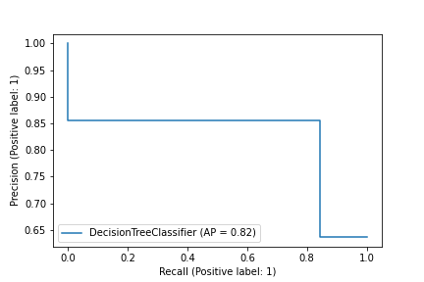

Sensitivity

0.7346938775510204

Specificty

0.8554216867469879

Precision

0.75

Negative Predictive Value

0.8452380952380952

Mean Squared Error

0.4351941398892446

Feature Importances

avg p valence electrons

decomposition_energy

sg_number

energy_per_atom

band center

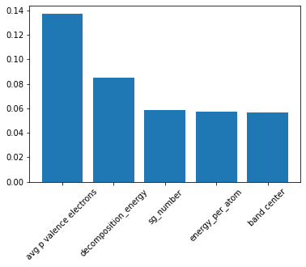

Gaussian NB

Accuracy Score:

0.6363636363636364

Confusion Matrix

[[ 0 0]  
 [192 336]]



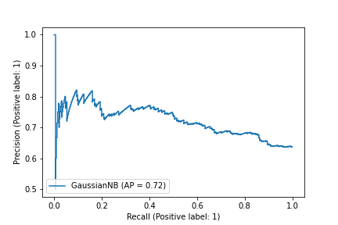

Sensitivity

nan

Specificty

0.6363636363636364

Precision

0.0

Negative Predictive Value

1.0

Mean Squared Error

0.6030226891555273

Linear Discriminant Analysis

Accuracy Score:

0.7708333333333334

Confusion Matrix

[[134 63]  
 [ 58 273]]



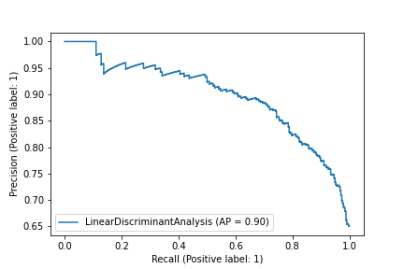

Sensitivity

0.6802030456852792

Specificty

0.824773413897281

Precision

0.6979166666666666

Negative Predictive Value

0.8125

Mean Squared Error

0.47871355387816905

Ada Boost Classifier

Accuracy Score:

0.7765151515151515

Confusion Matrix

[[135 61]  
 [ 57 275]]



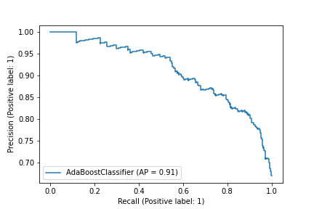

Sensitivity

0.6887755102040817

Specificty

0.8283132530120482

Precision

0.703125

Negative Predictive Value

0.8184523809523809

Mean Squared Error

0.47274184126735436

Feature Importances

decomposition_energy

avg p valence electrons

exfoliation_energy_per_atom

sg_number

energy_vdw_per_atom

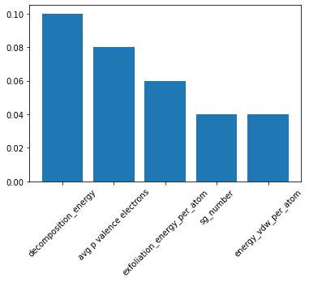

Gradient Boost Classifier

Accuracy Score:

0.8333333333333334

Confusion Matrix

[[140 36]  
 [ 52 300]]



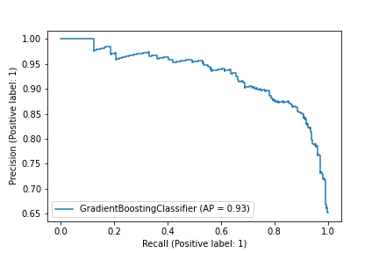

Sensitivity

0.7954545454545454

Specificty

0.8522727272727273

Precision

0.7291666666666666

Negative Predictive Value

0.8928571428571429

Mean Squared Error

0.408248290463863

Feature Importances

avg p valence electrons

decomposition_energy

number_of_magnetic_atoms

energy_per_atom

band center

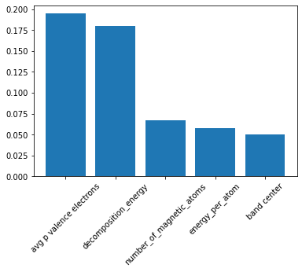

Random Forest Classifier

Accuracy Score:

0.8472222222222222

Confusion Matrix

[[238 56]  
 [ 65 433]]



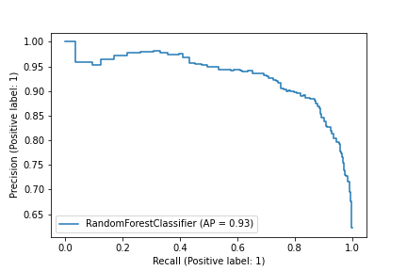

Sensitivity

0.8095238095238095

Specificty

0.8694779116465864

Precision

0.7854785478547854

Negative Predictive Value

0.885480572597137

Mean Squared Error

0.39086797998528583

Feature Importances

decomposition_energy

avg p valence electrons

exfoliation_energy_per_atom

Yang omega

band center

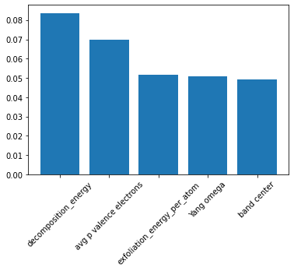

Support Vector Machines

Accuracy Score:

0.6906565656565656

Confusion Matrix

[[130 72]  
 [173 417]]



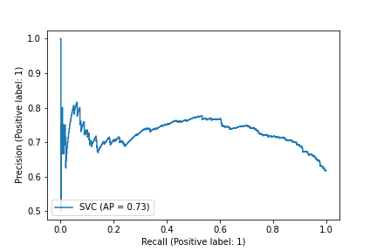

Sensitivity

0.6435643564356436

Specificty

0.7067796610169491

Precision

0.429042904290429

Negative Predictive Value

0.852760736196319

Mean Squared Error

0.5561865103932622

KNeighbours Classifier

Accuracy Score:

0.6919191919191919

Confusion Matrix

[[173 114]  
 [130 375]]



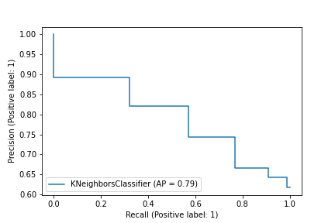

Sensitivity

0.6027874564459931

Specificty

0.7425742574257426

Precision

0.570957095709571

Negative Predictive Value

0.7668711656441718

Mean Squared Error

0.5550502752731576

Decision Tree Classifier

Accuracy Score:

0.7992424242424242

Confusion Matrix

[[220 76]  
 [ 83 413]]



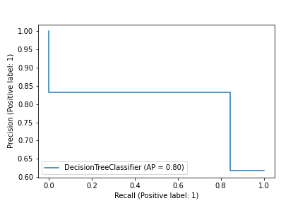

Sensitivity

0.7432432432432432

Specificty

0.8326612903225806

Precision

0.7260726072607261

Negative Predictive Value

0.8445807770961146

Mean Squared Error

0.44805979038246196

Feature Importances

avg p valence electrons

decomposition_energy

Yang omega

energy_per_atom

10-norm

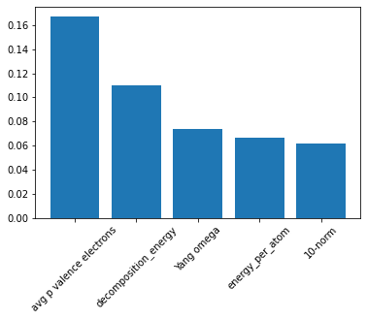

Gaussian NB

Accuracy Score:

0.6174242424242424

Confusion Matrix

[[ 0 0]  
 [303 489]]



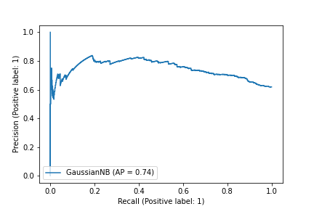

Sensitivity

nan

Specificty

0.6174242424242424

Precision

0.0

Negative Predictive Value

1.0

Mean Squared Error

0.618527087180309

Linear Discriminant Analysis

Accuracy Score:

0.8042929292929293

Confusion Matrix

[[226 78]  
 [ 77 411]]



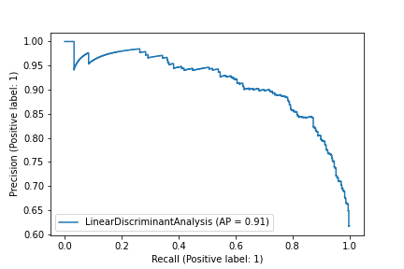

Sensitivity

0.743421052631579

Specificty

0.8422131147540983

Precision

0.7458745874587459

Negative Predictive Value

0.8404907975460123

Mean Squared Error

0.4423879188077707

Ada Boost Classifier

Accuracy Score:

0.797979797979798

Confusion Matrix

[[220 77]  
 [ 83 412]]



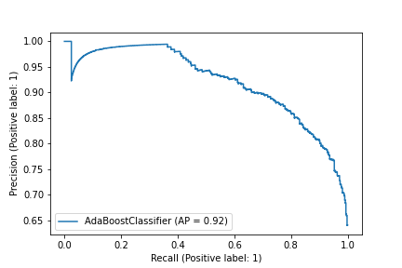

Sensitivity

0.7407407407407407

Specificty

0.8323232323232324

Precision

0.7260726072607261

Negative Predictive Value

0.8425357873210634

Mean Squared Error

0.4494665749754947

Feature Importances

decomposition_energy

avg p valence electrons

sg_number

exfoliation_energy_per_atom

sg_number

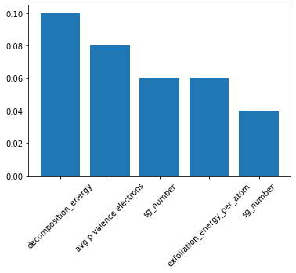

Gradient Boost Classifier

Accuracy Score:

0.8333333333333334

Confusion Matrix

[[225 54]  
 [ 78 435]]



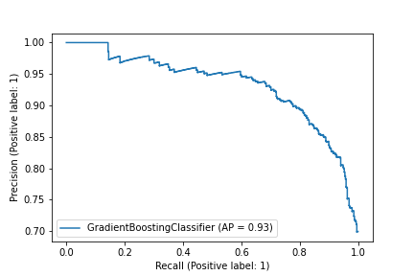

Sensitivity

0.8064516129032258

Specificty

0.847953216374269

Precision

0.7425742574257426

Negative Predictive Value

0.8895705521472392

Mean Squared Error

0.408248290463863

Feature Importances

avg p valence electrons

decomposition_energy

number_of_magnetic_atoms

10-norm

Yang omega

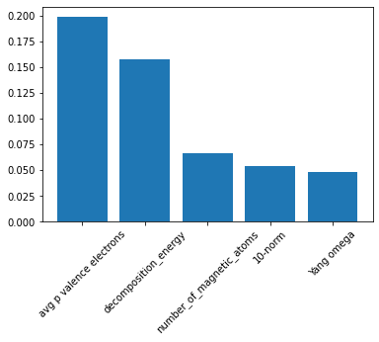

Random Forest Classifier

Accuracy Score:

0.8388625592417062

Confusion Matrix

[[295 81]  
 [ 89 590]]



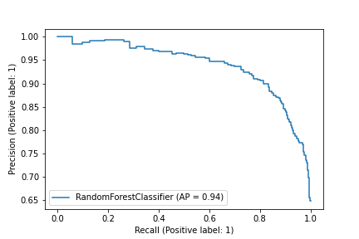

Sensitivity

0.7845744680851063

Specificty

0.8689248895434463

Precision

0.7682291666666666

Negative Predictive Value

0.879284649776453

Mean Squared Error

0.40141928299260093

Feature Importances

decomposition_energy

avg p valence electrons

band center

exfoliation_energy_per_atom

energy_per_atom

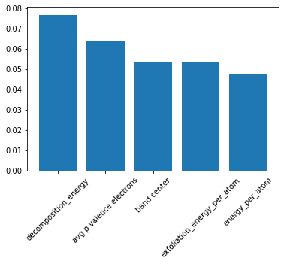

Support Vector Machines

Accuracy Score:

0.6947867298578199

Confusion Matrix

[[178 116]  
 [206 555]]



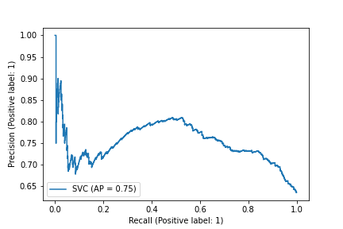

Sensitivity

0.6054421768707483

Specificty

0.7293035479632063

Precision

0.4635416666666667

Negative Predictive Value

0.827123695976155

Mean Squared Error

0.5524611028318465

KNeighbours Classifier

Accuracy Score:

0.6890995260663507

Confusion Matrix

[[221 165]  
 [163 506]]



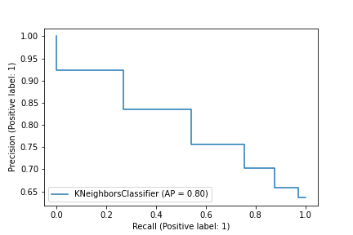

Sensitivity

0.572538860103627

Specificty

0.7563527653213752

Precision

0.5755208333333334

Negative Predictive Value

0.7540983606557377

Mean Squared Error

0.5575844993663734

Decision Tree Classifier

Accuracy Score:

0.7867298578199052

Confusion Matrix

[[292 133]  
 [ 92 538]]



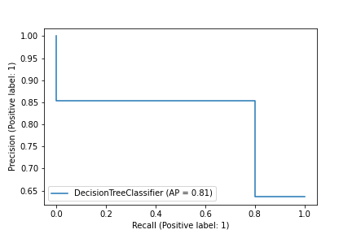

Sensitivity

0.6870588235294117

Specificty

0.8539682539682539

Precision

0.7604166666666666

Negative Predictive Value

0.8017883755588674

Mean Squared Error

0.46181180385530946

Feature Importances

avg p valence electrons

decomposition_energy

energy_per_atom

number_of_magnetic_atoms

Yang omega

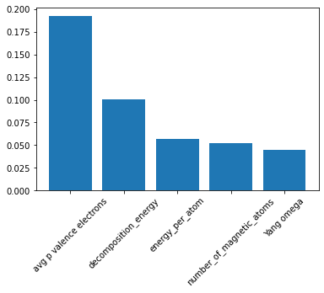

Gaussian NB

Accuracy Score:

0.6360189573459716

Confusion Matrix

[[ 0 0]  
 [384 671]]



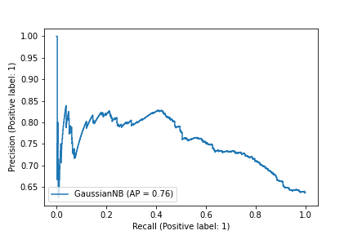

Sensitivity

nan

Specificty

0.6360189573459716

Precision

0.0

Negative Predictive Value

1.0

Mean Squared Error

0.6033084142078813

Linear Discriminant Analysis

Accuracy Score:

0.7981042654028436

Confusion Matrix

[[312 141]  
 [ 72 530]]



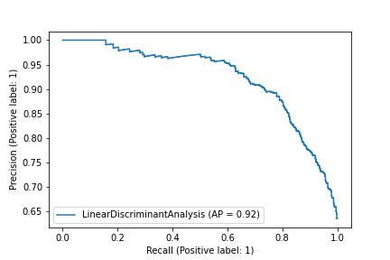

Sensitivity

0.6887417218543046

Specificty

0.8803986710963455

Precision

0.8125

Negative Predictive Value

0.789865871833085

Mean Squared Error

0.4493280923747773

Ada Boost Classifier

Accuracy Score:

0.7886255924170616

Confusion Matrix

[[295 134]  
 [ 89 537]]



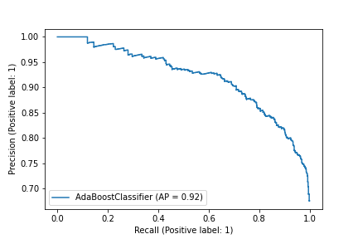

Sensitivity

0.6876456876456877

Specificty

0.8578274760383386

Precision

0.7682291666666666

Negative Predictive Value

0.8002980625931445

Mean Squared Error

0.4597547254601505

Feature Importances

decomposition_energy

exfoliation_energy_per_atom

sg_number

avg p valence electrons

frac d valence electrons

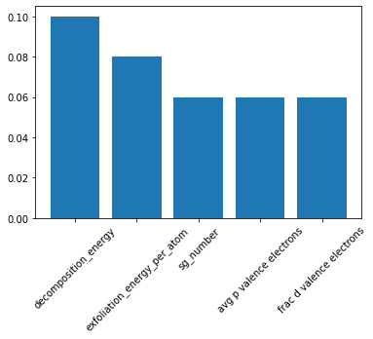

Gradient Boost Classifier

Accuracy Score:

0.8293838862559242

Confusion Matrix

[[298 94]  
 [ 86 577]]



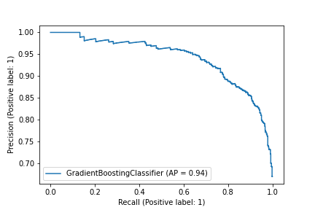

Sensitivity

0.7602040816326531

Specificty

0.8702865761689291

Precision

0.7760416666666666

Negative Predictive Value

0.8599105812220567

Mean Squared Error

0.41305703449290854

Feature Importances

avg p valence electrons

decomposition_energy

number_of_magnetic_atoms

energy_per_atom

Yang omega

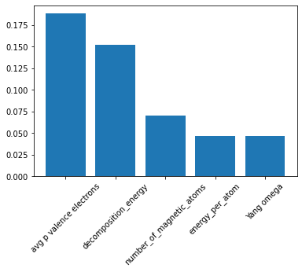

Random Forest Classifier

Accuracy Score:

0.819560272934041

Confusion Matrix

[[374 115]  
 [123 707]]



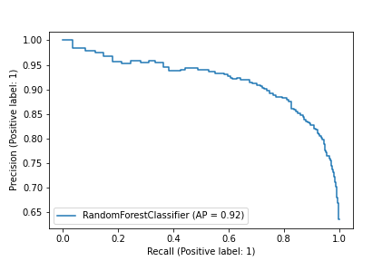

Sensitivity

0.7648261758691206

Specificty

0.8518072289156626

Precision

0.7525150905432596

Negative Predictive Value

0.8600973236009732

Mean Squared Error

0.4247819759193639

Feature Importances

decomposition_energy

avg p valence electrons

band center

exfoliation_energy_per_atom

Yang omega

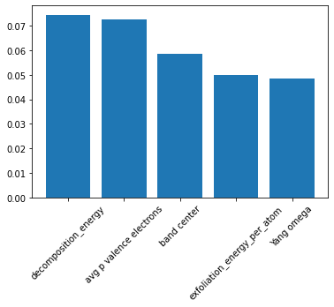

Support Vector Machines

Accuracy Score:

0.6921910538286581

Confusion Matrix

[[227 136]  
 [270 686]]



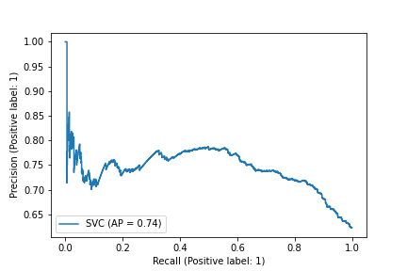

Sensitivity

0.6253443526170799

Specificty

0.7175732217573222

Precision

0.4567404426559356

Negative Predictive Value

0.8345498783454988

Mean Squared Error

0.5548053227676731

KNeighbours Classifier

Accuracy Score:

0.6671721000758151

Confusion Matrix

[[282 224]  
 [215 598]]



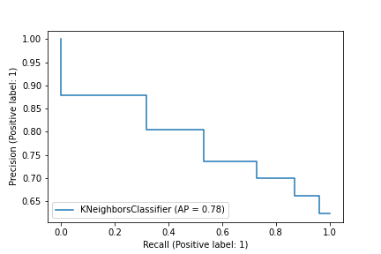

Sensitivity

0.5573122529644269

Specificty

0.7355473554735548

Precision

0.5674044265593562

Negative Predictive Value

0.7274939172749392

Mean Squared Error

0.5769123849634232

Decision Tree Classifier

Accuracy Score:

0.7634571645185747

Confusion Matrix

[[353 168]  
 [144 654]]



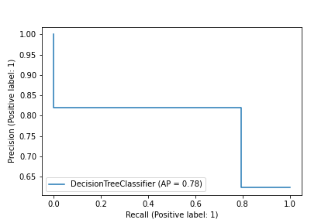

Sensitivity

0.6775431861804223

Specificty

0.8195488721804511

Precision

0.710261569416499

Negative Predictive Value

0.7956204379562044

Mean Squared Error

0.4863566957300221

Feature Importances

avg p valence electrons

decomposition_energy

energy_vdw_per_atom

number_of_magnetic_atoms

exfoliation_energy_per_atom

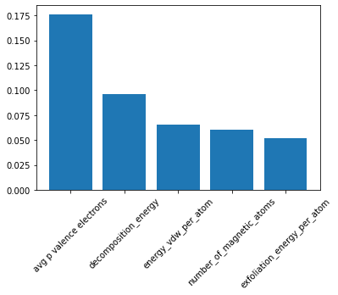

Gaussian NB

Accuracy Score:

0.623199393479909

Confusion Matrix

[[ 0 0]  
 [497 822]]



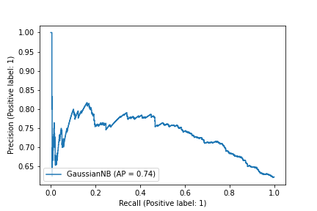

Sensitivity

nan

Specificty

0.623199393479909

Precision

0.0

Negative Predictive Value

1.0

Mean Squared Error

0.6138408641660239

Linear Discriminant Analysis

Accuracy Score:

0.7846853677028052

Confusion Matrix

[[389 176]  
 [108 646]]



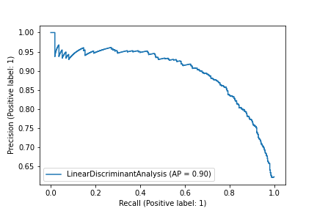

Sensitivity

0.6884955752212389

Specificty

0.8567639257294429

Precision

0.7826961770623743

Negative Predictive Value

0.7858880778588808

Mean Squared Error

0.46402007747207974

Ada Boost Classifier

Accuracy Score:

0.7952994692949203

Confusion Matrix

[[386 159]  
 [111 663]]



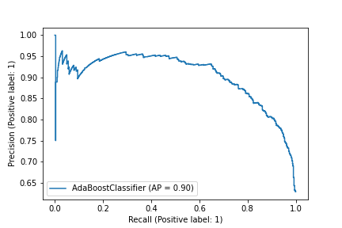

Sensitivity

0.708256880733945

Specificty

0.8565891472868217

Precision

0.7766599597585513

Negative Predictive Value

0.8065693430656934

Mean Squared Error

0.4524384275291828

Feature Importances

avg p valence electrons

decomposition_energy

sg_number

number_of_magnetic_atoms

exfoliation_energy_per_atom

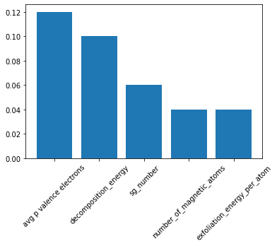

Gradient Boost Classifier

Accuracy Score:

0.819560272934041

Confusion Matrix

[[386 127]  
 [111 695]]



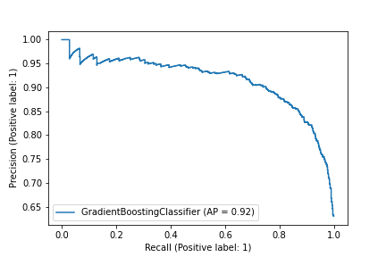

Sensitivity

0.7524366471734892

Specificty

0.8622828784119106

Precision

0.7766599597585513

Negative Predictive Value

0.8454987834549879

Mean Squared Error

0.4247819759193639

Feature Importances

avg p valence electrons

decomposition_energy

number_of_magnetic_atoms

energy_per_atom

Yang omega

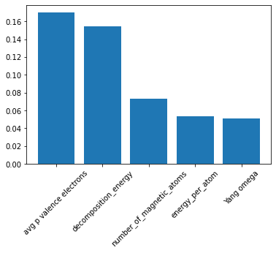

Random Forest Classifier

Accuracy Score:

0.8054327226784587

Confusion Matrix

[[448 149]  
 [159 827]]



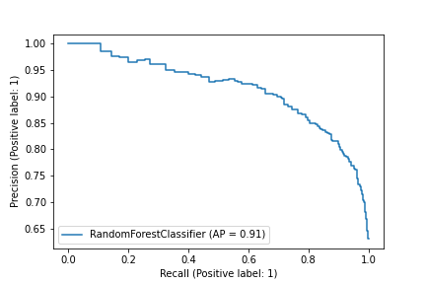

Sensitivity

0.7504187604690117

Specificty

0.8387423935091278

Precision

0.7380560131795717

Negative Predictive Value

0.8473360655737705

Mean Squared Error

0.4410978092459102

Feature Importances

decomposition_energy

avg p valence electrons

Yang omega

band center

energy_per_atom

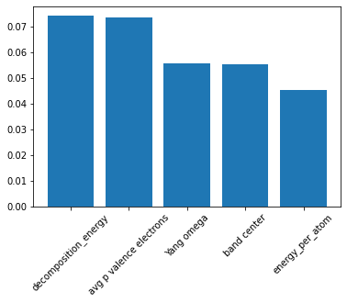

Support Vector Machines

Accuracy Score:

0.6620341124447252

Confusion Matrix

[[277 205]  
 [330 771]]



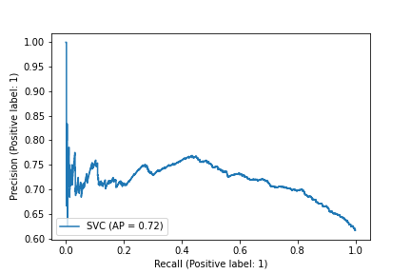

Sensitivity

0.5746887966804979

Specificty

0.7002724795640327

Precision

0.45634266886326197

Negative Predictive Value

0.7899590163934426

Mean Squared Error

0.5813483358153482

KNeighbours Classifier

Accuracy Score:

0.658875552747947

Confusion Matrix

[[325 258]  
 [282 718]]



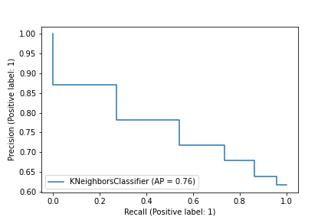

Sensitivity

0.5574614065180102

Specificty

0.718

Precision

0.5354200988467874

Negative Predictive Value

0.735655737704918

Mean Squared Error

0.5840585991594106

Decision Tree Classifier

Accuracy Score:

0.7706885660138977

Confusion Matrix

[[447 203]  
 [160 773]]



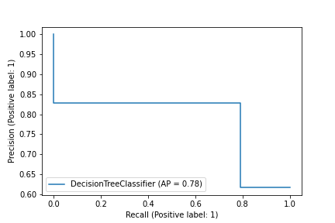

Sensitivity

0.6876923076923077

Specificty

0.8285101822079314

Precision

0.7364085667215815

Negative Predictive Value

0.7920081967213115

Mean Squared Error

0.47886473454003936

Feature Importances

avg p valence electrons

decomposition_energy

number_of_magnetic_atoms

energy_per_atom

Yang omega

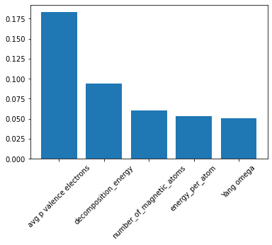

Gaussian NB

Accuracy Score:

0.6171825647504738

Confusion Matrix

[[ 8 7]  
 [599 969]]



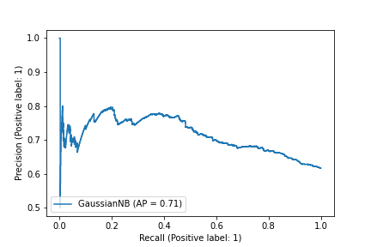

Sensitivity

0.5333333333333333

Specificty

0.6179846938775511

Precision

0.013179571663920923

Negative Predictive Value

0.992827868852459

Mean Squared Error

0.6187224218092684

Linear Discriminant Analysis

Accuracy Score:

0.786481364497789

Confusion Matrix

[[450 181]  
 [157 795]]



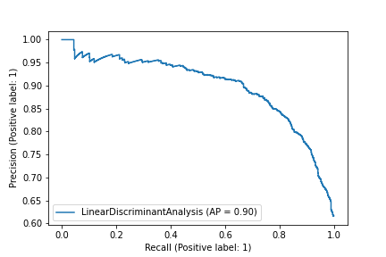

Sensitivity

0.7131537242472267

Specificty

0.8350840336134454

Precision

0.7413509060955519

Negative Predictive Value

0.8145491803278688

Mean Squared Error

0.46208076729313347

Ada Boost Classifier

Accuracy Score:

0.7883765003158559

Confusion Matrix

[[437 165]  
 [170 811]]



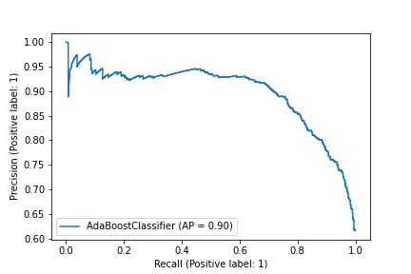

Sensitivity

0.7259136212624585

Specificty

0.8267074413863404

Precision

0.7199341021416804

Negative Predictive Value

0.8309426229508197

Mean Squared Error

0.46002554242579186

Feature Importances

avg p valence electrons

decomposition_energy

exfoliation_energy_per_atom

sg_number

max ionic char

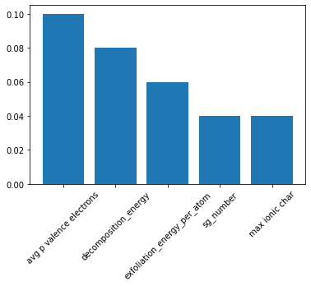

Gradient Boost Classifier

Accuracy Score:

0.8161718256475048

Confusion Matrix

[[445 129]  
 [162 847]]



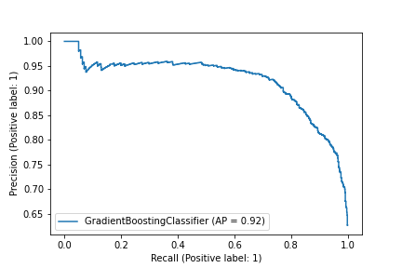

Sensitivity

0.7752613240418118

Specificty

0.8394449950445986

Precision

0.7331136738056013

Negative Predictive Value

0.867827868852459

Mean Squared Error

0.42875187970724427

Feature Importances

avg p valence electrons

decomposition_energy

number_of_magnetic_atoms

Yang omega

energy_per_atom

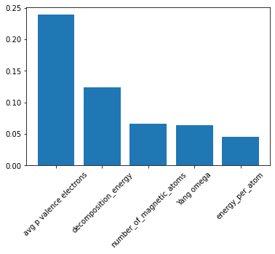

Random Forest Classifier

Accuracy Score:

0.7995666305525461

Confusion Matrix

[[492 144]  
 [226 984]]



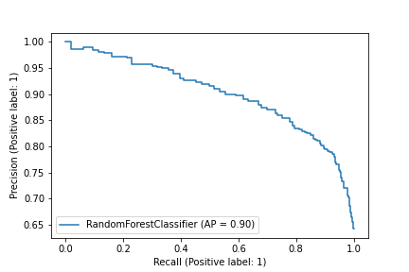

Sensitivity

0.7735849056603774

Specificty

0.8132231404958677

Precision

0.6852367688022284

Negative Predictive Value

0.8723404255319149

Mean Squared Error

0.44769785508471444

Feature Importances

decomposition_energy

avg p valence electrons

band center

Yang omega

exfoliation_energy_per_atom

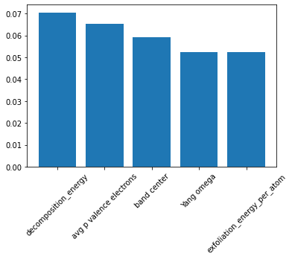

Support Vector Machines

Accuracy Score:

0.6625135427952329

Confusion Matrix

[[326 231]  
 [392 897]]



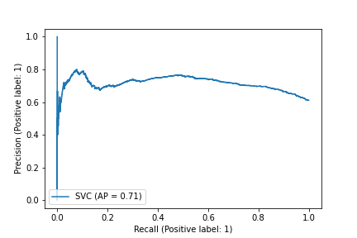

Sensitivity

0.585278276481149

Specificty

0.6958882854926299

Precision

0.45403899721448465

Negative Predictive Value

0.7952127659574468

Mean Squared Error

0.5809358460318721

KNeighbours Classifier

Accuracy Score:

0.6598049837486457

Confusion Matrix

[[379 289]  
 [339 839]]



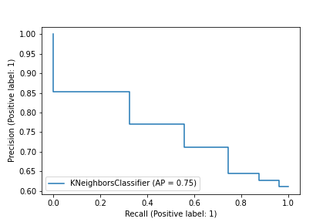

Sensitivity

0.5673652694610778

Specificty

0.7122241086587436

Precision

0.5278551532033426

Negative Predictive Value

0.7437943262411347

Mean Squared Error

0.5832623905682196

Decision Tree Classifier

Accuracy Score:

0.7670639219934995

Confusion Matrix

[[509 221]  
 [209 907]]



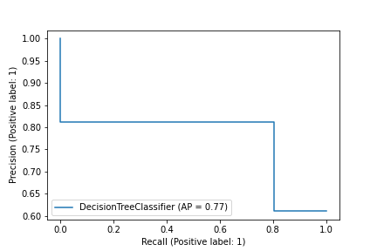

Sensitivity

0.6972602739726027

Specificty

0.8127240143369175

Precision

0.7089136490250696

Negative Predictive Value

0.8040780141843972

Mean Squared Error

0.4826345180428981

Feature Importances

avg p valence electrons

decomposition_energy

band center

Yang omega

number_of_magnetic_atoms

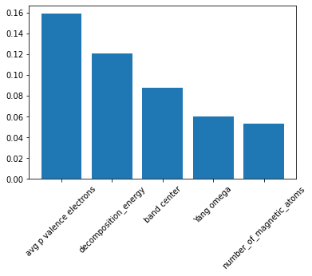

Gaussian NB

Accuracy Score:

0.6110509209100758

Confusion Matrix

[[ 0 0]  
 [ 718 1128]]



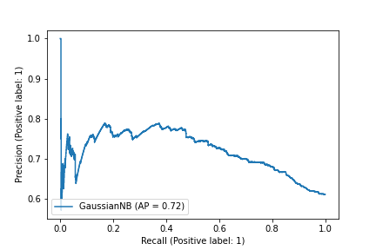

Sensitivity

nan

Specificty

0.6110509209100758

Precision

0.0

Negative Predictive Value

1.0

Mean Squared Error

0.6236578221187674

Linear Discriminant Analysis

Accuracy Score:

0.7806067172264355

Confusion Matrix

[[529 216]  
 [189 912]]



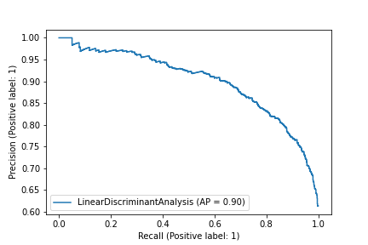

Sensitivity

0.7100671140939597

Specificty

0.8283378746594006

Precision

0.7367688022284122

Negative Predictive Value

0.8085106382978723

Mean Squared Error

0.46839436671843576

Ada Boost Classifier

Accuracy Score:

0.7903575297941495

Confusion Matrix

[[524 193]  
 [194 935]]



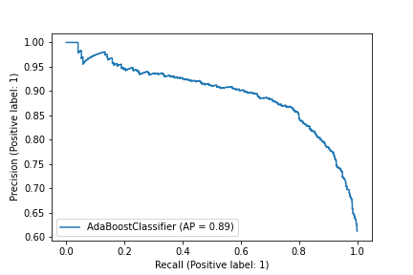

Sensitivity

0.7308228730822873

Specificty

0.8281665190434012

Precision

0.7298050139275766

Negative Predictive Value

0.8289007092198581

Mean Squared Error

0.4578673063299568

Feature Importances

decomposition_energy

exfoliation_energy_per_atom

Yang omega

Yang delta

Yang omega

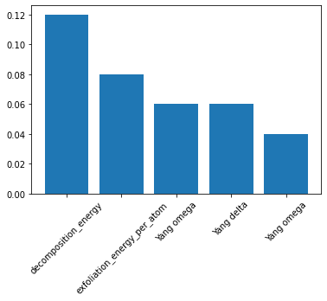

Gradient Boost Classifier

Accuracy Score:

0.8125677139761647

Confusion Matrix

[[513 141]  
 [205 987]]



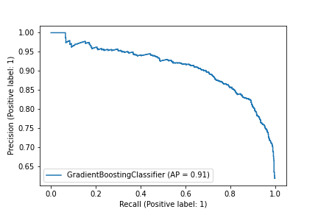

Sensitivity

0.7844036697247706

Specificty

0.8280201342281879

Precision

0.7144846796657381

Negative Predictive Value

0.875

Mean Squared Error

0.4329345054668608

Feature Importances

avg p valence electrons

decomposition_energy

band center

Yang omega

number_of_magnetic_atoms

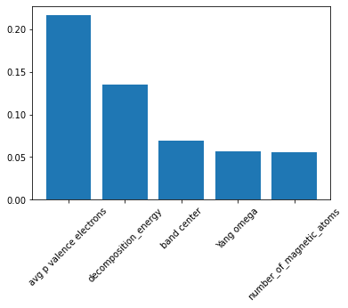

Random Forest Classifier

Accuracy Score:

0.7758293838862559

Confusion Matrix

[[ 493 134]  
 [ 339 1144]]



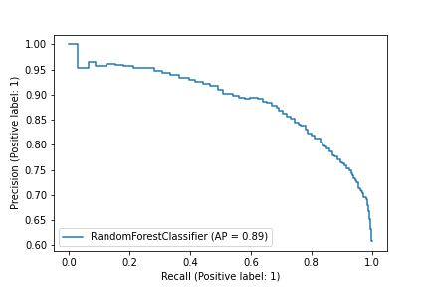

Sensitivity

0.7862838915470495

Specificty

0.7714093054619016

Precision

0.5925480769230769

Negative Predictive Value

0.8951486697965572

Mean Squared Error

0.47346659450667067

Feature Importances

avg p valence electrons

Yang omega

decomposition_energy

band center

exfoliation_energy_per_atom

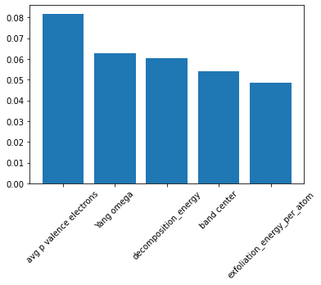

Support Vector Machines

Accuracy Score:

0.6578199052132702

Confusion Matrix

[[ 376 266]  
 [ 456 1012]]



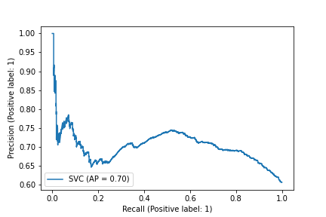

Sensitivity

0.5856697819314641

Specificty

0.6893732970027248

Precision

0.4519230769230769

Negative Predictive Value

0.7918622848200313

Mean Squared Error

0.5849616182167252

KNeighbours Classifier

Accuracy Score:

0.6488151658767772

Confusion Matrix

[[379 288]  
 [453 990]]



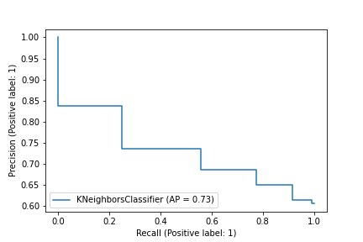

Sensitivity

0.568215892053973

Specificty

0.6860706860706861

Precision

0.45552884615384615

Negative Predictive Value

0.7746478873239436

Mean Squared Error

0.5926084998742617

Decision Tree Classifier

Accuracy Score:

0.6976303317535545

Confusion Matrix

[[478 284]  
 [354 994]]



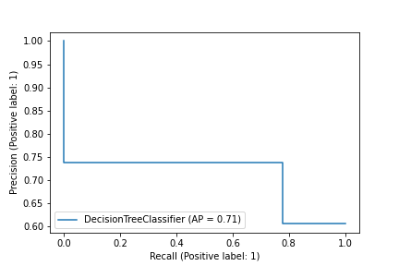

Sensitivity

0.6272965879265092

Specificty

0.7373887240356083

Precision

0.5745192307692307

Negative Predictive Value

0.7777777777777778

Mean Squared Error

0.5498815038228195

Feature Importances

avg p valence electrons

decomposition_energy

7-norm

energy_per_atom

Yang omega

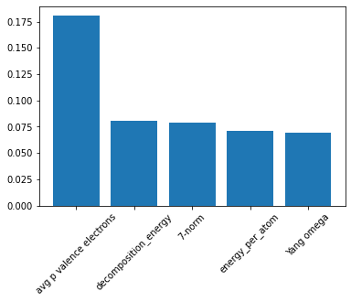

Gaussian NB

Accuracy Score:

0.6056872037914692

Confusion Matrix

[[ 0 0]  
 [ 832 1278]]



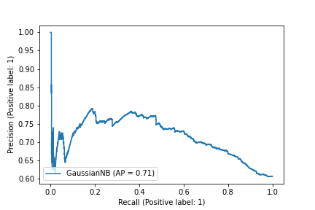

Sensitivity

nan

Specificty

0.6056872037914692

Precision

0.0

Negative Predictive Value

1.0

Mean Squared Error

0.6279433065241884

Linear Discriminant Analysis

Accuracy Score:

0.762085308056872

Confusion Matrix

[[ 556 226]  
 [ 276 1052]]



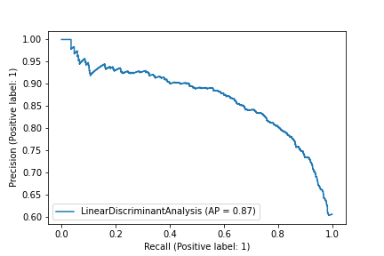

Sensitivity

0.710997442455243

Specificty

0.7921686746987951

Precision

0.6682692307692307

Negative Predictive Value

0.8231611893583725

Mean Squared Error

0.48776499663580614

Ada Boost Classifier

Accuracy Score:

0.7663507109004739

Confusion Matrix

[[ 541 202]  
 [ 291 1076]]



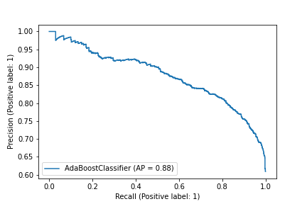

Sensitivity

0.7281292059219381

Specificty

0.787125091441112

Precision

0.6502403846153846

Negative Predictive Value

0.8419405320813772

Mean Squared Error

0.48337282619063937

Feature Importances

decomposition_energy

band center

decomposition_energy

band center

exfoliation_energy_per_atom

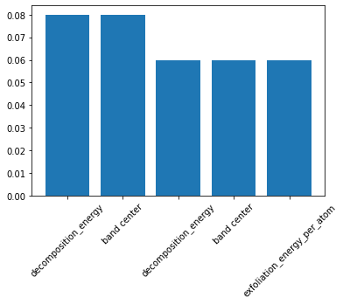

Gradient Boost Classifier

Accuracy Score:

0.7758293838862559

Confusion Matrix

[[ 532 173]  
 [ 300 1105]]



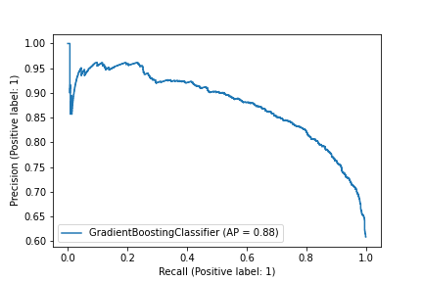

Sensitivity

0.7546099290780142

Specificty

0.7864768683274022

Precision

0.6394230769230769

Negative Predictive Value

0.8646322378716745

Mean Squared Error

0.47346659450667067

Feature Importances

avg p valence electrons

decomposition_energy

band center

Yang omega

10-norm

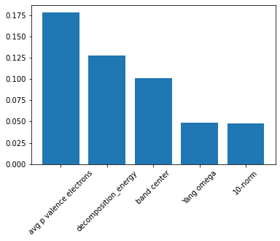

Random Forest Classifier

Accuracy Score:

0.7632687447346251

Confusion Matrix

[[ 642 282]  
 [ 280 1170]]



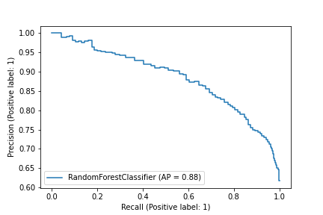

Sensitivity

0.6948051948051948

Specificty

0.8068965517241379

Precision

0.6963123644251626

Negative Predictive Value

0.8057851239669421

Mean Squared Error

0.4865503625169494

Feature Importances

decomposition_energy

band center

exfoliation_energy_per_atom

avg p valence electrons

frac p valence electrons

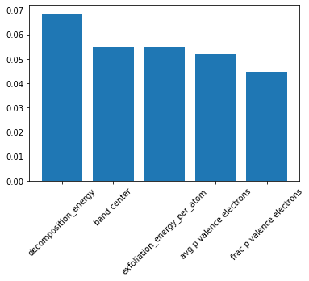

Support Vector Machines

Accuracy Score:

0.6647009267059815

Confusion Matrix

[[ 443 317]  
 [ 479 1135]]



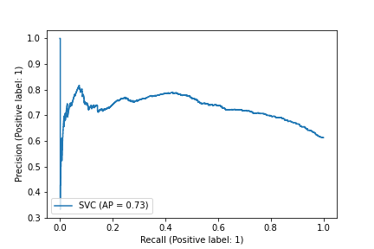

Sensitivity

0.5828947368421052

Specificty

0.7032218091697645

Precision

0.4804772234273319

Negative Predictive Value

0.7816804407713499

Mean Squared Error

0.5790501474777625

KNeighbours Classifier

Accuracy Score:

0.6225779275484414

Confusion Matrix

[[ 393 367]  
 [ 529 1085]]



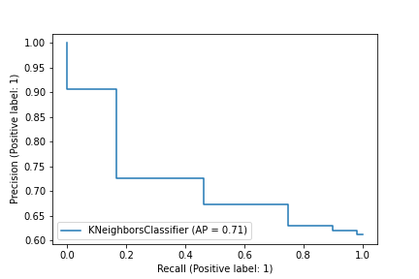

Sensitivity

0.5171052631578947

Specificty

0.6722428748451054

Precision

0.4262472885032538

Negative Predictive Value

0.7472451790633609

Mean Squared Error

0.6143468665595672

Decision Tree Classifier

Accuracy Score:

0.6470092670598147

Confusion Matrix

[[553 469]  
 [369 983]]



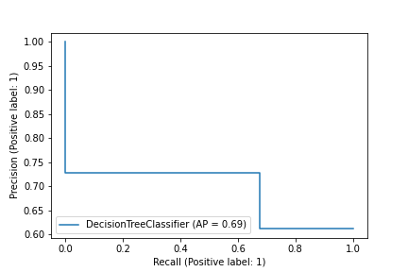

Sensitivity

0.541095890410959

Specificty

0.7270710059171598

Precision

0.5997830802603037

Negative Predictive Value

0.6769972451790633

Mean Squared Error

0.5941302323061716

Feature Importances

decomposition_energy

exfoliation_energy_per_atom

Yang omega

avg f valence electrons

band center

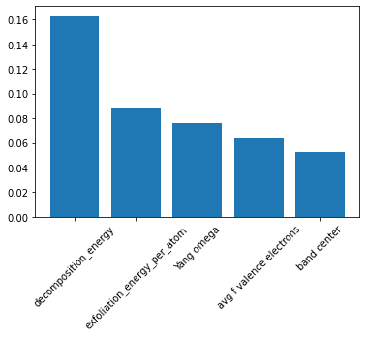

Gaussian NB

Accuracy Score:

0.5943555181128897

Confusion Matrix

[[ 121 162]  
 [ 801 1290]]



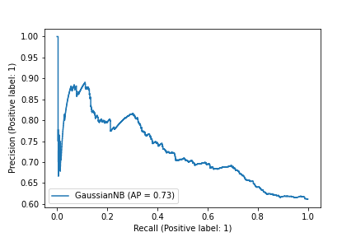

Sensitivity

0.4275618374558304

Specificty

0.6169296987087518

Precision

0.13123644251626898

Negative Predictive Value

0.8884297520661157

Mean Squared Error

0.6369022545784482

Linear Discriminant Analysis

Accuracy Score:

0.7611625947767481

Confusion Matrix

[[ 752 397]  
 [ 170 1055]]



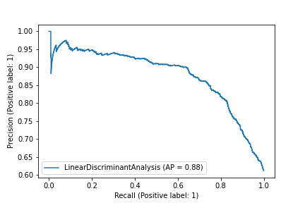

Sensitivity

0.6544821583986075

Specificty

0.8612244897959184

Precision

0.8156182212581344

Negative Predictive Value

0.7265840220385675

Mean Squared Error

0.48870993976309907

Ada Boost Classifier

Accuracy Score:

0.7523167649536647

Confusion Matrix

[[ 683 349]  
 [ 239 1103]]



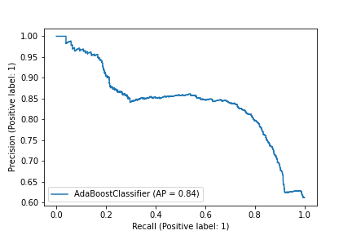

Sensitivity

0.6618217054263565

Specificty

0.8219076005961252

Precision

0.7407809110629068

Negative Predictive Value

0.759641873278237

Mean Squared Error

0.4976778426314912

Feature Importances

frac s valence electrons

decomposition_energy

Yang omega

decomposition_energy

Yang omega

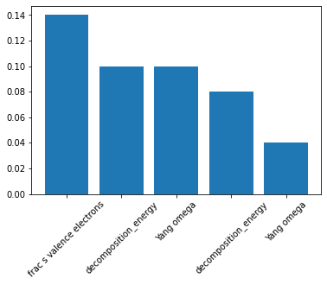

Gradient Boost Classifier

Accuracy Score:

0.7615838247683235

Confusion Matrix

[[ 644 288]  
 [ 278 1164]]



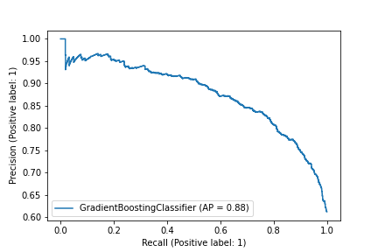

Sensitivity

0.6909871244635193

Specificty

0.8072122052704577

Precision

0.6984815618221258

Negative Predictive Value

0.8016528925619835

Mean Squared Error

0.488278788431032

Feature Importances

decomposition_energy

band center

exfoliation_energy_per_atom

V

sg_number

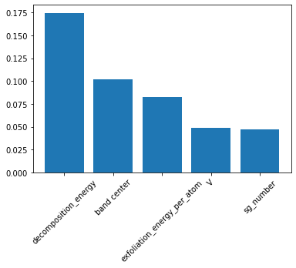

# Best Model

Random Forest Classifier

Accuracy Score:

0.821969696969697

Confusion Matrix

[[144 40]  
 [ 54 290]]



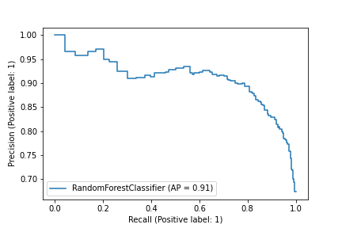

Sensitivity

0.782608695652174

Specificty

0.8430232558139535

Precision

0.7272727272727273

Negative Predictive Value

0.8787878787878788

Mean Squared Error

0.42193637320134303

Feature Importances

decomposition_energy

avg p valence electrons

band center

Yang omega

exfoliation_energy_per_atom

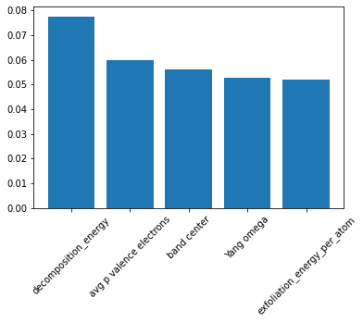

Best Training Ratio

0.2

# End of Machine Learning