SaafHawa model selection and cost analysis
AI4015 Assignment Beta | Riya Bhart | 23k0063

Roll number calculations
Parameter | Working | Result
R | Final two digits of 23k0063 | 63
D | (2 + 3 + 0 + 0 + 6 + 3) mod 10 | 4
Q | 1,500 + 25 × 63 | 3,075
N | 5 + (63 mod 4) | 8
p | 0.04 + 0.01 × 4 | 0.08
H | 4 + (63 mod 4) | 7
B | 1,200 + 10 × 63 | $1,830
T | 10 - (63 mod 3) | 10 s
Source for scenario constants and formulas: Assignment Beta pp. 3–6. The raw log meets the two-day timing requirement. Some exact-model benchmark and endpoint data remain open. The decision below is provisional.

Decision
Pilot a managed endpoint with a two-call orchestrated workflow and validate Urdu script, Roman Urdu, English, grounded municipal summaries and rate limits before rollout. GPT-5.4 nano is the provisional API cost comparator. Entry quota and task quality need validation before choosing it for production. An RTX 4090 memory-only estimate omits throughput contention, redundancy and operator time.

1 | Model comparison
Closed models are the first six rows. Open models are the last six and represent four creators. Commercial self-hosting is allowed under the named open licenses subject to their terms. Quoted open prices are public observed routes. Global lowest cost and cheapest qualifying routes were not established. Groq developer limits are published for the quoted endpoint. A question mark or unverified cell indicates missing evidence. Source keys on the final pages were accessed 2026-11-09.
Model / endpoint | Weights / context and max output | Input / output / cached USD per M | New paid limits / TTFT and TPS | Benchmarks / tools, JSON, mode and license | Sources
gpt-5.4-nano | OpenAI / Standard | Not disclosed | 400k / 128k | 0.2/1.25/0.02 | Unverified | 0.87 / 156.4 | Tool score unverified | Tools + JSON; none; proprietary | A M O
gpt-5.4-mini | OpenAI / Standard | Not disclosed | 400k / 128k | 0.75/4.5/0.075 | Unverified | Unverified | Unverified | Tools + JSON; none; proprietary | B O
claude-haiku-5-5 | Anthropic / Claude API paid | Not disclosed | 1M / 128k | 0.1/0.5/0.01 | Tier 1 unverified | Unverified | Unverified | Tools + JSON; disabled where supported; proprietary | C P X
claude-sonnet-5-5 | Anthropic / Claude API paid | Not disclosed | 1M / 128k | 2/10/0.1 | Tier 1 unverified | Unverified | Unverified | Tools + JSON; disable thinking; proprietary | D P X
gemini-3.6-flash | Google / Developer API paid | Not disclosed | 1,048,576 / 65,536 | 0.75/3.75/0.075 | Account-specific; unverified | Unverified | Unverified | Tools + JSON; minimal; proprietary | E T
grok-4.3 | xAI / Standard T0 | Not disclosed | 1M / unverified | 1.25/2.5/0.2 | 2,220 RPM equiv.; 10M TPM | 0.71 / 100.1 | AA Index 14; tool score unverified | Tools + JSON; none; proprietary; legacy | F N Q
gpt-oss-20b | OpenAI / Groq Developer | 20.9B / 3.6B | 131,072 / 65,536 | 0.075/0.3/? | 1,000 RPM; 250k TPM | Unverified / ~1,000 | Tau-Bench Retail 35.0%; MMLU 80.4% (low) | Tools + JSON; low; Apache 2.0 | G H Y
gpt-oss-120b | OpenAI / Groq Developer | 116.8B / 5.1B | 131,072 / 65,536 | 0.15/0.6/? | 1,000 RPM; 250k TPM | Unverified / ~500 | Tau-Bench Retail 49.4%; MMLU 85.9% (low) | Tools + JSON; low; Apache 2.0 | G H
qwen/qwen3-8b | Alibaba / OpenRouter paid | 8.2B dense | 40,960 native / unverified | 0.117/0.455/? | Route-dependent | Unverified | Unverified | Non-thinking; endpoint tool/JSON varies; Apache 2.0 | I R Z
qwen/qwen3-30b-a3b-instruct-2507 | Alibaba / OpenRouter paid | 30.5B / 3.3B | 262k / unverified | 0.09/0.3/? | Route-dependent | Unverified | Unverified | Non-thinking; endpoint tool/JSON varies; Apache 2.0 | J U
z-ai/glm-4.5-air | Z.ai / NovitaAI via OpenRouter | 106B / 12B | 131,072 / 98,304 | 0.13/0.85/0.025 | Route-dependent | 1.49 / 36 (route P50) | 12-test composite 59.8; per-task unverified | Thinking off; tools yes, strict JSON no; MIT | K V
deepseek/deepseek-v4-flash | DeepSeek / OpenRouter paid | 284B / 13B | 1M / unverified | 0.0474/0.45/0.0474 | Route-dependent | Unverified | Unverified | Non-thinking where supported; tool/JSON varies; MIT | L W
Two consequential uncertainties are GPT-5.4 nano’s new-account TPM and the mean additional tokens in gpt-oss low mode. Without the former, the pilot may need a quota increase or admission control even when the modeled bill fits. Every 100 reasoning tokens per LLM attempt adds 856 output tokens per query, and additional decode delay of 856 divided by output TPS. Tool-use benchmark coverage is incomplete and should be verified at the exact endpoint and mode.

2.1 and 2.3 | Token volume and heatwave load
Inputs by call are [2000, 2800, 3600, 4400, 5200, 6000, 6800, 7600]. Outputs are seven × 350 and 600. The retry adds 0.08 times the first seven inputs and outputs. Expected attempts = 8 + 7(0.08) = 8.56. Expected input = 38,400 + 0.08 × 30,800 = 40,864. Expected visible output = 3,050 + 0.08 × 2,450 = 3,246. An invalid call is assumed to fail validation before its tool executes.
Monthly volume = (23 + 7 × 5) × 3,075 = 178,350 queries. This yields 7,288,094,400 input and 578,924,100 visible output tokens.
Peak heatwave arrival rate = 0.35 × 5 × 3,075 / 120 = 44.8438 queries/min. Multiplying by expected attempts gives 383.86 RPM. Expected ITPM is 1,832,495, OTPM 145,563, and combined TPM 1,978,058. The Groq Developer 250k TPM is below this total even though 1,000 RPM exceeds demand. xAI T0’s listed caps clear the mean, subject to actual burst behavior. Verify TPM accounting, cache exemptions and per-second caps for every route.

2.2 | Monthly API bill
With c eligible prefix tokens and A expected attempts, per-query input cost is [(I - A c) × input rate + c × write rate + (A - 1)c × read rate] / 1,000,000. Assumption: one write per query. GPT-5.4 uses a modeled 1,408-token boundary under the 1,024/128 convention, no write premium and typically 5–10 minutes of inactivity retention. Current documentation notes eligibility depends on request settings. Verify billed cached tokens on the actual prompt.
Anthropic 5.5 uses minimum 512 and models a 5-minute write at 1.25× input with the full 1,500 tokens. The alternative 1-hour write is 2×. For Gemini, xAI and open routes, discount is zero in this estimate pending exact prefix policy and route validation. Gemini’s published explicit storage rate is $0.50/M-token-hour at the dated price. Unknown minimums and TTLs remain unresolved. Reasoning-enabled rows use visible output only as a lower bound until hidden output is verified.
Model | No cache | Modeled caching | Within budget (no/with)
gpt-5.4-nano | $2,181.27 | $1,839.55 | No / No
gpt-5.4-mini | $8,071.23 | $6,789.78 | No / No
claude-haiku-5-5 | $1,018.27 | $842.94 | Yes / Yes
claude-sonnet-5-5 | $20,365.43 | $16,656.46 | No / No
gemini-3.6-flash | $7,637.04 | $7,637.04 | No / No
grok-4.3 | $10,557.43 | $10,557.43 | No / No
gpt-oss-20b | $720.28 | $720.28 | Yes / Yes
gpt-oss-120b | $1,440.57 | $1,440.57 | Yes / Yes
qwen/qwen3-8b | $1,116.12 | $1,116.12 | Yes / Yes
qwen/qwen3-30b-a3b-instruct-2507 | $829.61 | $829.61 | Yes / Yes
z-ai/glm-4.5-air | $1,439.54 | $1,439.54 | Yes / Yes
deepseek/deepseek-v4-flash | $605.97 | $605.97 | Yes / Yes

2.4 | Self-hosting memory and concurrent sessions
Qwen3-8B uses full grouped-query attention. Hugging Face config [R] reports 36 layers, 8 KV heads, head dimension 128 and sliding window disabled. 8.2B parameters × (2, 1, 0.5) bytes give 16.4, 8.2 and 4.1 decimal GB at FP16, 8-bit and 4-bit. Quantization metadata and fragmentation are excluded. The published configuration is linked in the sources.
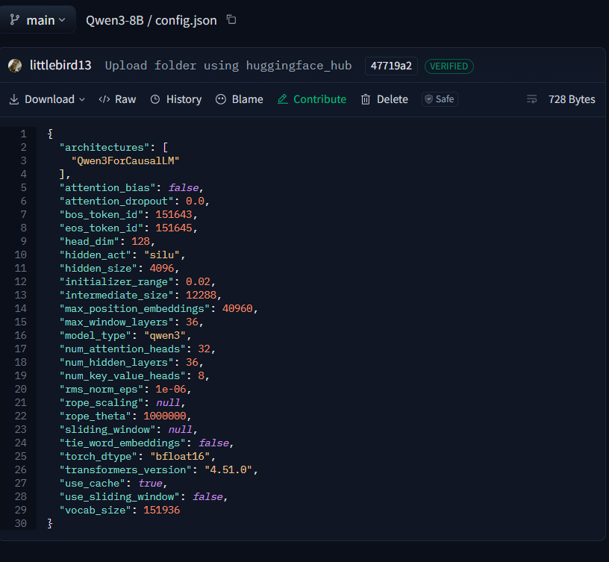
Figure 1. Qwen3-8B config.json on Hugging Face, revision 47719a2. The configuration shows 36 hidden layers, 8 key-value heads, and a head dimension of 128.
Longest live sequence = 7,600 final input + 600 output = 8,200 tokens. FP16 KV bytes = 2 × 36 × 8 × 128 × 8,200 × 2 = 1,209,139,200 (1.126 GiB). Model nominal 24 GB as 24 GiB of addressable VRAM. Reserve 10%. The memory slot limit is floor[(0.90 × 24 GiB - 4.1 GB) / KV] = 15. Actual throughput can bind before the memory slot limit.
Little’s Law gives mean in-flight sessions at peak as (queries/min ÷ 60) × seconds per query. At T = 10 s that is 7.47 sessions, rounded up to 8. Memory-only GPUs = ceil(sessions / 15) = 1. At the estimated full nano loop latency the same demand would imply 22.34 sessions. Neither value sizes for burst quantiles.

2.5 | Break-even
Runpod quotes $0.34/hr for Community Cloud RTX 4090 [S]. At 720 hours, self-hosting is $244.80 at Q. Use the GPU step function C(q) = 720 × 0.34 × ceil[(5 × 0.35 × q/120) × (10/60) / 15]. Compare to the lower-cost qualifying finalist on the original eight-call token workload for a consistent cost comparison.
The nano API line is $0.5982 × q per month with modeled caching. The first integer with a strict self-hosting advantage is Q* = 410 normal-day queries under these assumptions. This is 0.13× assigned traffic. A memory-only crossing is plausible as a volume calculation, but it is not an operating break-even unless a GPU load test sustains that traffic at the SLA. At GPU step boundaries the sign can reverse temporarily. An API redesign also reduces token cost. At Q the two-call nano estimate is $269.67/month without caching, which shifts the crossing materially.
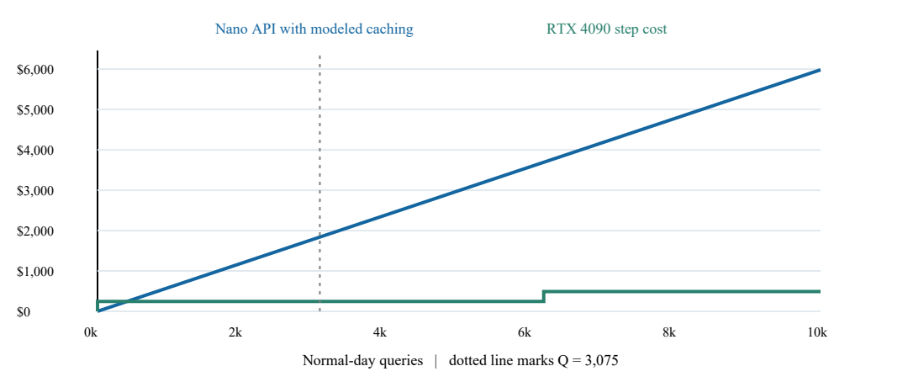

2.6 | Sequential latency and redesign
Timestamped raw log coverage (successful observations, distinct PKT days): {'air': (20, 2), 'weather': (20, 2), 'heat_index': (20, 2), 'kb': (20, 2)}. Measured pooled median = 0.252145 s. Failures are retained and excluded from the median. Local timings measure the fixed-input Rothfusz calculation and in-memory advisory lookup. Both APIs have at least 20 successful observations across 9 and 14 November 2026 (PKT).
Finalists for the timing comparison are nano and Grok 4.3 non-reasoning because published TTFT and decode estimates exist for the chosen settings. Grok is a latency comparison candidate despite its price and legacy status. TTFT for call k is modeled as benchmark TTFT × (0.6 + 0.4 × input_k/4,800). This is an assumed prefill scaling curve, not a measured one. Add (output_k - 1)/TPS per call. Add 0.08 times the first seven model durations for retries and 7 × pooled median for valid tool calls.
Model | Model retry contribution | Eight-call total | Two-call redesign
GPT-5.4 nano | 1.72 s | 29.90 s | 3.84 s
Grok 4.3 | 2.34 s | 40.17 s | 4.59 s
Redesign: one 2,000-input structured extraction call capped at 100 outputs, then execute air, weather and advisory retrieval together. Heat index follows weather, giving two median tool intervals on the critical path. A second call consumes an assumed 3,600 inputs and 180 outputs. Apply 8% retry probability to extraction only. The resulting times are modeled full-answer completion estimates, excluding queuing and assuming output fits the caps. Validate tool dependencies, per-tool tail latency and output quality in production.

Source keys | accessed 2026-11-09
Key and source | Key and source
A https://developers.openai.com/api/docs/models/gpt-5.4-nano | N https://artificialanalysis.ai/models/grok-4-3-non-reasoning/
B https://developers.openai.com/api/docs/models/gpt-5.4-mini | O https://developers.openai.com/api/docs/guides/prompt-caching
C https://platform.claude.com/docs/en/models/haiku-5-5/overview | P https://platform.claude.com/docs/en/build-with-claude/prompt-caching
D https://platform.claude.com/docs/en/about-claude/pricing | Q https://docs.x.ai/developers/rate-limits
E https://ai.google.dev/gemini-api/docs/models/gemini-3.6-flash | R https://huggingface.co/Qwen/Qwen3-8B/blob/main/config.json
F https://docs.x.ai/developers/models/grok-4.3 | S https://www.runpod.io/gpu-models/rtx-4090
G https://console.groq.com/docs/models | T https://ai.google.dev/gemini-api/docs/pricing
H https://deploymentsafety.openai.com/gpt-oss | U https://huggingface.co/Qwen/Qwen3-30B-A3B-Instruct-2507
I https://openrouter.ai/qwen/qwen3-8b/api | V https://huggingface.co/zai-org/GLM-4.5-Air
J https://openrouter.ai/qwen/qwen3-30b-a3b-instruct-2507 | W https://huggingface.co/deepseek-ai/DeepSeek-V4-Flash
K https://openrouter.ai/z-ai/glm-4.5-air | X https://platform.claude.com/docs/en/api/rate-limits
L https://openrouter.ai/deepseek/deepseek-v4-flash | Y https://artificialanalysis.ai/models/gpt-oss-20b/providers
M https://artificialanalysis.ai/models/gpt-5-4-nano-non-reasoning | Z https://huggingface.co/Qwen/Qwen3-8B

