DB LAB 1

23K0063

IN LAB TASKS

1. select * from EMPLOYEES where department_id <> 100;

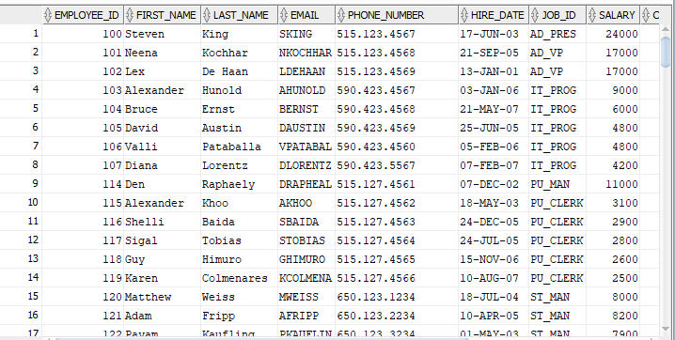

1. select * from EMPLOYEES where salary in (10000,12000,15000);

1. SELECT first_name, salary FROM employees WHERE salary <= 25000;

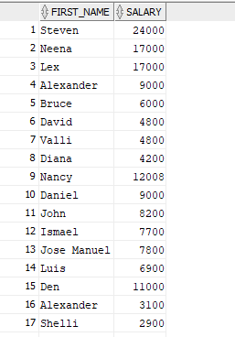

1. SELECT * FROM employees WHERE department_id <> 60;

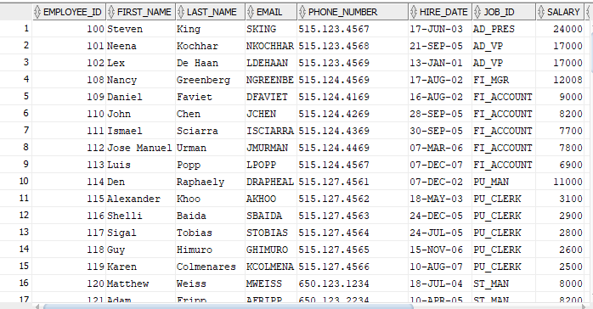

1. SELECT * FROM employees WHERE department_id BETWEEN 60 AND 90;

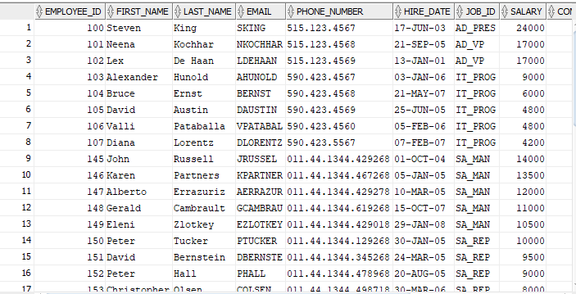

1. SELECT * FROM departments;

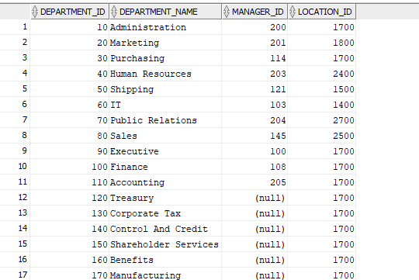

1. SELECT * FROM employees WHERE first_name = 'Steven';

1. SELECT * FROM employees WHERE salary BETWEEN 15000 AND 25000 AND department_id = 80;

1. SELECT * FROM employees WHERE salary < ANY (SELECT salary FROM employees WHERE department_id =100);

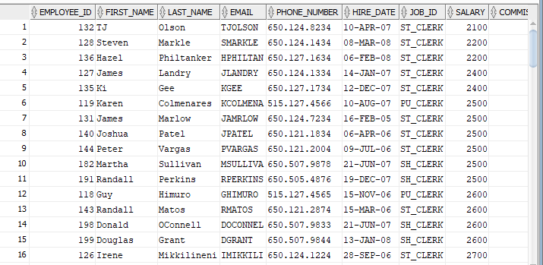

1. SELECT * FROM employees e WHERE department_id IN (SELECT department_id FROM employees GROUP BY department_id HAVING COUNT(*) = 1);

POST LAB

1. SELECT * FROM employees WHERE hire_date BETWEEN DATE '2005-01-01' AND DATE '2006-12-31';

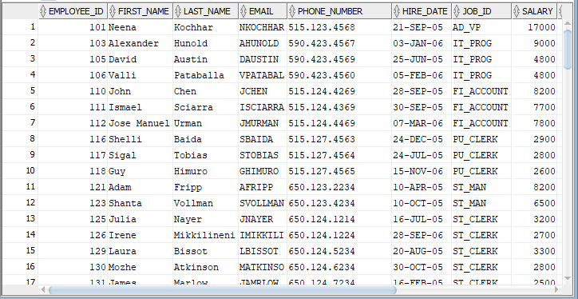

1. SELECT * FROM employees WHERE manager_id IS NULL;

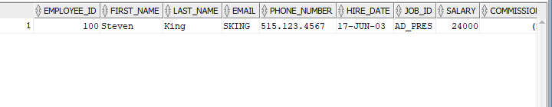

1. SELECT * FROM employees WHERE salary < ALL (SELECT salary FROM employees WHERE salary >8000);

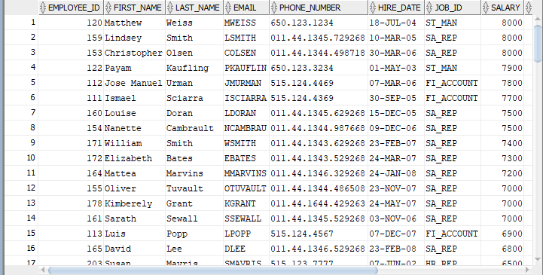

1. SELECT * FROM employees WHERE salary > ANY (SELECT salary FROM employees WHERE department_id = 90);



1. SELECT * FROM departments d WHERE EXISTS (SELECT 1 FROM employees e WHERE e.department_id = d.department_id);

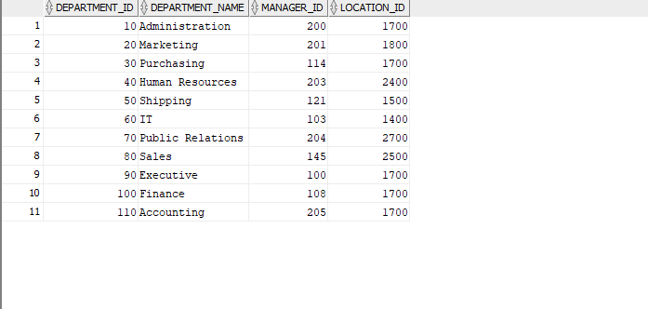

1. SELECT * FROM departments d WHERE NOT EXISTS (SELECT 1 FROM employees e WHERE e.department_id = d.department_id);

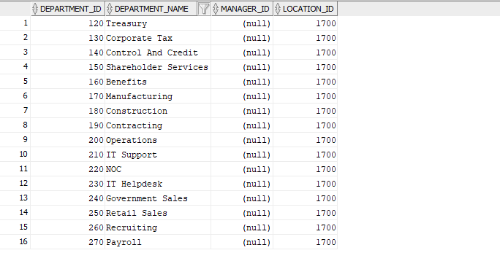

1. SELECT * FROM employees WHERE salary NOT BETWEEN 5000 AND 15000;

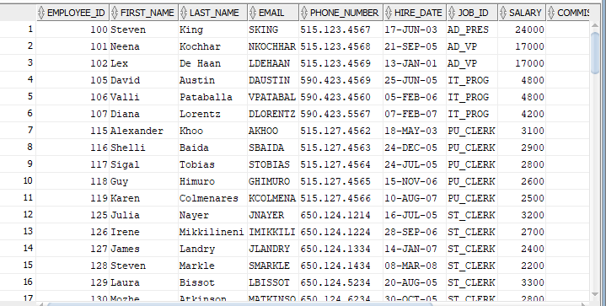

1. SELECT * FROM employees WHERE department_id IN (10, 20, 30) AND department_id <> 40;

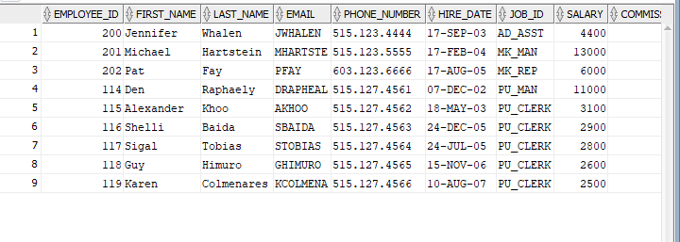

1. SELECT * FROM employees WHERE salary < (SELECT MIN(salary) FROM employees WHERE department_id = 50);
2. SELECT * FROM employees WHERE salary > (SELECT MAX(salary) FROM employees WHERE department_id = 90);

