DAY – 1
Github:- https://github.com/RiyaDominic/Demo_Works/tree/546f61f05ba81291f028612415c882c806f87cd7/Day_1
Desktop view
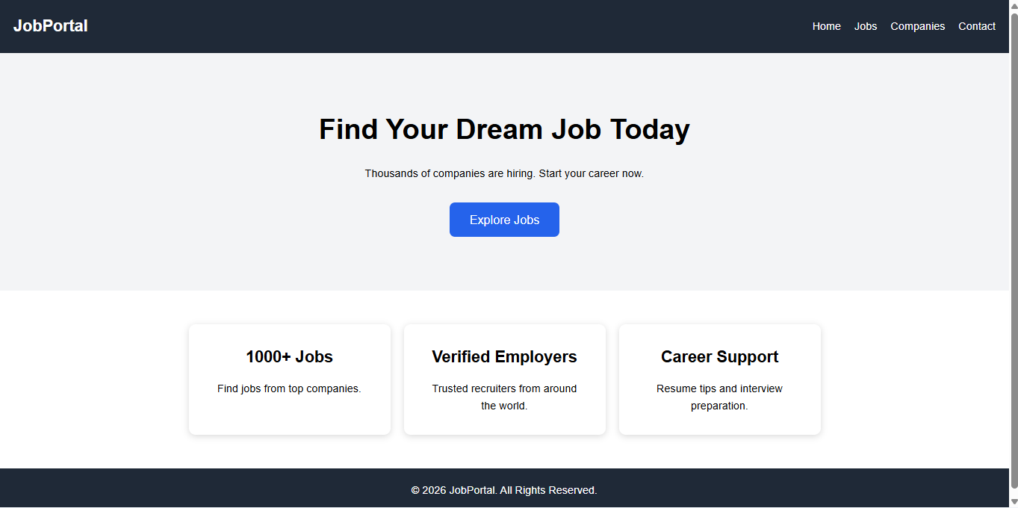
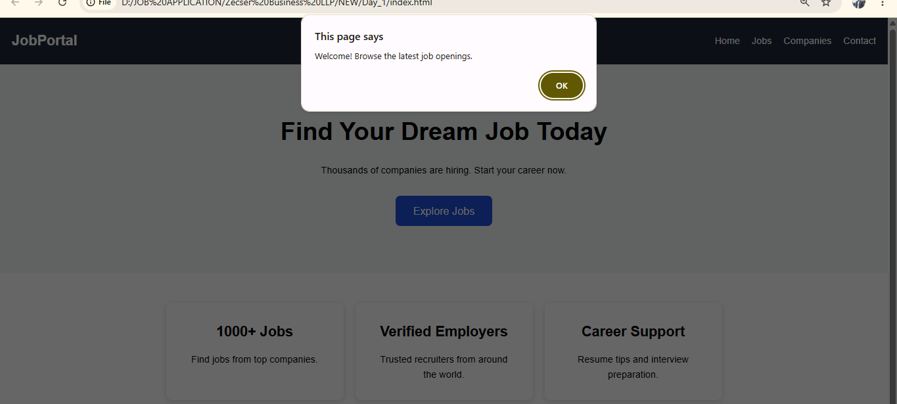

Mobile View
 |  | 

