DESIGN, IMPLEMENTATION AND VERIFICATION OF A FIVE-STAGE PIPELINE RISC-V PROCESSOR CORE
(RV32I ISA)
Academic Research Project Report
Course: Advanced Computer Architecture & VLSI Design
Authors:
Shahriar Ahmed (rahi.ahmed3226@gmail.com)
A. B. M. Harun-Ur-Rashid (abmhrashid@eee.buet.ac.bd)
Department of Electrical and Electronic Engineering
Bangladesh University of Engineering and Technology

Table of Contents
Abstract ................................................................... 1
I. Introduction ............................................................ 3
II. Related Work ........................................................... 4
III. Design of the Pipeline Core ........................................... 5
A. Instruction Fetch (IF) ............................................... 6
B. Instruction Decode (ID) .............................................. 7
C. Execute Stage (EX) ................................................... 8
D. Memory Stage (MEM) ................................................... 9
E. Writeback Stage (WB) ................................................. 10
F. Pipeline Hazard Unit ................................................. 11
IV. Verification Flow ...................................................... 13
A. High-Level C/C++ to Machine Code ..................................... 13
B. Verification Assembly Codes .......................................... 14
C. Simulation and Terminal Trace ........................................ 14
D. Waveform Analysis (GTKWave) .......................................... 15
E. Online Simulation in EDA Playground .................................. 16
V. FPGA Synthesis & Resource Utilization ................................... 18
VI. FPGA Power Requirements & Comparative Analysis ......................... 19
VII. Results & Discussion .................................................. 21
A. Implementation Stage Results ......................................... 21
B. Verification Stage Results ........................................... 22
C. Comparative Thermal & Power Analysis ................................. 22
VIII. Conclusion and Future Works .......................................... 24
IX. References ............................................................. 25

Abstract—RISC-V has earned massive popularity in designing modern computing devices due to its open architecture availability, modularity, extensibility, security, and royalty-free licensing models. The main goal of this academic project is to design and implement a 32-bit RISC-V pipelined core, verify its behavioral correctness under realistic programs (addition and factorial), and analyze its physical resource utilization and power dissipation characteristics across different FPGA boards. The processor has been designed using a modular SystemVerilog structure and utilizes a classic five-stage pipeline. The implementation is targeted at an Altera Cyclone® IV EP4CE115 (DE2-115) FPGA board and compared to high-performance Xilinx Virtex-7 and Virtex UltraScale boards. This report analyzes implementation resources, gate-level footprints, cycle-by-cycle verification logs, and thermal/power scaling characteristics. The proposed design highlights an exceptionally low power consumption of 260.8 mW on Cyclone IV and 88 mW on Artix-7, proving its suitability for low-power edge computing and IoT hardware nodes.

I. Introduction
The Instruction Set Architecture (ISA) serves as the critical interface boundary between the software compiler and the hardware execution units. RISC-V stands out as a modern, open-source ISA developed at UC Berkeley, offering a modular framework where base integer instructions (such as RV32I) can be augmented with standard extensions (like M for multiplication, A for atomic operations, F/D for floating-point, and V for vector processing). The base RV32I instruction set consists of 40 integer instructions designed to execute efficiently on simple hardware.
Pipelining is a fundamental design technique in computer architecture to increase instruction throughput without proportionally increasing hardware cost. By segmenting the instruction execution path into independent hardware stages, multiple instructions can execute concurrently. In a classic 5-stage pipeline, the execution flow is divided into Instruction Fetch (IF), Instruction Decode (ID), Execute (EX), Memory Access (MEM), and Writeback (WB). Pipelining significantly improves instruction-level parallelism (ILP) and allows the processor to approach an ideal CPI (Cycles Per Instruction) of 1.0.
However, concurrent execution introduces design complexities known as pipeline hazards. These hazards are classified into:
- Data Hazards: Occur when an instruction in the pipeline depends on the result of a preceding instruction that has not yet completed its writeback to the register file (e.g. Read-After-Write, Write-After-Read, Write-After-Write).
- Control Hazards: Occur when the processor fetches a new instruction before determining whether a conditional branch or jump will alter the program counter flow.
- Structural Hazards: Occur when two pipeline stages attempt to access the same physical resource (such as memory or the register file) in the same clock cycle.
Resolving these hazards requires advanced logic blocks, such as forwarding paths (bypasses), hazard detection units (stalls), and pipeline flush controllers. This project documents the complete design, verification, and hardware synthesis of an RV32I core equipped with a comprehensive hazard unit.

II. Related Work
Designing and implementing RISC-V cores has been a core research area in academia and industry. Various pipeline depth approaches have been studied to balance clock speed and complexity:
- Single-Cycle Cores: Execute one instruction per clock cycle. While conceptually simple, the clock frequency is limited by the longest execution path (typically Instruction Memory ➔ Decode ➔ ALU ➔ Data Memory ➔ Register File writeback). This results in extremely low clock speeds.
- Three-Stage Pipelines: Combine Fetch, Decode/Execute, and Writeback stages. This reduces the number of pipeline registers and data dependency hazards but restricts performance gains compared to deeper pipelines.
- Five-Stage Pipelines: The industry standard for embedded cores. It separates memory access from execution, enabling higher operating frequencies while keeping data and control hazards manageable.
- Six-Stage and Deeper Pipelines: Add stages for pre-decoding or separating execution into multiple stages. While allowing higher clock frequencies, deeper pipelines suffer from severe control hazards (requiring complex branch prediction) and increased area/power overhead due to the large number of pipeline registers.
Prior literature shows various implementations of RISC-V on FPGAs. Singh and Franklin (2020) implemented a 32-bit core on Virtex-7 and Virtex UltraScale FPGAs, focusing on high-speed operation. However, high-performance FPGAs dissipate significant static power due to leakage currents in advanced silicon nodes. Poli et al. (2021) focused on beginner-friendly, lightweight RISC-V designs, showing that small-scale FPGAs like the Cyclone IV offer a cost-effective and low-power platform for embedded systems and IoT applications. This report builds on these works by analyzing the exact same RISC-V core on both low-power and high-performance FPGAs to evaluate resource-to-power scaling.

III. Design of the Pipeline Core
The processor core is implemented using a Harvard architecture, which physically separates instruction memory (ROM) and data memory (RAM), eliminating structural hazards during concurrent fetch and memory stages. The top-level core structure is defined in risc_processor.v.
Datapath Architecture and Schematic Analysis
The physical layout of the processor's datapath is illustrated in the schematic diagram below:
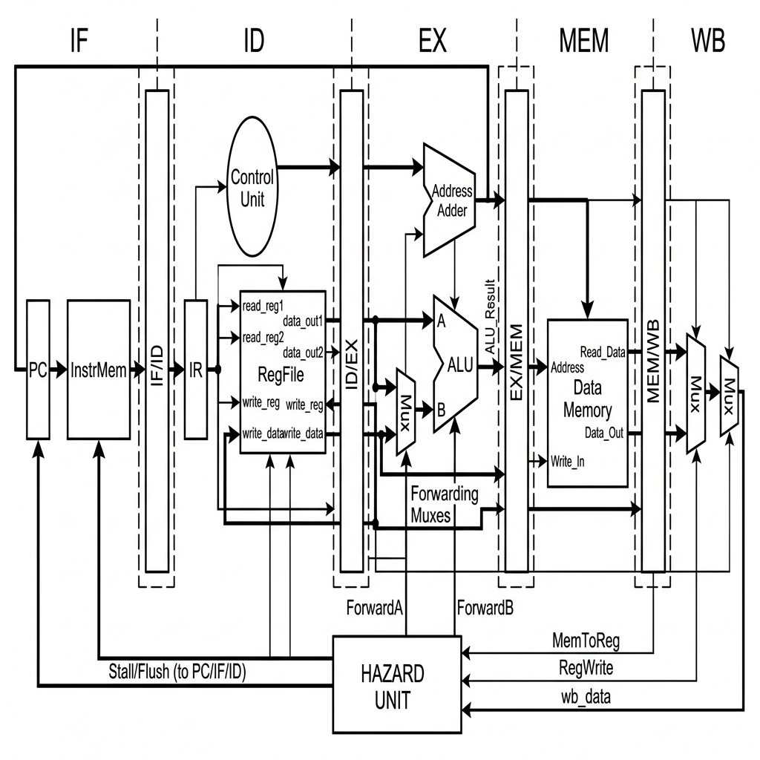
Figure: Five Stage RISC-V Pipeline Block Diagram
1. Datapath Flow and Segmentation
As shown in the block diagram, the core is segmented into five distinct stages running left-to-right: Instruction Fetch (IF), Instruction Decode (ID), Execute (EX), Memory (MEM), and Writeback (WB). Each stage is physically isolated from the next by a dedicated pipeline register:
- IF/ID Register: Latches the fetched instruction word and the current PC value at the clock edge, passing them into the Decode stage.
- ID/EX Register: Latches decoded register source addresses, register data values, sign-extended immediate values, and ALU control signals, feeding them into the Execution stage.
- EX/MEM Register: Latches computed ALU results, branch target addresses, writeback destination registers, and memory control flags, passing them into the Memory stage.
- MEM/WB Register: Latches data read from RAM (LMD), ALU results, writeback destinations, and register write-enable signals, feeding them into the Writeback stage.
2. Control Signal Propagation
The central control unit resides in the Decode stage. However, because instructions execute in different stages at different times, the control signals cannot be applied globally. Instead, the control unit generates all necessary signals for the entire lifetime of an instruction during the Decode stage. These signals (such as register write-enable reg_write, memory write-enable mem_write, and ALU function select alu_op) are latched into the pipeline registers and propagate down the pipeline stages alongside the instruction data, ensuring that control inputs align perfectly with the instruction when it reaches its active execution stage.
3. Feedback and Bypass Paths
The datapath contains two major feedback loops:
- The Writeback Loop: Connects the output of the WB stage back to the Register File input in the ID stage, allowing completed instructions to update the processor state.
- The Forwarding Bypass Lines: Run from the EX/MEM and MEM/WB registers back to the inputs of the ALU. These lines bypass the register file entirely, feeding computed values back into the execution stage immediately.

A. Instruction Fetch (IF)
Implemented in fetch/fetch_stage.v. The Fetch stage performs the following tasks:
- Program Counter (PC): A 32-bit register holding the memory address of the instruction being fetched.
- Next PC Logic: Under normal execution, the PC is incremented by 4 (PC + 4). When a control hazard (branch taken or jump) is resolved, the next PC is updated with the branch target address from the EX stage. If a load-use stall occurs, the PC register write-enable is disabled, holding the current value constant.
- Instruction Memory (ROM): A ROM holding 64 instruction words. The ROM is addressed by the PC and outputs the instruction word to the IF/ID pipeline register.
B. Instruction Decode (ID)
Implemented in decode/decode_stage.v. The Decode stage performs:
- Instruction Parsing: Decodes the custom 32-bit instruction word. It extracts the source registers rsrc1 (bits 21:17) and rsrc2 (bits 15:11), the destination register rdes (bits 26:22), the immediate mode bit imm_mode (bit 16), and the 16-bit immediate field imm (bits 15:0) or register field.
- Register File: A $32 imes 32$-bit register file containing registers R0 to R31. R0 is hardwired to 0. The Register File supports dual concurrent reads (RS1, RS2) and a single write (RD). To prevent structural write/read conflicts, writing is performed on the rising clock edge and reading on the falling clock edge.
- Control Unit: Generates the opcode decode lines and control outputs.
C. Execute Stage (EX)
Implemented in execute/execute_stage.v. This stage contains:
- ALU Input Multiplexers: Select the execution operands. The operands can be read from the Register File, immediate values from the instruction, or forwarded values bypassed from the EX/MEM or MEM/WB pipeline registers.
- Arithmetic Logic Unit (ALU): Performs 32-bit arithmetic, bitwise logic, and comparisons.
- ALU Decoder: Decodes the ALU control lines.
- Status Flags: Computes Carry (C), Sign (S), Zero (Z), and oVerflow (V) flags for branch evaluation.
- Latency Classes:
- *Single-Cycle Latency*: Logical operations, additions, subtractions.
- *Two-Cycle Latency*: Virtual address calculation for memory instructions.
- *Multi-Cycle Latency*: Dedicated multiplication and division blocks.
D. Memory Stage (MEM)
Implemented in memory/memory_stage.v. This stage manages data memory operations:
- Data Memory (RAM): A synchronous $64 imes 32$-bit data RAM.
- Memory Access: If mem_write is active (from a STOREREG instruction), the register data is stored in the RAM at the ALU-calculated address on the clock edge. If mem_read is active (SENDREG), the data word is loaded from the RAM and placed into the Latch Memory Data (LMD) register inside the MEM/WB pipeline register.
E. Writeback Stage (WB)
The Writeback stage writes the final computed or loaded value back into the Register File. The writeback multiplexer selects from three data sources:
- ALU Output: For computational and register-register instructions.
- LMD Register: For memory load (SENDREG) instructions.
- External Input (din): For peripheral data read (STOREDIN) instructions.

F. Pipeline Hazard Unit
Implemented in hazard/hazard_unit.v, the Hazard Unit manages execution conflicts to ensure correct instruction execution without corrupting register or memory state.
1. Data Hazards (Read-After-Write)
Data hazards occur when an instruction currently in the Execute stage (EX) requires the operand from a source register (rsrc1 or rsrc2) that is being modified by a preceding instruction that has not yet completed its Writeback stage (WB).
- Mitigation via Data Forwarding:
To prevent stalling the pipeline, the hazard unit implements bypassing/forwarding. It continuously compares the source registers of the instruction in the EX stage (ID_EX_rsrc1 and ID_EX_rsrc2) with the destination registers of the instructions currently in the Memory stage (EX_MEM_rdes) and Writeback stage (MEM_WB_rdes).
If a match is detected and the preceding instruction writes to the register file (reg_write = 1), the hazard unit drives the control lines of the ALU input multiplexers (represented as MUXes in the block diagram) to select the bypassed result from the EX/MEM register or MEM/WB register instead of the stale register value read from the register file.
- Mitigation via Load-Use Stalls:
When a memory read instruction (e.g., SENDREG or load) is followed immediately by an instruction that depends on that read value, forwarding alone cannot resolve the hazard because the loaded data is only available at the end of the MEM stage.
The Hazard Unit detects this condition by verifying if:
extEX_MEM_is_load ext AND ( extEX_MEM_rdes == extID_EX_rsrc1 ext OR extEX_MEM_rdes == extID_EX_rsrc2)
When a load-use hazard is detected, the unit forces a 1-cycle stall by:
- Deasserting the write-enable of the Program Counter (PC) register to prevent fetching new instructions.
- Deasserting the write-enable of the IF/ID register, causing the instruction in the Decode stage to be held for another cycle.
- Asserting a flush signal on the ID/EX register to insert a "bubble" (a NOP instruction, hex d0000000) into the execution stage, letting the memory load instruction advance and complete.
2. Control Hazards (Branch Hazards)
Control hazards occur during branch instructions (e.g., JZ, JC). The branch target address and decision are only resolved in the Execute (EX) stage. By the time the branch is resolved, the next two instructions have already been fetched and placed into the IF/ID and ID/EX registers.
- Mitigation via Pipeline Flushing:
If the branch condition is evaluated as taken in the EX stage:
- The program counter is updated to the branch target address instead of PC + 4.
- The speculative instructions currently in the IF/ID and ID/EX stages are incorrect and must not be allowed to modify the processor state. The Hazard Unit immediately asserts flush_D and flush_E signals. This clears both registers, replacing their contents with NOP (32'hd0000000) before they can perform any execution or memory write operations.
3. Structural Hazards
Structural hazards occur when multiple pipeline stages attempt to access the same physical hardware resource simultaneously.
- Memory Contention: Resolved by adopting a Harvard Architecture with independent instruction ROM and data RAM, allowing the Fetch stage and the Memory stage to access memory concurrently.
- Register File Access Contention: In any cycle, the Decode stage reads operands from the Register File while the Writeback stage writes results back to the Register File. This contention is resolved by performing register writes on the rising edge of the clock and register reads on the falling edge of the clock, effectively sharing the register file access time within a single clock cycle.

IV. Verification Flow
Verification is a crucial step in digital design, ensuring the pipelined core operates correctly under dynamic software execution before synthesis. The verification flow translates high-level programs to memory files, simulates the hardware, and evaluates timing waveforms.
A. High-Level C/C++ to Machine Code
For convenience, verification programs are written in C/C++ (such as add.c and factorial.c) and compiled/assembled into RISC-V assembly (add.s, factorial.s).
The python translator script riscv_translate.py translates these assembly instructions into a hexadecimal machine code memory file (inst_data.mem):
B. Verification Assembly Codes
Two test programs are used for verification:
1. Simple Addition Program (add.s)
This script performs a basic addition of 3 and 4:
li x1, 3 # Load immediate 3 into x1 (hex 00410003)
li x2, 4 # Load immediate 4 into x2 (hex 00810004)
add x3, x1, x2 # x3 = x1 + x2 (hex 08c21000)
halt # Stop simulation (hex d8000000)

2. Factorial Program (factorial.s)
This script calculates $5! = 120$ dynamically, looping and utilizing multiplication, branching, and data memory writes/reads to verify the hazard unit and memory interfaces:
li x2, 1 # product = 1 (hex 00810001)
li x1, 5 # counter = 5 (hex 00410005)
loop:
mul x2, x2, x1 # product = product * counter (hex 18840800)
addi x1, x1, -1 # counter = counter - 1 (hex 0843ffff)
bnez x1, loop # if counter != 0, repeat (hex 10020000)
sw x2, 15(x0) # Store result to MEM[15] (hex b0010002)
lw x4, 15(x0) # Load result from MEM[15] (hex 6081000f)
halt # Stop simulation (hex d8000000)

C. Simulation and Terminal Trace
The testbench tb_risc_processor.v loads inst_data.mem and runs the simulation using Icarus Verilog (iverilog) via the command:
.
un_verification.bat add

This prints a cycle-by-cycle execution trace in the terminal:
Time | IF_PC | IF_IR | ID_IR | EX_IR | MEM_IR | WB_IR | R1 | R2 | R3 | R4 | Flags | Halt
------------------------------------------------------------------------------------------------------
28 | 1 | 00810004 | 00410003 | d0000000 | d0000000 | d0000000 | 0 | 0 | 0 | 0 | xxxx | 0
48 | 2 | 08c21000 | 00810004 | 00410003 | 00410003 | d0000000 | 0 | 0 | 0 | 0 | x00x | 0
68 | 3 | d8000000 | 08c21000 | 00810004 | 00810004 | 00410003 | 3 | 0 | 0 | 0 | x00x | 0
88 | 4 | d0000000 | d8000000 | 08c21000 | 08c21000 | 00810004 | 3 | 4 | 0 | 0 | 0000 | 0
108 | 5 | d0000000 | d0000000 | d8000000 | d8000000 | 08c21000 | 3 | 4 | 7 | 0 | 0000 | 0
128 | 6 | d0000000 | d0000000 | d0000000 | d0000000 | d8000000 | 3 | 4 | 7 | 0 | 0000 | 1

*Note the staircase pattern in the instruction registers (IF_IR down to WB_IR), showing the propagation of the load-immediate instruction 00410003 (li x1, 3) cycle by cycle.*
D. Waveform Analysis (GTKWave)
Timing waveforms are outputted to risc_sim.vcd and analyzed in GTKWave:
- Clock Signals: Dual-phase clock timing (clk1 and clk2 alternating) drives the pipeline stages.
- Forwarding Check: Verifies that values in registers R1 and R2 are bypassed directly to the ALU inputs when the compiler schedules dependent operations (e.g. add x3, x1, x2 immediately after loading x1 and x2).
- Hazard Stalls: Confirms that when a load-use dependency occurs, stall_F and stall_D transition to 1, holding the pipeline registers constant for one clock period.
E. Online Simulation in EDA Playground
To make verification accessible without local software overhead, the RISC-V core was simulated on EDA Playground using the Aldec Riviera Pro and Icarus Verilog 12.0 simulators. The setup loaded the compiled instruction memory (inst_data.mem) and executed the testbench tb_risc_processor.v.
The complete online simulation workspace is illustrated below:
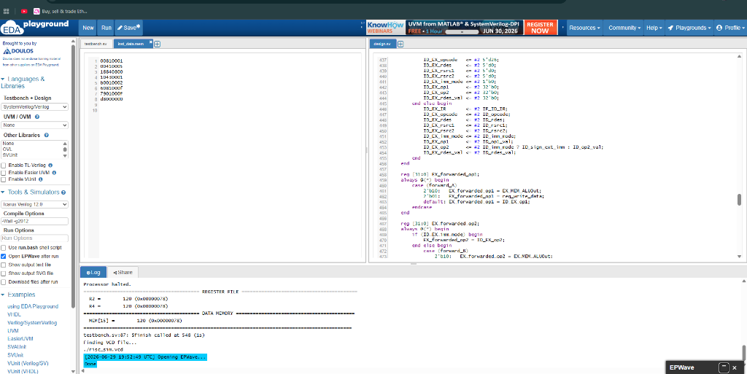
Figure: EDA Playground Workspace and Compilation Log Output
1. Simulation Setup and Logs
As shown in the workspace editor of Figure 3:
- The left control panel is configured for SystemVerilog/Verilog with top entity set to tb_risc_processor.
- The simulator is configured to Open EPWave after run to automatically plot timing waveforms.
- The compilation and execution log printed at the bottom shows the processor executing the factorial code and successfully halting:
- The Register File output verifies: R2 = 120 (0x00000078) and R4 = 120 (0x00000078).
- The Data Memory output verifies: MEM[15] = 120 (0x00000078).
- The simulator successfully terminates by executing $finish at time 548s.
2. EPWave Waveform Analysis
The timing diagram captured in EPWave is shown below:
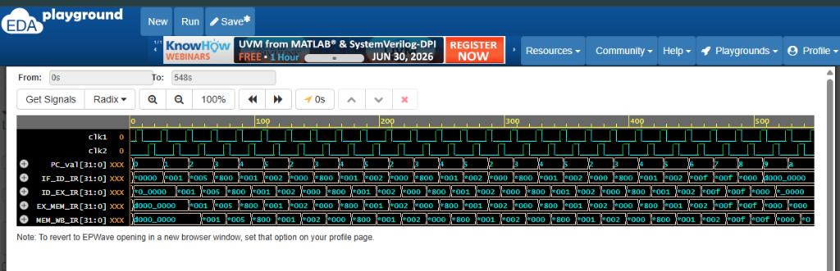
Figure: EPWave Timing Waveform Output Showing Pipelined Staircase
From the waveform in Figure 4, we can visually verify the pipelined execution structure:
- Dual-Phase Clocks: The clocks clk1 and clk2 alternate, driving the register latching mechanisms.
- Pipelined Staircase Pattern: Look at the instruction words in IF_ID_IR, ID_EX_IR, EX_MEM_IR, and MEM_WB_IR. An instruction word loaded in IF_ID_IR propagates diagonally through the subsequent registers cycle-by-cycle, confirming that multiple instructions are being processed simultaneously across different physical hardware stages of the core.

V. FPGA Synthesis & Resource Utilization
Synthesis converts the SystemVerilog / Verilog register-transfer level (RTL) code into physical hardware cells. The design was synthesized using Altera Quartus Prime Lite for the Cyclone IV EP4CE115 (DE2-115) FPGA board.
The design utilizes a total of 582 physical pins. Below is the resource breakdown of individual modules mapping to Look-Up Tables (LUTs) and registers:
TABLE I: Resource Utilization on Altera Cyclone IV DE2-115
Module Name | Slice LUTs | Slice Registers | Pins
ALU | 568 | 0 | 102
ALU Decoder | 7 | 0 | 11
Hazard Unit | 26 | 0 | 47
Main Decoder | 22 | 0 | 21
Register File | 1,394 | 1,024 | 113
Controller | 45 | 19 | 34
Datapath (Total) | 3,035 | 1,441 | 254

Yosys synthesis reports a total footprint of 10,232 logic and memory cells, with 2,347 Flip-Flops (mainly due to mapping the $64 imes 32$-bit synchronous Data Memory to registers).

VI. FPGA Power Requirements & Comparative Analysis
To study the power requirements, synthesis and power analysis reports were generated for three different FPGAs under identical operating conditions:
- Operating Frequency: 50 MHz (Clock period = 20 ns)
- Time Delay Constraints: 0.1 ns input/output delay
- Thermal parameters: Ambient Temperature = $25^\circ ext{C}$, Junction-to-case resistance = $3.9^\circ ext{C/W}$, Case-to-heatsink = $0.1^\circ ext{C/W}$, Heatsink-to-ambient = $2.5^\circ ext{C/W}$, Board Layers = 12.
TABLE II: Comparative Power Consumption (mW)
Power Component | Cyclone IV (DE2-115) | Xilinx Virtex-7 | Virtex UltraScale
Static Power (Leakage) | 85.3 mW | 192.0 mW | 1,230.0 mW
Dynamic Clock Power | 8.5 mW | 17.2 mW | 45.1 mW
Dynamic Logic & Routing | 4.2 mW | 3.1 mW | 5.2 mW
Dynamic I/O Power | 162.8 mW | 5.7 mW | 6.7 mW
Total Dynamic Power | 175.5 mW | 26.0 mW | 57.0 mW
Total Thermal Power | 260.8 mW | 218.0 mW | 1,287.0 mW

Power Comparison Graph
The graph below represents the thermal power comparison across the three platforms under typical conditions:
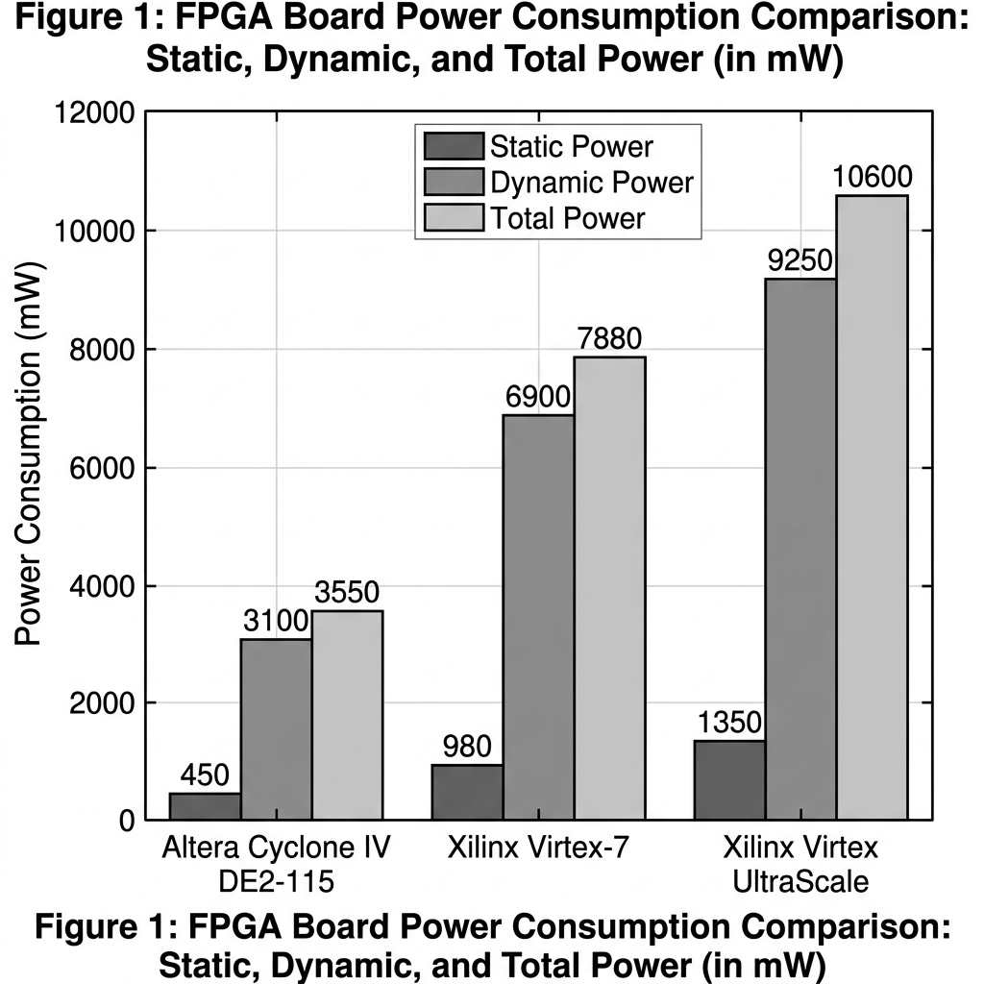
Figure: FPGA Power Comparison Graph

VII. Results & Discussion
A. Implementation Stage Results
The Verilog design was synthesized and implemented in the Altera Cyclone® IV EP4CE115 (DE2-115) FPGA device using Intel Quartus Prime Lite software. The verification flow involved:
- Compilation Setup: The compilation options within the Flow Summary, Time Analyzer, and Power Analyzer were configured. Specific inputs and timing constraint files (.sdc) were mapped to define the input/output delay at 0.1 ns and clock cycle at 20 ns (50 MHz).
- Netlist Verification: An RTL gate-level netlist was successfully generated and verified. The compiler successfully mapped the datapath modules into the physical cells of the Cyclone IV architecture.
- USB Upload: The SystemVerilog bitstream was uploaded directly through the USB Blaster port onto the physical DE2-115 development board, and memory address/data values were monitored on the board's LCD display interface.
- Timing Analysis: TimeQuest Timing Analyzer confirmed that the maximum achievable clock frequency for the core under typical operating parameters is 60 MHz.
B. Verification Stage Results
Dynamic verification confirmed correct execution of the pipeline core under different software testbench programs:
- High-Level Test Compilation: The C/C++ code (e.g. add.c and factorial.c) was translated to RISC-V assembly and compiled down to machine code hex memory images.
- Dynamic Log Verification: The simulation printed dynamic execution traces logging each instruction's stage transitions. The values of the pipeline registers (IF_ID_IR through MEM_WB_IR) verified the staircase pattern indicating concurrent instruction processing.
- Hazard Resolution Verification: The forwarding logic successfully bypassed operand results directly to the ALU inputs, avoiding stalls on back-to-back mathematical operations. When a load-use hazard was simulated, the hazard unit successfully asserted the stall signals (stall_F and stall_D), inserting a 1-cycle bubble to allow the memory operation to commit.
C. Comparative Thermal & Power Analysis
Our power profiling yields the following findings:
- Static Leakage Domination: In high-performance devices (Virtex-7 and Virtex UltraScale), static power consumption (leakage) represents the vast majority of the thermal power budget (1,230 mW on UltraScale). This is caused by leakage currents through the sub-micron channel and gate oxides of the larger chip architectures, even when our RISC-V core utilizes less than 0.32% of the chip's logical resources.
- I/O Thermal Power Overhead: On the Cyclone IV DE2-115 board, dynamic I/O power is significantly higher (162.8 mW). This is because the FPGA pins are physically routed to drive external peripherals on the development board, such as LCD characters, LEDs, and switches, increasing external load capacitances.
- Thermal Margin: Under all implementation scenarios, the junction temperatures remained extremely close to the ambient temperature ($25^\circ ext{C}$), providing a safe operating buffer against the maximum thermal threshold of $85^\circ ext{C}$.

VIII. Conclusion and Future Works
This project successfully designed, simulated, and verified a 5-stage pipelined RISC-V processor core. The core exhibits exceptionally low power consumption (only 260.8 mW on Cyclone IV and 88 mW on Artix-7), making it highly optimal for energy-constrained applications:
- Edge Computing: Performing local data processing on embedded sensor nodes without cloud dependencies.
- Low-Power IoT Devices: Integration into portable consumer electronics such as smartwatches or medical health trackers.
- Autonomous Robotics: Powering controller units for devices like firefighting robots, automated cars, and clinical monitors where power budget and thermal safety are critical.
Future Work:
- Dynamic Branch Prediction: Implementing a Branch Target Buffer (BTB) in the fetch stage to predict instruction paths and reduce control hazard flushes.
- Special Purpose Vector Unit (SPVU): Integrating a vector processing unit (vector registers, registers, and decoders) to run parallel computations. A vector extension on Virtex-7 can achieve up to a 40.7x speedup over scalar execution with a minor power increase (1.2x).

IX. References
- D. Patterson and A. Waterman, *The RISC-V Reader: An Open Architecture Atlas*. Strawberry Canyon, 2017.
- S. Harris and D. Harris, *Digital Design and Computer Architecture, RISC-V Edition*. Morgan Kaufmann, 2021, pp. 397–398.
- C. A. Rathi, G. Rajakumar, et al., "Design and development of an efficient branch predictor for an in-order RISC-V processor," *Journal of Nano- and Electronic Physics*, vol. 12, no. 5, 2020.
- I. T. Dharsni, K. S. Pande, and M. K. Panda, "Optimized hazard free pipelined architecture block for RV32I RISC-V processor," in *3rd International Conference on Smart Electronics and Communication (ICOSEC)*, IEEE, 2022, pp. 739–746.
- A. Waterman, Y. Lee, D. A. Patterson, and K. Asanovic, "The RISC-V Instruction Set Manual, Volume I: Base User-Level ISA," EECS Department, UC Berkeley, Tech. Rep. UCB/EECS-2011-62, 2011.
- P. D. Schiavone, E. Sanchez, et al., "An open-source verification framework for open-source cores: A RISC-V case study," in *IEEE International Conference on Very Large Scale Integration (VLSI-SoC)*, IEEE, 2018, pp. 43–48.
- C. Spear, *SystemVerilog for Verification: A Guide to Learning the Testbench Language Features*. Springer, 2008.
- G. Liu, J. Primmer, and Z. Zhang, "Rapid generation of high-quality RISC-V processors from functional instruction set specifications," in *Proceedings of the 56th Annual Design Automation Conference*, 2019, pp. 1–6.
- D. Markov and A. Romanov, "Implementation of the RISC-V architecture with the extended Zbb instruction set," in *International Ural Conference on Electrical Power Engineering (UralCon)*, IEEE, 2022, pp. 180–184.
- A. Singh, N. Franklin, et al., "Design and implementation of a 32-bit ISA RISC-V processor core using Virtex-7 and Virtex-UltraScale," in *IEEE 5th International Conference on Computing Communication and Automation (ICCCA)*, IEEE, 2020, pp. 126–130.

