**DATA STRUCTURES PROJECT 2020**

**GUIDELINES TO FOLLOW FOR EXECUTION.**

1) After running the program, the welcome screen and menu appear.

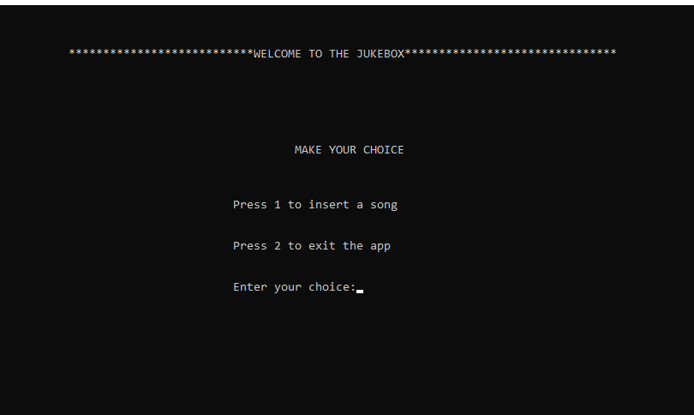

2) If you press 2 the program exits and if you press 1 you can insert a song.

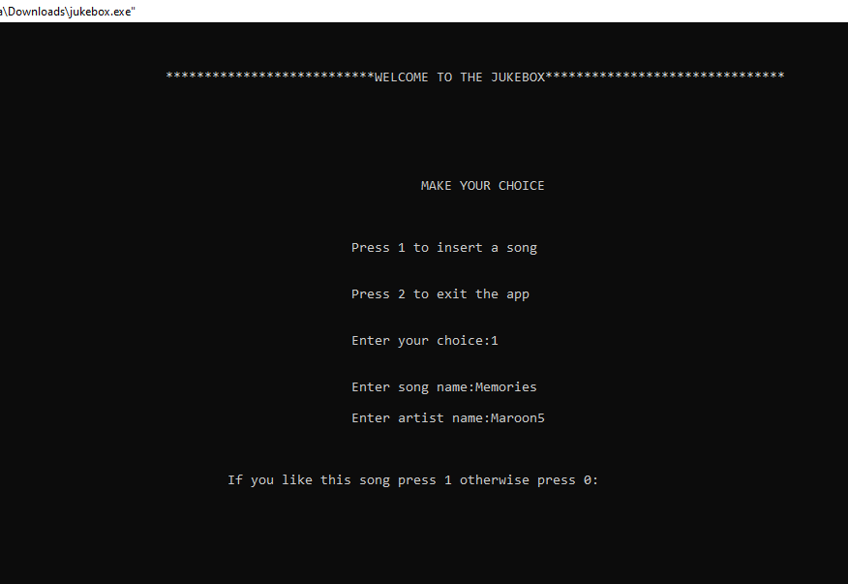

3) Once you add the song, you can like it and proceed.

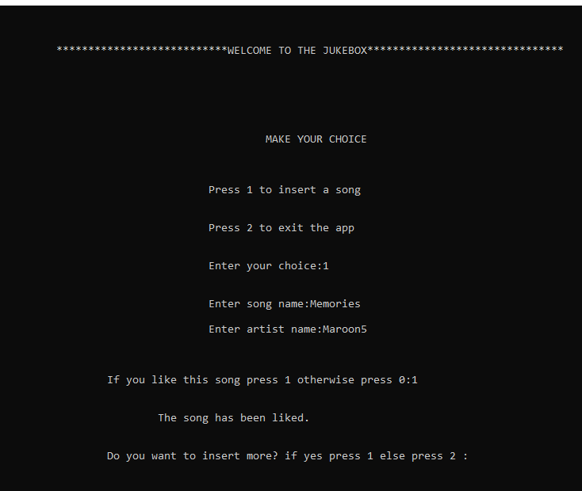

4) If you want to insert more press 1, otherwise 2.

If you press 2 the menu appears.

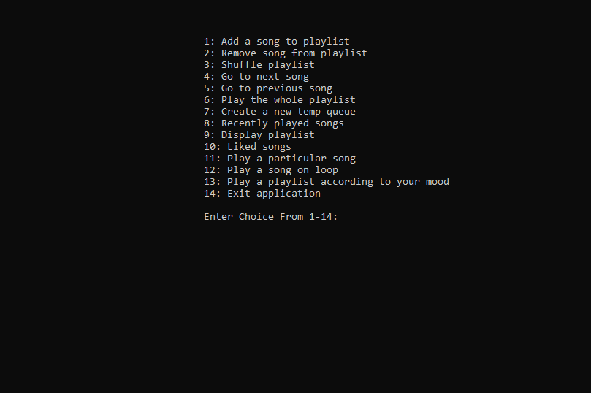

5) You can choose whichever function you want to perform. For example delete function is performed here.The menu appears again and you can continue using the program.

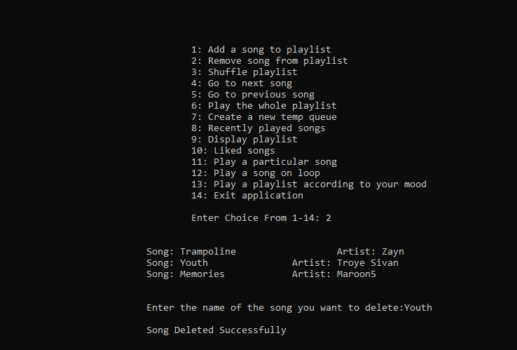

**THANK YOU.**