



Riya Idikkula

AJC20MCA-I047

INMCA2020-25 S9

<https://github.com/RiyaIdikkula/AI-Based-Next-Gen-Wedding-Planners>

riyaidikkul2025@mca.ajce.in

Scrum Master

**Ann Mary Thomas**

Assistant Professor  
Department of Computer Applications

**AI Based Next-Gen Wedding Planners**

20INMCA509 - Mini Project 2

**ABSTRACT**

The Wedding Planner system is designed to streamline and enhance the wedding planning process by providing a user-friendly platform for both customers and administrators. It offers a seamless experience for selecting occasions, event types, food menus, and additional services while allowing efficient management and oversight for administrators.

**Roles and Responsibilities:**

1. **Admin**: Manages the entire system, including customer details, occasions, event types, events, food menus, payments, feedback, and complaints.
2. **Customer**: Registers and logs in to explore and select occasions, event types, specific events, food menus, and additional services. They can also provide feedback and make payments.

**System Functionality:**

* **Admin Role**:
  + **Login**: Admins have a dedicated login page to access the admin interface.
  + **Customer Management**: Admins can view and manage customer details, including registrations and bookings.
  + **Occasion Management**: Admins can add and update wedding occasions, including their descriptions and images.
  + **Event Type Management**: Admins can manage event types associated with each occasion.
  + **Event Management**: Admins can add and update specific events, including descriptions and images.
  + **Food Menu Management**: Admins can manage food items by adding or updating the Starter, Main-course, and Dessert menus.
  + **Payment Management**: Admins oversee and manage payments made by customers.
  + **Feedback & Complaint Management**: Admins handle customer feedback and complaints to ensure service quality and customer satisfaction.
* **Customer Role**:
  + **Registration & Login**: Customers can register and log in to access the system.
  + **Occasion Selection**: Customers can view and choose from various occasions (Ceremony, Reception, Engagement).
  + **Event Type Selection**: Based on the selected occasion, customers can choose the type of event (Theme, Traditional, Destination).
  + **Event Selection**: Customers can select specific events based on the chosen event type.
  + **Food Selection**: Customers can select food packages, categorized into Starter Menu, Main-course Menu, and Dessert Menu, aligned with their chosen event.
  + **Additional Services**: Customers can select additional services such as photographers and makeup stylists.
  + **Event Details & Payment**: Customers provide event dates, number of guests, and make advance payments. Personal details such as name, email, phone number, and city are also required.
  + **Feedback & Complaints**: Customers can provide feedback ratings and file complaints to ensure continuous improvement of services.

**Technology Used:**

* Frontend:HTML,CSS
* Backend:DJANGO

**FEASIBILITY STUDY**

The feasibility study for the AI-Based Next-Gen Wedding Planner Management System aims to determine the practicality and viability of the project. It assesses whether the proposed solution, integrating VR technology and machine learning algorithms, can successfully meet the requirements of streamlining wedding planning processes. Key considerations include resource availability, cost estimation for development and maintenance, and the anticipated benefits to the organization. The study will provide insights into whether proceeding with the system's development aligns with business objectives and whether it will ultimately deliver value by enhancing the efficiency and effectiveness of wedding planning services.

* **Operational Feasibility:**

Operational feasibility of the AI-Based Next-Gen Wedding Planner Management System focuses on evaluating how well the proposed software solution addresses current challenges in wedding planning. This includes assessing the system's ability to effectively coordinate between multiple vendors, cater to personalized client preferences, and manage logistical complexities. Key factors include determining the acceptance and adaptation of new technologies like VR and machine learning among users (wedding planners, clients, vendors) and ensuring that the proposed solution is perceived as acceptable and beneficial compared to alternative approaches. Operational feasibility also involves visualizing the system's operational workflow post-implementation to ensure seamless integration and functionality within existing organizational processes.

* **Technical Feasibility:**

Technical feasibility examines the practicality of implementing the AI-Based Next-Gen Wedding Planner Management System using current technology resources. This includes assessing the stability and scalability of VR technology for virtual trials and machine learning algorithms for personalized recommendations. It involves analyzing the technical skills and capabilities of the development team to deploy and maintain the system effectively. Additionally, compatibility with existing software systems used by vendors (such as inventory management and payment systems) is crucial to ensure seamless integration and interoperability. The feasibility study will ascertain whether the technological infrastructure supports the envisioned functionalities and whether any new technologies required are readily available and feasible to implement.

* **Economic Feasibility:**

Economic feasibility evaluates the financial viability of developing and implementing the AI-Based Next-Gen Wedding Planner Management System. This includes estimating the initial costs for software development, hardware acquisition (including VR equipment), and ongoing maintenance. It further explores potential benefits such as increased operational efficiency, enhanced customer satisfaction leading to repeat business, and competitive advantage in the wedding planning industry. A comprehensive cost-benefit analysis will be conducted to determine whether the projected benefits justify the investment costs over the system's lifecycle. The feasibility study aims to ensure that the system not only meets organizational objectives but also generates sustainable long-term financial gains for the organization.

**REQUIREMENT GATHERING**

**Date: [19-06-2024]**

1. **Project Overview:**

The AI-Based Next-Gen Wedding Planner Management System aims to revolutionize the wedding planning process by integrating advanced technologies such as VR and machine learning. It seeks to streamline coordination between wedding planners, clients, and vendors, offering personalized recommendations and ensuring a smooth and memorable wedding experience.

2. **System Scope:**

This project will be a prototype initially, focusing on developing and integrating key modules like Customer, Admin, Food Section, Event, and Fashion. It will serve as a proof of concept to demonstrate the feasibility and functionality of the system.

3. **Target Audience:**

Primary users include engaged couples seeking wedding planning services, wedding planners, and vendors (caterers, fashion boutiques, jewelry stores). Stakeholders also include administrators overseeing the system's operation.

4. **Modules:**

* + - Customer Module: Allows clients to specify wedding preferences and select food, jewelry, and attire options.
    - Admin Module: Coordinates interactions between clients, vendors, and different modules. Manages payments, budgeting, and overall coordination.
    - Food Section Module: Handles food-related arrangements and dietary preferences.
    - Event Module: Covers logistical and thematic aspects of wedding planning, including destination weddings.
    - Fashion Module: Integrates VR technology for virtual trials of jewelry and attire, and ML algorithms for personalized fashion recommendations.

5. **User Roles:**

* + - Customer: Engaged couples and their families; interact with the system to plan and customize their weddings.
    - Admin: System administrators; manage and oversee all interactions, payments, and logistics.

6. **System Ownership:**

Ownership of the AI-Based Next-Gen Wedding Planner Management System would typically reside with an organization specializing in event management or software development for commercial deployment.

7. **Industry/Domain:**

The system is related to the event management industry. It focuses specifically on wedding planning, utilizing advanced technologies like VR for virtual trials and machine learning for personalized recommendations to enhance the planning experience for clients and streamline operations for wedding planners and vendors.

8. **Data Collection Contacts:**

Name: Sharon [Michael Events]

Role: Head

Contact Information: 8606448126

9. **Questionnaire for Data Collection:**

1. **What are the most challenging aspects of wedding planning from your experience?**

Wedding planning involves managing numerous details and expectations simultaneously, from coordinating vendors and handling logistics to ensuring every aspect aligns with the couple's vision. Challenges often include managing budget constraints, navigating differing opinions from stakeholders, and handling unforeseen circumstances gracefully to ensure a seamless event.

1. **How do you currently manage coordination between multiple vendors during wedding preparations?**

Effective vendor coordination begins with clear communication and detailed contracts outlining expectations and deliverables. Regular meetings and updates ensure everyone remains informed and aligned with the timeline and requirements. Using centralized communication channels and tools helps streamline coordination and minimize misunderstandings.

1. **What are the common bottlenecks or delays you encounter in the wedding planning process?**

Common bottlenecks include delays in vendor responses, changes in client preferences, and logistical challenges such as venue availability. Unclear communication, unexpected weather conditions, and issues with third-party suppliers can also impact timelines. Proactive planning, contingency plans, and open communication are key to mitigating these delays.

1. **How important do you believe technology, such as virtual reality (VR) for virtual trials, could be in enhancing the wedding planning experience?**

Technology like VR for virtual trials can significantly enhance the wedding planning experience by allowing clients to visualize and make informed decisions about venues, décor, and attire remotely. It improves client satisfaction, reduces decision-making time, and enhances the overall planning process's efficiency and accuracy.

1. **To what extent do you personalize wedding planning services based on client preferences and cultural backgrounds?**

Personalization is fundamental to our approach. We tailor every aspect of the wedding, from theme and décor to menu and entertainment, to reflect the couple's unique style and cultural traditions. We prioritize understanding cultural nuances and integrating meaningful elements to create a memorable and authentic experience.

1. **What challenges do you face in ensuring all vendors are aligned with the client’s expectations and timeline?**

Challenges include managing differing schedules and priorities among vendors, interpreting and executing client preferences accurately, and ensuring consistent quality across all services. Effective communication, detailed contracts, and proactive issue resolution are essential to aligning vendors with client expectations and timelines.

1. **How do you handle last-minute changes or unexpected issues during wedding events?**

We maintain flexibility and readiness to adapt to last-minute changes or unexpected issues by having contingency plans in place. Close communication with vendors and staff ensures quick decision-making and problem-solving. Our experience allows us to handle unforeseen challenges calmly while prioritizing the couple's experience.

1. **How do you measure client satisfaction with your wedding planning services?**

We measure client satisfaction through post-event surveys, direct feedback sessions. We evaluate aspects such as communication, attention to detail, execution of preferences, and overall event success. Continuous improvement based on client feedback is integral to our service approach.

1. **What methods do you use to collect feedback from clients after their weddings, and how do you incorporate this feedback into your services?**

We use structured post-event surveys and follow-up meetings to gather detailed feedback from clients. We analyze responses to identify strengths and areas for improvement. Feedback is incorporated into our training programs, service enhancements, and process refinements to ensure ongoing client satisfaction and service excellence.

1. **How do you currently manage budgeting and financial aspects of wedding planning?**

We meticulously track expenses and revenues using spreadsheets and financial software. Budgets are initially set based on client preferences and adjusted as needed throughout the planning process. Regular financial reviews ensure adherence to budgets and profitability.

**TABLE DESIGN**

**Login table**

|  |  |  |  |
| --- | --- | --- | --- |
| Column name | Data Type | description | constraints |
| Login_id | int | Login ID | Primary key |
| Register_id | int | Register Id | Foreign key |
| Customer_email | varchar | Email ID of the customer |  |
| Customer_password | varchar | Password of the customer |  |
| Role | int | Choose admin/user |  |

**Register Table**

|  |  |  |  |
| --- | --- | --- | --- |
| Column name | Data Type | description | constraints |
| Register_id | int | Registeration ID | Primary key |
| user_name | varchar | Name of the customer |  |
| user_Phone | int | Phone number of the customer |  |
| Role | int | Choose user/admin |  |

**Package Table**

|  |  |  |  |
| --- | --- | --- | --- |
| Column name | Data Type | description | constraints |
| Package_id | int | Package ID | Primary key |
| Package_name | varchar | Package Name |  |
| Package_price | varchar | Price of the Package |  |

**Occasion Table**

|  |  |  |  |
| --- | --- | --- | --- |
| Column name | Data Type | description | constraints |
| Occasion_id | int | Wedding ID | Primary key |
| Name | varchar | Type of Occasion wedding/Reception/Engagement |  |
| Description | varchar | Description of the Occasion |  |

**Event Table**

|  |  |  |  |
| --- | --- | --- | --- |
| Column name | Data Type | description | constraints |
| oid |  |  |  |
| Event_id | int | Event ID | Primary key |
| Event_type_name | varchar | Type of wedding Theme/Destination/Traditional |  |
| Event_description | varchar | Description of the wedding |  |
| Images | longblob | Picture of the Event |  |

**Food Table**

|  |  |  |  |
| --- | --- | --- | --- |
| Column name | Data Type | description | constraints |
| Food_id | int | Food ID | Primary key |
| Package_id | int | Package ID | Foreign Key |
| Starter_id | int | Starters ID | Foreign Key |
| Main-course_id | int | Main Course ID | Foreign Key |
| Dessert_id | int | Dessert ID | Foreign Key |

**Starter Table**

|  |  |  |  |
| --- | --- | --- | --- |
| Column name | Data Type | description | constraints |
| Starter _id | int | Starters ID | Primary key |
| Name of starters | VARCHAR | Enter the starters name |  |
| Starter_description | varchar | Enter the description of food |  |
| Starter_Pictures | longblob | Picture of the Startert |  |
| Starter_Veg/non-veg | varchar | Enter veg or non-veg |  |

**Main Course Table**

|  |  |  |  |
| --- | --- | --- | --- |
| Column name | Data Type | description | constraints |
| Main-course_id | int | Main Course ID | Primary key |
| Package_id | int | Package ID | Foreign Key |
| Name of Main course | varchar | Enter the main course name |  |
| Main-course_description | varchar | Enter the description of food |  |
| Main-course_Pictures | longblob | Picture of the Main Course |  |

**Desert Table**

|  |  |  |  |
| --- | --- | --- | --- |
| Column name | Data Type | description | constraints |
| Desert_id | int | Desert ID | Primary key |
| Package_id | int | Package ID | Foreign Key |
| Desert_name | VARCHAR | Enter the desert name |  |
| Desert_description | varchar | Enter the description of desert |  |
| Desert_Pictures | longblob | Picture of the desert |  |

**Purchase Table**

|  |  |  |  |
| --- | --- | --- | --- |
| Column name | Data Type | description | constraints |
| Purchase_id | int | Parchase ID | Primary key |
| Guest | int | Number of guest |  |
| dates | date | Date of the Function |  |
| Register_id | int | Registeration ID | Foreign key |
| Food_id | int | Food ID | Foreign key |
| Event_id | int | Event ID | Foreign key |
| Photographer_id | int | Photographer ID | Foreign key |
| Stylist_id | int | Stylist ID | Foreign key |

**Photograper Table**

|  |  |  |  |
| --- | --- | --- | --- |
| Column name | Data Type | description | constraints |
| Photographer_id | int | Photographer ID | Primary key |
| Photographer_name | varchar | Name of the Photographer |  |
| Photographer_description | varchar | Description of the photographer and his works |  |
| image | longblob | Image of works |  |
| Photographer_Ratings | varchar | Ratings of the photographer |  |

**Stylist Table**

|  |  |  |  |
| --- | --- | --- | --- |
| Column name | Data Type | description | constraints |
| Stylist_id | int | Stylist ID | Primary key |
| Stylist_name | varchar | Name of the Stylist |  |
| Stylist _description | varchar | Description of the Stylist and his works |  |
| image | longblob | Image of works |  |
| Ratings | varchar | Ratings of the Stylist |  |

**Feedback**

|  |  |  |  |
| --- | --- | --- | --- |
| Column name | Data Type | description | constraints |
| Feedback_id | int | Feedback ID | Primary key |
| Register_id | int | Registeration ID | Foreign key |
| feedback | varchar | Feedback enter |  |
| Feedback_rating | varchar | Rating | check (rating >= 1 and rating <= 5) |

**Complaint Box**

|  |  |  |  |
| --- | --- | --- | --- |
| Column name | Data Type | description | constraints |
| Complaint_id | int | Feedback ID | Primary key |
| Register_id | int | Registeration ID | Foreign key |
| compalint | varchar | Enter Complaint |  |

**FIGMA**

**Login Page**

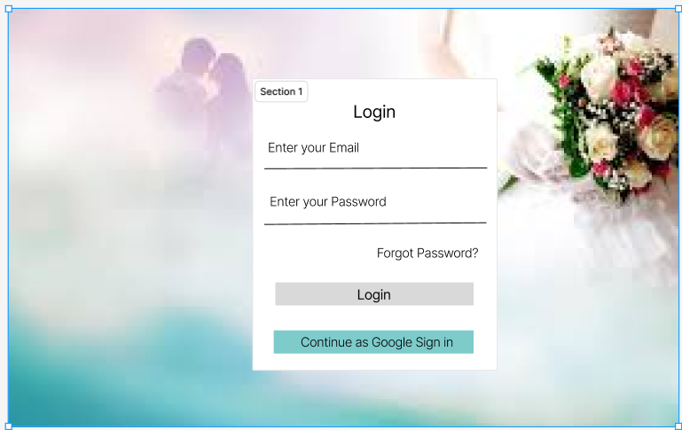

**Register Page**

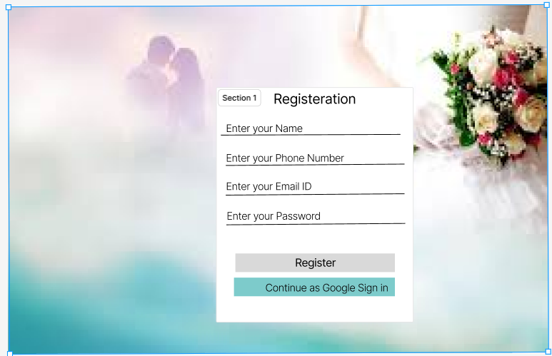

**Index Page**

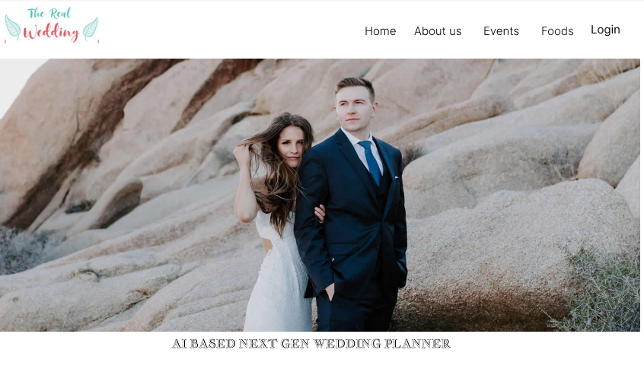

**Admin Page**

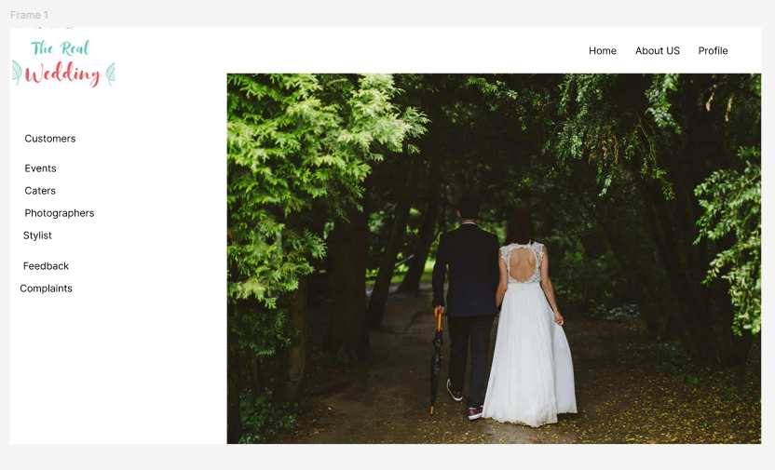

**Home Page**

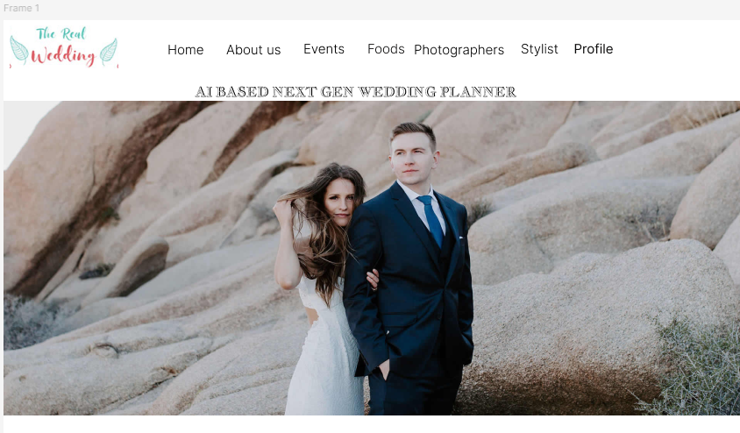

**UML DESIGN**

**Use Case Diagram**

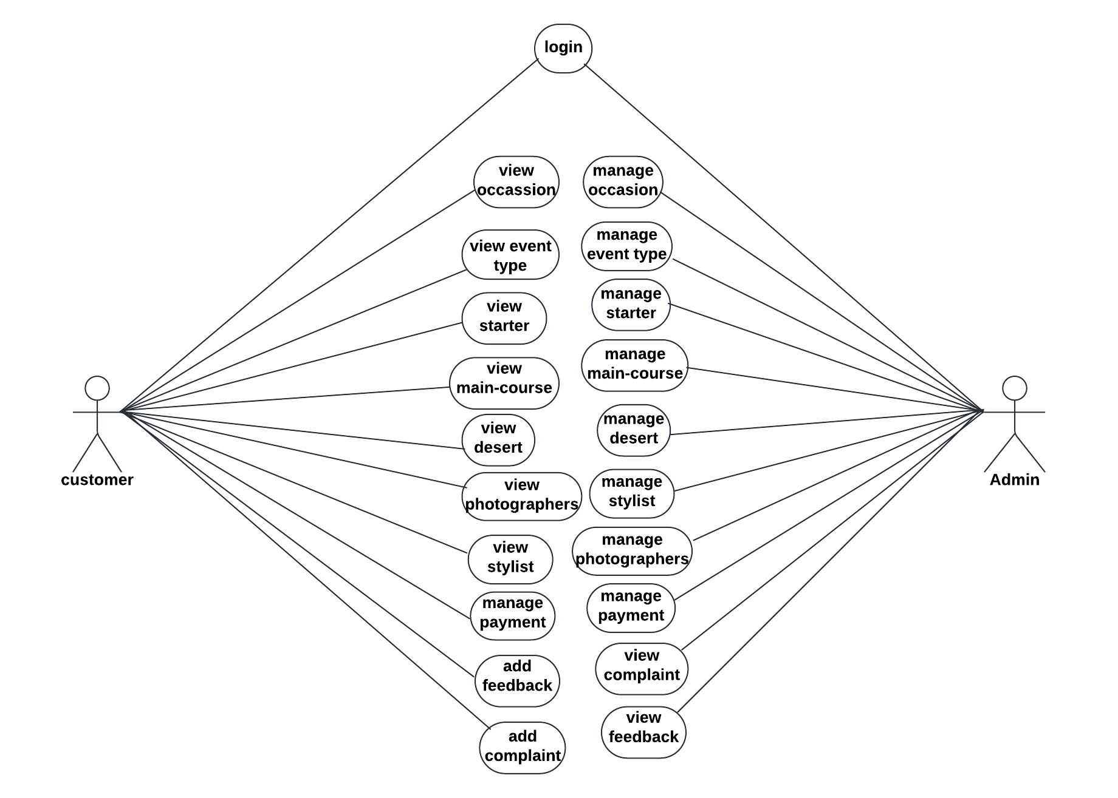

**Activity-Customer**

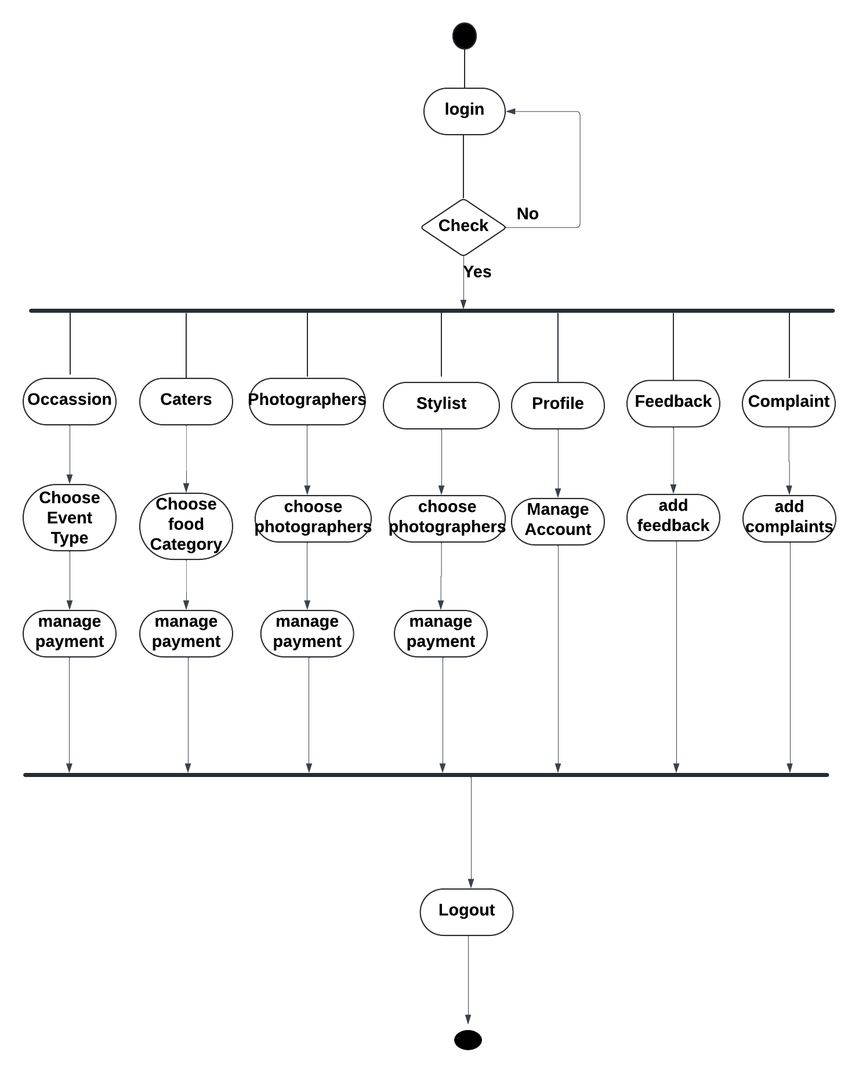

**Activity-Admin**

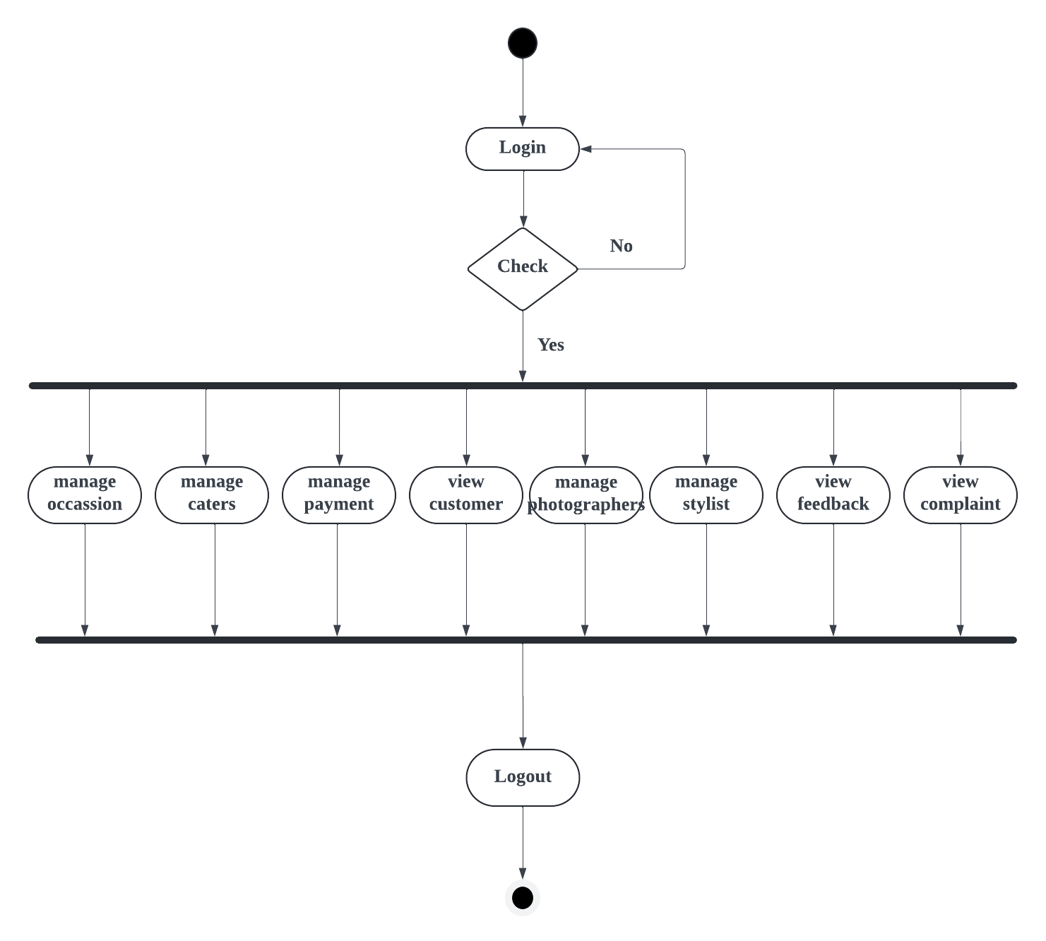

**Sequence Diagram**

