20MCA136 – NETWORKING & SYSTEM ADMINISTRATION LAB         Dept. of Computer Applications

**NETWORKING & SYSTEM ADMINISTRATION LAB**

**Name: Riya Jacey Kurian**

**Roll No: 29**

**Batch: B**

**Date: 07/06/2022**

**Experiment No: 26**

**Aim**

Install Linux, Apache, MySQL, PHP (LAMP) stack.

**Procedure**

A “LAMP” stack is a group of open-source software that is typically installed together to enable a server to host dynamic websites and web apps.

**Step 1:** Installing Apache and Updating the Firewall

The Apache web server is a popular open source web server that can be used along

with PHP to host dynamic websites.

First, make sure your apt cache is updated with:

* **Sudo apt update**

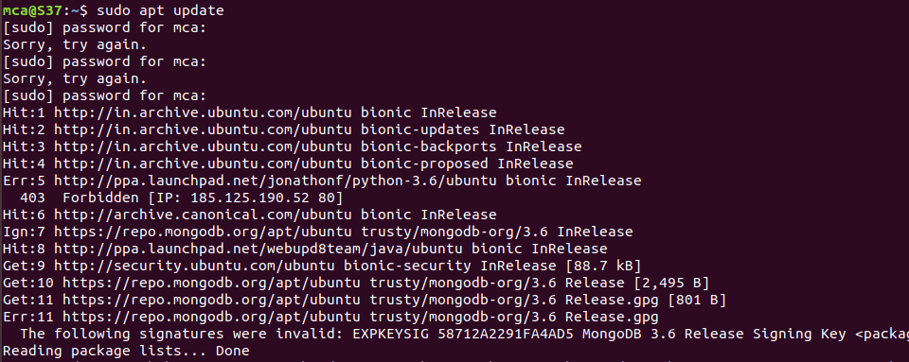

Once the cache has been updated, you can install Apache with:

* **Sudo apt install apache2**

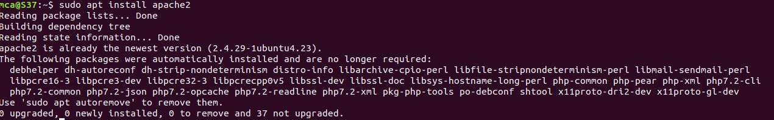

After entering this command, apt will tell you which packages it plans to install and how much extra disk space they’ll take up. Press Y and hit ENTER to confirm, and the installation will proceed.

**Adjust the Firewall to Allow Web Traffic**

Next, assuming that you have followed the initial server setup instructions and enabled the UFW firewall, make sure that your firewall allows HTTP and HTTPS traffic. You can check that UFW has an application profile for Apache like so:

* **Sudo ufw app list**

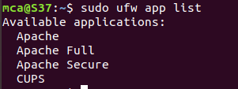

To allow incoming HTTP and HTTPS traffic for this server, run

* **Sudo ufw app info “Apache Full”**

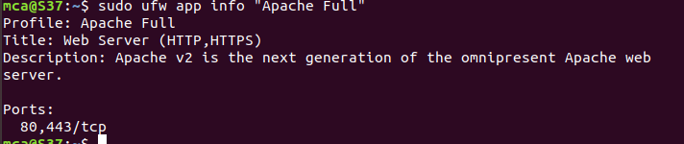

* **Sudo ufw allow “Apache Full”**



Visit our servers public IP address in web browser(http://server_ip) and will see thw default Ubuntu apache web page.

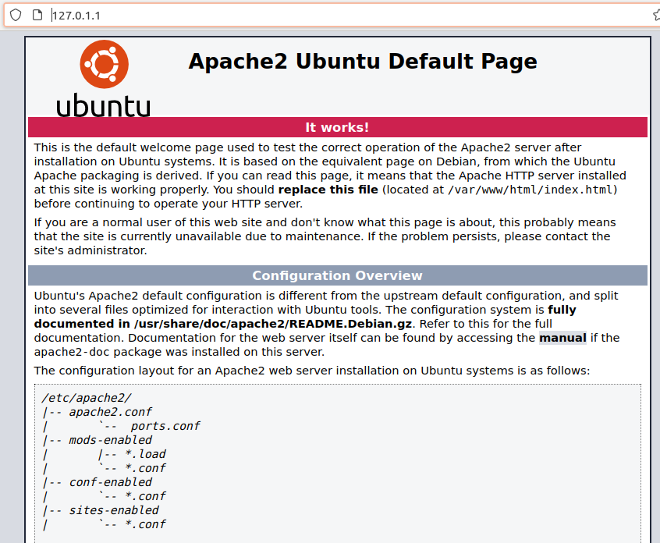

The Apache2 default index page will be displayed in case the webserver is up and running.

**Installing MySQL**

**Step 2:** use apt to acquire and install this software:

* **sudo apt install mysql-server**

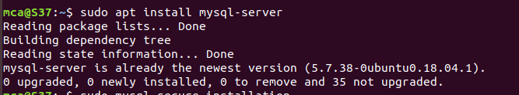

This command, too, will show you a list of the packages that will be installed, along with the amount of disk space they’ll take up. Enter Y to continue. When the installation is complete, run a simple security script that comes pre-installed with MySQL which will remove some dangerous defaults and lock down access to your database system. Start the interactive script by running:

* **sudo mysql_secure_installation**

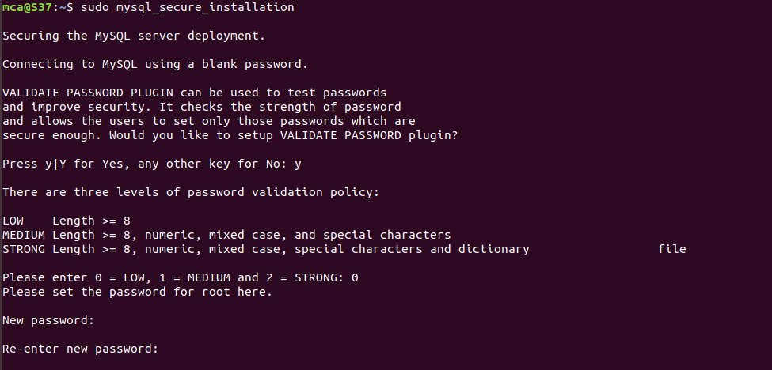

This will ask if you want to configure the VALIDATE PASSWORD PLUGIN.

Answer Y for yes, or anything else to continue without enabling.

When you’re finished, test if you’re able to log in to the MySQL console by typing:

* **sudo mysql**

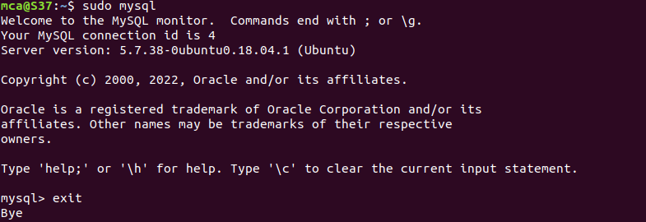

This will connect to the MySQL server as the administrative database user **root**, which is inferred by the use of sudo when running this command.

To exit the MySQL console, type:

* **exit**