**NETWORKING & SYSTEM ADMINISTRATION LAB**

**Name: Riya Jacey Kurian**

**Roll No: 29**

**Batch: B**

**Date:26-04-2022**

**Experiment No.: 8**

**Aim**

Familiarization of Linux Commands

**Procedure**

**1.** **sudo useradd**

This command is used to add a user.

Syntax :- $ sudo useradd username

**Output :-**



**2. passwd**

This command is used to create password for the user.

Syntax :- $ sudo passwd username

Output :-



**3.groupadd**

This command is used to create new group.

Syntax :- $ sudo groupadd -g id groupname

Output :-



**4.usermod**

This command is used to add users to the group.

Syntax :- $ sudo usermod -G groupname usernme

**id username**

This command which shows the particular belongs to which group.

Syntax :- $ id username

Output :-



**5.compgen**

This command is used to view all groups.

Syntax :- $ compgen -g

$ compgen -g groupname

Output:-

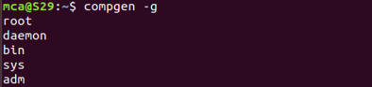



**6. userdel,groupdel**

This command is used to delete a user and group

Syntax :- $ sudo userdel groupname

$ sudo groupdel groupname

Output:-



**7. chmod**

This command is used to change directory permission of files (read,write,execute).

Syntax :- $ chmod +rwx filename

$ chmod -wx filename

$ chmod -rwx filename

Output:-

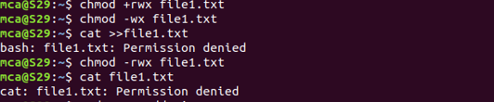

**8. chown, ls -l**

This command is used to give ownership to userand ls -l command is used to show the ownership details.

Syntax :-$ sudo chown username filename

$ ls -l filename

Output:-

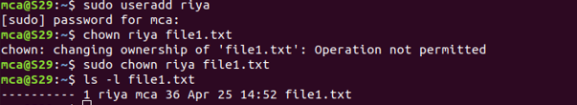

**9. ssh**

The ssh command provides a secure encrypted connection between two hosts over an insecure network.

Syntax:- $ sudo ssh mca@ipaddress

