**Name : Riya Katherin**

**Roll No : 19042**

**Student Id : 20222317020**

**Class: T.Y. B.Sc. I.T.**

**Div: A**

**Subject : Software Project Management**

**Project:**

**REAL TIME WQATER QUALITY MONITORING SYSTEM USING IOT**

**College :**

**S.I.W.S. N.R Swamy College of Commerce & Economics**

**And Smt. Thirumalai College of Science**

**Wadala , Mumbai -400031**

* ER Diagram : An Entity-Relationship diagram describes interrelated things of interest in a specific domain of knowledge. A basic ER diagram is composed of entity types and specifies relationships that can exist between entities.

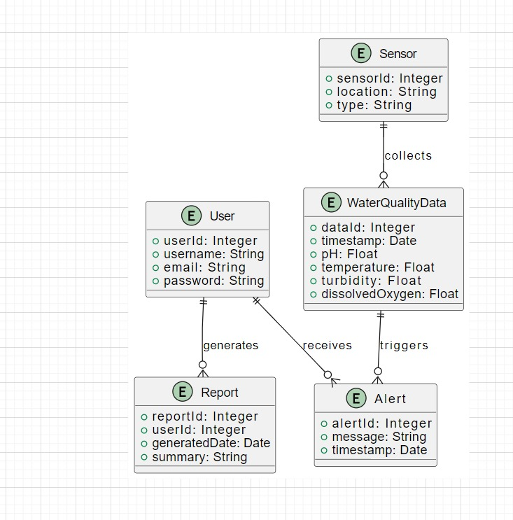

* Class Diagram : Class diagram in the Unified Modeling Language (UML) is a type of static structure diagram that describes the structure of a system by showing the system’s classes, their attributes, operations and the relationships among objects.

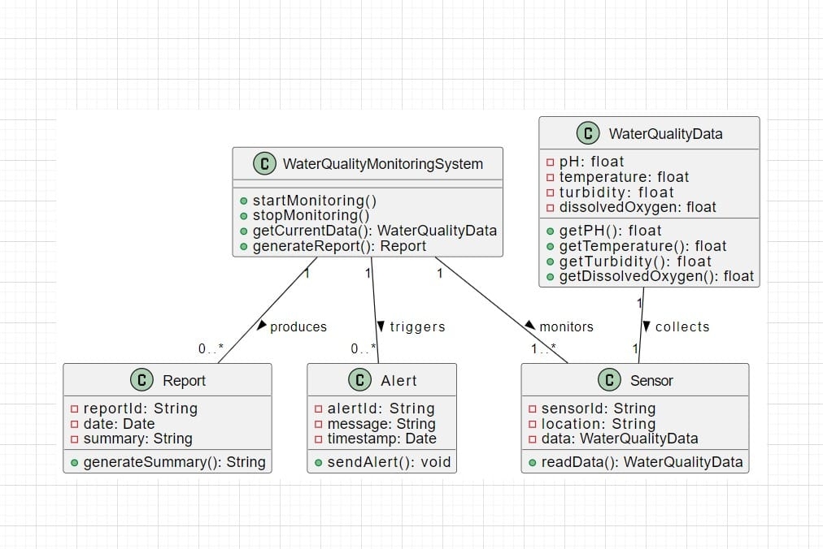

* Sequence Diagram : A Sequence Diagram simply depicts interaction between objects in a sequential describes how and in what order a group of objects works together.

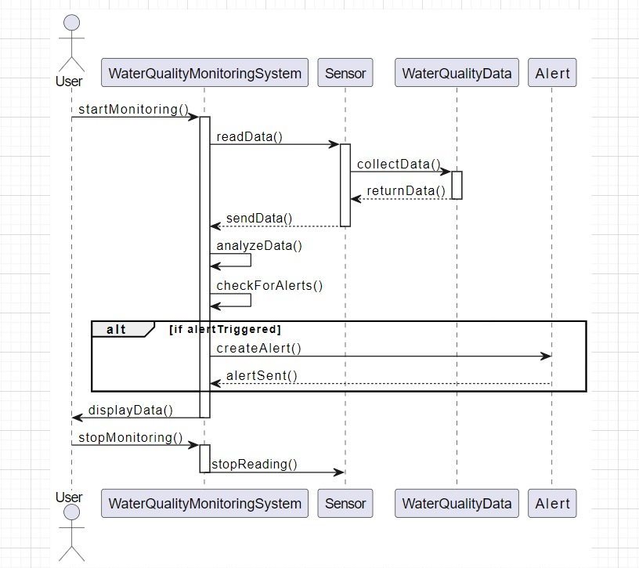

* State Transition Diagram : State Transition Diagrams describe all of the states that an object can have, the events under which an object changes state, the conditions that must be fulfilled before the transition occur and the activities undertakes during the life of an object.
* 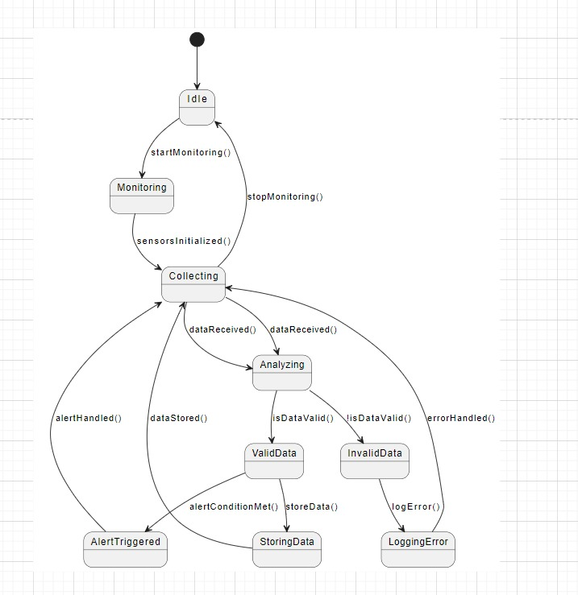

Activity Diagram : Activity Diagram are graphical representation of workflows of stepwise activities and actions with support for choice, iteration and concurrency.

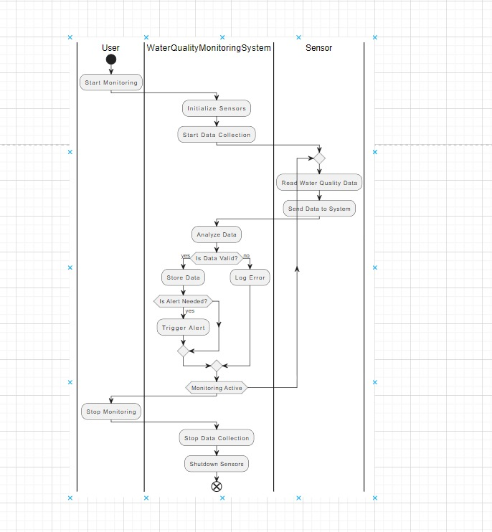

Component Diagram: A component diagram in the AI Health Engine illustrates the system's key parts, like the AI Engine, diagnosis module, treatment plan generator, and scheduler, all connected to a central database. It shows how these components interact with user interfaces for patients, doctors, and admins to deliver healthcare services efficiently.

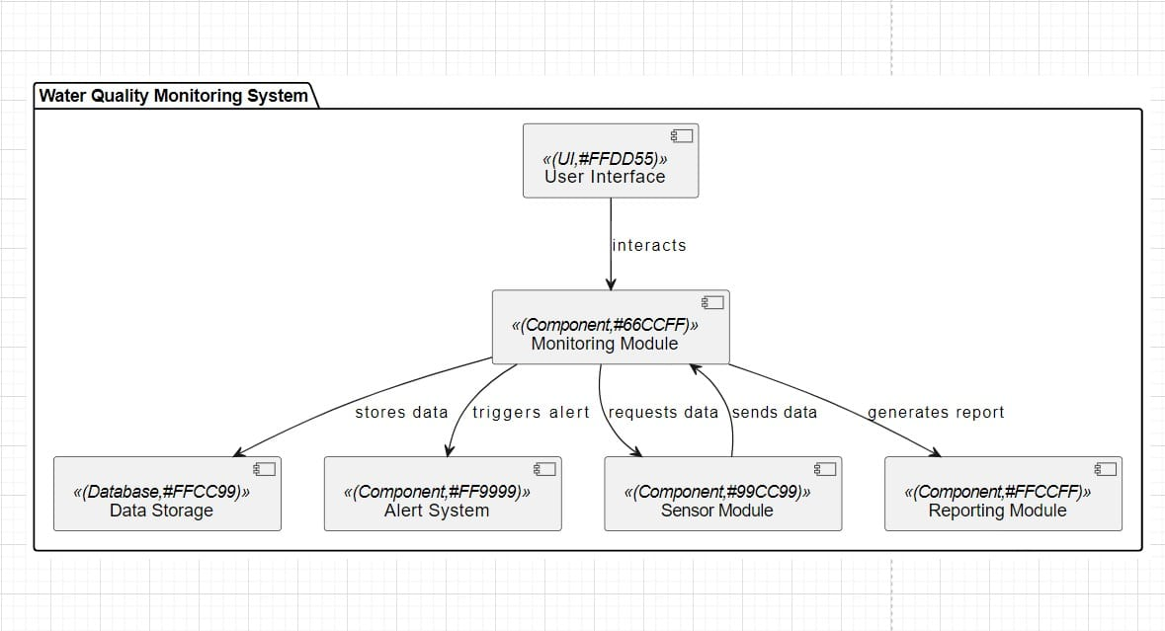

**Deployment Diagram:** **A deployment diagram in the AI Health Engine shows the physical setup of the system, detailing how software components like the AI Engine, diagnosis module, and database are deployed across different servers or cloud infrastructure. It highlights the system's architecture, ensuring scalability, reliability, and seamless user access for patients, doctors, and admins.**

