**Build a Watson powered Chat Bot using Mobile Services, Watson Conversation, Text to Speech**

Step 1: Go to URL <https://console.ng.bluemix.net/developer/getting-started/> and click on **CREATE PROJECT**

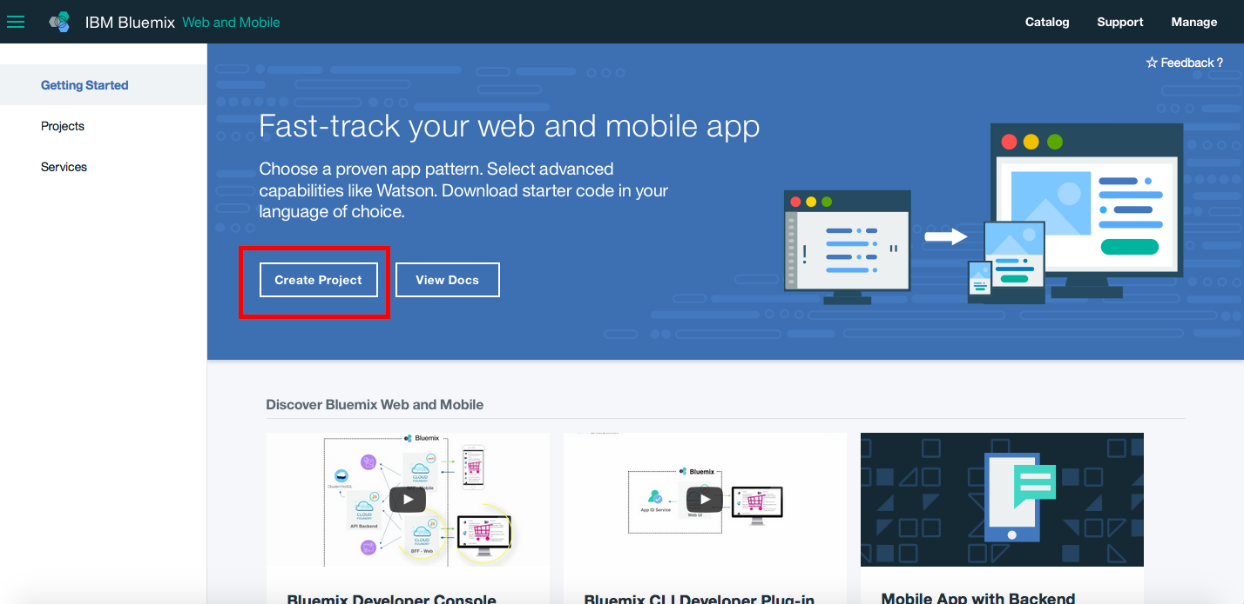

Step 2: Click on **MOBILE APP** and Click on **NEXT**

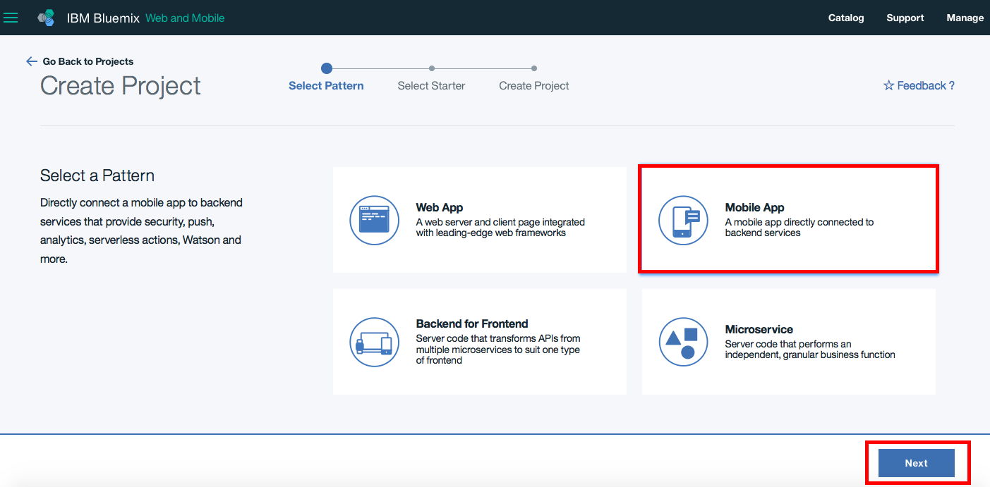

Step 3: Filter by **ANDROID** and then click on **Watson Conversation** and Click on **NEXT**

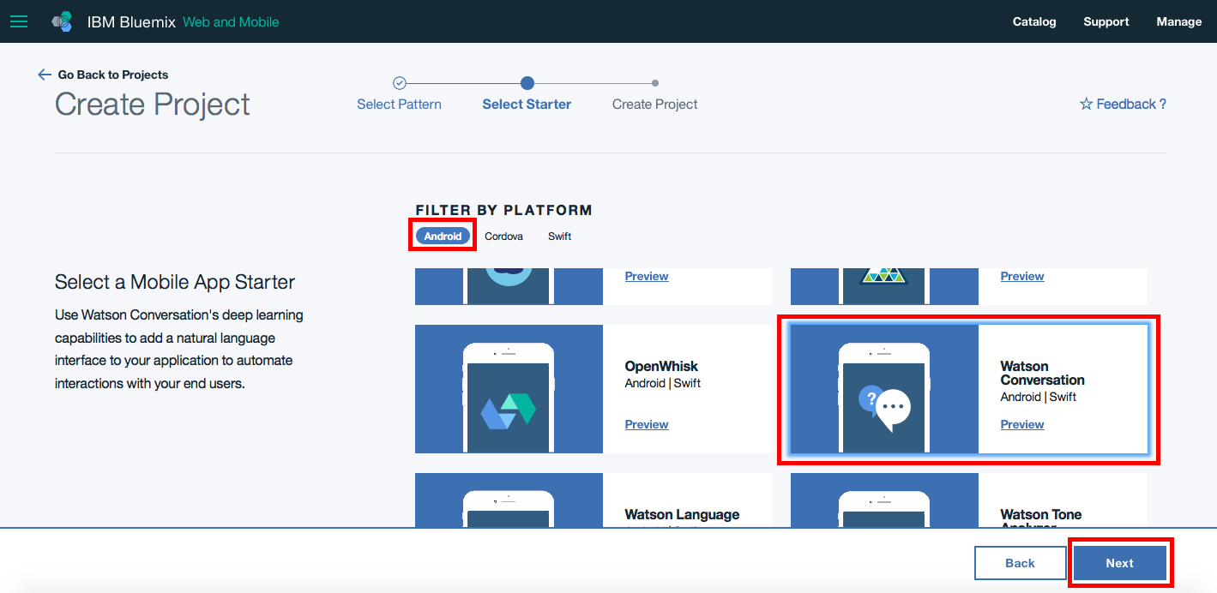

Step 4: Enter **Project Name** and Select platform as **Android** and click on **CREATE**

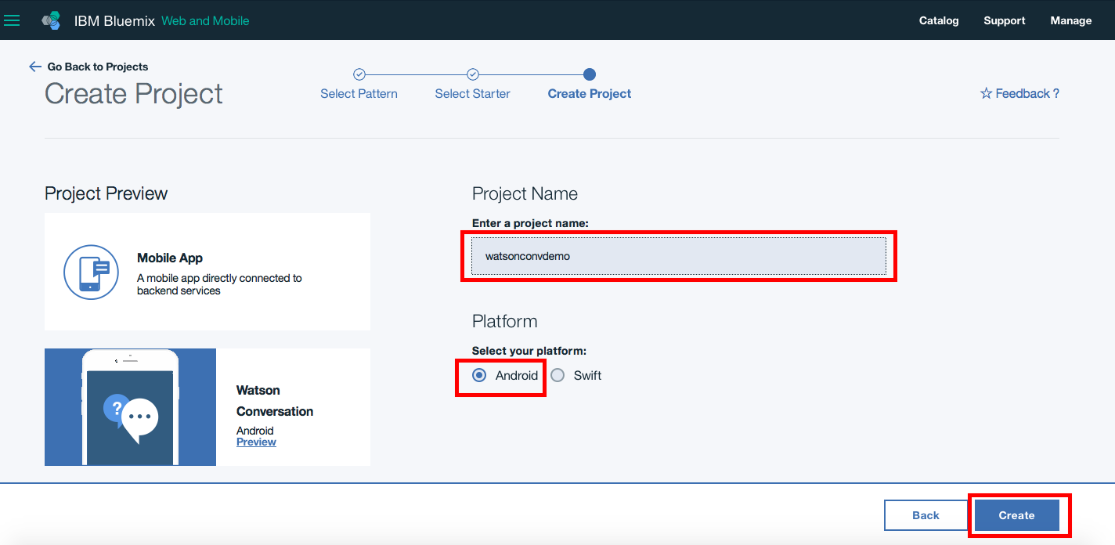

Step 5: Click on **Get the Code**

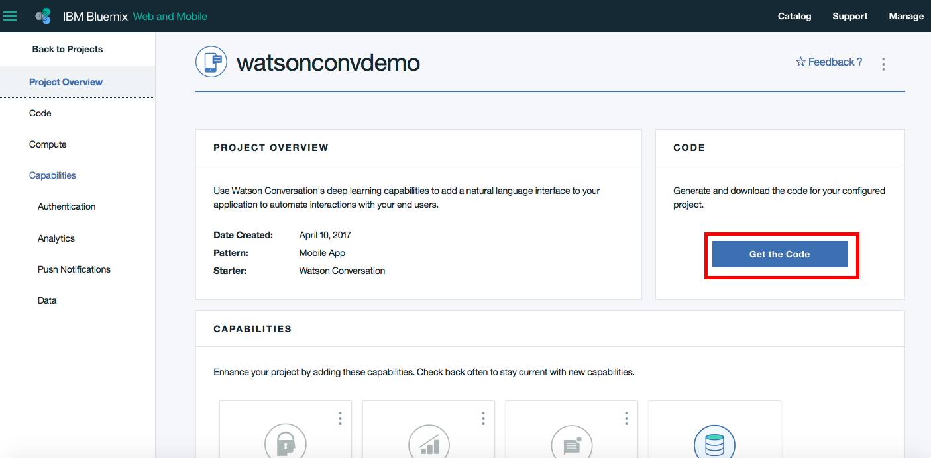

Step 6: Click on **Generate Code**

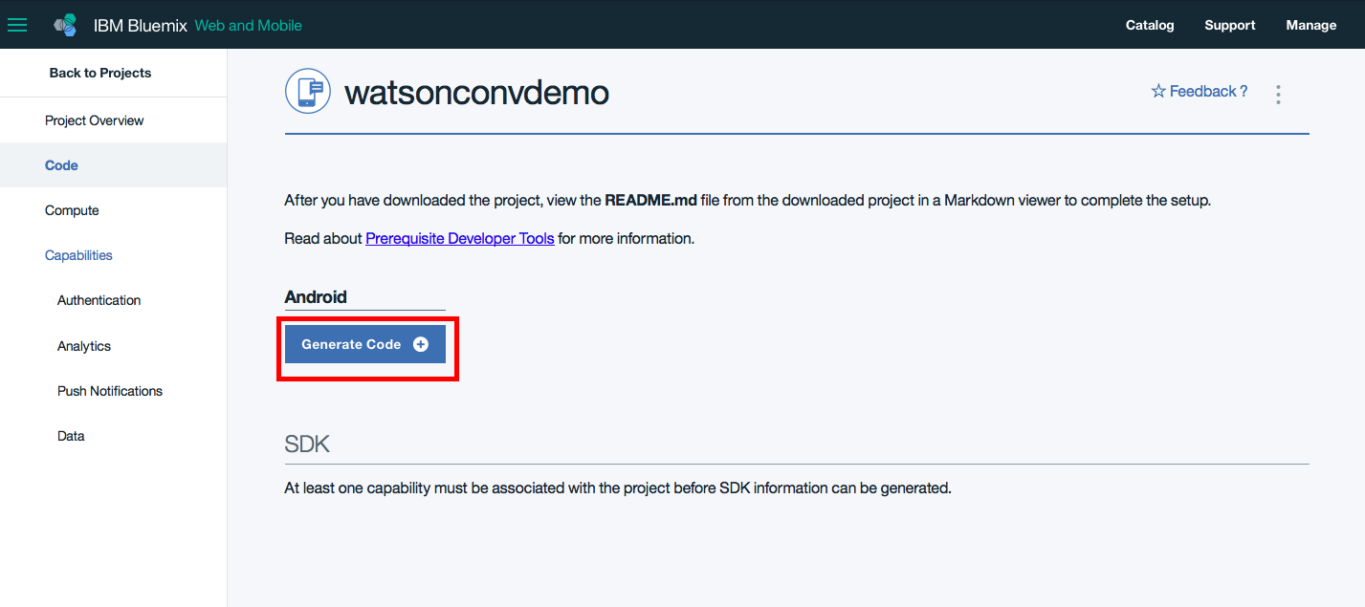

Step 7: **Download the generated code.**

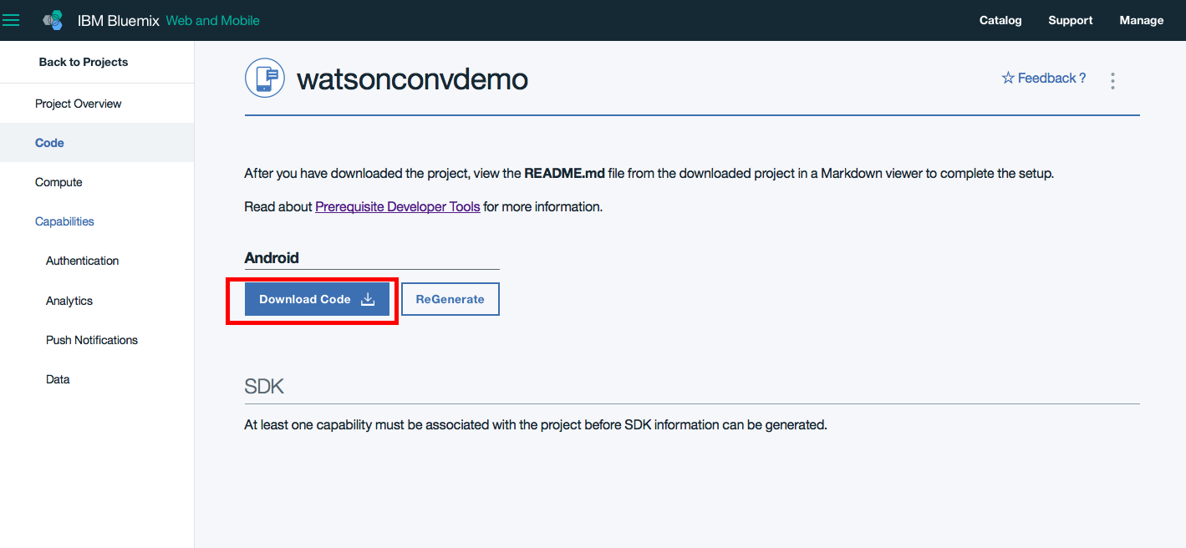

Step 8: Unzip the generated code and then Import it into Android Studio

Step 9: In the build.gradle(app), insert dependency

compile **'com.ibm.watson.developer_cloud:android-sdk:0.2.3'**

Step 10: In res>values>watson_credentials.xml enter the Watson Conversation password, Username, Workspace ID and insert last two lines to insert Text to Speech Username & Password

<**resources**>  
<**string name="watson_conversation_password"**>B1DGAjZyJycL</**string**>  
<**string name="watson_conversation_username"**>a054c82a-3415-4bb6-aab2-6ff567ae8a99</**string**>  
<**string name="watson_conversation_workspace_id"**>37da996b-c40d-4096-943f-b45292cf91a1</**string**>  
<**string name="watson_tts_username"**>28c90e0b-a0a6-4e23-b100-fa2906725b69</**string**>  
<**string name="watson_tts_password"**>6EMhkhkkbLpx</**string**>  
</**resources**>

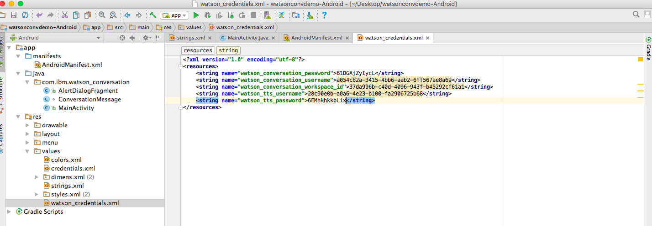

You will get the credentials when you create Watson Conversation Service & Text to Speech Service in Bluemix

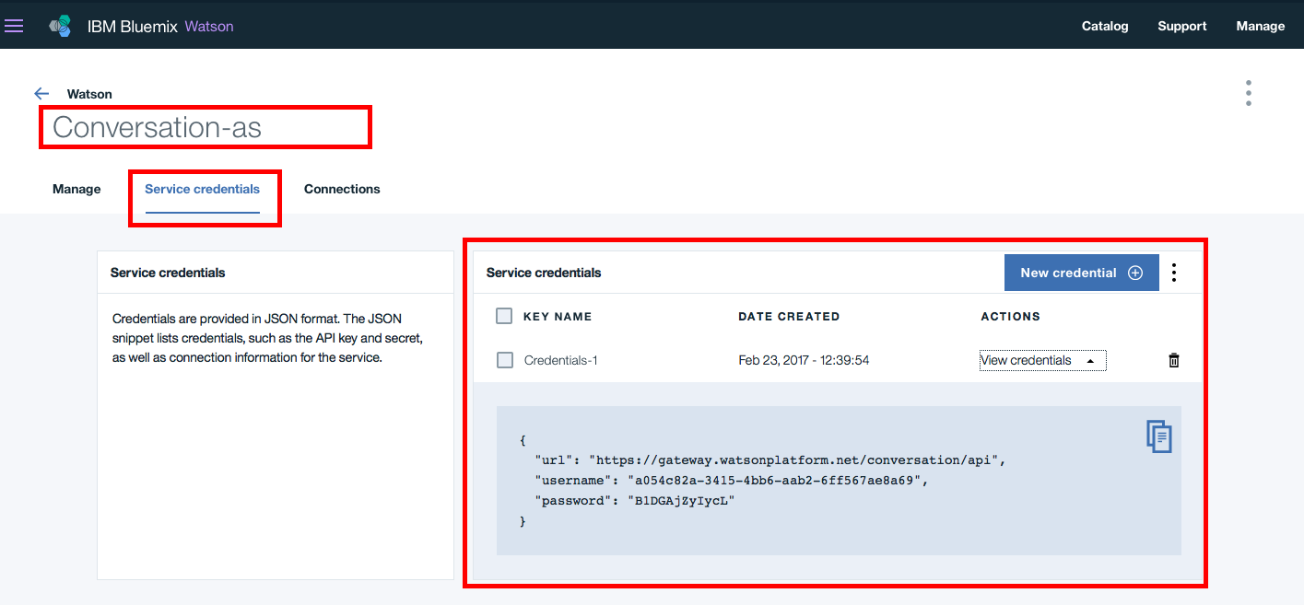

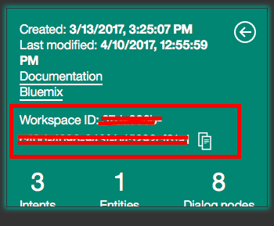

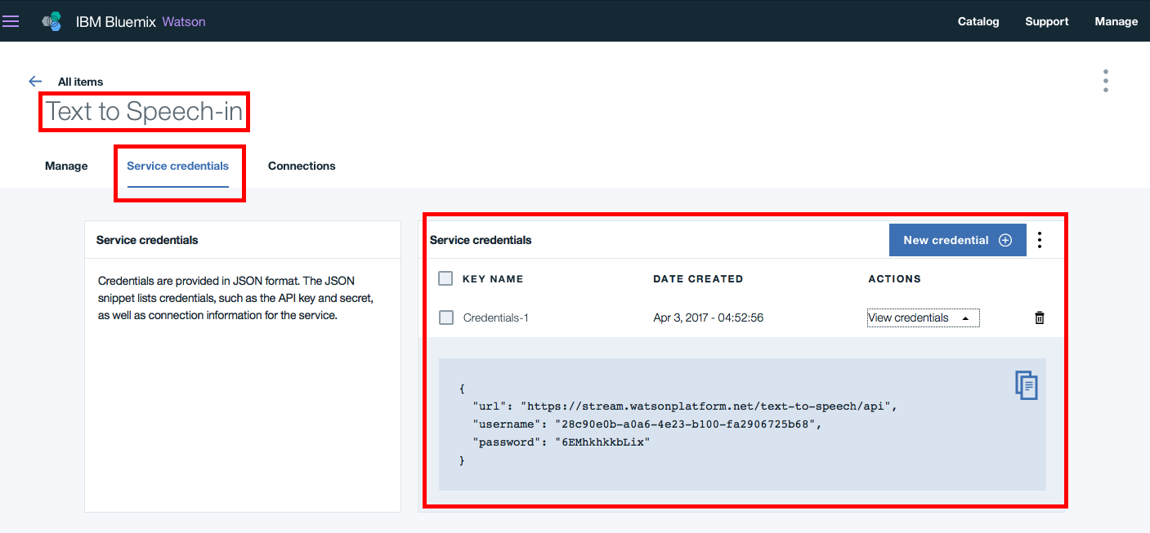

Step 11:

**private** TextToSpeech initTextToSpeechService()

{

TextToSpeech service = **new** TextToSpeech();  
 service.setUsernameAndPassword(getString(R.string.***watson_tts_username***),getString(R.string.***watson_tts_password***));

**return** service;

}

Step 12: Import

**import** com.ibm.watson.developer_cloud.text_to_speech.v1.TextToSpeech;  
**import** com.ibm.watson.developer_cloud.text_to_speech.v1.model.Voice;

**import** com.ibm.watson.developer_cloud.android.library.audio.StreamPlayer;

Step 13: Create the method WatsonTask.

StreamPlayer **streamPlayer**;

**private class** WatsonTask **extends** AsyncTask<String, Void, String> {  
 @Override  
 **protected** String doInBackground(String...texttoSpeech) {  
  
  
 TextToSpeech textToSpeech = initTextToSpeechService();  
 **streamPlayer** = **new** StreamPlayer();  
 **streamPlayer**.playStream(textToSpeech.synthesize(texttoSpeech[0], Voice.***EN_ALLISON***).execute());  
 **return "textToSpeech"**;  
 }  
  
 @Override  
 **protected void** onPostExecute(String result) {  
  
  
 }  
  
}

Step 14:

Call the method inside

addMessageFromUser(ConversationMessage message) {

if (message.getUser().equals(USER_Watson)){

………………………………………………………..

………………………………………………………..

………………………………………………………..

**new** WatsonTask().execute(message.getMessageText());

}