**WATSON POWERED TONE ANALYZER SLACK BOT**

This blog will help you build a Watson powered tone analyzer Slackbot that can understand the tone of conversation and respond to you likewise!

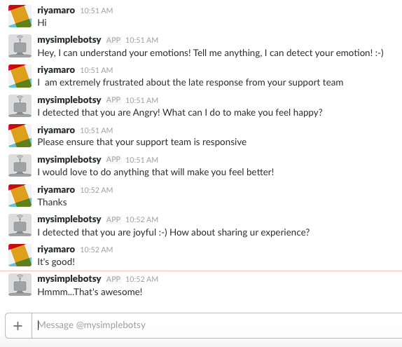

Let us understand the technology that is powering this bot.

[Watson Conversation](https://www.ibm.com/watson/developercloud/doc/conversation/index.html) service helps you build and deploy chatbot that can understand natural language input and uses machine learning to respond.

[Tone Analyzer](https://www.ibm.com/watson/developercloud/tone-analyzer.html) service detects tones(emotional, social, and language) in written text. It can analyze tone at both document and sentence levels.

Steps to create tone analyzer slackbot:

1. CREATE SLACK TEAM
2. CREATE CUSTOM SLACKBOT
3. CREATE BLUEMIX ACCOUNT & CREATE APP
4. CONFIGURE WATSON CONVERSATION SERVICE
5. CONFIGURE NODE-RED

**Create Slack Team:**

You can follow steps to create a Slack team [here](https://get.slack.help/hc/en-us/articles/206845317-Create-a-Slack-team)

You can ignore this step if you have an existing Slack team with admin permission to create Slackbot.

**Create Custom Slackbot:**

You can refer [this](https://api.slack.com/bot-users) to create custom bot users

Or click on this link <https://my.slack.com/services/new/bot> to create a bot.

Start by choosing a username for your bot and click on **Add bot Integration.** Take a note of **API Token** which is required in later steps!

**Create Bluemix Account and Create App:**

Sign Up for IBM Bluemix 30 day free trial to create the app <https://console.ng.bluemix.net>

Ignore the previous step if you have a Bluemix account. Sign in to Bluemix and goto Catalog and Select NODE RED STARTER in BOILERPLATE SECTION

Enter unique App Name and Host Name and then click on CREATE.

In the next page, Click on Visit App URL. It will redirect you to a new page. Keep clicking on Next until you reach NODE-RED FLOW editor page. In between, you will have to enter Username and Password to make your Flow Editor more secure.

Go back to your Bluemix App, click on CONNECTIONS. Then click on CONNECT NEW. It will redirect you to Catalogs, over there search for **Conversation** Service and click on it. Enter service name or leave it default and click on CREATE. Repeat the same process to connect **Tone Analyzer** Service to your NODE RED app.

**Configure Watson Conversation Service:**

Go to Conversation service that you had created in Bluemix and then check out this video to configure Watson Conversation Service

<https://youtu.be/QRXZb7ill0U>

**Configure NODE RED App:**

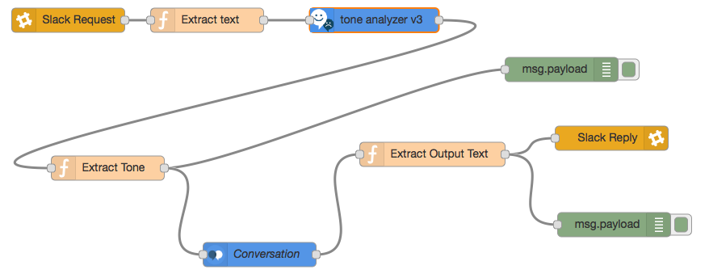

Import Node RED flow from [here](https://github.com/RiyaMRoy04/Slackbot_ToneAnalyzer_WCS/blob/master/NodeRED_Slackbot_Flow.txt) to your Node RED flow editor and then edit Slack API token in Slack Request and Slack Reply node and Conversation Workspace ID (can be found in Conversation Workspace Tool). If Slack Request and Reply node is not present. Go to right side ( three line) of your Node RED Flow Editor and then click on Manage Palette, search for Slackbot and install it.

Click on DEPLOY and then go to Slack team to chat with your custom slackbot! Happy Chatting!