**LANGUAGE TRANSLATOR SLACKBOT**

POWERED BY

**WATSON CONVERSATION** AND **LANGUAGE TRANSLATOR**

***DO IT YOURSELF!***

INDEX

1. SETTING UP APP ON BLUEMIX
2. CONFIGURING WATSON CONVERSATION
3. CONFIGURING SLACK
4. CONFIGURING NODERED

**SETTING UP APP ON BLUEMIX**

1. Select NODE-Red Starter from Boilerplates

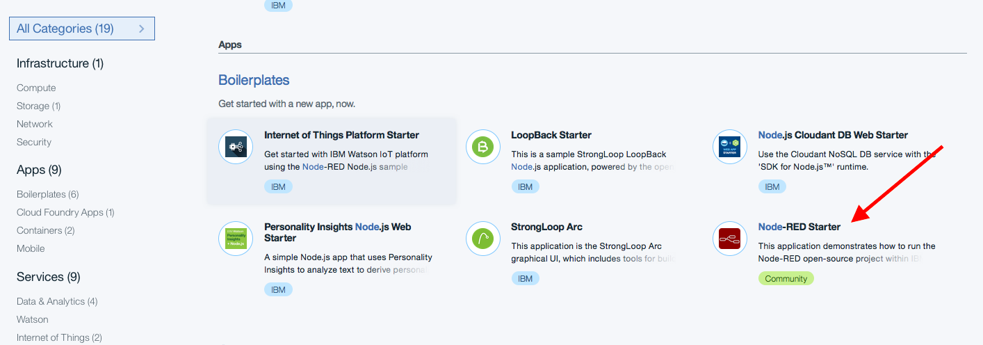

1. Enter App name and CREATE SERVICE

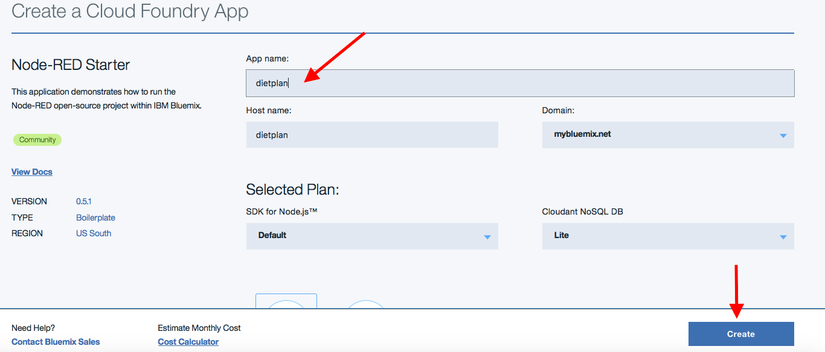

1. Bind Conversation & Language Translator service to the Node-RED App

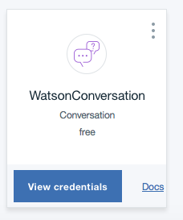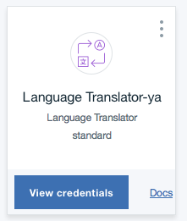

**CONFIGURE WATSON CONVERSATION**

1. Click on Watson Conversation service and **Launch Tool**

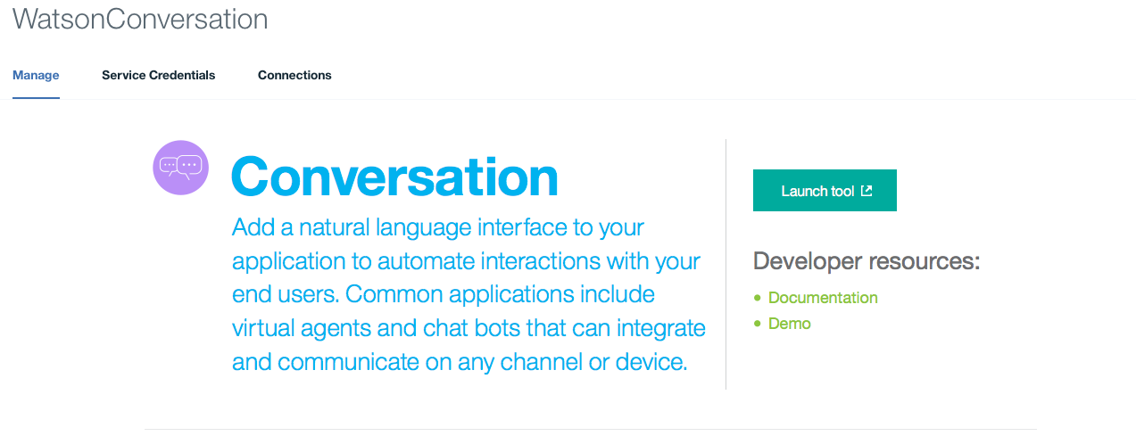

1. In workspaces, click on ../../../Desktop/Screen%20Shot%202017-02-20%20at%2011.35.16%2 to import workspace

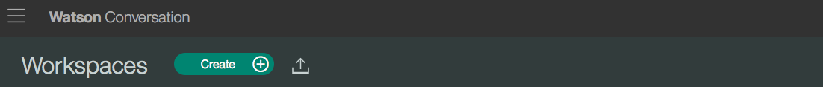

1. Choose file nutritions_conversation_workspace.json from <https://github.com/ECoDIndia/Watson_Healthcare_Conversation/tree/master/Nutritions_Slackbot_discovery> and Import **Everything** and Click **Import**

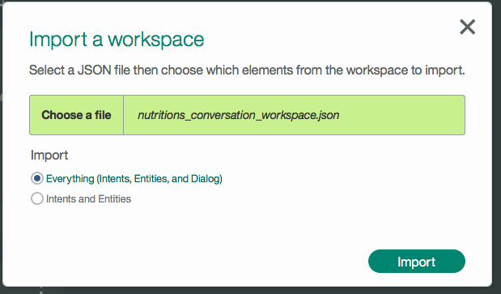

**CONFIGURE SLACK**

1. **CREATE NEW TEAM IN SLACK**

* Create a new team in slack <https://slack.com/create#email> by entering your Email ID.
* Enter 6-digit confirmation code that you have received in your Email ID.
* Create new username and password.
* Enter details about your team and company name.
* Choose the address you’ll use to sign into Slack (Address has to be unique) and Click on **CREATE TEAM.**
* Review and agree the Terms and Conditions.
* If required, send invitations to your friends or skip it for now.
* Your team is set up! You can enter into your team with the address you had set. For Example: nutritionistgroup.slack.com

1. **Configure Slash Command in Slack**
2. Goto your team, In the left side, click as shown below. In the drop down click on **Apps & Integrations**

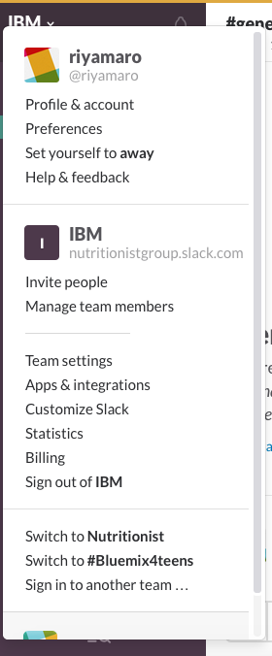

1. Click on Build in the right side



1. Click on Make a Custom Integration as shown in the image below

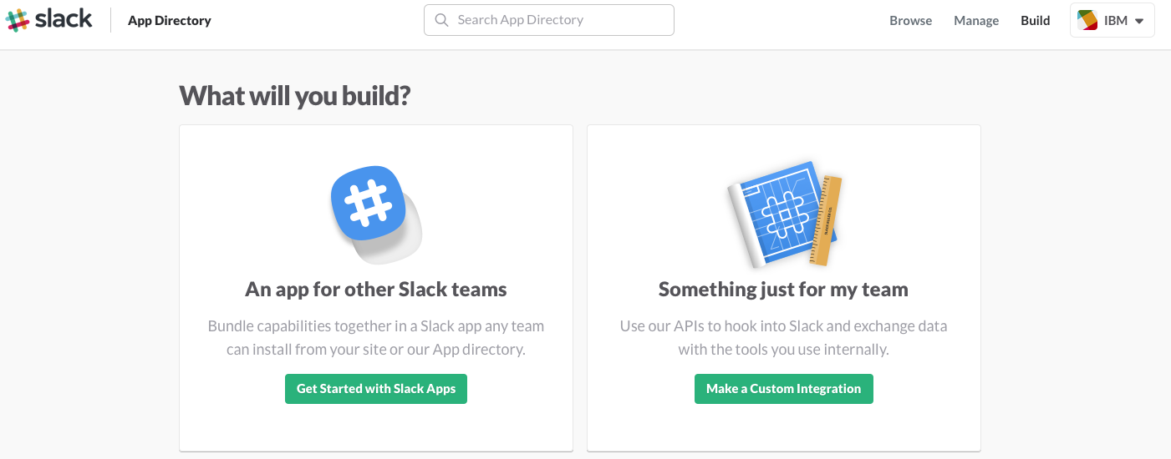

1. Click on Bots as shown below

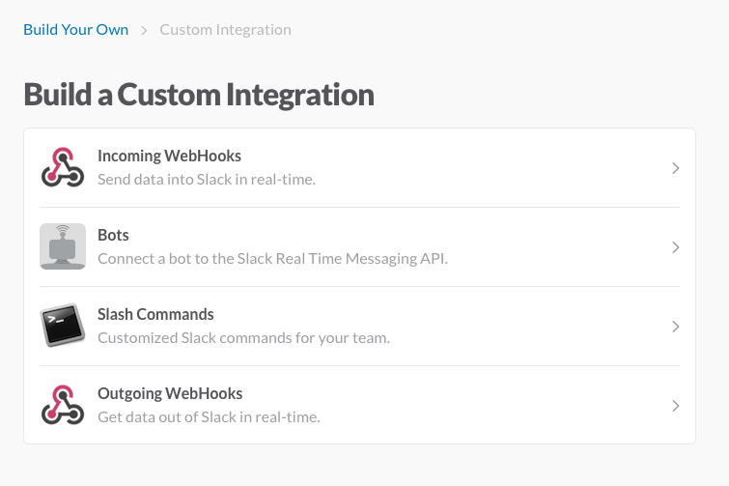

1. Choose a name (For Example:/nutritionist) and Add Slash Command Integration
2. URL is your node-red URL with HTTP IN URL appended (Note down your request URL(For example /slack), have to be added in the Node-Red HTTP In node). Method is **POST**.

**Note down TOKEN in notepad (required in later steps)**

1. Customize Name and Icon as shown in image below
2. Edit the description and **SAVE INTEGRATION** as shown in the image above

**CONFIGURE NODERED**

Import nodes from <https://github.com/ECoDIndia/Watson_Healthcare_Conversation/blob/master/Nutritions_Slackbot_discovery/conversation_nutritionist_nodered.txt> into NODE-RED flow editor

1. Enter the same request URL that you had entered while configuring slash command with Method POST.

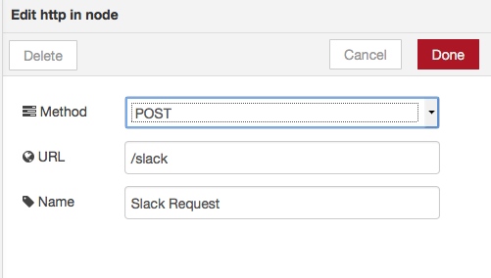

1. Enter your token from Slash Command configuration ( as noted in the earlier steps)

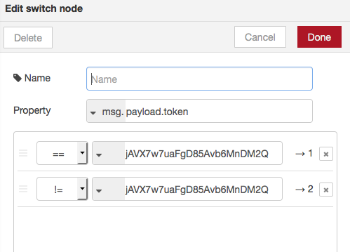

1. Enter your conversation **Workspace ID** ( Shown in the Conversation tool in Bluemix🡪Workspace🡪View Details)

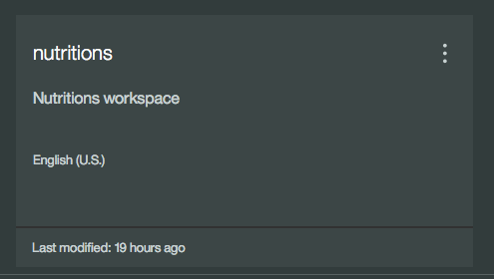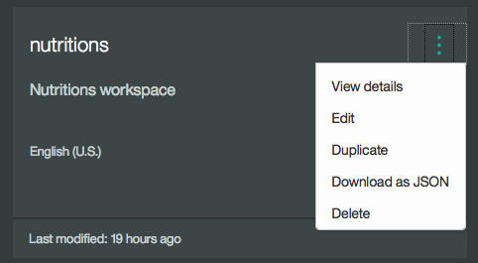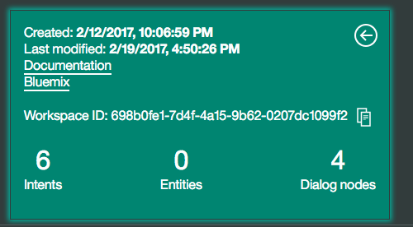

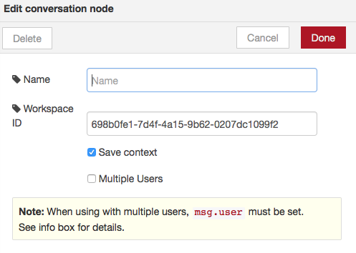

1. Enter your **Environment ID** & **Collection ID** in the **discovery node** (noted in the earlier steps).

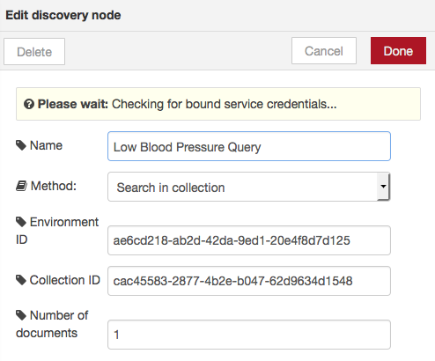

1. Click **DEPLOY** in NODE-RED and then go to Slack team. Open any Channels and then type /<slash-command> Text

../../../Desktop/Screen%20Shot%202017-02-20%20at%204.57.18%2

1. You can see the response now!

