**WORKSHOP**

**BUILD WATSON POWERED SLACKBOT USING WATSON CONVERSATION SERVICE AND TONE ANALYZER**

Build a Watson powered Slack bot that detects your emotion using Tone Analyzer and have conversation using Watson Conversation Service

1. CREATE SLACK TEAM
2. CONFIGURE SLACK BOT
3. CONFIGURE BLUEMIX
4. CONFIGURE NODERED

**CREATE SLACK TEAM:**

Go to <https://slack.com/get-started> and If you have a team, you can join existing team or you can create a new team.

**CONFIGURE SLACKBOT:**

After creating the team, configure the Slack Bot by clicking on <https://my.slack.com/services/new/bot> as shown below

* Enter a **USERNAME** and click on **Add bot integration**

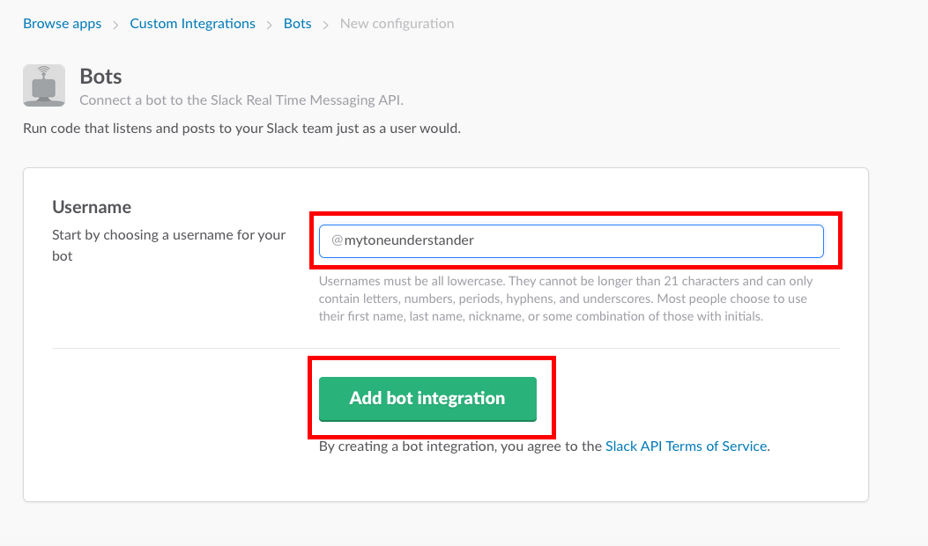

* Take a note of API Token. Required in later steps.

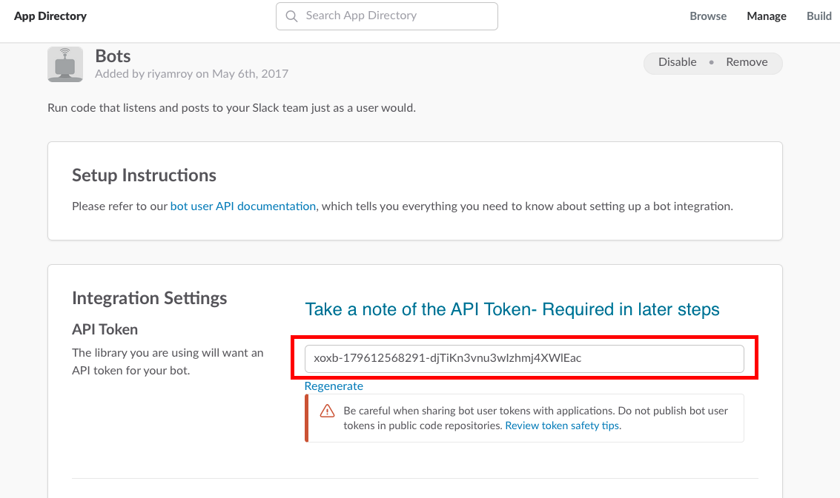

**CONFIGURE BLUEMIX & NODERED: INSTRUCTOR LED**

Go to <https://console.ng.bluemix.net> and then click on **CATALOG.** Create **NODE RED Boilerplate** and connect **Tone Analyzer service** **and WATSON CONVERSATION SERVICE** by clicking on **CONNECT NEW TAB** in **Connections**