# Pre-requisite

Requirements

Below are the required components and options to run the Microsoft Copilot Studio workshop.

*Note: if you’re creating a new tenant for the training, you may skip that part.*

|  |  |
| --- | --- |
| Category | Details |
| Licenses | Unless you already have adequate licenses for Copilot Studio and Power Automate, workshop student can be assigned the below trial licenses:   * Microsoft Copilot Studio Viral Trial * Microsoft Power Automate Free   The viral trial licenses start showing up for the Microsoft 365 admin when at least one user has started a viral trial, by logging into:   * <https://copilotstudio.microsoft.com/> * <https://make.powerautomate.com/> |
| Power Platform admin center tenant settings | In the Power Platform Admin Center tenant settings (<https://admin.powerplatform.microsoft.com/tenantsettings>), make sure **Publish Copilots with AI features** is enabled.   |
| Power Platform DLP Policies | Make sure the **connectors** you wish to use during the workshop are not blocked by a Data Loss Prevention policy in the Power Platform environment you wish to use for the training: <https://admin.powerplatform.microsoft.com/dlp>  Learn more: [Manage data policies](https://learn.microsoft.com/en-us/power-platform/admin/prevent-data-loss)  The below connectors are needed to perform the labs:   * Microsoft Dataverse * MSN Weather * ServiceNow * HTTP * Chat without Microsoft Entra ID authentication in Copilot Studio * Direct Line channels in Copilot Studio * Knowledge source with SharePoint and OneDrive in Copilot Studio * Knowledge source with public websites and data in Copilot Studio * Knowledge source with documents in Copilot Studio   A screenshot of a computer  AI-generated content may be incorrect.  For **custom connectors**, add the <https://restcountries.com> pattern.  A close-up of a computer screen  Description automatically generated |
| Environment configuration | Make sure you use an environment where a **Dataverse data store** is enabled, as this is required by Copilot Studio: <https://admin.powerplatform.microsoft.com/environments>  You should also make sure that the environment **Region** is supported by Copilot Studio: [Regional settings and data locations](https://learn.microsoft.com/en-us/microsoft-copilot-studio/data-location?tabs=web#data-locations)  It’s best to do the training on a **dedicated** environment.  If you’re using a test/trial tenant, this can be the **Default** environment. |
| Environment settings | In your [environment settings](https://admin.powerplatform.microsoft.com/environments) (Power Platform Admin Center > Environment > Settings), go to **Product** > **Features**, and make sure **Copilot (preview)** is enabled to be able on invoke AI Builder prompts: <https://admin.powerplatform.microsoft.com/environments>  More information: [Manage feature settings](https://learn.microsoft.com/en-us/power-platform/admin/settings-features#copilot-preview).  A screenshot of a review  AI-generated content may be incorrect. |

Section 1: Sign in to create an agent

Your first task is to sign in so that you can create your agent.

1. Go to <https://copilotstudio.microsoft.com/> and type in your email that you'll use to build the agent. Sign in with your work, school, or developer account if you aren't working with an instructor.

**Note:** Your account might already have been set up. If screens like the following images don't show, you can skip to step 7.

1. Select **Next**.

[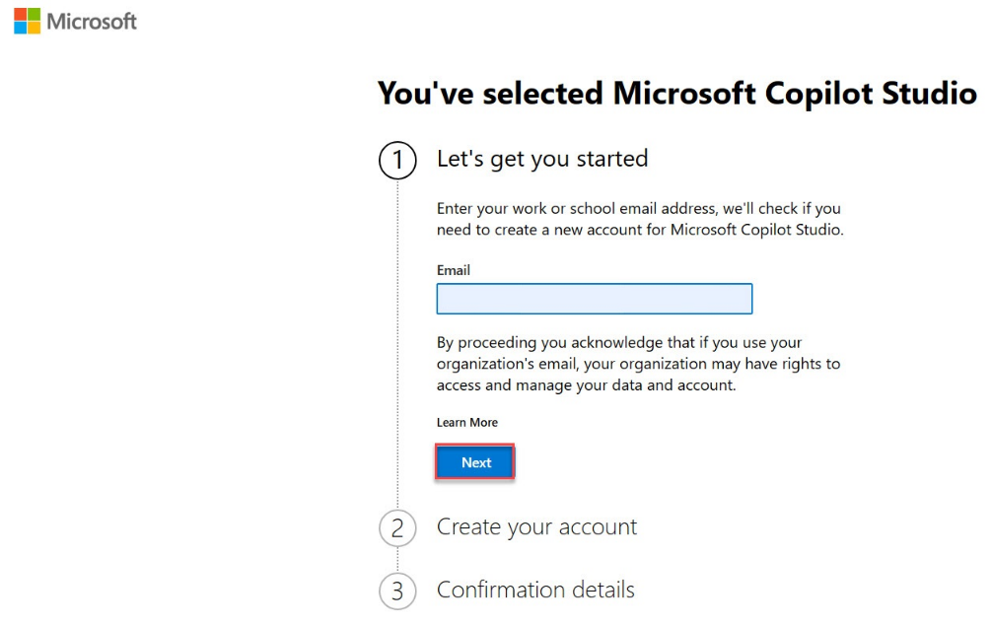](https://learn.microsoft.com/en-us/training/modules/plan-first-chatbot-online-workshop/media/continue.png#lightbox)

1. Select **Get started**.

[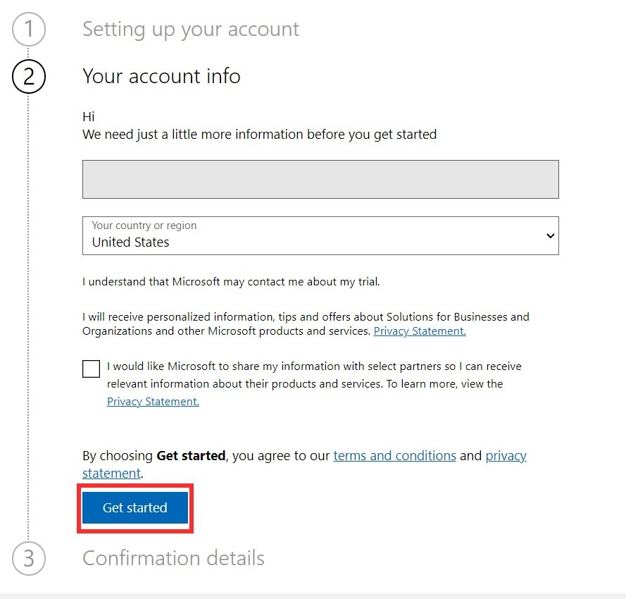](https://learn.microsoft.com/en-us/training/modules/plan-first-chatbot-online-workshop/media/get-started.png#lightbox)

1. Select **Get started** under **Confirmation details**.

[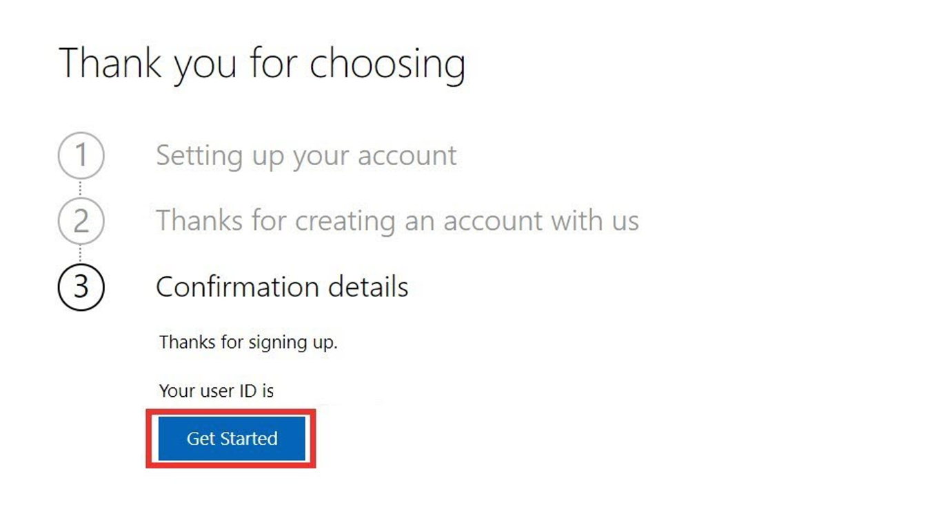](https://learn.microsoft.com/en-us/training/modules/plan-first-chatbot-online-workshop/media/confirmation.png#lightbox)

1. Select your country/region and then select **Start free trial**.

[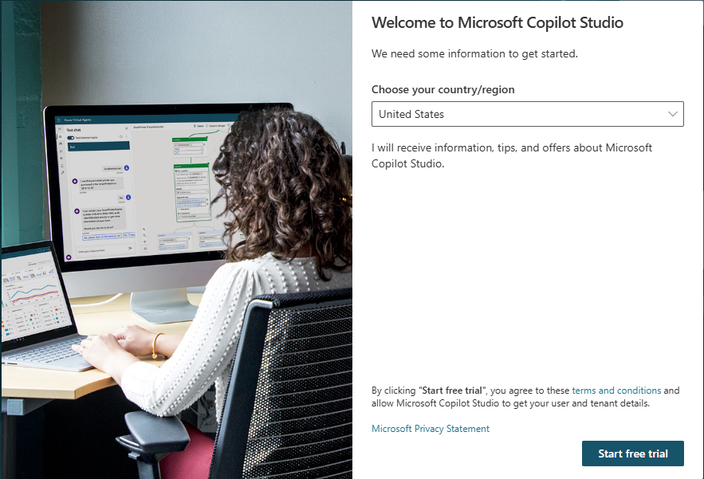](https://learn.microsoft.com/en-us/training/modules/plan-first-chatbot-online-workshop/media/start-free.png#lightbox)

**Important:** Skip to here if your account was already set up.

1. You should be redirected to copilotstudio.microsoft.com. If not, go to the maker environment URL for Microsoft Copilot Studio: copilotstudio.microsoft.com. An **Environment selector** box is located in the upper-right corner. An environment is where your organization stores, manages, and shares the agent, business data, apps, and Microsoft Power Automate flows. You can select the **Environment selector** button to display the agents within that environment.
2. If you're working with an instructor, confirm now with your instructor the environment to use, if you didn't already do so.

Section 2: Setup a ServiceNow instance

*Get a ServiceNow developer account*

1. **Navigate** to <https://developer.servicenow.com>
2. Choose **Sign up and Start Building**
3. **Fill** out the form and select **Sign Up**
4. **Validate** your email address by **opening** the link sent to you.

*Log into the ServiceNow developer portal*

1. Once logged in to <https://developer.servicenow.com/dev.do#!/home>

Click on your **user** icon on the top right corner, and choose **Change User Role**.

1. Select **Admin** and **Change User Role**

*Create a developer instance*

1. From <https://developer.servicenow.com/dev.do#!/home>
2. Select **Start Building**.*

*Note #1: it may take a few minutes to fully provision the environment.*

You’ll be redirected to a page that looks like this <https://dev261120.service-now.com/now/nav/ui/classic/params/target/ui_page.do%3Fsys_id%3D43fe7b6b83070210888759d0deaad3ed>

*Note #2: if the latest version (e.g. Washington) isn’t available, you can set one up in a previous version (e.g. Vancouver) and update it to the latest version.*

Important notes before running the workshop

Make sure the ServiceNow instance isn’t hibernating

ServiceNow developer environment stay up only for a short period of time and automatically hibernate.

Make sure the instance is up and running before students start lab 3.

1. **Log** into <https://developer.servicenow.com/>
2. Check that the instance is **available**, or **wake it up**.