**Sensors used in Autonomous Vehicles**

Autonomous vehicles (AVs) rely on various types of sensor technologies to perceive the environment and to make logical decisions based on the gathered information similar to humans. These sensors measure wave sources and detect various physical phenomena. They have distinct properties that enable them to perform different tasks under specified conditio

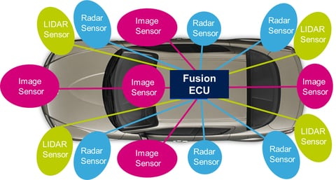

Fig1: Use of Different sensors in the motor drive

Types of Sensors, advantages and disadvantages

|  |  |  |  |  |
| --- | --- | --- | --- | --- |
| Sl.No | Type of Sensors | Technology | Advantages | Disadvantages |
| 1 | **Camera** | Visible (VIS) | low cost, high resolution | The reliability of cameras is limited in difficult environmental conditions, li snow, ice, or fog and in darkness.Not provide distance information |
| Infrared (IR) | less susceptible to weather or lighting conditions |
| 2 | **RADAR** | Radio Detection and Ranging technology | Radar sensors are robust, inexpensive, and provide reliable data even in adverse weather conditions | low resolution of radar data, only detect object and does not classify |
| 3 | **LIDAR** | Light Detection and Ranging, which is a technology deployed on space platforms and airborne platforms. | reliable data, independent of environmental factors, Long range, robust | manual setup is complex and cost-intensive |
| 4 | **UltraSonic** | rely on sonic transducers to transmit sonic waves |  |  |

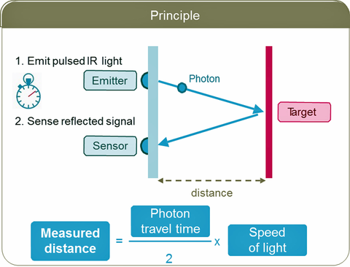

Fig2: Principal of Lidar distance measurement