INDIVIDUAL LAB-WORK RECORD
ASSIGNMENT 1
Scenario 1: Implementation of Selenium Python and Behave BDD
Student Name | __Riya Maiti______________________
Roll No. | ___31_____________________
Module | Web Automation / BDD
Experiment | Scenario 1: Implementation of Selenium Python and Behave BDD
Date | ________________________

1. Problem Statement
To configure a Python-based Behaviour Driven Development (BDD) automation framework using Behave and Selenium WebDriver, implement an end-to-end browser scenario in Gherkin, execute it, and study the generated pass/fail behaviour.

2. Objective
- Set up Python, Behave and Selenium for browser automation.
- Understand Feature, Scenario, Given, When and Then constructs.
- Map Gherkin steps to Python step definitions.
- Execute and debug an end-to-end browser test.
- Record browser and terminal output as laboratory evidence.

3. Theory
Behaviour Driven Development describes expected application behaviour in a form readable by both technical and non-technical stakeholders. Behave is a Python BDD framework that reads .feature files written in Gherkin. Selenium WebDriver controls a real browser. Together they provide a clear separation between the behavioural specification and its automation implementation.
- Feature: high-level capability under test.
- Scenario: one concrete behaviour/test flow.
- Given: establishes preconditions.
- When: performs the action.
- Then: verifies the expected outcome.
- Step definition: Python function bound to a Gherkin step.
- WebDriver: interface used by Selenium to automate the browser.

4. Tools, Software and Concepts Used
- Python 3.x
- PyCharm IDE
- Behave
- Selenium WebDriver
- Chrome or compatible browser
- Gherkin / BDD
- Assertions and browser locators

5. Environment Setup

5.1 Installation Commands
python -m venv venv
.\venv\Scripts\Activate.ps1
pip install selenium behave
behave --version

5.2 Folder Structure
assignment1/
└── features/
├── browser.feature
├── environment.py
└── steps/
└── browser_steps.py

6. Implementation

6.1 Feature File - browser.feature
Feature: Verify a web page using Selenium
Scenario: Open Example Domain and verify content
Given Chrome browser is launched
When I open the Example Domain website
Then the page title should be "Example Domain"
And the page should contain "Example Domain"

6.2 Step Definitions - browser_steps.py
from behave import given, when, then
from selenium import webdriver
from selenium.webdriver.common.by import By
@given("Chrome browser is launched")
def launch_browser(context):
context.driver = webdriver.Chrome()
context.driver.maximize_window()
@when("I open the Example Domain website")
def open_site(context):
context.driver.get("https://example.com")
@then('the page title should be "Example Domain"')
def verify_title(context):
assert context.driver.title == "Example Domain"
@then('the page should contain "Example Domain"')
def verify_text(context):
text = context.driver.find_element(By.TAG_NAME, "body").text
assert "Example Domain" in text

6.3 Environment Cleanup - environment.py
def after_scenario(context, scenario):
if hasattr(context, "driver"):
context.driver.quit()

7. Execution Steps
- Open the project in PyCharm and activate the virtual environment.
- Run `behave` in the project terminal.
- Observe Chrome opening Example Domain.
- Verify that all Given/When/Then steps pass.
- If a step fails, inspect the failure line, locator, browser state and assertion.
- Capture both browser and Behave terminal output.

8. Output Screenshot 1 - Browser Output
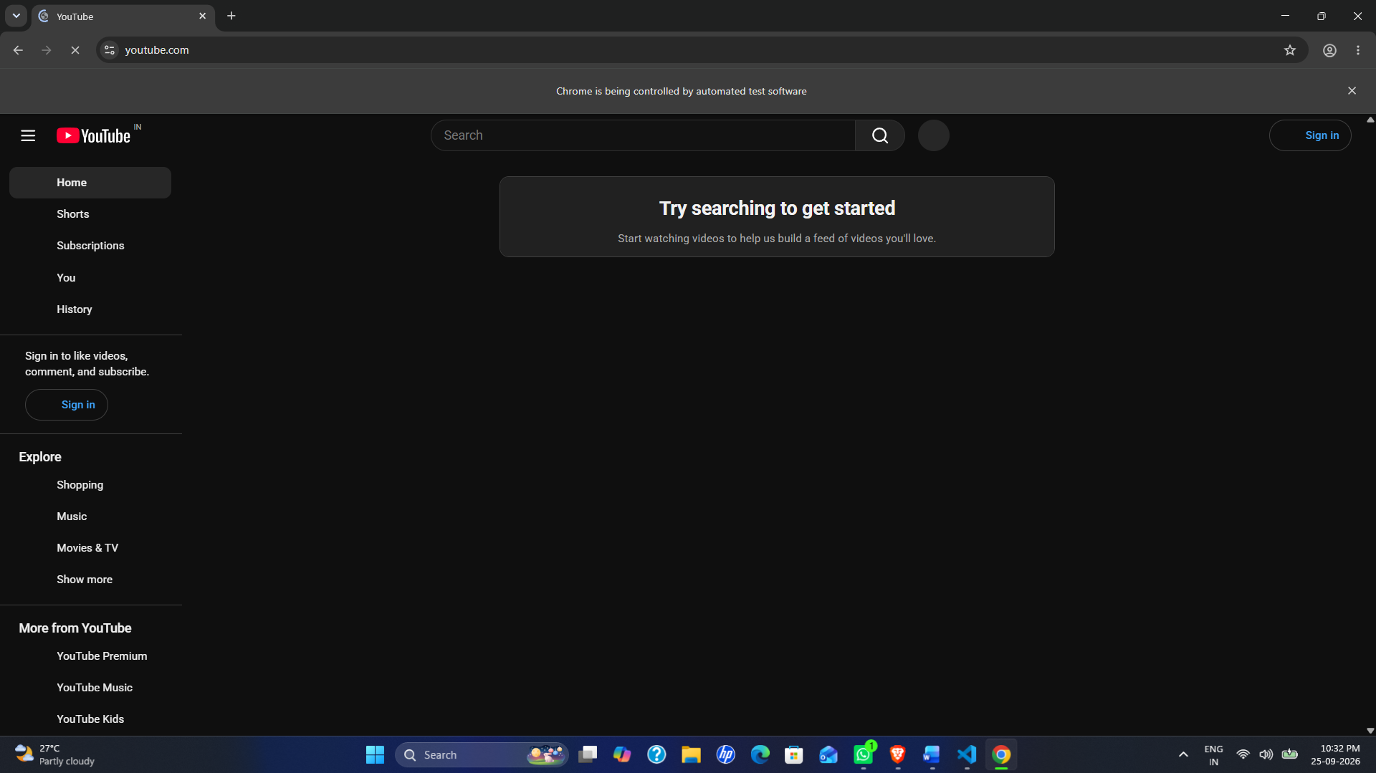

9. Output Screenshot 2 - Behave Terminal Result
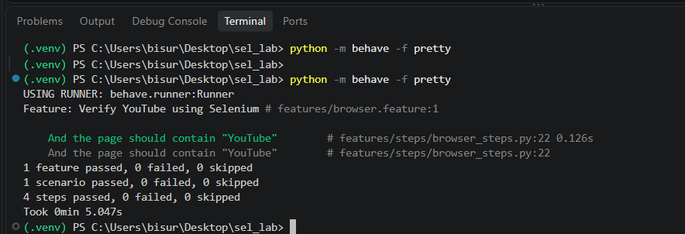

10. Expected Output
Behave should report one feature and one scenario executed successfully, with all steps passing. The browser should display Example Domain. Actual output screenshots must be inserted above after execution.

Result
Selenium browser automation was integrated with Behave BDD and a complete Given-When-Then scenario was implemented.

Observation
The feature file remains readable while Selenium-specific implementation stays in Python. This makes the test easier to maintain and debug.

Conclusion
The experiment demonstrates the basic structure and execution flow of an end-to-end Selenium Python Behave BDD framework.

