Elastic File Storage
Amazon Elastic File System (EFS) is a scalable and fully managed file storage service provided by Amazon Web Services (AWS). It allows you to create and configure file systems that can be accessed concurrently from multiple EC2 instances, providing a highly available and scalable storage solution for your applications and workloads.
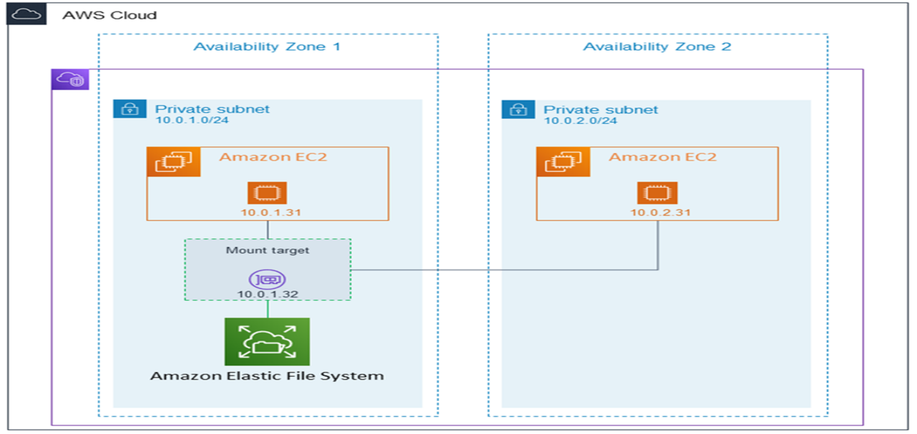
Amazon EFS supports for only Amazon Linux instance:
Step 1: Launching EC2 Instances
1. Sign in to AWS Management Console.
2. Go to the EC2 dashboard.
3. Click on "Launch Instance".
4. Configure instance details:
- Instance Name: EFS-1
5. Choose an Amazon Machine Image (AMI) for Linux.
6. Select instance type: t2.micro.
- Key Pair: EFS
- Network: Choose Subnet-1a
- Security Group: Create a new security group (SG) and add NFS and allow from anywhere.
7. Launch the instance.
8. Repeat the above steps to launch another instance named EFS-2 in Subnet-1b with the same configuration.
Step 2: Creating an EFS File System
1. Go to the EFS service in the AWS Management Console.
2. Click on "Create file system".
3. Specify details:
- Name: Optional
- VPC: Default
- Enable region button.
Click on "Next".
4. In the Network settings:
- Delete all security groups.
- Select the newly created security group (NFS).---which is created while creating instance
Click on "Next" and review the configuration.
Click on "Create file system".
Step 3: Accessing the two EC2 instances named EFS-1 & EFS -2 in two different PowerShell sessions and performing the specified tasks:
Accessing EFS-1 Instances in Two Different PowerShell Sessions:
1. Open Two PowerShell Sessions:
- Open two separate PowerShell windows or tabs on your local machine.
For each Instance:
2. SSH into the Instance:
- Use the SSH command to connect to the EFS-1 instance
ssh -i [path-to-your-keypair.pem] ec2-user@[instance-public-ip]
3. Switch to Root User:
- Gain root access by executing the following command:
sudo su
4. Create a Directory:
- Make a directory named "efs" using the following command:
mkdir efs
5. Install Amazon EFS Utilities:
- Use yum package manager to install the Amazon EFS utilities:
yum install -y amazon-efs-utils
6. List Files:
- Execute the following command to list files in the current directory:
ls
7. Verify Installation (Optional):
- Optionally, you can verify the installation of the Amazon EFS utilities by checking the version:
efs-utils --version
Repeat Steps 2-7 for ------------------------- EFS-2 Instance.
By following these steps, you'll have accessed each EFS-1 instance in separate PowerShell sessions, switched to the root user, created a directory named "efs," installed the Amazon EFS utilities, and listed files in the directory. This setup allows you to configure and manage each instance individually as needed.
Step 4: Attaching EFS to EC2 Instances
1. Go to the EFS service in the AWS Management Console.
2. Click on the target EFS file system.
3. Click on the "Attach" button.
4. Choose "Mount via DNS" option.
5. Copy the displayed command. ,on both ec2 instances(powershell)
6. Paste and execute the copied command in the terminal to mount the EFS file system onto the instance.
Step 5: Verify and Test EFS
- Change the directory to EFS on both instances.
Df -h
Cd /efs
2. Create a file on one instance.
Touch file1
ls
- Verify that the file automatically synchronizes and appears on the other instance.
ls
By above steps, we can successfully create EC2 instances, configured them, created an EFS file system, and attached it to the instances in the same availability zone in the Mumbai region. Now, the instances can seamlessly access and share files stored in the EFS file system.
Scenario-Based Questions on Amazon EFS
- Multiple EC2 instances across different Availability Zones must read and write the same files at the same time. Which AWS storage service fits this requirement and why?
- An application running on EC2 in three different AZs needs a shared file system with low operational overhead. How would EFS support this setup?
- You mounted an EFS file system on one EC2 instance. Can another EC2 instance modify the same file simultaneously? What happens in such a scenario?
- Your team tried to attach an EFS file system to an EC2 instance, but the mount command timed out. What networking components would you check first?
- An EC2 instance in a private subnet is unable to mount EFS. What configuration might be missing at the subnet or VPC level?
- You created an EFS file system but forgot to create mount targets in all AZs. How will this affect EC2 instances in those AZs?
- Why does EFS require mount targets in each Availability Zone, and what happens if one AZ goes down?
- Two applications in different subnets need access to the same EFS file system. How should the EFS networking and security groups be configured?
- Your security team wants only specific EC2 instances to access EFS. How can security groups be used to enforce this?
- While mounting EFS, the command specifies -t nfs4. Why does EFS use NFS, and what advantage does it provide?
- An organization wants to migrate from EBS to EFS because multiple EC2 instances need concurrent access to data. What limitation of EBS is driving this decision?
- An application team complains about increased latency when accessing EFS from EC2. What factors related to networking or AZ placement should be considered?
- Can an EFS file system be accessed from EC2 instances in different VPCs? If yes, what networking setup is required?

