**CYCLE 2**

**1. Program to Sort strings**

CODE

import java.util.Scanner;

import java.util.Arrays;

public class stringsort

{

public static void main(String[] args)

{

int i,j;

Scanner sc = new Scanner(System.in);

System.out.println("Enter the number of words");

int num=sc.nextInt();

String word[]=new String[num];

sc.nextLine();

for( i=0;i<num;i++)

{

System.out.println("\nEnter a Word\n");

word[i]=sc.nextLine();

}

for( i=0;i<num-1;i++)

{

for( j=i+1;j<num;j++)

{

if(word[i].compareTo(word[j])>0)

{

String temp = word[i];

word[i]=word[j];

word[j]=temp;

}

}

}

System.out.println("Sorted Strings using compareTo function ="+Arrays.toString(word));

System.out.println(word);

}

}

OUTPUT

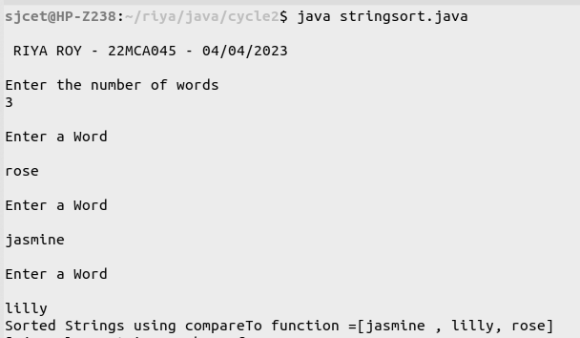

**2. Search an element in an array.**

import java.util.Scanner;

public class search

{

public static void main(String[] args)

{

int i,j,x=0;

boolean state = false;

Scanner sc = new Scanner(System.in);

System.out.println("\n RIYA ROY - 22MCA045 - 04/04/2023\n");

System.out.println("Enter the number of elemets in array");

int num=sc.nextInt();

String word[]=new String[num];

sc.nextLine();

for( i=0;i<num;i++)

{

System.out.println("\nEnter a Word\n");

word[i]=sc.nextLine();

}

System.out.println("Enter the element to Search");

String search = sc.nextLine();

for( i=0;i<num;i++)

{

if(word[i].equals(search))

{

x = i;

state = true;

}

}

if(state)

{

System.out.println("Element found at position = "+x);

}

else

{

System.out.println("Element found not found");

}

}

}

OUTPUT

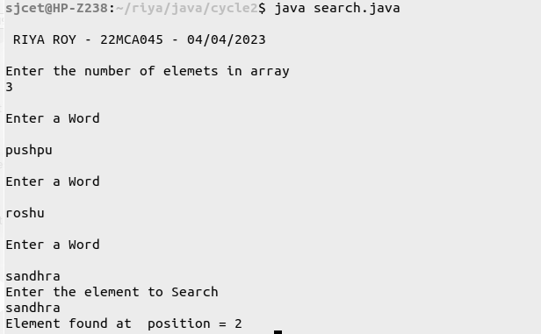

**3. Perform string manipulations**

import java.util.Scanner;

public class string_man

{

public static void main(String[] args)

{

System.out.println("\n RIYA ROY - 22MCA045 - 04/04/2023\n");

System.out.println("Enter The String");

Scanner sc = new Scanner(System.in);

String str1 = sc.nextLine();

System.out.println("Length of String = "+str1.length());

System.out.println("Character at First position = "+str1.charAt(1));

System.out.println("String Contains 'Col' sequence :"+str1.contains("Col"));

System.out.println("String ends with e : "+str1.endsWith("e"));

System.out.println("Replace'col' with 'kol' : "+str1.replaceAll("Col","kol"));

System.out.println("LOWERCASE : "+str1.toLowerCase());

System.out.println("UPPERCASE : "+str1.toUpperCase());

}

}

OUTPUT

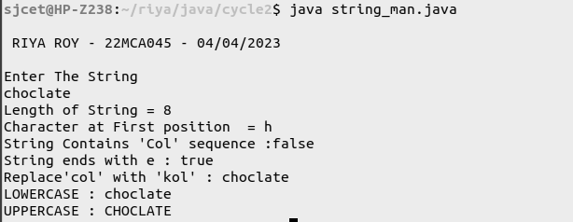

**4. Program to create a class for Employee having attributes eNo, eName eSalary.**

**Read nemploy information and Search for an employee given eNo, using the**

**concept of Array of Objects.**

import java.util.Scanner;

import java.util.Scanner;

public class employee

{

int eNo;

String eName;

double eSalary;

public void getdetails()

{

System.out.println("\nEnter the Employee details");

Scanner sc = new Scanner(System.in);

System.out.println("Employee number : ");

eNo=sc.nextInt();

System.out.println("Name : ");

sc.nextLine();

eName=sc.nextLine();

System.out.println("Salary : ");

eSalary=sc.nextDouble();

}

void display()

{

System.out.println("Empolyee No :"+eNo);

System.out.println("Name :"+eName);

System.out.println("Salary Amount"+eSalary+"\n");

}

public static void main(String[] args) {

System.out.println("\n RIYA ROY - 22MCA045 - 04/04/2023\n");

System.out.println("\nEnter the No. of Employee's");

Scanner sc1 = new Scanner(System.in);

int num = sc1.nextInt();

employee arr[]=new employee[num];

for(int i =0;i<num;i++)

{

arr[i]=new employee();

arr[i].getdetails();

}

System.out.println("\nInformations of all the employee's");

for(int i=0;i<num;i++)

{

arr[i].display();

}

boolean state = false;

System.out.println("\nEnter the Employee Number to get details of a employee");

int num2= sc1.nextInt();

for(int i=0;i<num;i++)

{

if(arr[i].eNo==num2)

{

System.out.println("\nEmployee details");

arr[i].display();

}

}

}

}

OUTPUT

