Experiment-5

Objective:
To train and evaluate a Convolutional Neural Network (CNN) using Keras to classify images from the Fashion-MNIST dataset and study the effect of parameters like filter size, regularization, batch size and optimizer on model performance.

Theory:
Convolutional Neural Networks (CNNs) are a type of deep learning model mainly used for image classification and computer vision tasks. CNNs automatically extract important features from images using convolution operations.
A typical CNN architecture contains the following layers:
1. Convolution Layer
This layer applies filters to the input image to detect features such as edges, shapes and textures.
2. Pooling Layer
Pooling reduces the spatial size of feature maps and helps in reducing computation. It also makes the model more robust.
3. Flatten Layer
This layer converts the 2-D feature maps into a 1-D vector so that it can be passed to the fully connected layer.
4. Fully Connected (Dense) Layer
This layer performs the final classification.
The Fashion-MNIST dataset contains grayscale images of clothing items such as shirts, shoes, bags and coats. Each image has a size of 28 × 28 pixels.
The performance of the CNN model depends on several parameters:
1. Filter Size
Filters detect features from the image. Different filter sizes capture different levels of details.
2. Regularization
Regularization techniques such as L2 regularization help prevent overfitting.
3. Batch Size
Batch size determines the number of samples processed before updating model weights.
4. Optimizer
The optimizer updates model weights to minimize the loss function. Common optimizers include Adam, SGD and RMSprop.
Model performance is evaluated using:
- Accuracy
- Loss

Algorithm:
- Import the required libraries such as TensorFlow, Keras and Matplotlib.
- Load the Fashion-MNIST dataset.
- Normalize the image pixel values between 0 and 1.
- Reshape the images to make them suitable for CNN input.
- Build the CNN model using convolution, pooling and dense layers.
- Compile the model using an optimizer and loss function.
- Train the model on the training dataset.
- Evaluate the model performance on the test dataset.
- Repeat the training with different parameter values.
- Compare the accuracy obtained for different configurations.
Code-:
import tensorflow as tf
from tensorflow.keras import layers, models
from tensorflow.keras.datasets import fashion_mnist
import matplotlib.pyplot as plt
import numpy as np

# Load Dataset

(X_train, y_train), (X_test, y_test) = fashion_mnist.load_data()

# Normalize
X_train = X_train / 255.0
X_test = X_test / 255.0

# Reshape for CNN
X_train = X_train.reshape(-1,28,28,1)
X_test = X_test.reshape(-1,28,28,1)

print("Training data shape:", X_train.shape)

# Class labels
class_names = ['T-shirt','Trouser','Pullover','Dress','Coat',
'Sandal','Shirt','Sneaker','Bag','Ankle Boot']

# Build CNN Model

model = models.Sequential()

model.add(layers.Conv2D(32,(3,3),activation='relu',input_shape=(28,28,1)))
model.add(layers.MaxPooling2D((2,2)))

model.add(layers.Conv2D(64,(3,3),activation='relu'))
model.add(layers.MaxPooling2D((2,2)))

model.add(layers.Conv2D(64,(3,3),activation='relu'))

model.add(layers.Flatten())

model.add(layers.Dense(64,activation='relu'))
model.add(layers.Dense(10,activation='softmax'))

# Compile Model

model.compile(
optimizer='adam',
loss='sparse_categorical_crossentropy',
metrics=['accuracy']
)

model.summary()

# Train Model

history = model.fit(
X_train,
y_train,
epochs=10,
batch_size=64,
validation_data=(X_test,y_test)
)

# Evaluate Model

test_loss, test_acc = model.evaluate(X_test,y_test)

print("\nTest Accuracy:",test_acc)

# Accuracy Graph

plt.figure()

plt.plot(history.history['accuracy'])
plt.plot(history.history['val_accuracy'])

plt.title("Model Accuracy")
plt.xlabel("Epoch")
plt.ylabel("Accuracy")

plt.legend(['Train','Validation'])

plt.show()

# Loss Graph

plt.figure()

plt.plot(history.history['loss'])
plt.plot(history.history['val_loss'])

plt.title("Model Loss")
plt.xlabel("Epoch")
plt.ylabel("Loss")

plt.legend(['Train','Validation'])

plt.show()

# Predictions

predictions = model.predict(X_test)

# Show Sample Predictions

plt.figure(figsize=(10,6))

for i in range(9):

plt.subplot(3,3,i+1)

plt.imshow(X_test[i].reshape(28,28), cmap='gray')

predicted_label = np.argmax(predictions[i])

plt.title("Pred: " + class_names[predicted_label])

plt.axis('off')

plt.show()

Graph-:
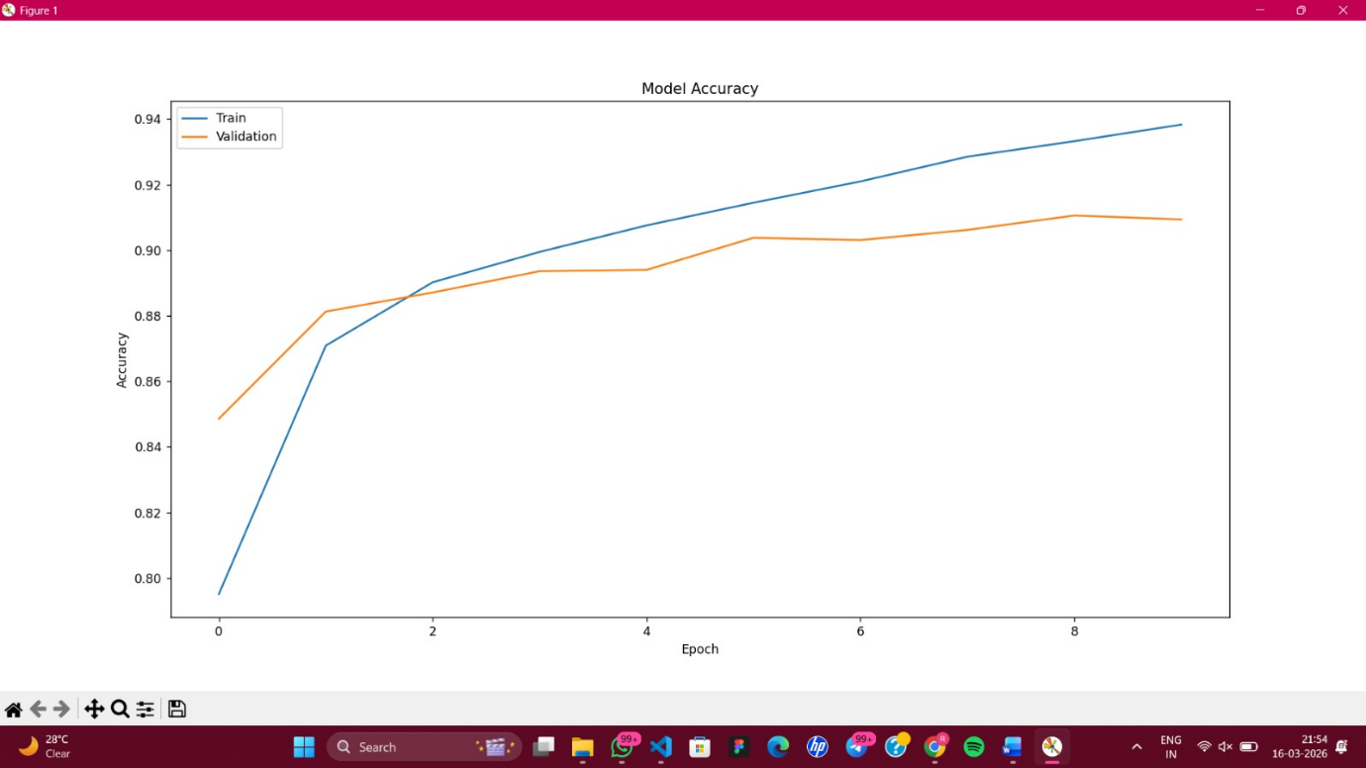
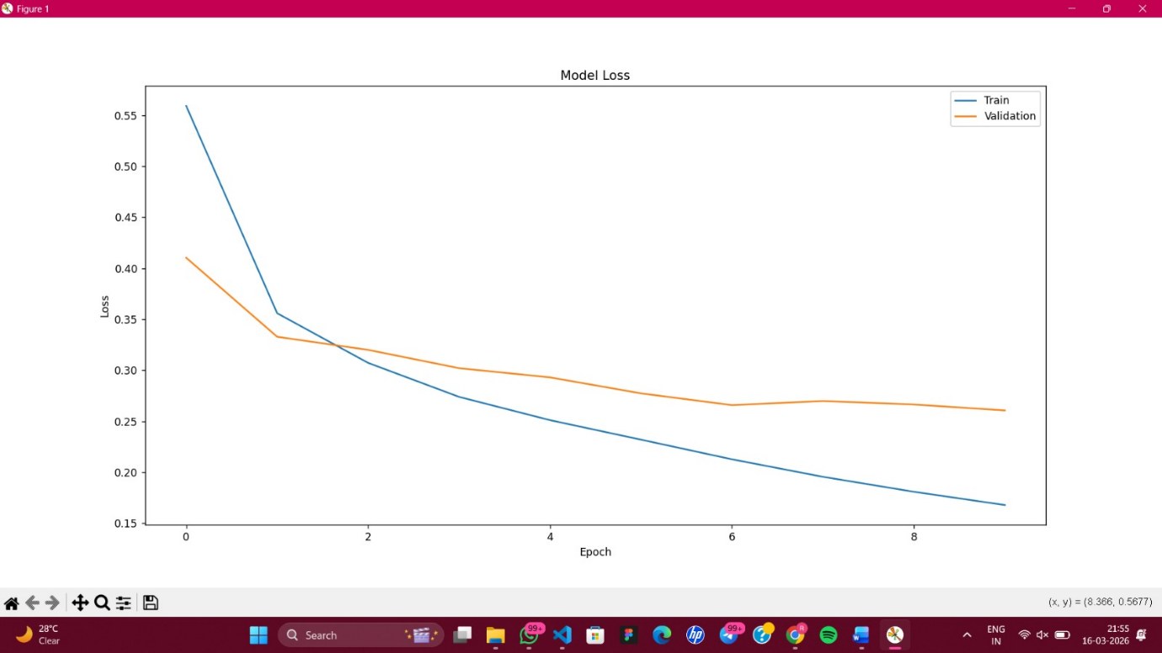
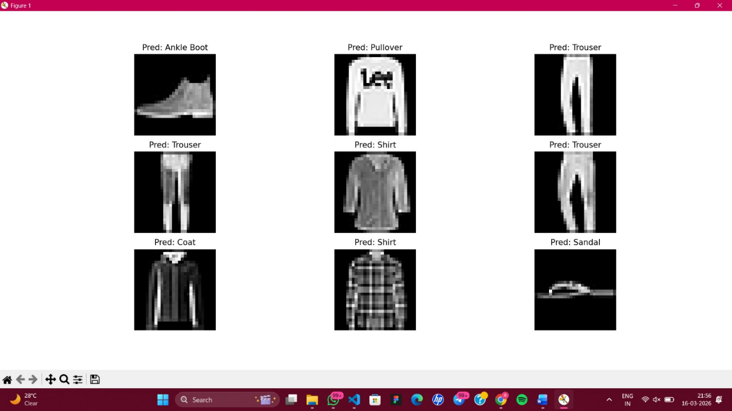
Evaluation with Variations-:
1. Filter Size
Filter Size | Accuracy
3 × 3 | ~90%
5 × 5 | ~88%
Smaller filters capture fine details and generally give better performance.
2. Regularization
Regularization | Accuracy
None | ~90%
L2 (0.001) | ~91%
L2 (0.01) | ~89%
Regularization helps reduce overfitting but too much regularization may reduce accuracy.

3. Batch Size
Batch Size | Effect
32 | Stable training
64 | Balanced performance
128 | Faster training but slight drop in accuracy

4. Optimizer
Optimizer | Accuracy
Adam | ~91%
SGD | ~88%
RMSprop | ~90%
Adam optimizer generally provides faster convergence and better performance.

Result:
The CNN model successfully classified the images in the Fashion-MNIST dataset. The performance varied depending on parameters such as filter size, regularization, batch size and optimizer.
Among the tested configurations, filter size 3×3, batch size 64 and Adam optimizer provided better performance.

Conclusion:
This experiment demonstrated how CNNs can be used for image classification. The results show that hyperparameters significantly affect model performance.
Using appropriate filter sizes, moderate batch size and efficient optimizers like Adam helps improve classification accuracy.

Limitations:
- Training CNN models requires significant computational resources.
- Large models may lead to overfitting.
- Model performance depends on dataset quality.
- Hyperparameter tuning can be time-consuming.
- Only a basic CNN architecture was used.

Future Scope:
- Use deeper CNN architectures for better performance.
- Apply dropout and other regularization techniques.
- Use data augmentation to improve model generalization.
- Test the model on larger image datasets.
- Implement transfer learning using pretrained models.

