Experiment-1

Objective:- WAP to visualize the Perceptron Learning Algorithm using numpy and matplotlib/seaborn in Python. Evaluate performance of a single perceptron for NAND and XOR truth tables as input dataset

Description:- The Perceptron Learning Model of a neural network used for binary classification problems. It consists of an input layer with input features, associated weights, a bias term, and an activation function. The activation function use here is step function. This model is works for data only that are linearly separable .Percepton is also a single layer neural network which only have a input and gives output , There are no hidden layer in this model .In this experiment, a single-layer perceptron is implemented to model the logical behavior of NAND and XOR gates.
For each input pair $\left(x_{1} , x_{2}\right)$, the perceptron computes a net input given by the weighted sum of inputs and bias:
$$z=w_{1}x_{1}+w_{2}x_{2}+b$$
The net input is passed through a step activation function, which produces a binary output (0 or 1). The predicted output is then compared with the actual target output, and the error is calculated.
Error is calculated by the function or formula based on it exists in P or N.
If its in P:- W=W+x
If its in N :- W=W-x

Based on this error, the weights and bias are updated using the perceptron learning rule.

Code:-
import matplotlib.pyplot as plt
import numpy as np
import time

### data (NAND gate) ###
data = [
(0, 0, 1),
(0, 1, 1),
(1, 0, 1),
(1, 1, 0)
]

# ### XOR gate data (uncomment to test XOR) ###
# data = [
# (0, 0, 0),
# (0, 1, 1),
# (1, 0, 1),
# (1, 1, 0)
# ]

### ideal fixed weight and bias (reference line) ###
w_true = [-1, -1]
b_true = 1.5

#### initial learned weights ####
w1 = 0
w2 = 0
b = 0
epoch = 1

#### interactive graph mode ###
plt.ion()

## for drawing same graph again and again ###
fig, ax = plt.subplots()

#### graph drawing function ####
def draw_graph(epoch, w1, w2, b):
ax.clear()

# plot data points
for x1, x2, y in data:
if y == 1:
ax.scatter(x1, x2, color="green", s=100)
else:
ax.scatter(x1, x2, color="red", s=100)

x = np.array([-0.5, 1.5])

# true boundary (fixed)
y_true = (-w_true[0] * x - b_true) / w_true[1]
ax.plot(x, y_true, "k--", label="True boundary (wᵀx)")

# learned boundary
if w2 != 0:
y_pred = (-w1 * x - b) / w2
ax.plot(x, y_pred, "b", label=f"Predicted boundary (Epoch {epoch})")

ax.set_xlim(-0.5, 1.5)
ax.set_ylim(-0.5, 1.5)
ax.set_xlabel("x1")
ax.set_ylabel("x2")
ax.set_title(f"Perceptron Learning – Epoch {epoch}")
ax.legend()
ax.grid(True)

plt.pause(1.0)

### training loop ###
while True:
print(f"\n===== Epoch {epoch} =====")
print("x1 x2 y z y_pred w1 w2 b")

error = 0

for x1, x2, y in data:
z = x1 * w1 + x2 * w2 + b
y_pred = 1 if z >= 0 else 0

if y == 1 and y_pred == 0:
w1 += x1
w2 += x2
b += 1
error += 1

elif y == 0 and y_pred == 1:
w1 -= x1
w2 -= x2
b -= 1
error += 1

print(f" {x1} {x2} {y} {z:>3} {y_pred} {w1:>2} {w2:>2} {b:>2}")

draw_graph(epoch, w1, w2, b)
epoch += 1

if error == 0:
print("\nTraining converged")

# ===== Accuracy & Confusion Matrix =====
y_true = []
y_pred_list = []

for x1_, x2_, y_ in data:
z_ = x1_*w1 + x2_*w2 + b
yp_ = 1 if z_ >= 0 else 0
y_true.append(y_)
y_pred_list.append(yp_)

correct = 0
for i in range(len(y_true)):
if y_true[i] == y_pred_list[i]:
correct += 1

accuracy = (correct / len(y_true)) * 100
print("Final Accuracy =", accuracy, "%")

tp = tn = fp = fn = 0
for yt, yp in zip(y_true, y_pred_list):
if yt == 1 and yp == 1:
tp += 1
elif yt == 0 and yp == 0:
tn += 1
elif yt == 0 and yp == 1:
fp += 1
elif yt == 1 and yp == 0:
fn += 1

print("\nConfusion Matrix")
print(" Predicted 0 Predicted 1")
print(f"Actual 0 {tn} {fp}")
print(f"Actual 1 {fn} {tp}")

break

plt.ioff()
plt.show()

Graph-:
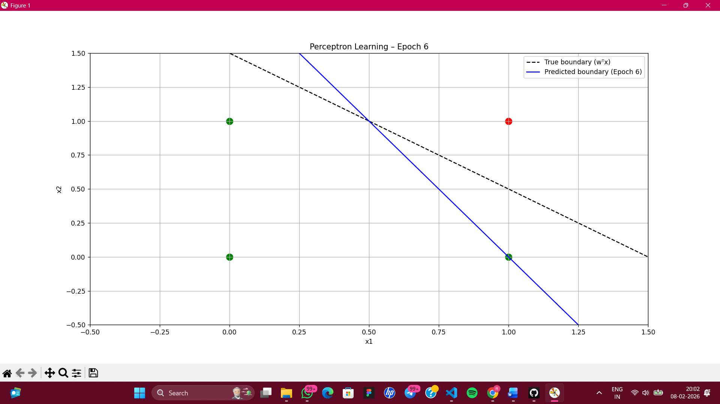

EVALUTION OF MODEL :-

Training converged
Final Accuracy = 100.0 %

Confusion Matrix
Predicted 0 Predicted 1
Actual 0 1 0
Actual 1 0 3

COMMENTS:-
Limitations-: This model only works for the data which is linearly separable and not on data which are not linearly separable like this model fails on the XOR model or data.
Scope:-We can solve this model using different activation function so that It can work on non-linear data too

