## 1)Housing Price Prediction using ( Linear Regression )

**import pandas as pd**

**path="C:\\Users\\lijoj\\Desktop\\OnlinePythonInternship\\Data\\homeprices.csv"**

**data=pd.read_csv(path)**

**print(data)**

**print(data.info())**

**print (len(data))**

**print(len(data.columns))**

**print(data.shape)**

**print(data.size)**

**print(data.shape[0])**

**print(data.shape[1])**

**rows,columns=data.shape**

**print(columns)**

**print(data.size)**

**inputs=data.drop('price','columns')**

**output=data.drop('area','columns')**

**print(inputs)**

**print(output)**

**import matplotlib.pyplot as plt**

**plt.xlabel('Area')**

**plt.ylabel('Price')**

**plt.scatter(inputs,output,marker='*',color='red')**

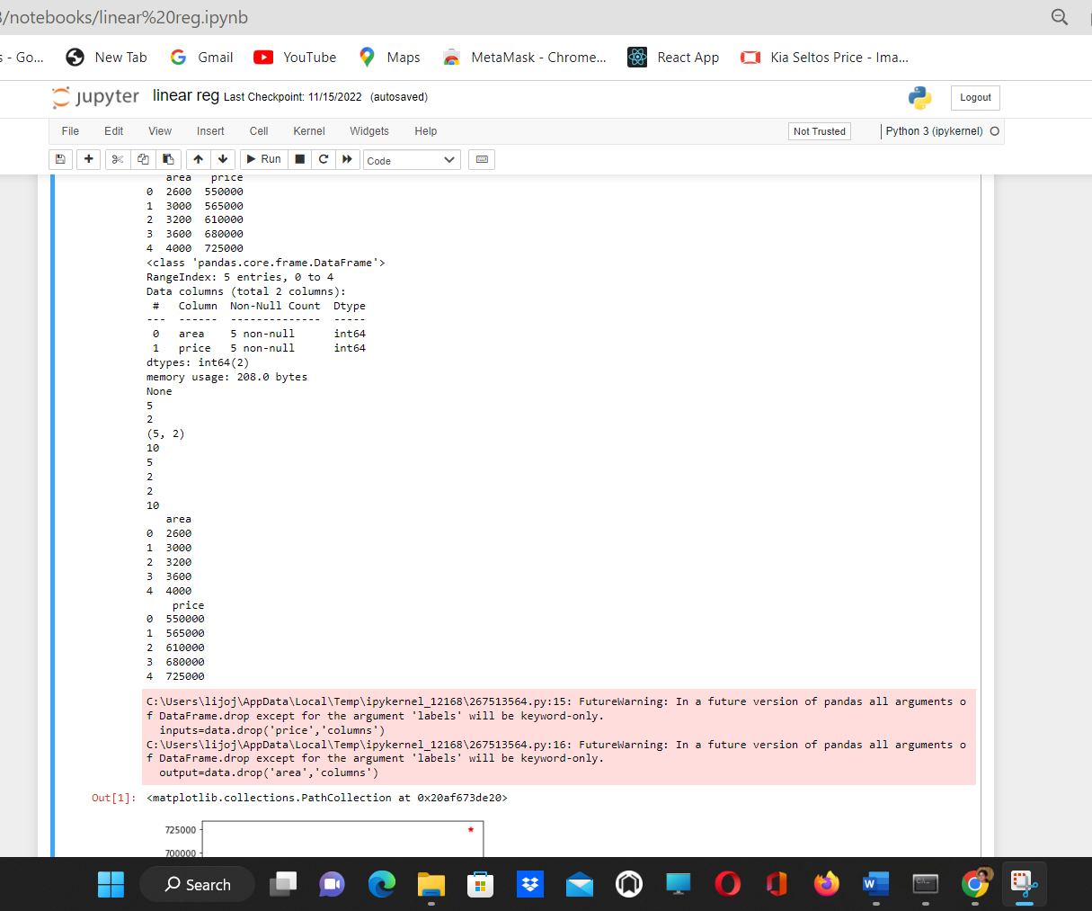

# **2) Write a program for House Price Prediction Multiple Linear Regression**

**import pandas as pd**

**path="C:\\Users\\lijoj\\Desktop\\OnlinePythonInternship\\Data\\homeprices_Mul.csv"**

**data=pd.read_csv(path)**

**print(data)**

**print(data.info())**

**medianval=data.bedrooms.median()**

**print(medianval)**

**data.bedrooms=data.bedrooms.fillna(medianval)**

**inputs=data.drop('price','columns')**

**output=data.drop(['area','bedrooms','age'],'columns')**

**print(inputs)**

**print(output)**

