Full-Cycle Testing

### **END-to-END test coverage**

We perform all types of testing: Functional, GUI, Usability, Security, Database testing, Cross-platform, Cross-browser, Accessibility, Installation, Configuration, Localization, Performance/Load, Stress testing etc.

### **Process transparency**

We strive to provide you with complete transparency for everything we do in the scope of your project. Seamlessly integrating with your business and development processes, we assure your full access to the testing progress of your software.

### **Confirmed KPIs**

We understand that it is highly important to you to understand how we’re progressing with our testing tasks and whether our progress aligns with your goals. We always outline your most important QA KPIs and keep you informed about their status.

Dedicated Team

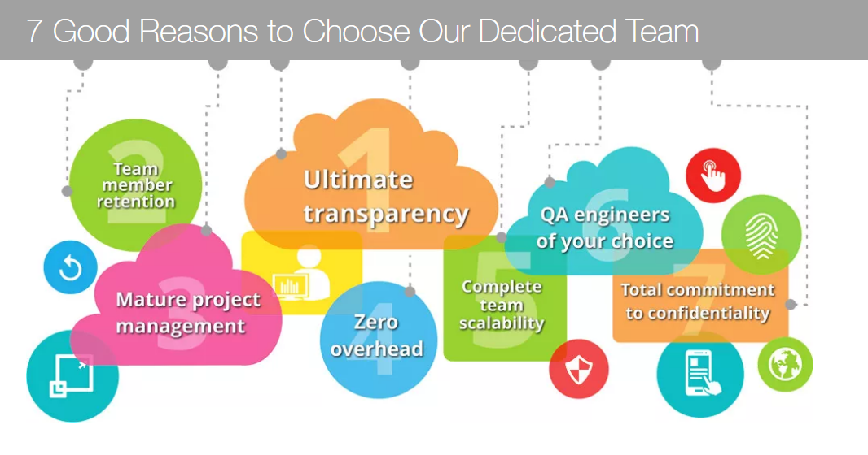

# Web Application Testing

Web Application Testing

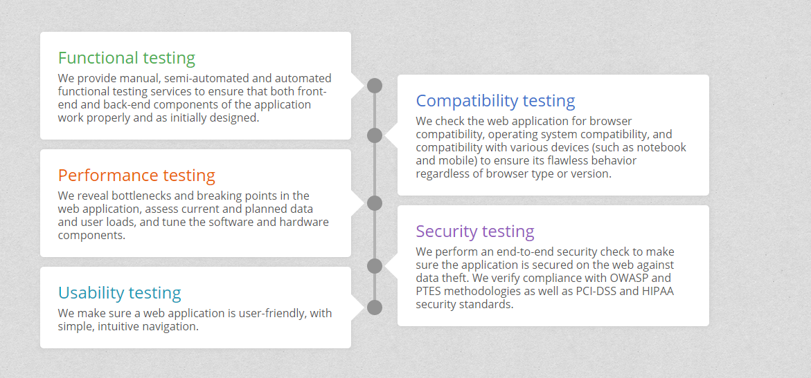

Mobile Application Testing

