Summer Internship Project Report On

**Imaginify – Turn Words Into Imagination**

By

**Riya Suthar(230173116015)**

GUIDED BY

**Prof. OM P Mehta**

DEPARTMENT OF INFORMATION TECHNOLOGY

A PROJECT REPORT SUBMITTED TO GUJARAT TECHNOLOGICAL UNIVERSITY IN PARTIAL FULFILLMENT OF THE REQUIREMENTS FOR DEGREE OF BACHELOR OF ENGINEERING IN INFORMATION & TECHNOLOGY

**June 2025**



**VISHWAKARMA GOVERNMENT ENGINEERING COLLEGE**

**CHANDKHEDA, AHMEDABAD**

**CERTIFICATE**



This is to certify that Summer Internship project work embodied in this report entitled  **“Imaginify – Turn Words Into Imagination “** was carried out by  **Riya Suthar(230173116016)** at **Vishwakarma Government Engineering College** for partial fulfilment of B.E. degree to be awarded by Gujarat Technological University. This project work has been carried out under my supervision and is to the satisfaction of department.

Date:

Place:

**Internal Guide:** **Head of Deaprtment:**

Name: Prof. OM P Mehta Name: Dr. Vibha Patel

Signature: Signature:

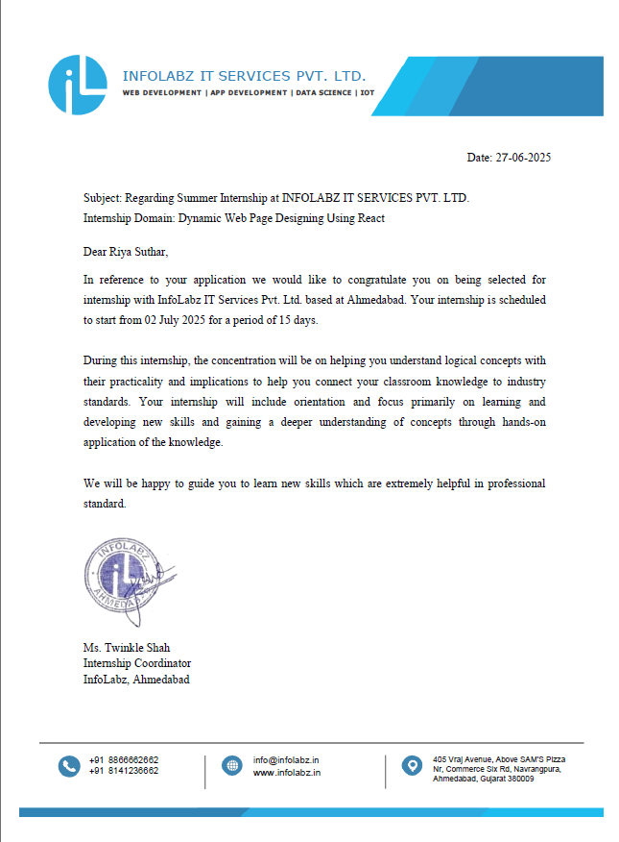

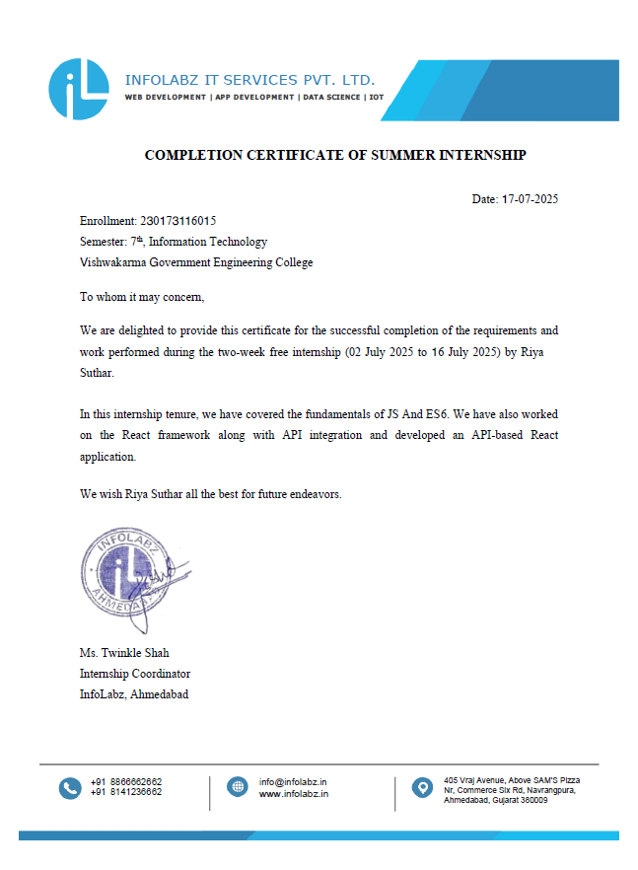

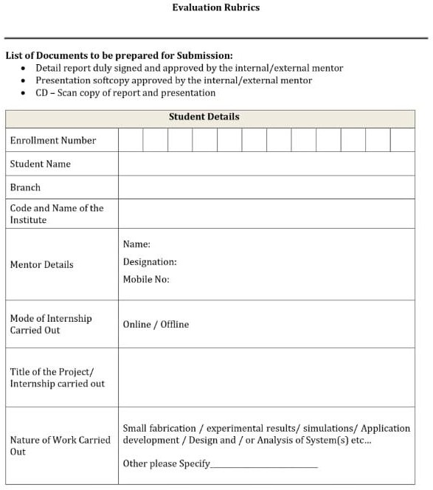

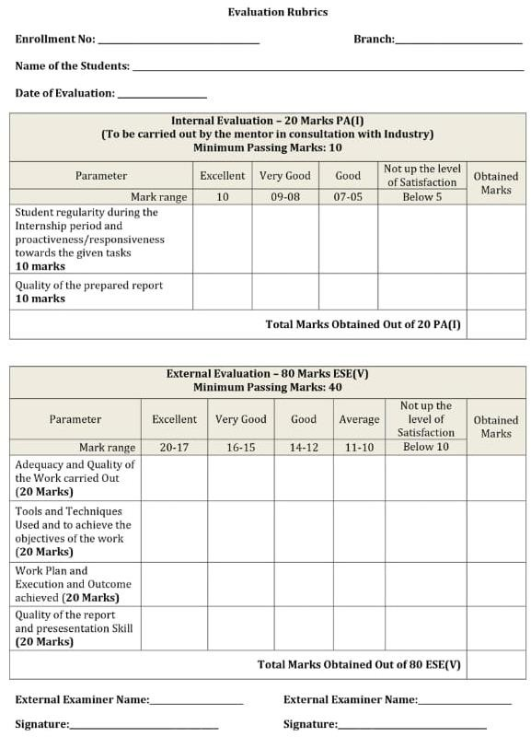

**ACKNOWLEDGMENTS**

* I would like to express my heartfelt gratitude to everyone who contributed to the successful completion of my project, *Imaginify – Turn Words Into Imagination*.  
  This project has been an enriching experience that enabled me to strengthen my skills in full-stack development, API integration, cloud storage, and the implementation of modern AI-driven web applications.
* First and foremost, I am deeply thankful to my mentors and faculty members for their continuous guidance, encouragement, and valuable feedback throughout the development journey. Their insightful suggestions greatly contributed to improving both the technical functionality and user experience of the application.
* I would also like to acknowledge the invaluable resources and documentation provided by the React, Node.js, MongoDB, and Tailwind CSS communities, as well as the Clipdrop Stable Diffusion API. The open-source libraries, tutorials, and forums proved to be essential in overcoming challenges and implementing advanced features of the application.
* A special thanks goes to my peers and friends who actively tested the application, shared their feedback, and suggested improvements. Their constant support and motivation inspired me to build a more reliable and user-friendly platform.
* Lastly, I am sincerely grateful to my family for their unwavering support, patience, and belief in my abilities, which gave me the confidence and determination to successfully complete this project.

**ABSTRACT**

*Imaginify – Turn Words Into Imagination* is a full-stack AI-powered web application designed to transform text prompts into visually appealing images using the Clipdrop Stable Diffusion API. The project demonstrates how cutting-edge generative AI can be integrated with modern web technologies to create an interactive, user-centric platform.

The application is built with **React** for the frontend, ensuring a responsive and intuitive user interface styled with **Tailwind CSS**, and **Node.js with Express** for the backend, which manages API requests and authentication. Data is securely stored in **MongoDB**, while generated images are uploaded and managed through **Cloudinary** for optimized cloud storage and retrieval. To ensure secure access, **JWT-based authentication** has been implemented, allowing users to sign up, log in, and maintain their personal history of generated images.

The platform provides users with a seamless workflow:

1. **Text-to-Image Generation** – Users can input any descriptive text, which is processed through the Stable Diffusion API to produce high-quality AI-generated images.
2. **User Account & History Management** – Each user can securely create an account, generate multiple images, and view their history of previously generated content.
3. **Scalable SaaS-Style Architecture** – The project adopts a software-as-a-service approach, showcasing how full-stack applications can integrate third-party AI services to deliver creative solutions.

The focus of this project lies in three major aspects:

1. **Generative AI Integration** – Harnessing the power of Stable Diffusion to convert imagination into visuals.
2. **Secure and Scalable Architecture** – Using JWT authentication, MongoDB, and Cloudinary to ensure data protection, reliability, and scalability.
3. **Responsive and Engaging Design** – Delivering a modern, mobile-friendly UI for an effortless user experience.

Overall, *Imaginify* highlights the potential of combining AI with web development to create innovative, real-world applications. It not only serves as a demonstration of technical skills in **React, Node.js, MongoDB, and API integration**, but also as an example of how generative AI can be leveraged to develop SaaS-based creative tools for the future.

**Index**

|  |  |
| --- | --- |
| Content | Page No. |
| Title & Cover Page | I |
| Certificate | II |
| Acknowledgments | VII |
| Abstract | VIII |
| Table of Contents | X |
| List of Figures | XI |
| List of Tables | XI |
| Chapter 1. Introduction | 1 |
| Chapter 2. Background and Literature Review | 2 |
| Chapter 3. Diagrams and Data Dictionary./In case of research proposal proposed flowchart with explanation. | 3 |
| Chapter 4. Results/Screenshots  Note: Screenshot and results should be with explanation | 6 |
| Chapter 5. Conclusion and Future Scope. | 11 |

**TABLE OF CONTENT**

|  |  |  |  |
| --- | --- | --- | --- |
| **Chapter No.** | **Chapter Title** | **Subtopics** | **Page No.** |
| **1** | **Introduction** | 1.1 Overview  1.2 Objectives  1.3 Scope  1.4 Technology Stack | 1 |
| **2** | **Background and Literature Review** | 2.1 Existing Systems  2.2 Advantages of Proposed System 2.3 Technology Background | 2 |
| **3** | **System Architecture, Flowchart, and Data Dictionary** | 3.1System Architecture Diagram 3.2Flowchart Diagram  3.3Data Dictionary Table | 3 |
| **4** | **Results / Screenshots** | 4.1 Overview  4.2 Homepage – All News Feed 4.3 Category View – Sports  4.4 Category View – Politics  4.5 Category View – Health  4.6 Category View – Fitness  4.7 Category View – Entertainment  4.8 Responsive Web Layout  4.9 Summary of Results | 6 |
| **5** | **Conclusion and Future Scope** | 5.1 Conclusion  5.2 Limitations  5.3 Future Scope | 11 |

**List Of Figures**

|  |  |  |
| --- | --- | --- |
| **Figure No.** | **Figure Title** | **Page No.** |
| Fig. 3.1 | System Architecture of NewsScope | 3 |
| Fig. 3.2 | Flowchart of NewsScope | 4 |
| Fig. 4.1 | NewsScope Homepage Screenshot | 6 |
| Fig. 4.2 | Category View – Technology News | 7 |
| Fig. 4.3 | Responsive Web Layout | 9 |

**List Of Table**

|  |  |  |
| --- | --- | --- |
| **Table No.** | **Table Title** | **Page No.** |
| Table 3.1 | Data Dictionary – NewsScope | 5 |

**CHAPTER 1. INTRODUCTION**

**1.1 Overview**

In the era of Artificial Intelligence, generative models are revolutionizing the way people create and interact with digital content. Traditionally, creating images required artistic skills or access to complex design tools. With the rise of AI, however, it is now possible to generate high-quality visuals instantly from simple text descriptions.

*Imaginify – Turn Words Into Imagination* is a full-stack AI-powered web application that enables users to convert text prompts into images using the Clipdrop Stable Diffusion API. The platform is designed as a SaaS-style application, allowing users to securely sign up, generate AI-based images, and manage their history. Built with React for the frontend and Node.js with Express for the backend, the application also integrates MongoDB for data management, Cloudinary for image storage, and Tailwind CSS for a modern and responsive UI.

This project showcases how generative AI can be combined with web technologies to deliver an innovative, user-friendly platform that transforms imagination into reality.

**1.2 Objectives**

* To enable users to generate AI-powered images from simple text prompts.
* To implement secure authentication and authorization using JWT.
* To provide a history management feature where users can view previously generated images.
* To integrate Cloudinary for efficient and scalable image storage.
* To design a responsive and intuitive user interface with Tailwind CSS.
* To demonstrate how a SaaS-style full-stack application can leverage modern technologies and AI APIs.

**1.3 Scope**

* Users can sign up, log in, and manage their profiles.
* Users can input text prompts and generate AI-based images in real time.
* Each generated image is stored in Cloudinary and linked to the user’s account history.
* The application works seamlessly across devices including desktops, laptops, tablets, and smartphones.
* Provides a scalable architecture suitable for future enhancements like image sharing, downloads, or premium features.

**1.4 Technology Stack**

* **Frontend:** React JS, Tailwind CSS, JavaScript (ES6), HTML5, CSS3
* **Backend:** Node.js, Express.js
* **Database:** MongoDB
* **Authentication:** JSON Web Tokens (JWT)
* **AI Integration:** Clipdrop Stable Diffusion API
* **Cloud Storage:** Cloudinary
* **Tools:** Visual Studio Code, GitHub, Browser Developer Tools, Postman
* **Hosting:** Localhost / Cloud Hosting (e.g., Vercel, Render, or Netlify for frontend; Railway/Heroku for backend)

**CHAPTER 2. BACKGROUND AND LITERATURE REVIEW**

**2.1 Existing Systems**

* Existing AI art platforms such as **DALL·E, MidJourney, and Stable Diffusion-based applications** allow users to generate images from text prompts. However, many of these platforms are either **subscription-based**, have **limited free usage**, or lack features like **personal history management**.
* Some existing tools provide powerful AI image generation but do not focus on **user authentication, storage, or scalability**, making it difficult for users to securely manage and revisit their generated images.
* Additionally, many platforms have **complex user interfaces**, which may discourage beginners or non-technical users from exploring AI-based creativity.

**2.2 Advantages of Proposed System**

* **Free and Accessible** – Provides an easy-to-use interface for generating images without a paywall.
* **Secure Authentication** – Implements JWT-based login and signup to protect user data.
* **History Management** – Allows users to view and manage previously generated images.
* **Cloud Storage Integration** – Uses Cloudinary for efficient and scalable image storage.
* **Responsive Design** – Built with Tailwind CSS to ensure compatibility across devices (desktop, tablet, and mobile).
* **Scalable SaaS Architecture** – Designed with a modular architecture that can be extended for premium features, sharing, or downloads in the future.

**2.3 Technology Background**

* **React JS**: A component-based JavaScript library used for building dynamic and responsive user interfaces. It enables fast rendering with the virtual DOM and supports reusable UI components.
* **Node.js & Express.js**: Backend runtime and framework for building scalable server-side applications, handling API requests, and managing authentication.
* **MongoDB**: A NoSQL database used for storing user information and maintaining history of generated images.
* **JWT (JSON Web Tokens)**: Provides secure authentication and authorization for user login sessions.
* **Clipdrop Stable Diffusion API**: A generative AI API that transforms text prompts into high-quality images.
* **Cloudinary**: A cloud-based media storage and management service used to efficiently store, optimize, and deliver AI-generated images.
* **Tailwind CSS**: A utility-first CSS framework for creating responsive, modern, and customizable designs with minimal effort

**CHAPTER 3. SYSTEM ANALYSIS / SYSTEM REQUIREMENTS**

**3.1 System Architecture**

In the traditional process of digital content creation, users rely on graphic design tools or image editing software to create visuals, which requires both technical expertise and time. Existing AI art platforms, while powerful, often come with limitations such as paid subscriptions, lack of user history management, or restricted accessibility. Beginners and non-technical users may also find these platforms complex and unintuitive.  
Therefore, there is a need for a user-friendly, secure, and accessible platform that leverages generative AI to convert simple text prompts into high-quality images while offering features such as authentication, history tracking, and responsive design.

**3.2 Proposed System**

The proposed system, *Imaginify – Turn Words Into Imagination*, is a full-stack AI web application that provides users with the ability to:

* Input a text prompt and generate AI-based images using the Clipdrop Stable Diffusion API.
* Securely sign up and log in using JWT-based authentication.
* Store and retrieve generated images linked to their accounts with the help of MongoDB and Cloudinary.
* Manage history to view previously generated outputs.
* Access the platform through a clean, responsive, and intuitive UI across multiple devices.

This system aims to simplify the AI image generation process and deliver a SaaS-style solution that combines innovation, accessibility, and scalability.

**3.3 Functional Requirements**

The system should provide the following functional features:

1. **User Authentication** – Sign up, log in, and manage user sessions securely using JWT.
2. **Text-to-Image Generation** – Allow users to enter text prompts and generate corresponding images using the Clipdrop Stable Diffusion API.
3. **History Management** – Store generated images for each authenticated user and allow them to view their history.
4. **Image Storage** – Upload and store generated images securely in Cloudinary.
5. **Responsive UI** – Ensure that the platform adapts to desktop, tablet, and mobile devices.
6. **Navigation & Usability** – Enable easy navigation across pages like Home, Generate, History, and Profile.

**3.4 Non-Functional Requirements**

The system should also meet the following quality attributes:

* **Performance** – Fast API responses and smooth navigation using React’s virtual DOM.
* **Security** – JWT-based authentication to protect user accounts and data.
* **Scalability** – Architecture designed to accommodate future enhancements like sharing, premium subscriptions, or additional AI models.
* **Reliability** – High availability of stored images through Cloudinary and robust backend handling with Node.js.
* **Usability** – Simple, modern, and intuitive design with Tailwind CSS.
* **Portability** – Compatible with various devices and browsers.

**3.5 System Requirements**

**a) Hardware Requirements**

* **Minimum Configuration:**
  + Processor: Intel i3 or equivalent
  + RAM: 4 GB
  + Storage: 10 GB free space
  + Display: 1366x768 resolution
* **Recommended Configuration:**
  + Processor: Intel i5 or higher
  + RAM: 8 GB or more
  + Storage: 20 GB free space
  + Display: 1920x1080 resolution (Full HD)

**b) Software Requirements**

* **Frontend:** React JS, Tailwind CSS, HTML5, CSS3, JavaScript (ES6)
* **Backend:** Node.js, Express.js
* **Database:** MongoDB
* **AI Integration:** Clipdrop Stable Diffusion API
* **Authentication:** JSON Web Tokens (JWT)
* **Cloud Storage:** Cloudinary
* **Tools:** Visual Studio Code, GitHub, Postman, Browser Developer Tools
* **Hosting Platforms:** Vercel / Netlify (Frontend), Render / Railway / Heroku (Backend)

**CHAPTER 4. RESULTS / SCREENSHOTS**

**CHAPTER 5. CONCLUSION AND FUTURE SCOPE**

**5.1 Conclusion**

* The *Imaginify* application successfully demonstrates how generative AI can be integrated into a full-stack web application to convert simple text prompts into creative images.
* By combining React, Node.js, MongoDB, Cloudinary, and the Clipdrop Stable Diffusion API, the system provides users with secure authentication, AI-driven image generation, history management, and a responsive, user-friendly interface.
* The project highlights the potential of SaaS-style AI tools that make advanced technology accessible to users through an intuitive platform.

**5.2 Limitations**

* Dependent on the Clipdrop Stable Diffusion API, which may have limitations on free usage or API rate limits.
* Requires a stable internet connection since image generation and storage depend on cloud services.
* Currently lacks advanced personalization features (e.g., prompt enhancement, image editing, or fine-tuning).
* No offline mode available as the application relies entirely on online APIs and databases.

**5.3 Future Scope**

* Implement advanced prompt customization (e.g., styles, filters, or resolution options).
* Introduce personalized dashboards where users can organize and categorize their generated images.
* Add premium features such as higher-resolution images, faster generation, or extended storage.
* Support multiple AI models for diverse image styles (photorealistic, cartoon, abstract, etc.).
* Provide sharing and download options, enabling users to share generated images directly on social media.
* Add dark mode and accessibility features for an enhanced user experience.
* Expand scalability to handle a larger user base through cloud deployment and microservices.