E. Prototype Build Guide — Figma Clickable Prototype
Page-by-page structure, content, images, and wiring for the Taniti prototype
This guide lets you rebuild the clickable prototype in your own Figma account and publish a public Share link (Share ▸ Anyone with the link ▸ can view, then copy the 'Present' URL). A fully working live web version is also provided (see live URL on the cover). Use a mobile-first frame (e.g., 390 × 844) or desktop 1440-wide frames.
Global styles
- Palette: Sunset Coral #D85A3A, Deep Coral #8A3324, Sand/Cream #FFF7EC, Ink #2B2B2B, Teal accent #1F6F78.
- Headings: a rounded/geometric display font; Body: a clean humanist sans (e.g., Nunito / Poppins).
- Reusable top nav component: LOGO + Lodging · Transportation · Entertainment · FAQs · Contact.
- Large tap targets and 16px+ body text (from testing feedback).
1. Homepage
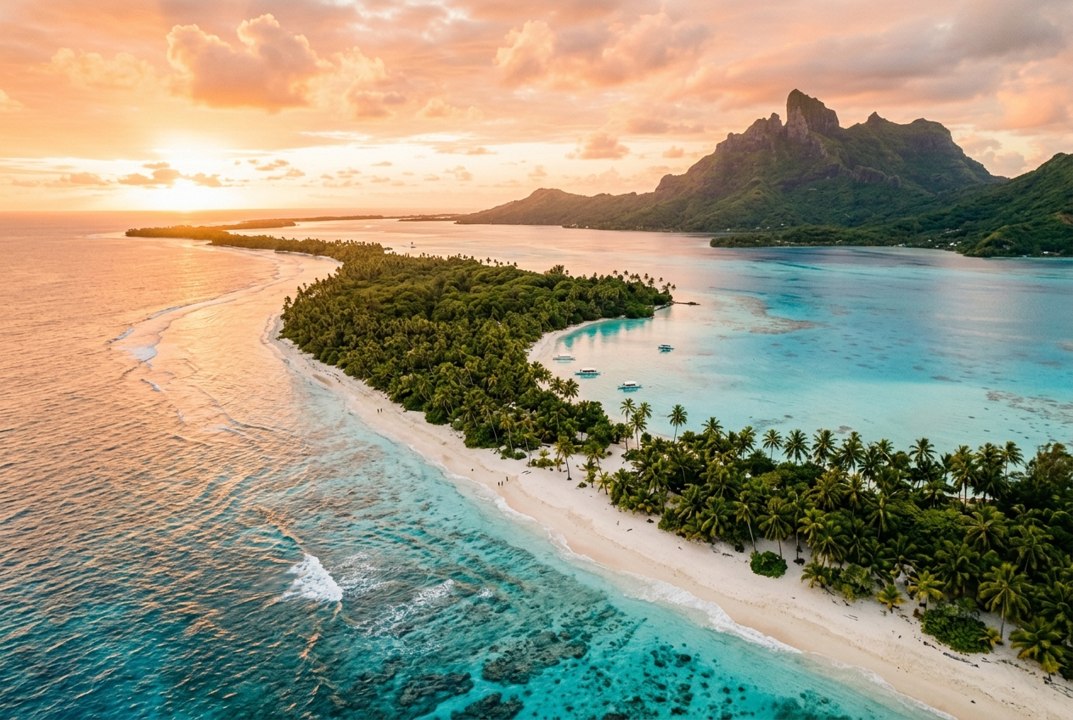
Suggested image for Homepage (AI-generated — see References).
- Full-width hero image (Figure) with headline 'Discover Taniti — Your Island Escape' and a 'Plan Your Trip' button that links to Lodging.
- Three preview cards (Lodging, Transportation, Attractions) linking to their pages.
- 'Explore Now' button → Entertainment/Attractions; 'View FAQs' → FAQs.
2. Lodging
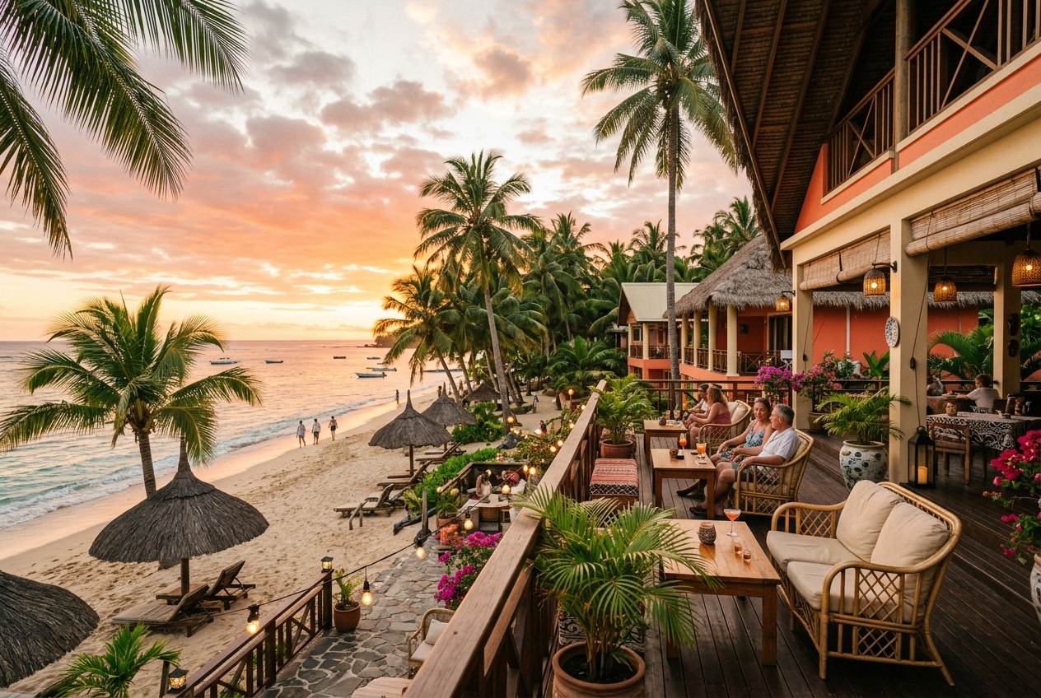
Suggested image for Lodging (AI-generated — see References).
- Banner image + heading 'Where to Stay'.
- Four cards: Taniti Grand Resort ($$$), Beachfront Hotels ($$), Merriton Landing B&Bs ($), Seaside Campground ($ — cheapest / most budget-friendly).
- Each card has a 'Book' button → Contact page (added from Nicole's feedback).
3. Transportation
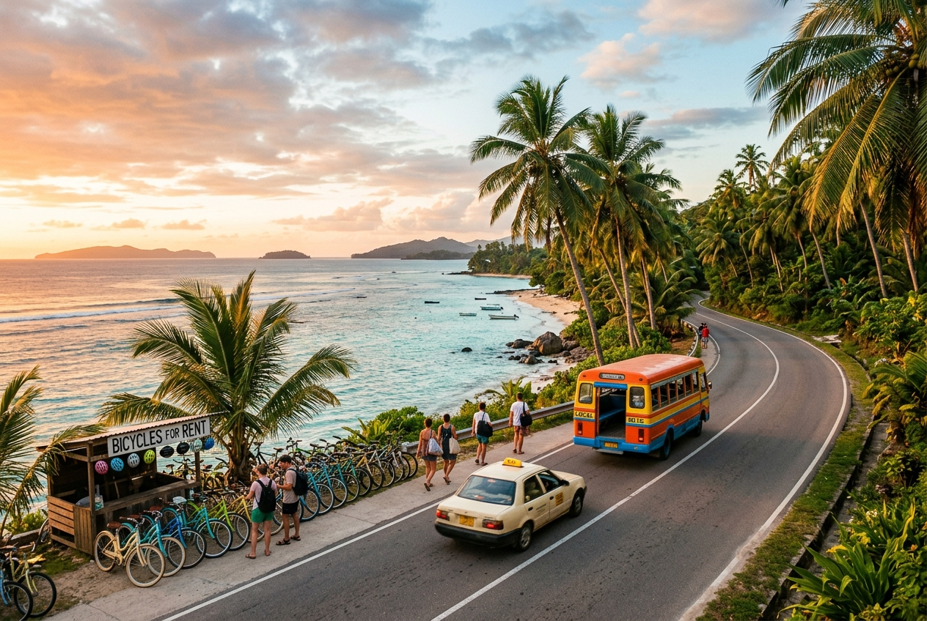
Suggested image for Transportation (AI-generated — see References).
- Banner + heading 'Getting Around Taniti'.
- List: rental cars (near the airport), public buses in Taniti City (5 a.m.–11 p.m.), private island buses, taxis, and bike rentals (helmets required by law).
- Callout box: 'No car? No problem' — buses, taxis, bikes, and walking.
4. Entertainment / Attractions
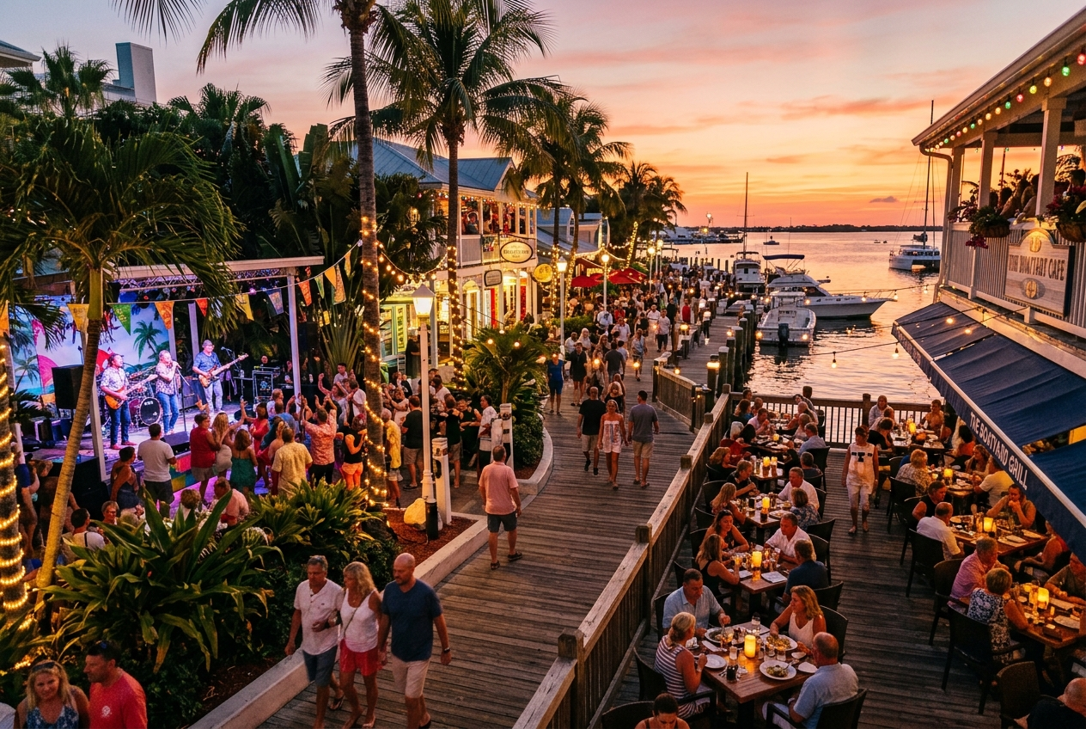
Suggested image for Entertainment / Attractions (AI-generated — see References).
- Banner + heading 'Things to Do'.
- Merriton Landing card: dining/restaurants, live music & nightlife, shopping, and boat tours.
- Additional cards: Mount Taniti volcano hikes, rainforest waterfall trails, beaches & snorkeling.
5. FAQs
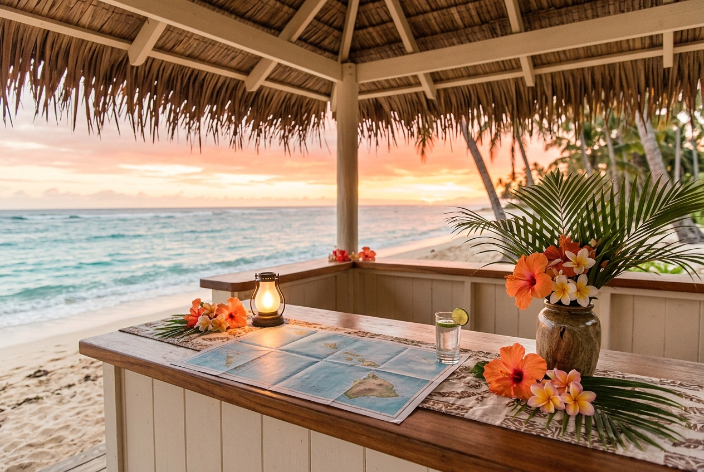
Suggested image for FAQs (AI-generated — see References).
- Banner + heading 'Frequently Asked Questions' as a tappable accordion (from Nicole's feedback).
- Q: Legal drinking age? A: 18. Q: Currency? Q: Is it safe? Q: Getting around without a car?
- 'Still have questions? Contact us' button → Contact.
6. Contact
Suggested image for Contact (AI-generated — see References).
- Banner + heading 'Plan & Book Your Trip'.
- Form fields: Name, Email, Travel dates, Message + 'Send / Book' button → confirmation state.
- Visitor Center phone, email, and address.
Wiring the clicks (Figma Prototype tab)
- Nav links on every page → corresponding page (use the shared nav component).
- 'Plan Your Trip' → Lodging; 'Book' → Contact; 'Contact us' → Contact.
- 'Send / Book' → a confirmation overlay ('Thanks! We'll be in touch').
- Set the Homepage as the flow starting point, then Share ▸ copy the public link.

