MEMBERS:

RIYA VISHNOI – MITCHELL – PRABHKIRTA-SHILONG

* BILL MANAGEMENT SYSTEM -

DATABASE SYSTEM QUERIES

Table of Contents

PRABHKIRAT’S SYSTEM QUERIES 2

QUERY 1: 2

QUERY 2: 2

QUERY 3: 2

QUERY 4: 2

RIYA’S SYSTEM QUERIES 4

QUERY 1: 4

QUERY 2: 4

QUERY 3: 5

QUERY 4: 5

QUERY 5: 5

QUERY 6: 5

QUERY 7: 6

QUERY 8: 6

MITCHELL’S SYSTEM QUERIES 7

QUERY 1: 7

QUERY 2: 7

QUERY 3: 7

QUERY 4: 7

QUERY 5: 8

QUERY 6: 8

SHILOONG’S SYSTEM QUERIES 9

QUERY 1: 9

QUERY 2: 9

QUERY 3: 9

## PRABHKIRAT’S SYSTEM QUERIES

### QUERY 1:

DESCRIPTION: The user should be able to see all of his bills for the following months.

This query lets the user see his due rent, electricity bill, and missed ones from the past month!

### QUERY 2:

DESCRIPTION: Lets the user view all his missed bills and informs him of the bill category he missed.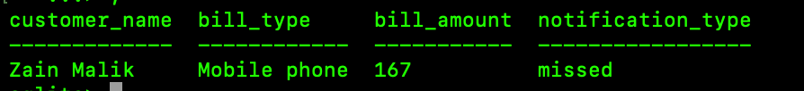

### QUERY 3:

DESCRIPTION: Delete paid bills completely form the database

1st image before-

2nd image after-

(No result meaning no entry found)

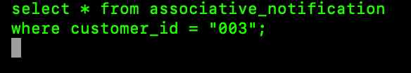

### QUERY 4:

DESCRIPTION: Updates the date of user bills if the provider made an error or the user got extension!

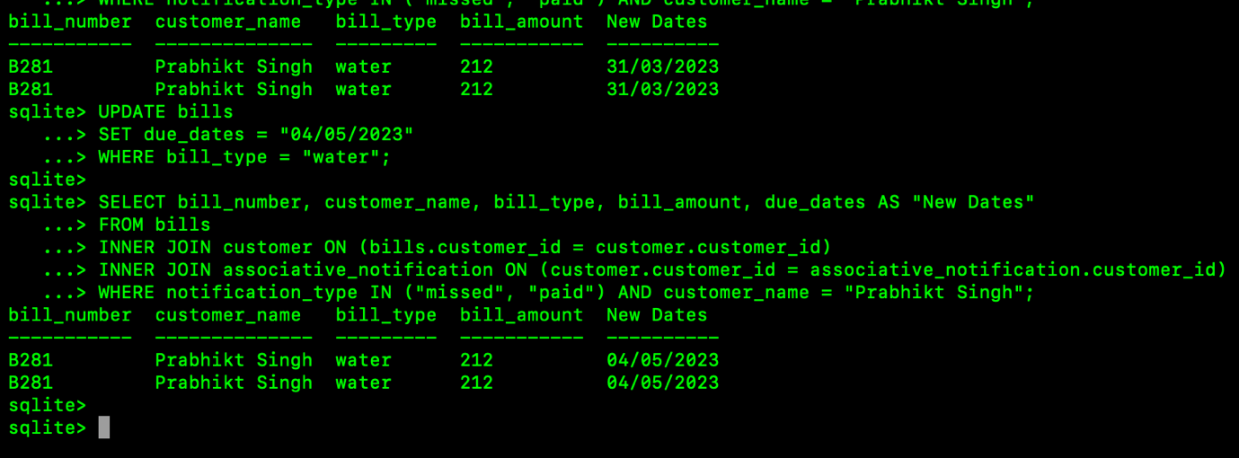

## RIYA’S SYSTEM QUERIES

### QUERY 1:

DESCRIPTION: This allows the system provider (our team to view the newly enrolled members)—since they won’t have any bills right after registration.

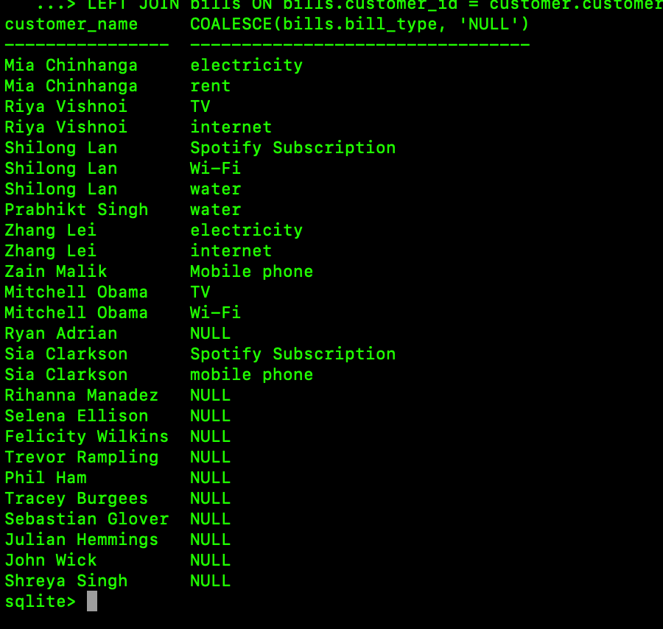

### QUERY 2:

DESCRIPTION: View if the user was fined for their missed bill.

NOTE: We are assuming the provider charge’s the user 1.5 times more on a missed bill as a fine.



### QUERY 3:

DESCRIPTION: View the total amount paid in bills for each month

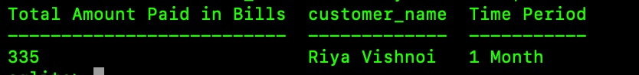

### QUERY 4:

DESCRIPTION: View the bill history of the user

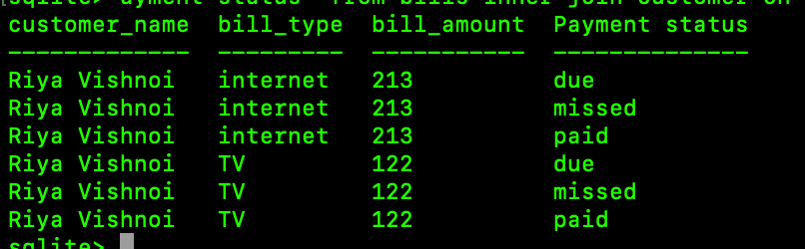

### QUERY 5:

DESCRIPTION: The user can also update any bill that the provider accidentally missed updating.

NOTE ** we assume the user needs to use his unique identity code to do this for security reasons”



### QUERY 6:

DESCRIPTION: Lets the provider view their monthly earnings from multiple users.

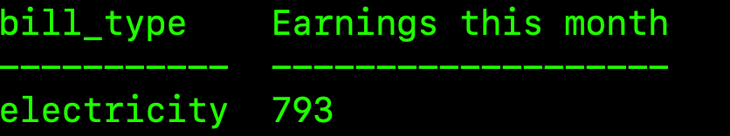

### QUERY 7:

DESCRIPTION: Give’s the System the ability to see how much money is paid to each provider for this month. This is helpful for the systems data storage

### QUERY 8:

DESCRIPTION: View which bank account is linked to which bill number for the user

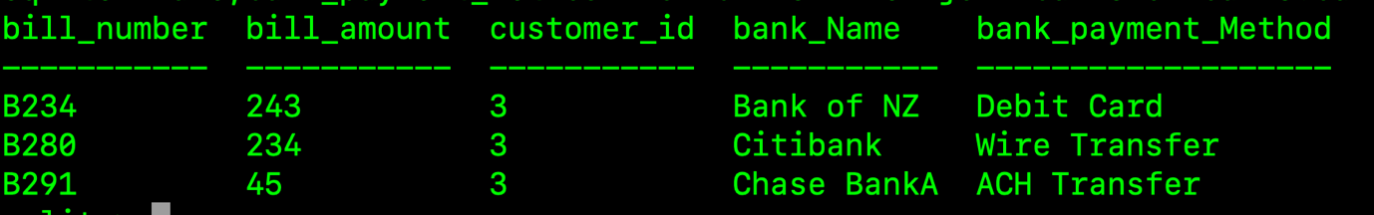

## MITCHELL’S SYSTEM QUERIES

### QUERY 1:

DESCRIPTION: view average money spent in expenses for the user.

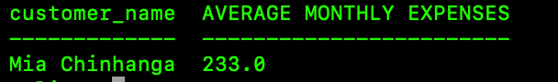

### QUERY 2:

DESCRIPTION: delete a given providers all paid bills

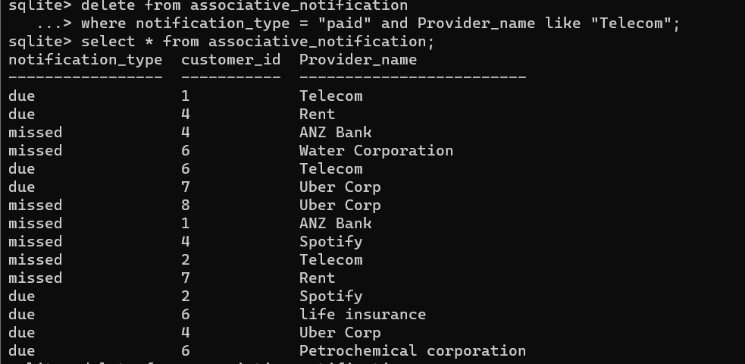

### QUERY 3:

DESCRIPTION: view the total number of user’s and providers enrolled in our system

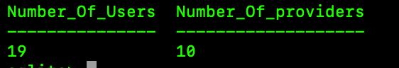

### QUERY 4:

DESCRIPTION: add a new customer



### QUERY 5:

DESCRIPTION: Customer should be able to update his personal details:

### QUERY 6:

DESCRIPTION: Customer can add or subtract amount to their bank balance

## SHILOONG’S SYSTEM QUERIES

### QUERY 1:

DESCRIPTION: Comprehensive report on the customer’s bills and bank information

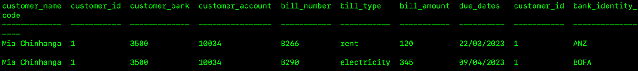

### QUERY 2:

DESCRIPTION: View the due dates of multiple bills

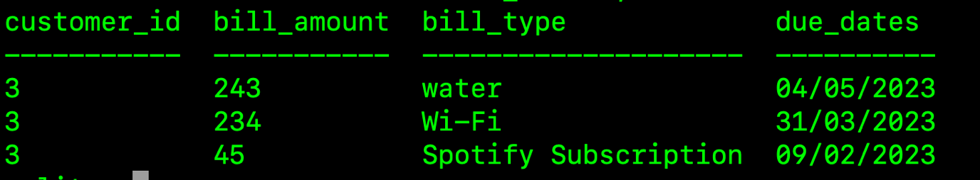

### QUERY 3:

DESCRIPTION: View customer’s Personal Information

