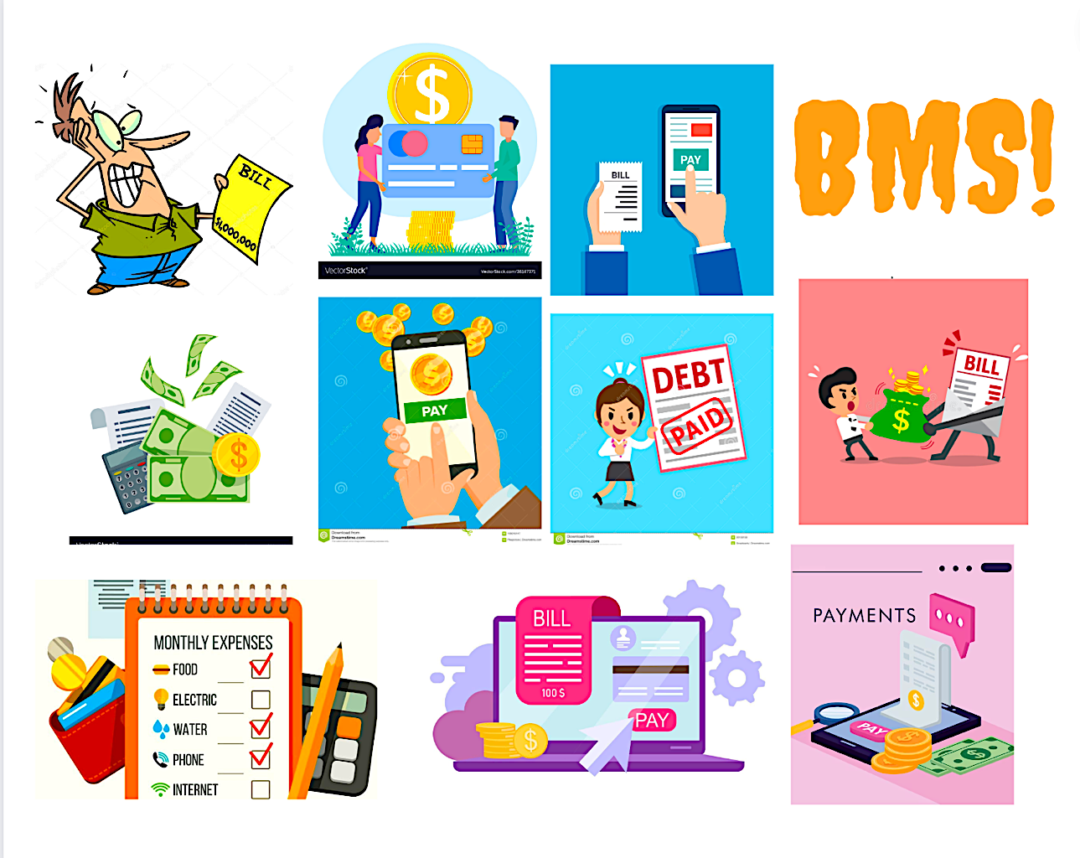

BILL Management System

** To Better Manage your bills, All in one Place**

A Report By Riya Vishnoi, Mitchell, Prabhkirat and Shilong

Cover Credit: Riya Vishnoi

Table of Contents

Section 1: System Idea in a Nutshell 3

Section 2: Story Behind the Idea 4

Section 3: Information Offered to the Users 5

Section 4: Data Stored by the System 6

Section 5: Where is the Data coming from? 7

Section 6: The Target User 8

Section 7: Similar Systems 9

Section 8: Benefit to the Users 10

Section 9: Diagrams and Visual/Logical Design 11

Section 10: Team Recognition! 12

# **Section 1: System Idea in a Nutshell**

Bill Management System is a relatively easy and adaptable system. Our primary focus is to provide users with the ease of paying each expense in one place. We understand the hassle of going to different providers or apps to deliver numerous amounts of bills.

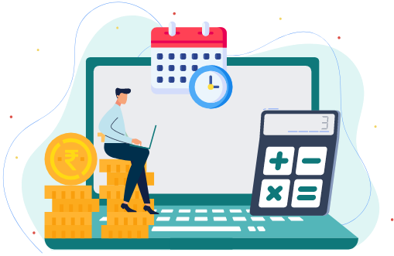

We came up with the idea to collaborate with banks and bill providers to make a database where every user can come to one place to pay all the bills.

Through this database, the user can meet his bills on time and catch up on their bill history with its built-in feature.

This system also has one unique feature. Users are free to put in their Card details for easy automatic payments. We follow a highly secured protocol and strive towards the highest level of security.

(Riya Vishnoi)

# **Section 2: Story Behind the Idea**

Bill Management is not a foreign topic to anyone. It has been the cause of stress for a lot of people. It has been spoken about in multiple TED talks and has acquired a top spot with numerous Motivational Speakers.

Despite all this knowledge about bill management, many people need help with the mismanagement of their bills. The sole reason is- The number of bills and the vast number of bill providers. It takes a little while before it becomes a humongous task.

Many students who leave their homes for the first time struggle with the same issue.

To tackle this problem, Our team devised a simple solution- Multiple Bills in one database. This system would help users access all types of bills in one go.

BMS (Bill Management System) would be a helpful and efficient way to save time and tackle expenses like a PRO!

* --This chart represents some of the different types of bills a normal User pays monthly--

(Riya Vishnoi)

# **Section 3: Information Offered to the Users**

Our system says it all with banking and bill details, it offers users an efficient use of their money and time. Keeping track of your daily life can be stressful without a system to keep you in check.

BMS helps users manage all their bills in one place rather than going to different websites and tackling every bill individually. Beyond that, our system keeps a record of the user's history, which the user can access at any time. It also allows the user to attack the upcoming due dates of their payments.

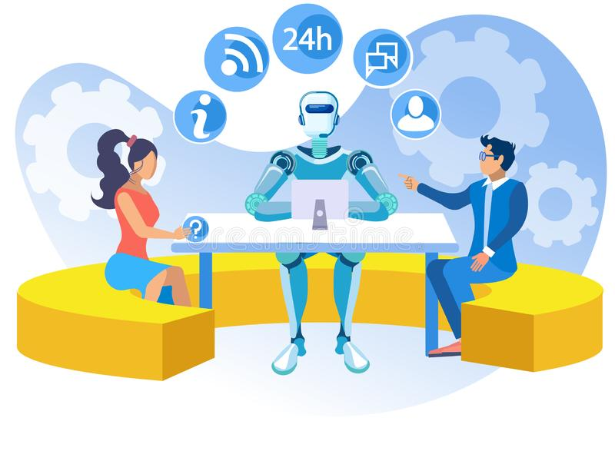

The system also offers a reminder option to notify users of bills that must be paid on specific dates. We strive to update the user with their invoice due dates and provide them with an acknowledgement slip.

The user can bend the app in a lot of ways.

1. It can be used to Manage, Track and Review old and upcoming payments.
2. It can also be used to keep an eye on one’s payment trends and monthly budgets. (Mitchell & Prabhkirat)

# **Section 4: Data Stored by the System**

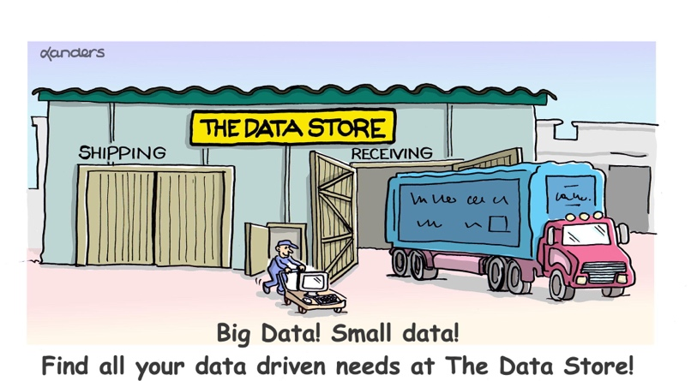

The primary data that will be stored will belong to the user, consisting of their personal information.

Personal Information: Name ; Address; Phone Number; Email Address

*It is necessary for the system to maintain up-to-date financial information to pay the Bills on a Timely Basis.*

Financial Information: Credit or Debit card; Bank - Collected Information;

The other data that the system can* store is keeping a trend analysis of the user's payments. Certain types of queries will let the user figure out how much they are paying on certain expenses.

(Prabhkirat)

# **Section 5: Where is the Data coming from?**

The data will mostly be coming from the user and the billing provider, the user will provide their banking details, name, address, and the billing provider will provide the bill amount along with the type of bill. With the whole information from both actors, we can kick-start our system by analysing the data.

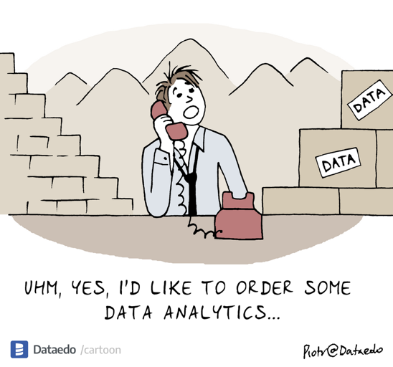

We also have a third actor who plays a special role in the system- The Bank. This actor is responsible for providing the system with User Information and also Validating the Manual Information entered by the user.

The data will be achieved through records of previous payment history that are stored online, along with some information from the bill providers regarding every specific user.

The system does not rely on the insecure saving of user data. It follows a Level 4 encryption and values the Users' need for privacy and Data Integrity.

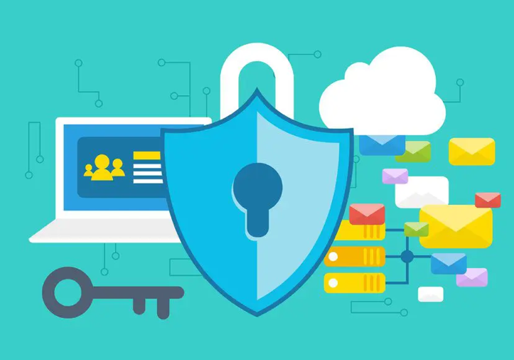 (Mitchell)

# **Section 6: The Target User**

Ideally, any person would use this system regardless of their work sector. We provide the ability to use this system as a Household bill Management system and a company's Bill/Invoices Management system.

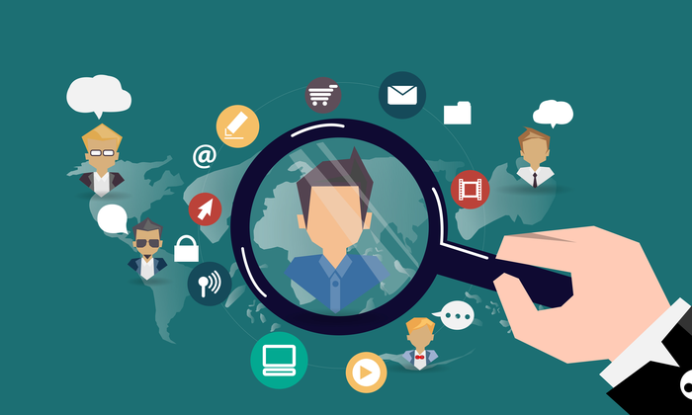

Bill management function can provide users with safe and convenient electricity, water, gas, phone, broadband and other convenient life payment services. A system would solve the dilemma of travelling to many places to pay. Workers and homemakers can manage and pay all the bills without leaving home. People can have more time to do everything.

(Shilong)

# **Section 7: Similar Systems**

There are several apps that provide features similar to our BMS system. Some of the Systems follow certain features whereas some of them provide similar functionality.

1. Alipay: It is committed to providing "simple, secure, fast and convenient" payment solutions for enterprises and individuals. It has features like- power, water bill payments, and mobile phone recharge. It is similar to our System however it has a lot of miscellaneous features which increases the complexity of the system
2. Prism: Prism is an IOS/Android app designed to manage your bills. The main goal is to avoid late and missing payments. It is quite similar to our system in encryption and the basic concept. However, it does not provide the user with acknowledgement of their paid bills by keeping a track of the history.
3. Bill Keeper: This app helps people pay their bills on time. It also helps manage future payments—Which is the main MANTRA of our system. Similar to our system, Bill keeper allows the user to set up reminders and keep track of old payments

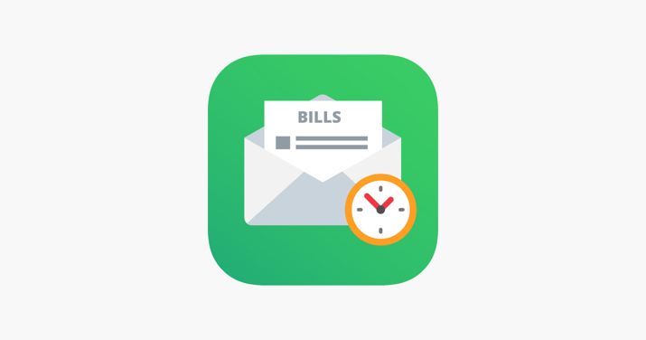

(Shilong & Mitchell)

# **Section 8: Benefit to the Users**

This section is focused on the benefits offered to the user.

1. The primary feature the system offers is keeping track of past payments. This will help the user to verify any payments they have or haven’t made.
2. We also provide the user with Notifications/ Reminders to help them never miss out on a due date. This can be beneficial to a user who has huge amounts of bills to keep a track of or just for people who have busy life schedules.
3. The other feature we offer is to help users analyse his/her payment trends. It helps the user to improve their expenses and better manage their bills.
4. This app Provides the user with the ease of paying their bills. Users can set up automatic payments and not worry about their bills again. After every bill payment, the bank and the app will notify the user.

 (Riya Vishnoi)

# **Section 9: Diagrams and Visual/Logical Design**

Credit: Riya Vishnoi & Mitchell