Lab Practical #01:
Study of basic networking commands and IP configuration.
Practical Assignment #01:
- Perform and explain various networking commands listed below:
  - ipconfig
  - ping
  - getmac
  - systeminfo
  - traceroute / tracert
  - netstat
  - nslookup
  - hostname
  - pathping
  - arp

ipconfig

Description:
- display IP address (IPv4/IPv6)
- To view Wi-Fi or Ethernet connection status
- It helps you check or fix your internet connection.
- Shows basic IP address info.
No. | Option | Description
1 | Ipconfig | Shows basic network info like Ip address
2 | Ipconfig/all | Shows full details like Ip address, MAC, DNS
3 | Ipconfig/release | Disconnects your Ip address
4 | Ipconfig/renew | Gets a new Ip address from the router
5 | Ipconfig/? | Shows help for all ipconfig commands

Implementation:

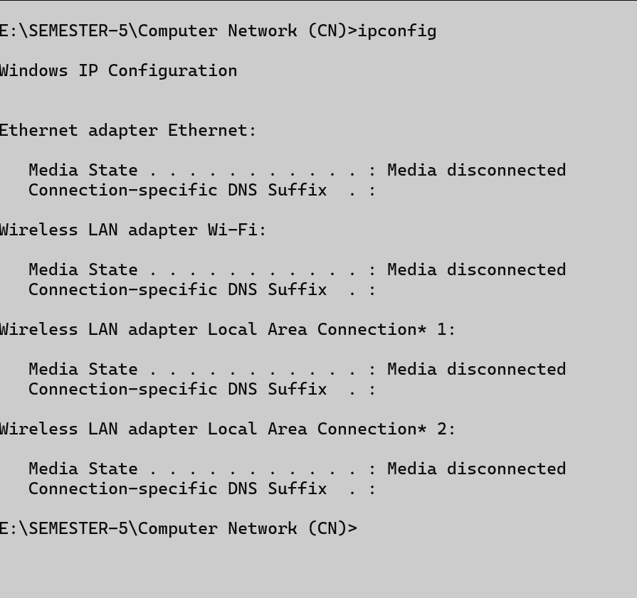
Ipconfig:

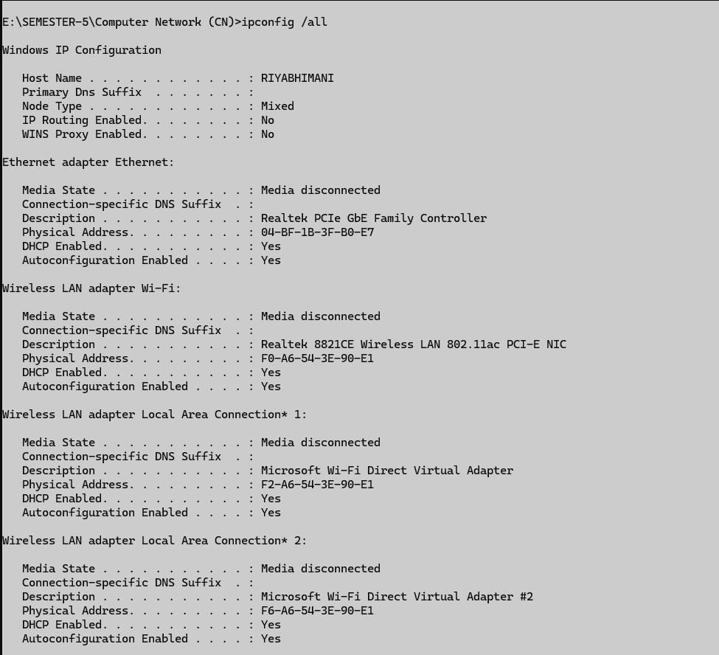
Ipconfig/all:

Ipconfig/release: 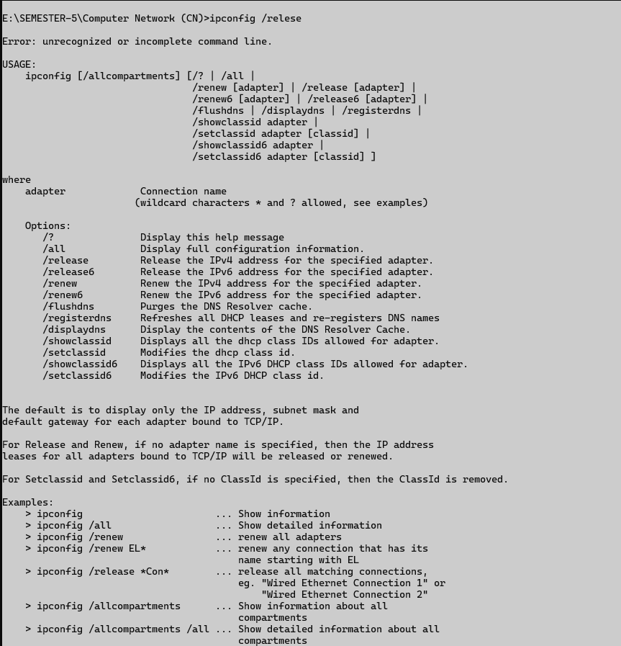

Ipconfig/renew: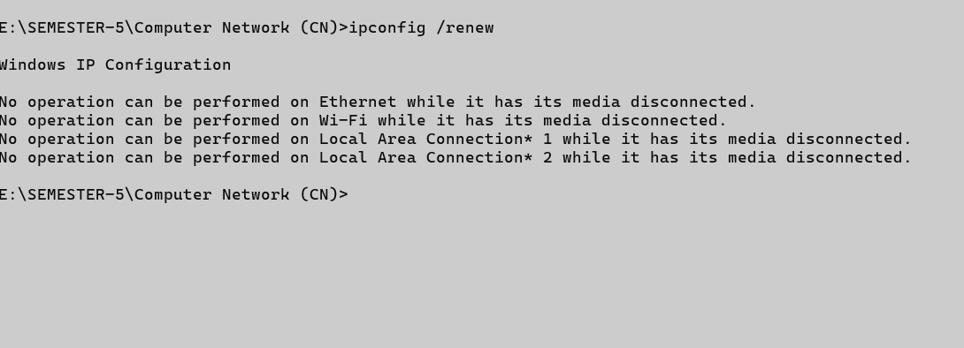
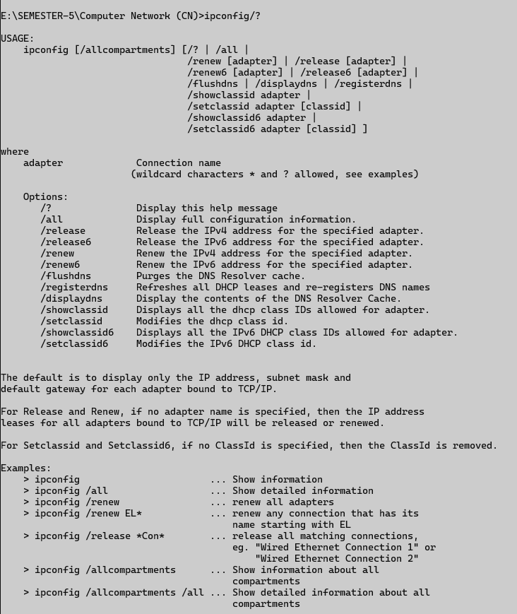
Ipconfig/?

ping

Description:
- It is used to check if a device is reachable over a network or the internet.
- Check your internet connection.
- Check if internet is working.
- Measure network speed/delay
- Output: response time, TTL (Time to live), packets send and received
No. | Option | Description
1 | -a (ping -a google.com ) | Shows the host name from an Ip address.
2 | -t (ping -t google.com ) | Pings continuously until you stop.
3 | -l (ping -l 100 google.com) | Set a custom size of ping packet
4 | -n (ping -n 5 google.com) | Set number of ping to send
5 | ping | Shows help for all ipconfig commands

Implementation:
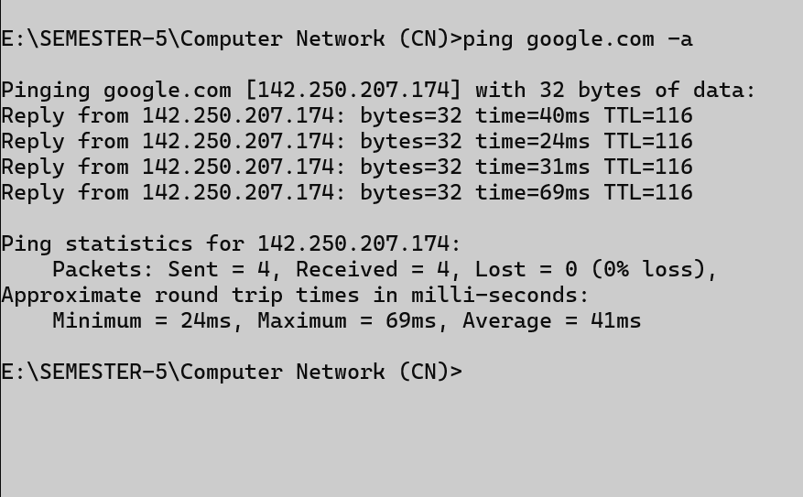
ping -a google.com:

Ping -t google.com:
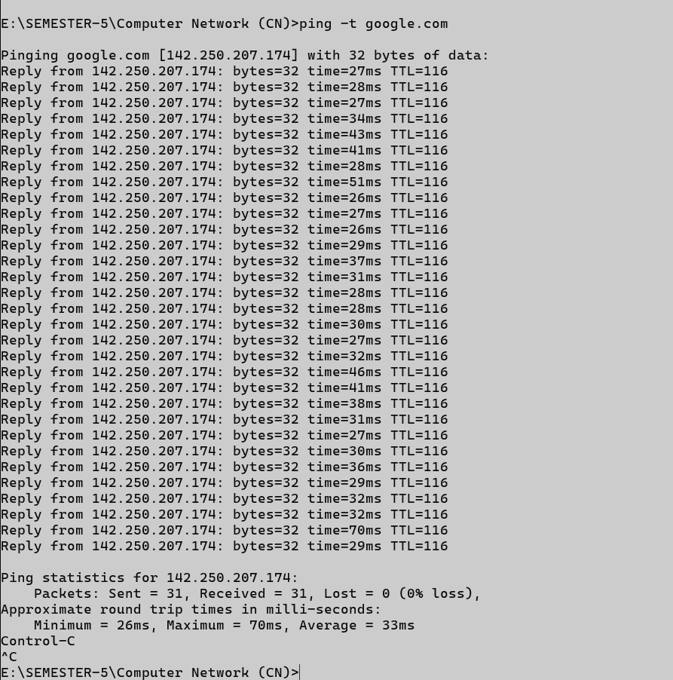

Ping -l 64:
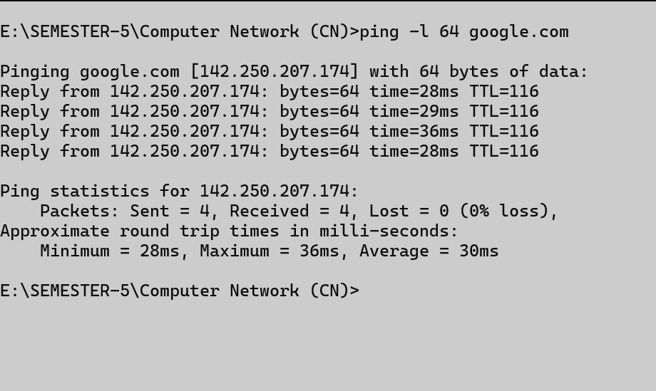
Ping -n 2:
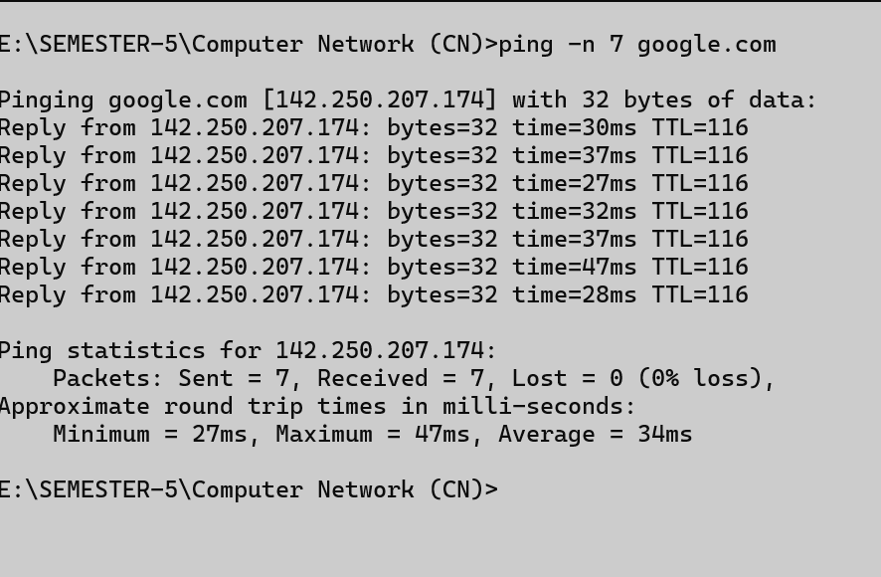
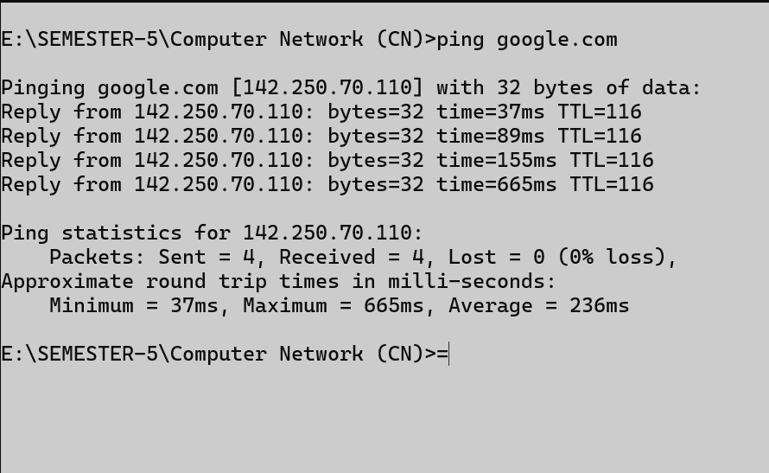
Ping:

Getmac

Description:
- Shows the MAC address of your computer’s network adapter.
- MAC is unique ID for your computer’s network hardware.
- Find your MAC address and helpful in IT support.

No. | Option | Description
1 | Getmac /? | Shows help for all ipconfig commands.
2 | Getmac/ fo csv | Shows output in CSV format
3 | Getmac / NH | Removes the header row.
4 | Getmac/v | Shows detailed info like connection name and status.

Getmac/? :
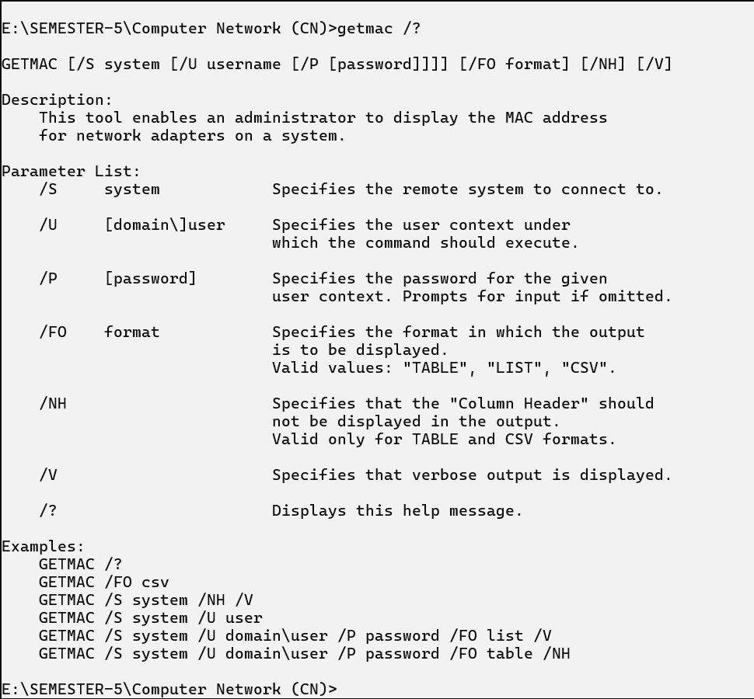
Getmac / Fo csv:
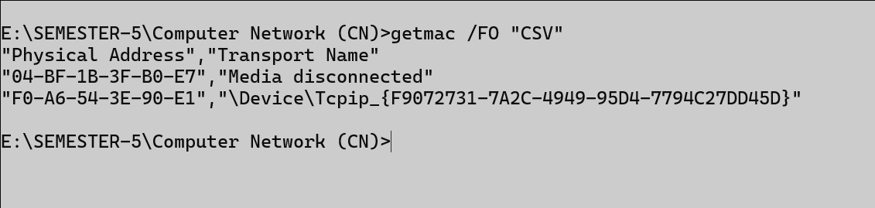
Getmac /NH:

Getmac/v:
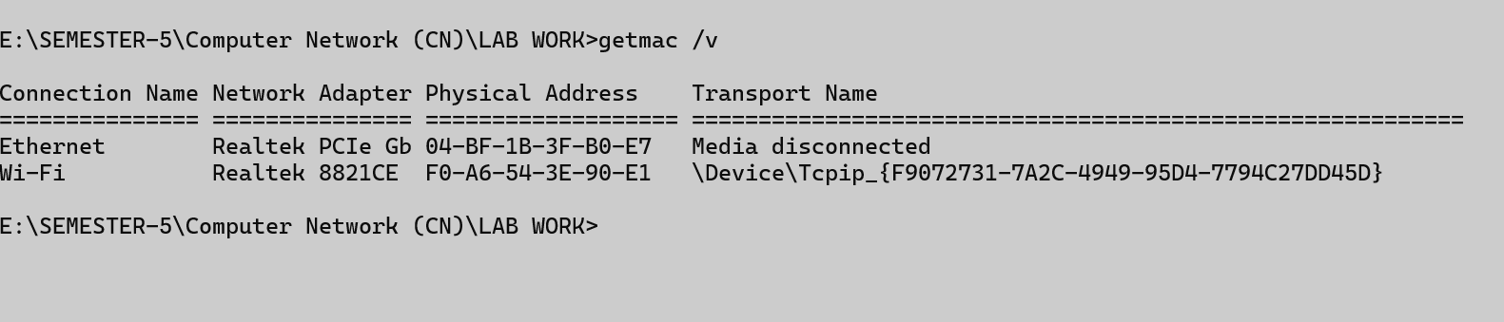

Systeminfo

Description:
- Show detailed information about your computer system.
- Give you a full report of your PC’s hardware and software.
- Find the boot time or update history.

No. | Option | Description
1 | systeminfo | Shows help for all systeminfo commands.
2 | Systeminfo/S systemname | Shows detailed configuration info of a remote system.
3 | Systeminfo/S systemname /U username | Gets remote system details using specified user credentials.
4 | Systeminfo/FO | Formats system information output as TABLE, LIST, or CSV.

Systeminfo:
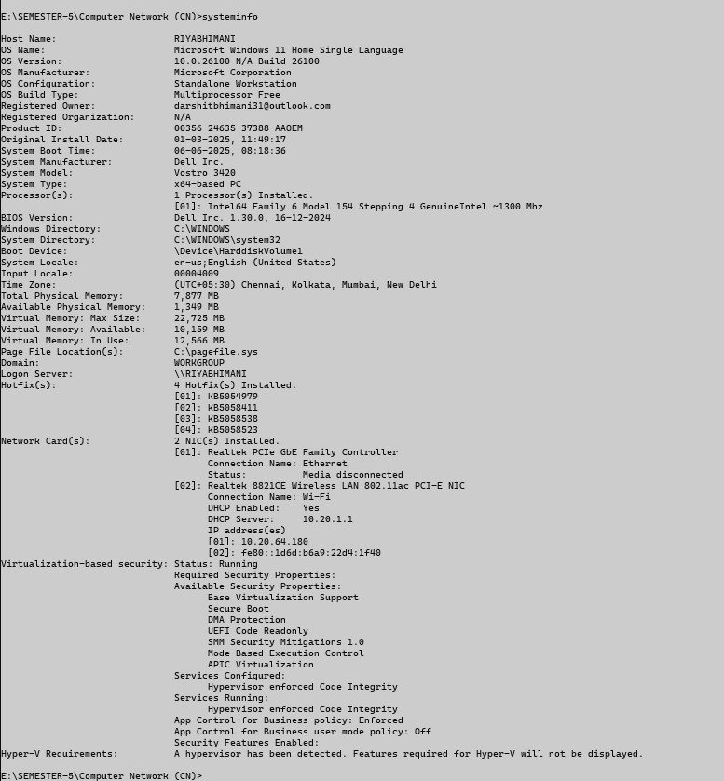

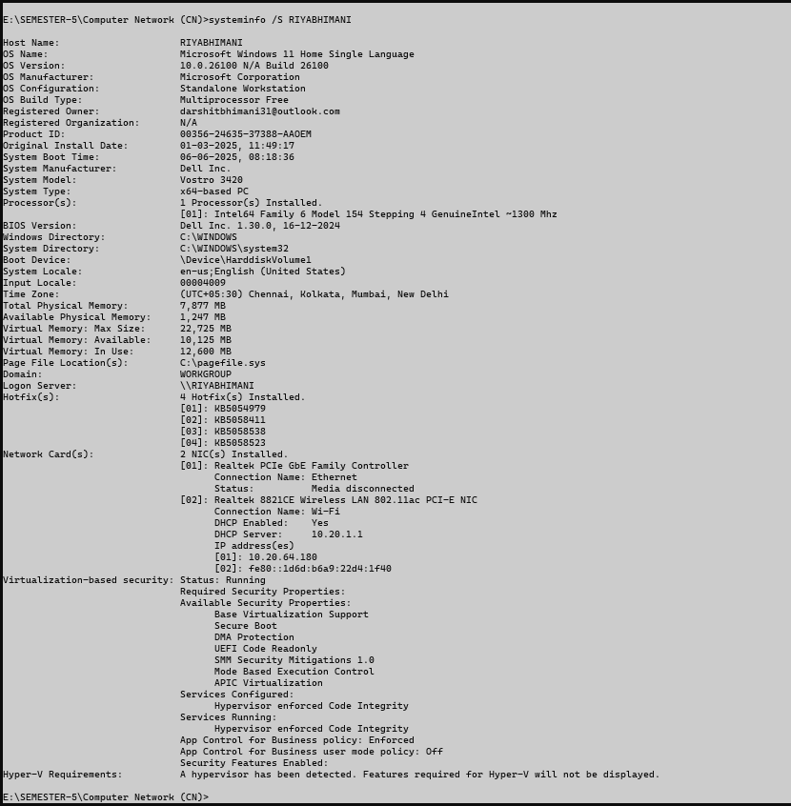
System/S :

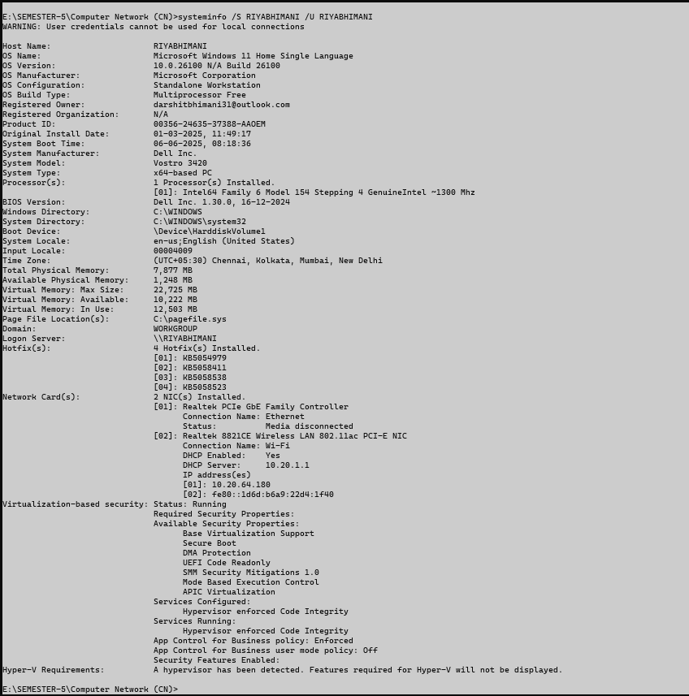
System/S/U:

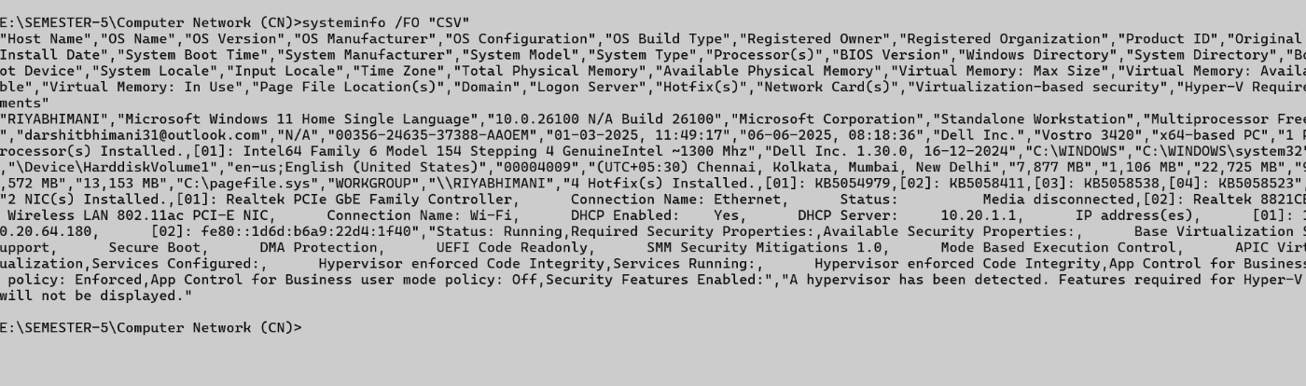
System/FO :

Traceroute / tracert

Description:
- This command shows the full path that your data takes to go from your computer to another website or server on the internet.
- Helps you see how your data travels.
- Helps troubleshoot slow internet or no connection.
- Sends small packets to the destination
No. | Option | Description
1 | -d (tracert -d google.com) | Don’t show router names(faster)
2 | -h (tracert -h 10 google.com) | Set how many steps to try
3 | -w (tracert -w 1000 google.com) | Set how long to wait for each hop
4 | -4 (tracert -4 google.com) | IPv4 only (like 192.168.1.1)
5 | -5 (tracert -6 google.com) | IPv6 only (like 2401:4900::1)

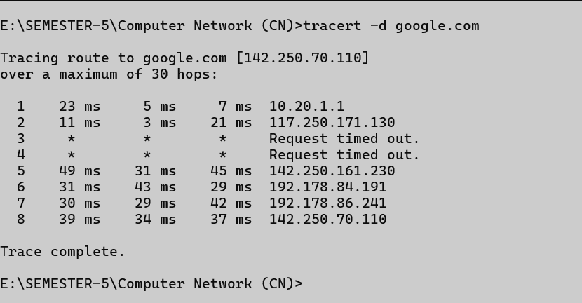
Tracert -d google.com:

Tracert -h 5 google.com:
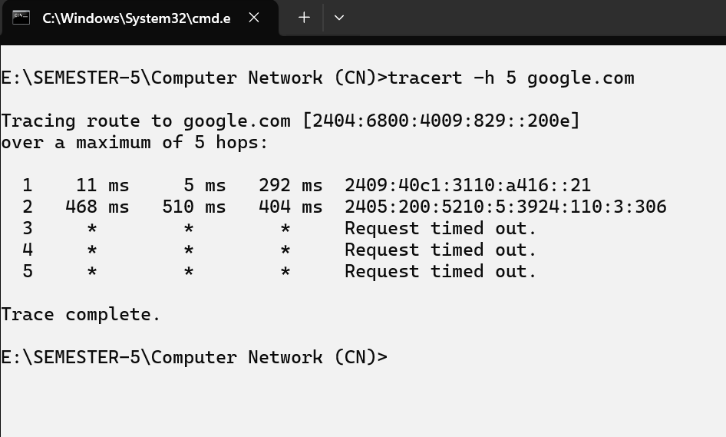
Tracert -w 10 google.com:
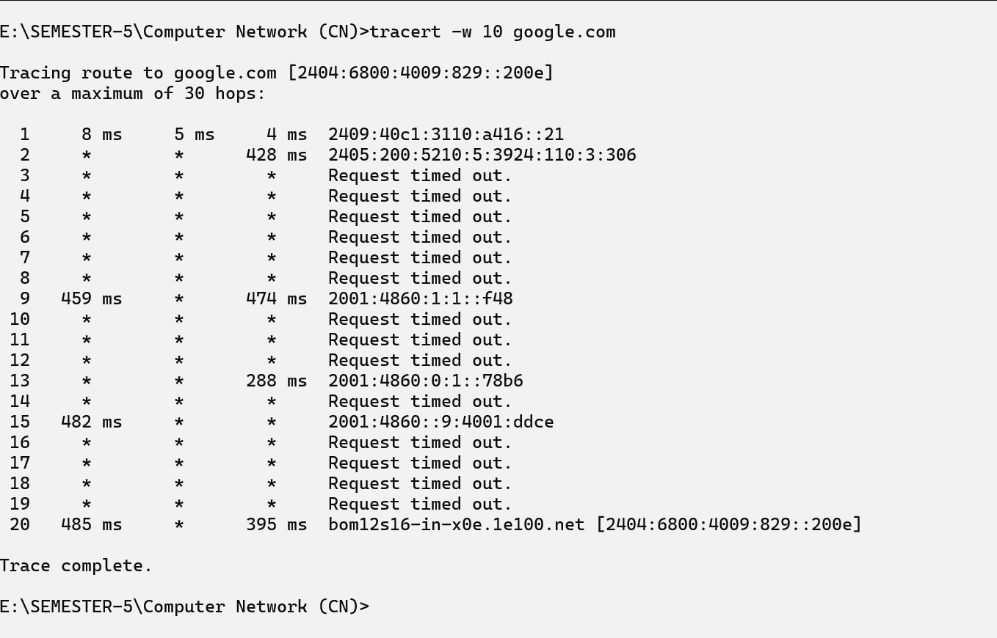
Tracert -4 google.com:
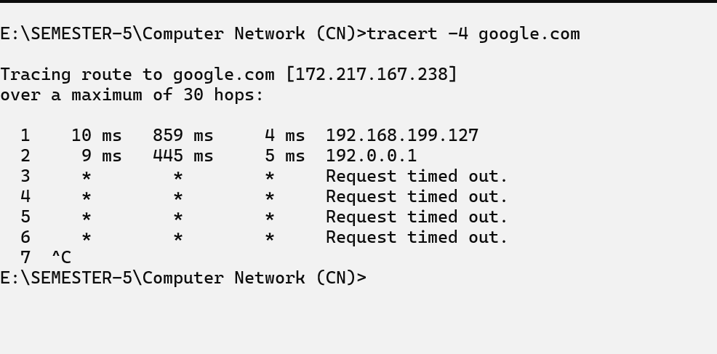
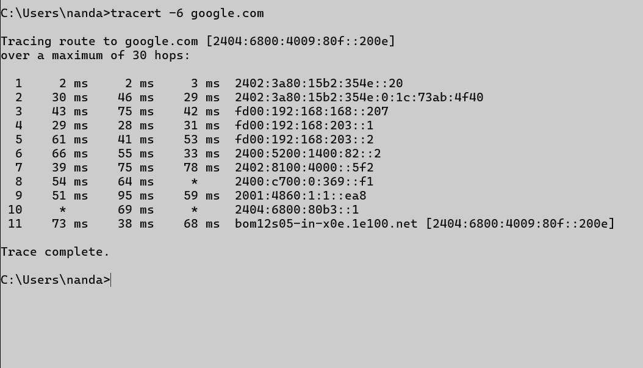
Tracert -6 google.com:

Netstat

Description:
- Show detailed information about your computer’s network connections.
- To check active internet or network connections.
- To see which programs are using the internet.
No. | Option | Description
1 | Netstat/? | Shows detailed info like connection name and status.
2 | Netstat -a | Shows all connections and ports
3 | Netstat -b | Shows the name of the program / app using each connection/port.
4 | Netstat -c | -c is used in Linux, not in windows.

Netstat/?:
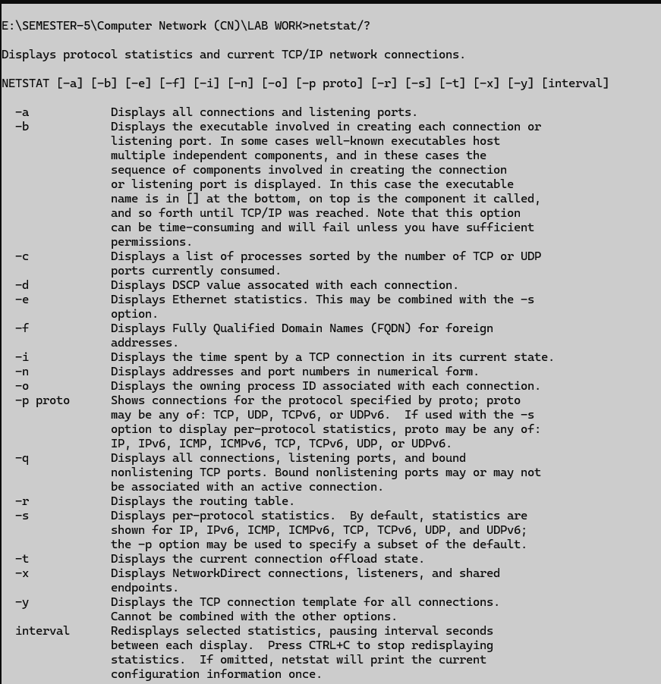

Netstat -a:
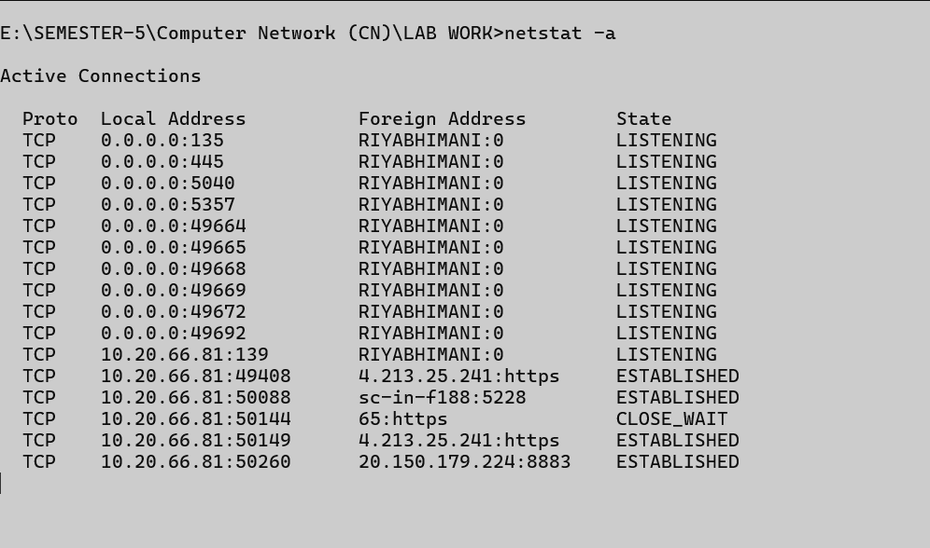
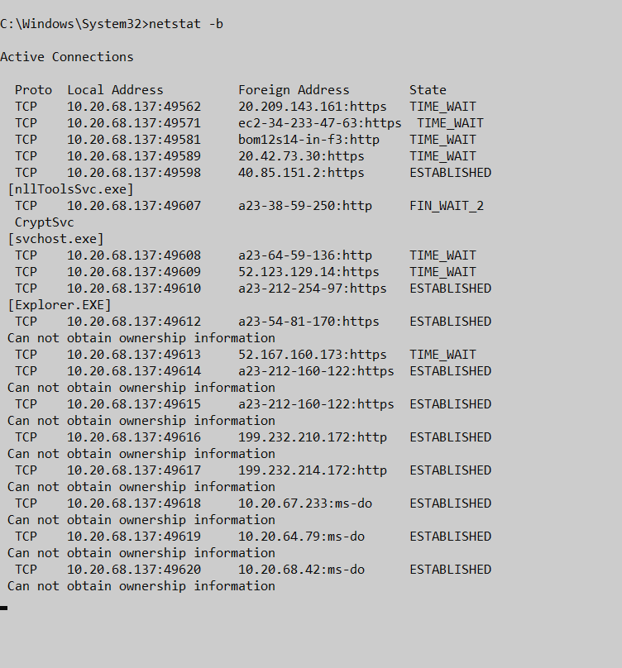
Netstat -b:

netstat -c:
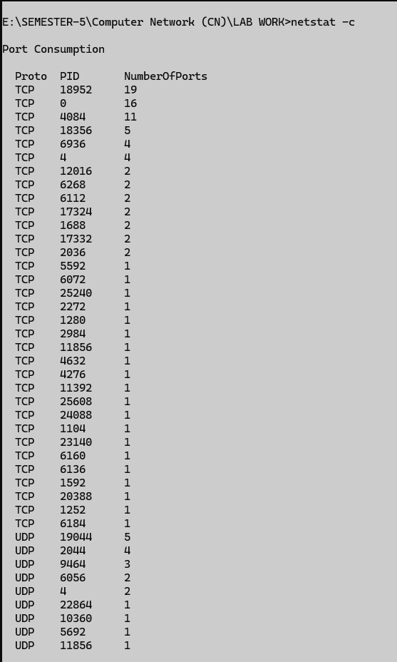

Nslookup

Description:
- Checking if a domain is correctly resolving to an Ip.
- Finding mail servers for a domain.
- To see the Ip address of a domain.
- Helpful in networking and website troubleshooting.
No. | Option | Description
1 | Host (host google.com) | Any device with an Ip address.
2 | Server (nslookup) | A host that provides a service.

Host:
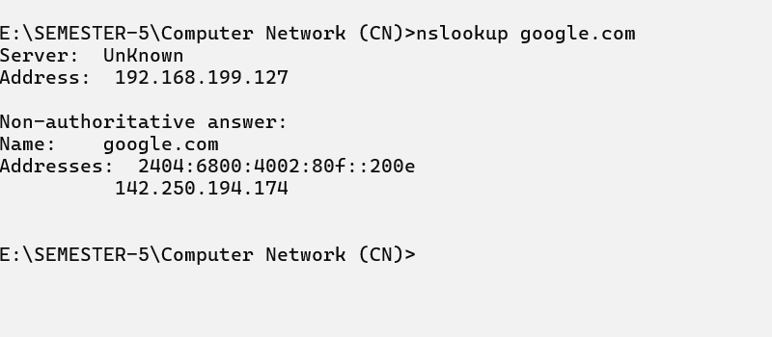
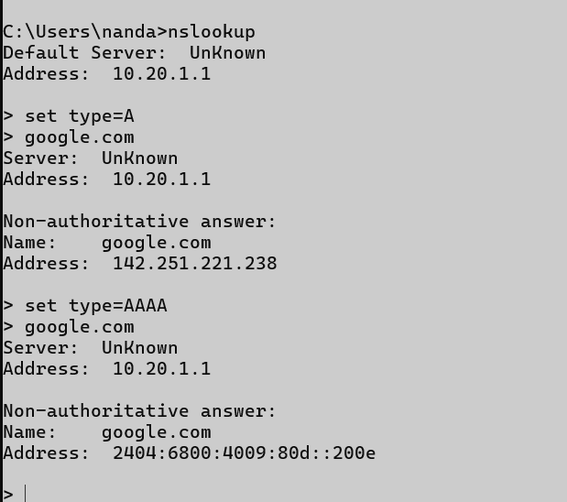
Server:

Hostname

Description:
- See the current name of the machine.
- This hostname helps in identifying a device on a network.
No. | Option | Description
1 | hostname | Show current hostname.

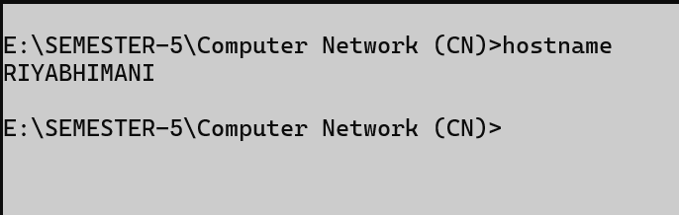
Hostname:

Pathping

Description:
- The pathping command helps you find where your network connection is slow or losing data.
- Here’s how you can use it in a very simple way.

No. | Option | Description
1 | /? (pathping) | Shows detailed info like connection name and status.
2 | -h (pasthping -h 10 google.com) | Limits how far the packet can travel.
3 | -g (pathping -g google.com) | Force path through specific routers.
4 | -w (pathping -w 3000 google.com) | sets how long pathping waits for a reply from each hop before considering it timed out.

Pathping:
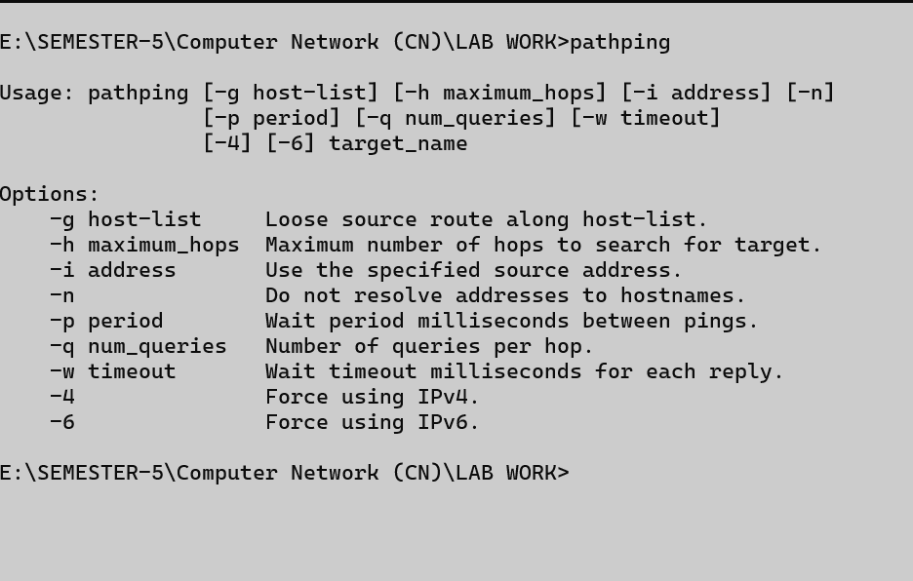
pathping -h:
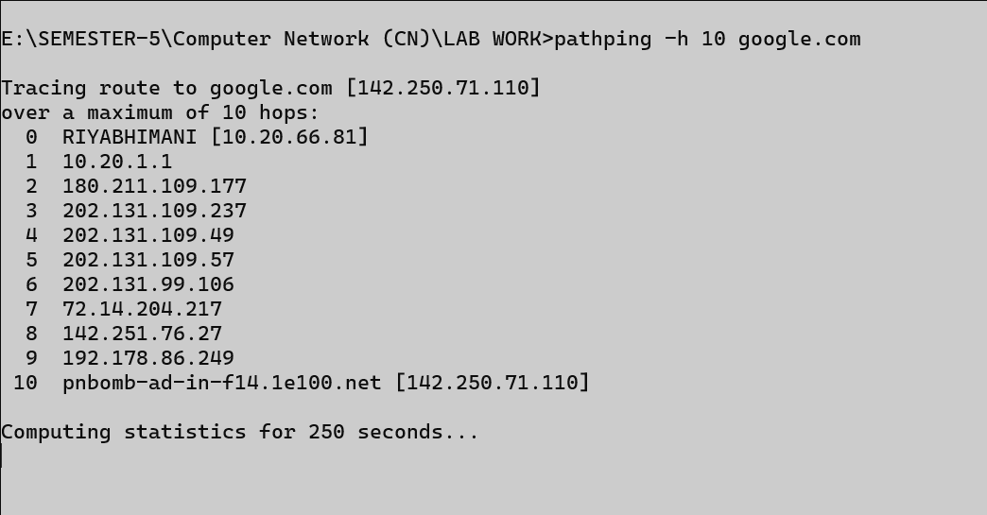

pathping -g google.com
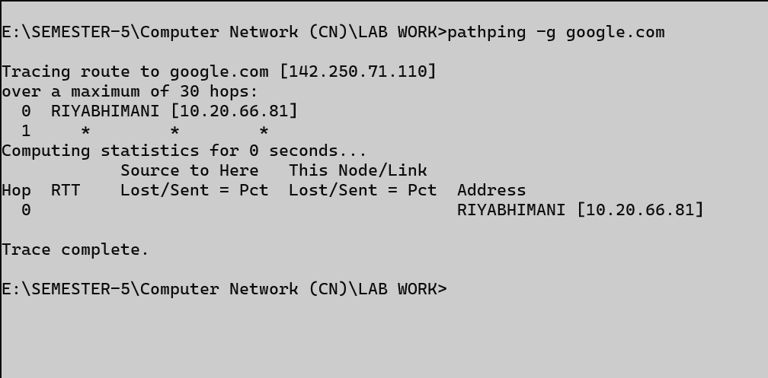
pathping -w 3000 google.com
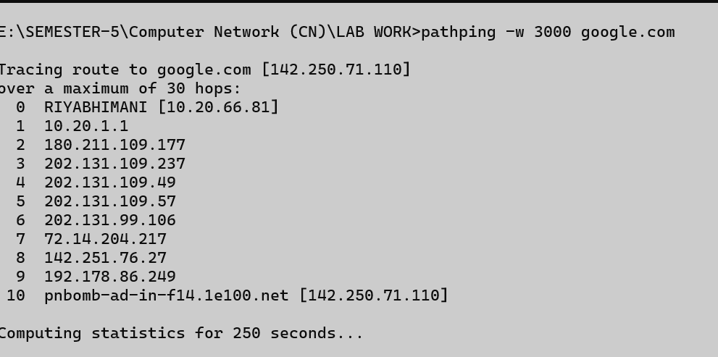

Arp

Description:
- ARP stands for Address Resolution Protocol.
- It is used to find the MAC address of a device from its Ip address in a local network.
No. | Option | Description
1 | Arp/? | Shows help for all systeminfo commands.
2 | Arp -a | Shows the ARP table (IP to MAC address mapping)
3 | Arp -g | Shows IP-to-MAC address mappings on the local network.

Arp/?
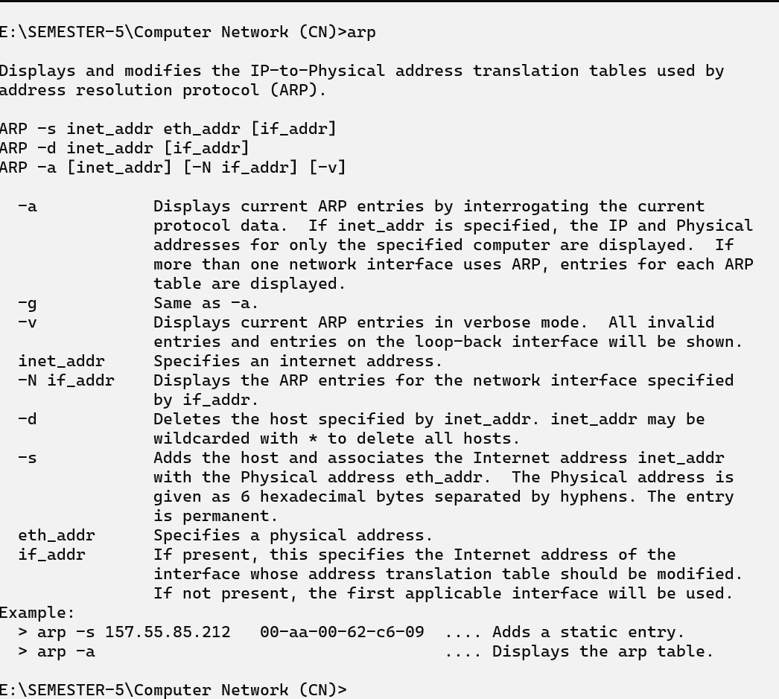

Arp -a
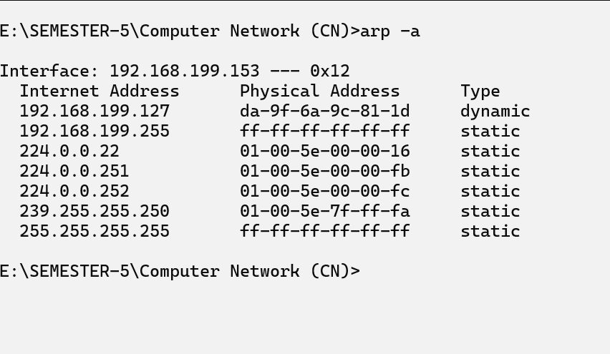
Arp -g:
