**SMART TRAFFIC COMMERCIAL BILBOARD**

**TEAM : TEAM TRACKER.**

**SUBMITTED TO :**

Name : Rifat Bin Rashid.

Department: Department Of CSE.

**SUBMITTED BY:**

1. Name: Arpon Kar Angtip.

Id: 011221180.

1. Name: Arshad Md. Adel

Id: 011221299

1. Name: Md. Jamilur Rahman

Id: 011211097

1. Name: A.H.M. Fahim Tanjim

Id: 011211021

1. Name: Mahabub Hasan Riyad

Id: 011211007

**Description**

Efficient traffic management is vital to the development of any country or region. It plays a crucial role in managing the residents' daily working time, and a poorly functioning transport management system can lead to the collapse of the traffic system, wasting millions of daily working hours. This can significantly hinder the growth and development of a country. Therefore, implementing an effective transportation management system is essential for the progress of a developing country.

However, during rush hours, managing traffic flow can be a challenging task for traffic police. Hiring more labor can be expensive, and the outcome may not be as efficient. Our project aims to solve this problem optimally. We plan to install a billboard that can be controlled manually and automatically using a specific time period. The led billboard will display messages to stop cars, show traffic messages to individual lane users, and provide information on traffic management. It will also display when passengers overpass. In case of an emergency, there will be an emergency traffic management system that will display emergency messages on billboards. Additionally, if a specific lane is congested or blocked, sensors will notify drivers to use an alternative route. There will also be an option for emergency help, where the location of the nearest emergency facility will be transmitted wirelessly to the controller, and the billboard will be shown the corresponding message.

**Features**

Now a days traffic management is so necessary. Because it is going worst day by day by making so much traffic. To save our valuable working time we build that project to ensure development and also reduce people suffering from traffic. To ensure that system will incorporate the following things:

1. Through android apps it will show any kind of message in led billboard by communication module (Wi-Fi or Bluetooth).

2. It will trace any kind of opposite lane is block through motion sensor and suggest them use to alternative way.

3. Maintain proper transportation through billboard automatically or manually also through apps.

4. At emergency time there will be sound detector and bill board will show emergency pass and block the other lane.

5. there will GPS tracker for any emergency help it will transmit location in mobile through communication module.

**Necessary** **Components**

|  |  |  |  |
| --- | --- | --- | --- |
| SL NO. | Name | Model | Quantity |
| 01 | Arduino | UNO R3 | 1 |
| 02 | LED Bulb | 5mm small LED | 400 |
| 03 | Resistor | 10K | 1 |
| 04 | Resistor | 220 Ohms | 42 |
| 05 | IC | 74HC595 | 7 |
| 06 | IC | ULN2803 | 1 |
| 07 | IC | 7805 | 2 |
| 08 | Sound Sensor |  | 4 |
| 09 | Motion detector Sensor |  | 2 |
| 10 | Servo Motor | MG995 | 1 |
| 11 | Push Button |  | 8 |
| 12 | Dote Board |  | 1 |
| 13 | 16pin IC Base |  | 7 |
| 14 | 18pin IC Base |  | 1 |
| 15 | 28pin IC Base |  | 1 |
| 16 | Male Hader |  | 2 |
| 17 | Female Hader |  | 2 |
| 18 | Capacitor | 100uf- 25V | 1 |
| 19 | Capacitor | 10uf - 50V | 2 |
| 20 | 5 Way Gang Board |  | 1 |
| 21 | DC Socket |  | 1 |
| 22 | SPST Switch |  | 1 |

**Estimate Cost-5000/=TK.**

**DIAGRAM**

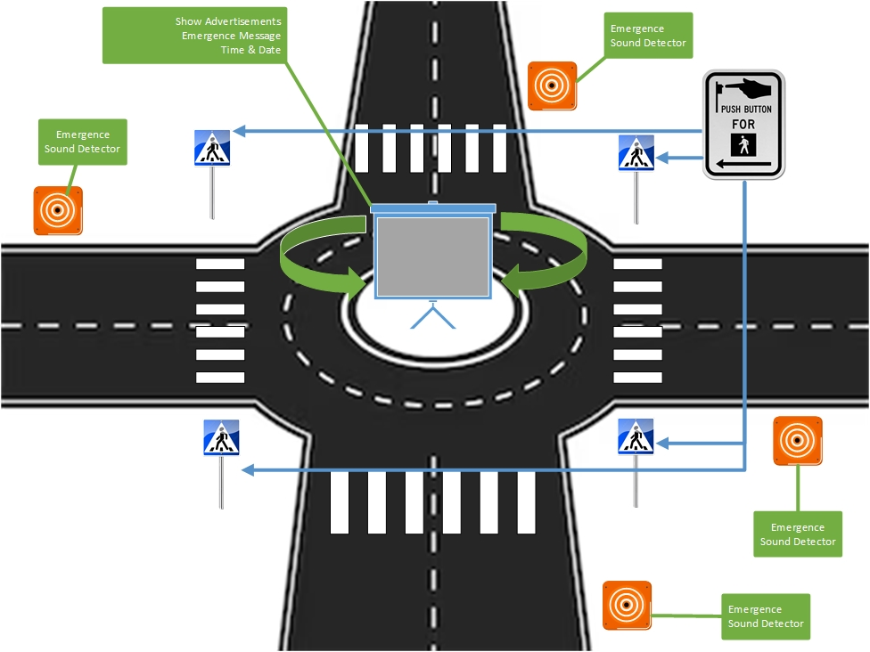

**Future Scope of Work**

The future scope of our work involves the implementation of a sensor-based system to monitor speeding vehicles. In addition, our system will include smart fire detection and an automatic emergency response system for accidents. This will include the transfer of emergency support to the location of the incident and display a helpful message on an LED billboard. Our aim is to ensure efficient and effective management of such situations, promoting safety and security for all.