A PROJECT REPORT
ON

Computer-Aided Identification of New Candidate Inhibitor Molecules for LSD1, a Protein Target in Cancer

Submitted to

DES PUNE UNIVERSITY
SCHOOL OF SCIENCE AND MATHEMATICS
DEPARTMENT OF LIFE SCIENCES

M.Sc. BIOINFORMATICS

By
Riya Durg
M.Sc. Bioinformatics (Semester III)
(Academic Year: 2026-2027)

As a part of ‘Mini Project’ for the course
SMBI600 : Cheminformatics and Computer Aided Drug Design

Under the guidance of
Dr. Kushagra Kashyap

DES PUNE UNIVERSITY
SCHOOL OF SCIENCE AND MATHEMATICS
DEPARTMENT OF LIFE SCIENCES
M.Sc. BIOINFORMATICS
SMBI600 : Cheminformatics and Computer Aided Drug Design

CERTIFICATE

This is to certify that Riya Durg has satisfactorily completed the mini-project entitled “Computer-Aided Identification of New Candidate Inhibitor Molecules for LSD1, a Protein Target in Cancer” as a part of internal assessment and curriculum of for M.Sc. Bioinformatics, Semester-III during the academic year 2026-27.

Place: Pune
Date:

Internal Guide Head of School
Dr. Kushagra Kashyap Dr. Tushar Deshmukh

DECLARATION

I affirm that the mini-project titled “Computer-Aided Identification of New Candidate Inhibitor Molecules for LSD1, a Protein Target in Cancer” has been conducted by me under the guidance of Dr. Kushagra Kashyap. The findings presented in this report are authentic and represent the outcome of my work done at DES Pune University, Pune. None of the data presented here has been previously submitted for any other University or Institute for the award of any degree, and the data mentioned has been acquired through genuine work. Any relevant material taken from the open literature has been referred to and cited as per established ethical norms and practices. I also confirm that all the material which has been taken from other sources and incorporated in this project report is duly acknowledged. If any material is not duly acknowledged and found incorporated in this report, it is entirely my responsibility. I am fully aware of the implications of any such act which might have been committed by me, advertently or inadvertently.

Place: Pune Riya Durg
Date: PRN: 3522511021

Acknowledgement
I would like to express my sincere gratitude to my guide, Dr. Kushagra Kashyap, for his guidance, patience and encouragement throughout this mini-project. His suggestions at every stage helped me understand not only how to run the software but why each step was necessary.
I am thankful to Dr. Tushar Deshmukh, Head of the School of Science and Mathematics, and to the Department of Life Sciences, DES Pune University, for providing the facilities and academic environment that made this work possible.
I also wish to acknowledge the developers and maintainers of the public databases and free software used in this project, including ChEMBL, the Protein Data Bank, the Enamine compound catalogue, RDKit, AutoDock and PLIP. This project would not have been possible without these freely available resources.
Finally, I thank my classmates and my family for their support during the course of this work.

Student’s Name: Riya Durg
PRN Number: 3522511021

TABLE OF CONTENTS
▪ Abstract i
▪ List of Tables ii
▪ List of Figures iii

1. Background & Introduction 1
2. Objectives 3
3. Materials & Methods 4
4. Results & Discussion 7
5. Conclusions 14
6. Future Directions 15
7. References 16

LIST OF TABLES
Table I. Steps used to clean the activity data 7
Table II. Physical properties of active and inactive compounds 8
Table III. Chemical groups linked to higher or lower activity 9
Table IV. Enamine compounds found at each similarity cut-off 11
Table V. Docking results for the twenty tested molecules 12
Table VI. Closeness of the top five molecules to the FAD cofactor 13
Table VII. Contacts made by the top five molecules with the protein 13

LIST OF FIGURES
Figure 1. Activity against molecular weight and greasiness 8
Figure 2. Distribution of weight and greasiness by activity class 9
Figure 3. Activity of compounds with and without each chemical group 10
Figure 4. Common chemical cores among active compounds 10
Figure 5. Similarity between compounds in the dataset 11

ABSTRACT
LSD1 is a protein that controls which genes in a cell are switched on. In several cancers, including acute myeloid leukaemia and small cell lung cancer, it is too active, so blocking it is a possible treatment. In this project, computer methods were used to find new molecules that might block LSD1. Activity data for 10,160 tested compounds were downloaded from ChEMBL and cleaned, giving 3,601 usable molecules. Comparing strong and weak compounds showed that greasier, more ring-rich molecules were more active, while molecular size made no difference. A ring group called pyrrolidine was most strongly linked to high activity. A catalogue of 4,805,565 purchasable compounds was searched for molecules resembling the known active ones, giving 14 close matches. These were docked into the LSD1 structure using AutoDock4. The best new molecule scored −10.36 kcal/mol, better than three of six known inhibitors.

1. BACKGROUND & INTRODUCTION
Every cell in the body contains the same set of genes, but not all genes are switched on at the same time. Cells control this partly by placing small chemical tags on the proteins that DNA is wrapped around. Some tags switch genes on and others switch them off. One group of proteins adds these tags and another group removes them.
LSD1, also written KDM1A, is one of the proteins that removes such tags. It was the first protein of its kind to be discovered (Shi et al., 2004). By removing tags, it keeps certain genes switched off. This is a normal and necessary job in a healthy cell.
The problem arises when there is too much LSD1 activity. In acute myeloid leukaemia, a cancer of the blood, and in small cell lung cancer, LSD1 keeps switched off the genes that would normally make immature cells grow up into ordinary working cells. The cells therefore stay immature and keep dividing. If LSD1 can be blocked, those genes can switch back on and the cells may stop multiplying. This is why LSD1 is studied as a cancer drug target, and why several molecules that block it have reached clinical trials.
One feature of LSD1 matters a great deal for this project. The protein cannot work on its own. It needs a helper molecule called FAD, which sits permanently inside the protein at the bottom of the pocket where drug molecules bind. Any computer method that studies this pocket must keep FAD in place. If FAD is deleted during file preparation, which several standard programs do automatically, the pocket becomes an empty cavity and all later results become meaningless without any error being shown.
Finding a new medicine by laboratory testing alone is slow and expensive, because millions of chemical compounds exist and only a very small number will work. Computer-aided drug design narrows this down before any laboratory work begins. The idea is straightforward. Scientists have already tested thousands of compounds against LSD1 and published how well each one worked. That published data can be downloaded and examined for patterns: what do the compounds that work have in common, and what do the compounds that fail have in common? Those patterns can then be used to search catalogues of purchasable chemicals for molecules that look similar to the ones that work.
The promising molecules found this way can then be fitted into a three-dimensional model of the protein by a process called molecular docking. Docking tries many positions and shapes for the molecule inside the protein pocket and estimates how tightly each one would stick. The result is a score. A more negative score means a better predicted fit. Docking does not prove that a molecule will work, but it provides a sensible ranking so that laboratory testing can start with the most promising candidates.
This project applies that whole sequence to LSD1, from collecting published activity data through to examining exactly which parts of the protein the best molecules touch.

2. OBJECTIVES
The aim of this project was to use freely available data and software to identify purchasable chemical compounds that may act as inhibitors of the cancer-related protein LSD1. The specific objectives were:
- To collect published measurements of how strongly different compounds block LSD1, and to clean this data so that only reliable, comparable measurements remain.
- To sort the cleaned compounds into active, moderately active and inactive groups using accepted potency limits.
- To find out whether basic physical properties, such as size and greasiness, differ between the strong and the weak compounds.
- To identify which small chemical groups are found more often in strong compounds than in weak ones, and to test whether those differences are statistically meaningful rather than due to chance.
- To search a large catalogue of purchasable chemicals for molecules that closely resemble the known strong compounds.
- To prepare a three-dimensional structure of LSD1 for docking, keeping the essential FAD helper molecule in place.
- To dock the newly found molecules, together with known strong compounds for comparison, and to rank them by predicted binding strength.
- To examine which parts of the protein the best-scoring molecules touch, and to check whether they reach the FAD helper molecule.

3. MATERIALS & METHODS
3.1 Choice of target protein
The protein chosen was human LSD1, also called lysine-specific histone demethylase 1A. Its entry in the ChEMBL database is CHEMBL6136 and its UniProt accession number is O60341. It was chosen because a large amount of published activity data is available for it, because that data covers both strong and weak compounds, and because good three-dimensional structures of the protein exist.
3.2 Collection of activity data
Activity data were downloaded from the ChEMBL database (https://www.ebi.ac.uk/chembl/; Zdrazil et al., 2024) through its web services interface. All records of the IC50 type for target CHEMBL6136 were retrieved, giving 10,160 measurements. IC50 is the amount of a compound needed to reduce the activity of the protein by half, so a smaller IC50 means a stronger compound.
3.3 Cleaning the data
Only records measured in nanomolar units were kept, because values recorded in different units cannot be compared directly. Records marked with a ‘less than’ or ‘greater than’ sign were removed, since these are limits rather than actual measurements. Records without a value or without a chemical structure were also removed.
The remaining IC50 values were converted to pIC50 using the formula pIC50 = 9 − log₁₀(IC50 in nM). This puts potency on a scale where a larger number means a stronger compound, which is easier to average and to plot. As a check, the calculated values were compared with the pChEMBL values supplied by the database itself; the largest difference was 0.0055, confirming the calculation was correct.
Chemical structures were then standardised using RDKit (https://www.rdkit.org). Each structure was read, salts were removed, the largest fragment was kept, and the structure was rewritten in a single standard form so that identical molecules written in different ways would be recognised as the same. Where a compound had been tested more than once, the median pIC50 was used.
3.4 Grouping by activity
Compounds were sorted into three groups: active (pIC50 of 7 or above, meaning an IC50 of 100 nM or less), moderate (pIC50 between 5 and 7) and inactive (pIC50 below 5, meaning an IC50 above 10 micromolar). Compounds outside a molecular weight range of 150 to 900 or a greasiness (LogP) range of −5 to 8 were removed; inspection showed these were peptide-like molecules rather than ordinary small molecules.
3.5 Physical properties and chemical groups
Seven standard properties were calculated for every compound with RDKit: molecular weight, greasiness (LogP), polar surface area, number of hydrogen bond donors and acceptors, number of rotatable bonds and number of rings. Active and inactive compounds were compared using the Mann-Whitney U test, which does not assume the data follow a normal distribution. Because a large dataset can make even a meaningless difference appear statistically significant, an effect size called Cliff’s delta was also calculated. A difference was treated as real only when it was both statistically significant and had a Cliff’s delta of at least 0.15.
Twenty-six common chemical groups were then searched for in every molecule using SMARTS patterns. For each group, compounds containing it were compared with those lacking it. Because many groups were tested at once, p-values were corrected using the Benjamini-Hochberg method. The chemical cores of the active compounds were extracted using the Bemis-Murcko method (Bemis & Murcko, 1996).
3.6 Searching for new compounds
A catalogue of 4,805,565 purchasable compounds supplied by Enamine (https://enamine.net) was searched. The 25 strongest known LSD1 compounds were used as reference molecules. Every catalogue compound was converted into a MACCS fingerprint, which records which small structural features a molecule contains, and compared with each reference using the Tanimoto coefficient. This gives a number between 0, meaning nothing in common, and 1, meaning identical. Salts were stripped before comparison and molecules with fewer than twelve heavy atoms were skipped, since very small fragments cannot resemble a drug-sized molecule.
All matches of 0.70 or above were recorded so that the number of hits at every cut-off could be reported, rather than fixing a single limit in advance.
3.7 Preparing the protein structure
The structure used was PDB entry 6TUY (Menna et al., 2022), obtained from the Protein Data Bank (https://www.rcsb.org; Berman et al., 2000). It shows human LSD1 together with its partner protein CoREST, the FAD helper molecule, and a known inhibitor, at a resolution of 2.60 angstroms. It was chosen because it contains FAD, because the bound inhibitor is of the reversible type, and because its resolution is good.
The protein and FAD were separated before preparation. Missing atoms were rebuilt and hydrogens added at pH 7.4 using PDBFixer (Eastman et al., 2017), after which FAD was put back. The file was then prepared for docking with AutoDockTools (Morris et al., 2009), which assigns the partial charges AutoDock4 requires. The default settings of this program delete non-standard residues, which would have removed FAD, so that option was switched off and the presence of FAD was confirmed in the final file.
3.8 Docking
Twenty molecules were docked: the fourteen catalogue compounds matching at 0.90 or above, and the six strongest known LSD1 inhibitors for comparison. Three-dimensional shapes were generated with RDKit and converted to the required format using Meeko.
The search box was centred on the position of the inhibitor seen in the crystal structure, at coordinates (−2.722, 43.384, 85.953), and measured 60 by 60 by 60 points with 0.375 angstrom spacing, which is 22.5 angstroms on each side. Affinity maps were calculated with AutoGrid4 and docking was performed with AutoDock4 version 4.2.6 (Morris et al., 2009) using ten genetic algorithm runs per molecule and 2,500,000 energy evaluations per run. As an independent check, the same molecules were also docked with AutoDock Vina version 1.2.7 (Trott & Olson, 2010).
3.9 Examining the contacts
The five best-scoring molecules were analysed with PLIP (Adasme et al., 2021), which detects hydrogen bonds, water-repelling contacts, ring stacking, salt bridges and halogen bonds. PLIP treats FAD as a separate molecule rather than part of the pocket, so distances from each docked molecule to FAD were measured directly instead.
3.10 Code written for this project
The following Python scripts were written as part of this project and are marked as new development: data download and cleaning; property and chemical group analysis with statistics; the catalogue similarity search using parallel processing; selection and clustering of matches; preparation of the protein and molecule files; generation of the AutoDock4 parameter files; and extraction of results from the AutoDock4 output. All other programs used are existing software and are cited above.

4. RESULTS & DISCUSSION
4.1 Cleaning the activity data
The 10,160 downloaded measurements were reduced step by step as shown in Table I. The largest single loss came from removing records marked with ‘less than’ or ‘greater than’ signs, which accounted for 4,521 records, or about 45 per cent of the data. These are not true measurements: they only say that the real value lies beyond the range the experiment could measure. Keeping them would have meant averaging numbers that were never actually measured.
Table I. Steps used to clean the activity data, showing how many records remained after each step.
Step | Remaining | Removed
Downloaded from ChEMBL | 10,160 | —
Kept only nanomolar units | 10,059 | 101
Kept only exact measurements | 5,538 | 4,521
Had both a value and a structure | 5,534 | 4
Value greater than zero | 5,534 | 0
After combining repeat tests | 3,647 compounds | —
After removing peptide-like molecules | 3,601 compounds | 46
Combining repeat measurements of the same compound gave 3,647 unique molecules. A further 46 were removed because they were far outside the normal size and greasiness range of drug molecules; these had an average molecular weight of 1,577, which is roughly four times that of a typical drug, and were peptide-like compounds. This is not surprising, because the natural material LSD1 acts on is itself a short piece of protein.
The final dataset contained 3,601 compounds: 1,527 active, 1,670 moderately active and 404 inactive. Having a reasonable number in all three groups was important, because comparing strong with weak compounds is only possible if both are present in useful numbers.
4.2 Physical properties
Table II compares the seven calculated properties between active and inactive compounds. Four showed real differences and three did not.
Table II. Physical properties of active and inactive compounds. A difference was counted as real only if it was both statistically significant and had an effect size of at least 0.15.
Property | Active | Inactive | Difference | Effect size | Real?
Molecular weight | 429.59 | 427.22 | +2.36 | −0.002 (negligible) | No
Greasiness (LogP) | 4.07 | 3.15 | +0.91 | 0.381 (medium) | Yes
Polar surface area | 71.46 | 74.32 | −2.86 | −0.164 (small) | Yes
H-bond donors | 2.00 | 2.00 | 0.00 | 0.016 (negligible) | No
H-bond acceptors | 4.00 | 5.00 | −1.00 | −0.333 (medium) | Yes
Rotatable bonds | 6.00 | 6.00 | 0.00 | −0.115 (negligible) | No
Number of rings | 5.00 | 4.00 | +1.00 | 0.385 (medium) | Yes
The clearest result is that molecular size does not matter. Active and inactive compounds had almost exactly the same median molecular weight, 429.59 against 427.22, and the effect size of −0.002 is as close to zero as it is possible to get. What does matter is greasiness. Active compounds were about one unit greasier on the LogP scale, had one more ring, one fewer hydrogen bond acceptor and a slightly smaller polar surface area.
The number of rotatable bonds is worth noting as a caution. Its p-value was 0.00032, which looks convincing, yet the median value was exactly the same in both groups and the effect size was negligible. This shows why a p-value on its own is not enough when the dataset is large: with nearly two thousand compounds, even a difference of no practical importance can appear statistically significant.
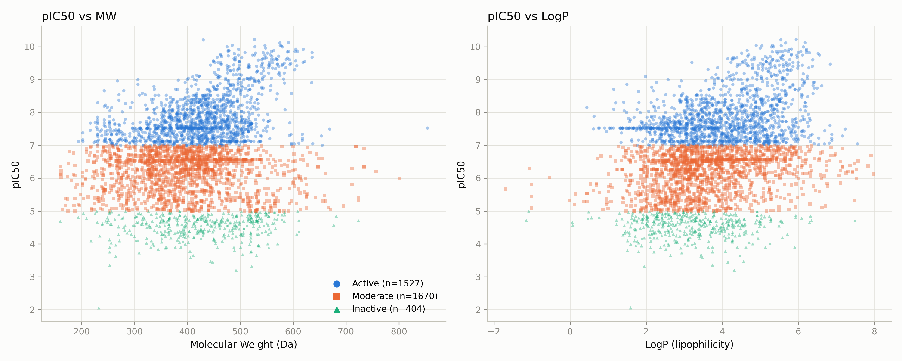
Figure 1. Activity (pIC50) plotted against molecular weight and greasiness. Each point is one compound, coloured by activity class. The horizontal bands appear because the classes are defined by pIC50 limits. The right-hand panel shows active compounds shifted towards higher greasiness, while the left-hand panel shows no such shift for weight.
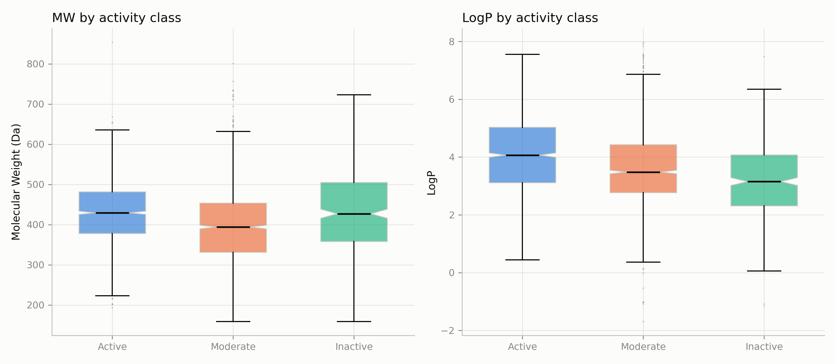
Figure 2. Distribution of molecular weight and greasiness by activity class. The boxes cover the middle half of each group and the line inside each box is the median. The weight distributions overlap almost completely, while the greasiness distributions are clearly shifted.
Taken together, these results say that bulk physical properties explain only part of what makes a compound active. Since size and flexibility make no difference, the explanation must lie in the specific chemical groups a molecule contains. That is what the next section examines.
4.3 Chemical groups linked to activity
Twenty-three chemical groups occurred often enough to be tested. Table III lists those with a real effect, ordered from the most helpful to the most harmful.
Table III. Chemical groups linked to higher or lower activity. The difference column shows the change in median pIC50 between compounds that contain the group and those that do not. A positive value means compounds with that group tend to be stronger.
Chemical group | Compounds with it | Difference in pIC50 | Effect size | Corrected p-value
Pyrrolidine | 543 | +1.35 | 0.511 (large) | 3.0 × 10⁻⁷⁹
Piperidine | 1,182 | +0.79 | 0.333 (medium) | 1.5 × 10⁻⁵⁸
Nitrile | 1,240 | +0.75 | 0.365 (medium) | 1.8 × 10⁻⁷¹
Primary amine | 741 | +0.66 | 0.281 (small) | 1.6 × 10⁻³¹
Tertiary amine | 1,958 | +0.51 | 0.224 (small) | 1.4 × 10⁻³⁰
Benzene ring | 3,510 | +0.28 | 0.233 (small) | 2.8 × 10⁻⁴
Ester | 221 | −0.41 | −0.237 (small) | 1.0 × 10⁻⁸
Sulfonamide | 266 | −0.50 | −0.181 (small) | 2.2 × 10⁻⁶
Urea | 46 | −0.54 | −0.180 (small) | 0.049
Pyrimidine | 366 | −0.70 | −0.426 (medium) | 4.2 × 10⁻⁴⁰
Ketone | 32 | −1.44 | −0.417 (medium) | 1.1 × 10⁻⁴
Piperazine | 276 | −1.73 | −0.557 (large) | 9.1 × 10⁻⁵³
Two groups stand out. Pyrrolidine, a five-membered ring containing one nitrogen atom, had the strongest positive link: compounds containing it were about 1.35 pIC50 units stronger, which corresponds to roughly a twenty-fold improvement in potency. It was also 8.5 times more common among active compounds than among inactive ones. At the opposite end, piperazine, a six-membered ring with two nitrogen atoms, had the strongest negative link, with compounds containing it being about 1.73 units weaker. Piperazine was nearly twelve times more common among inactive compounds.
It is worth noting that pyrrolidine and piperazine are both nitrogen-containing rings of similar size, yet they have opposite effects. This suggests the binding pocket is quite particular about the exact shape and arrangement of the ring, rather than simply preferring nitrogen rings in general.
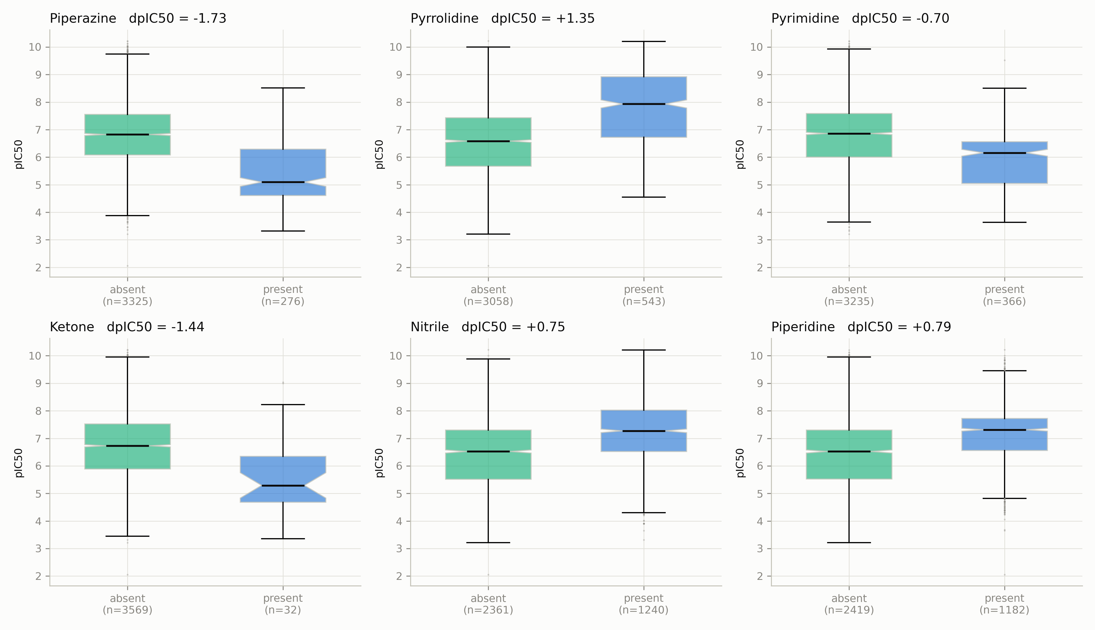
Figure 3. Activity of compounds with and without each of the six chemical groups showing the largest effect. For each group, the left box shows compounds lacking the group and the right box shows compounds containing it.
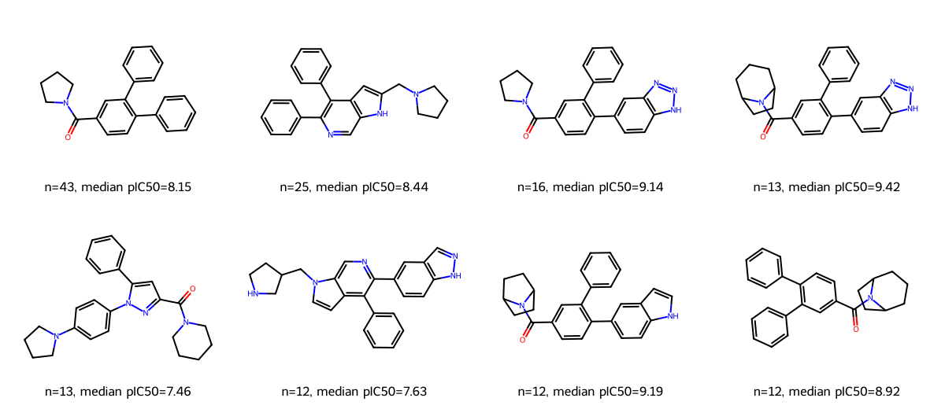
Figure 4. The most common chemical cores found among the active compounds containing a pyrrolidine group. The number of compounds sharing each core and their median pIC50 are shown beneath each structure.
Examining the chemical cores of the 385 active compounds containing pyrrolidine showed 132 different cores, so the active compounds do not all belong to a single chemical family. The most common core was shared by 43 compounds with a median pIC50 of 8.15, while a related core shared by 13 compounds reached a median of 9.42. This variety is useful, because it means the search for new molecules is not limited to copies of one scaffold.
4.4 Similarity within the dataset
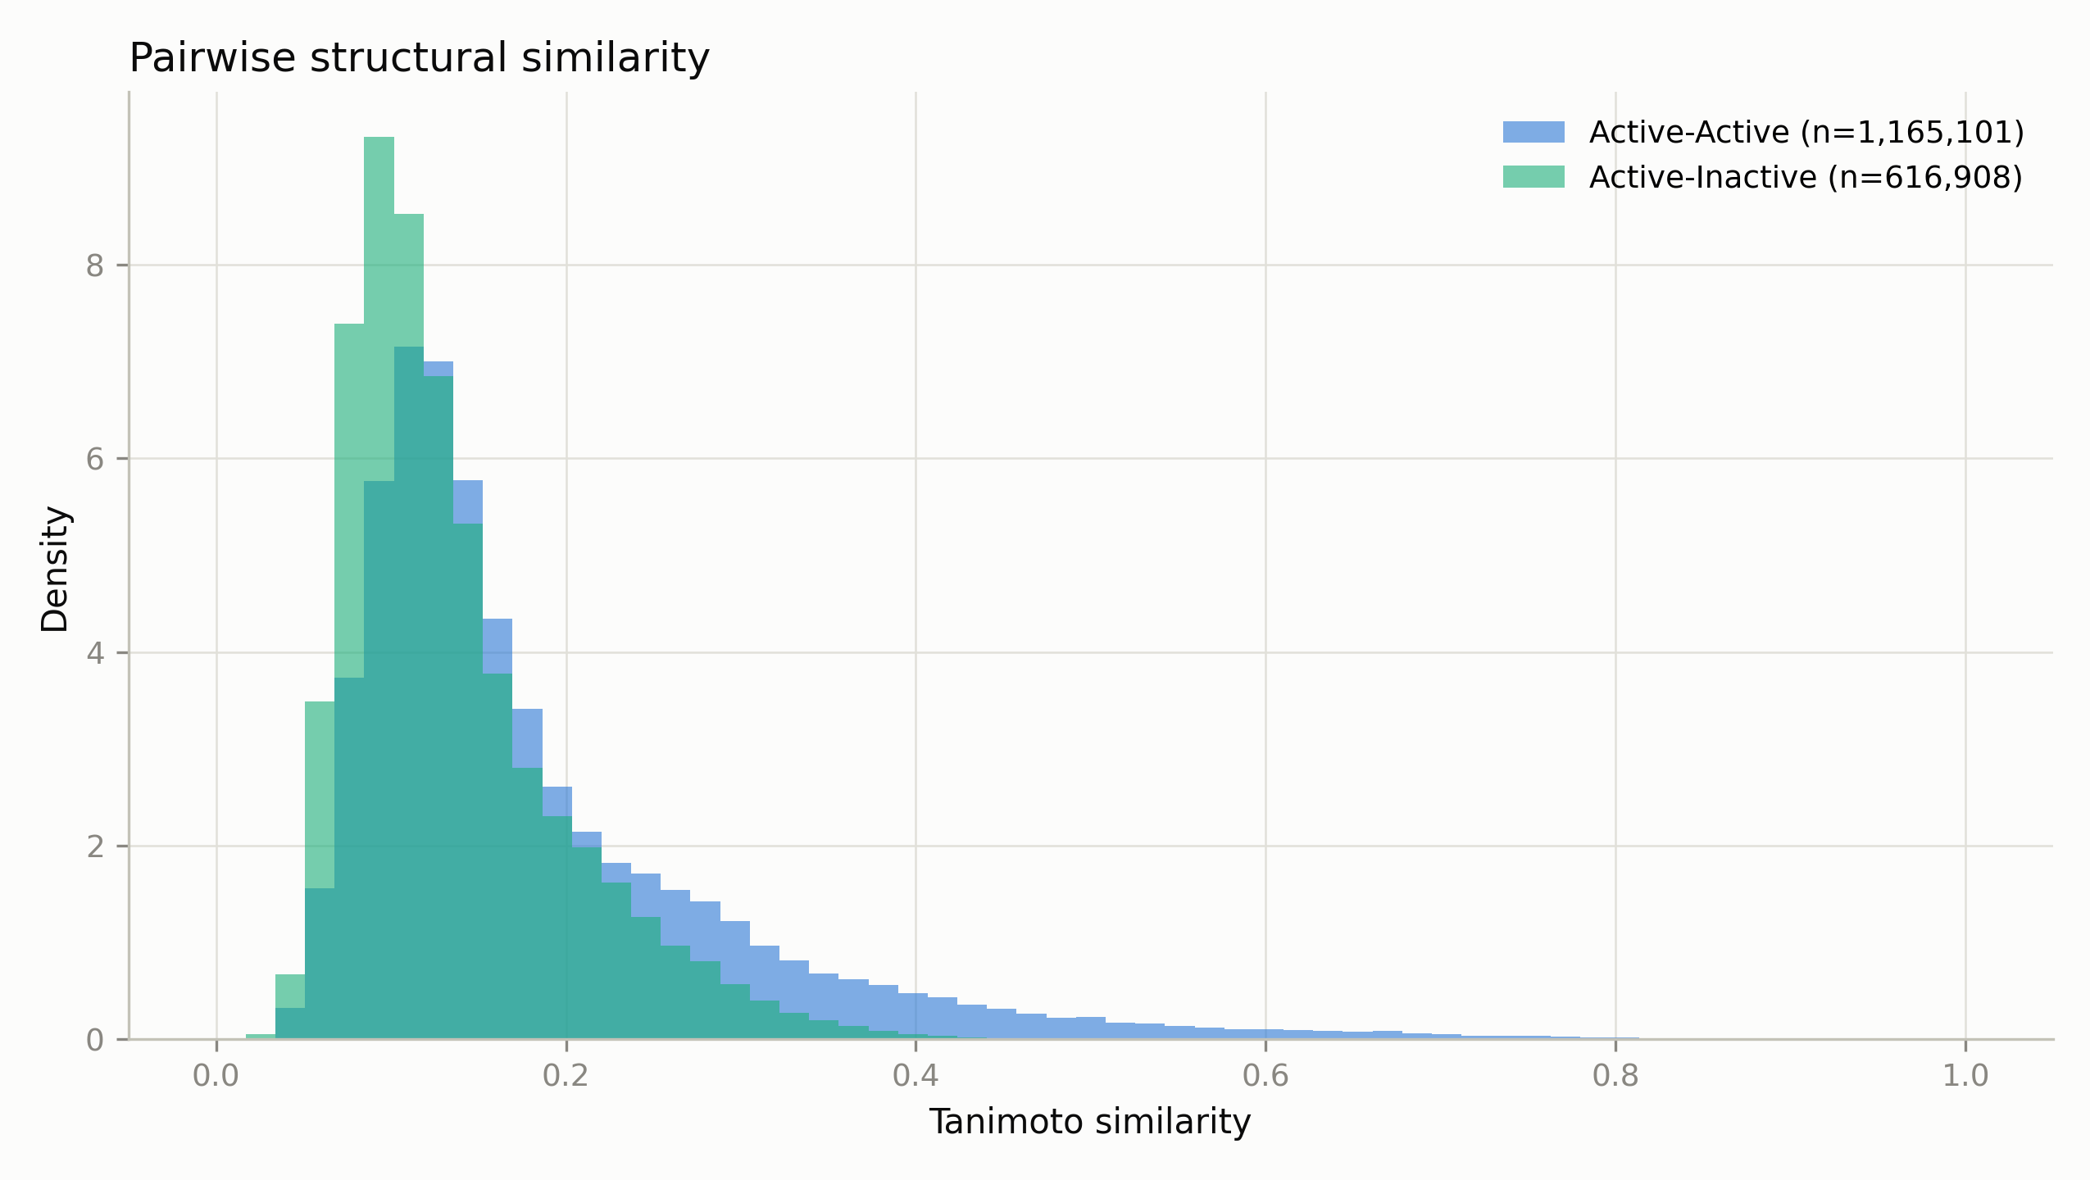
Figure 5. Similarity between pairs of compounds in the dataset. The blue distribution compares active compounds with each other; the green distribution compares active compounds with inactive ones.
Active compounds were somewhat more similar to one another than to inactive compounds, but the two distributions overlap considerably. This is consistent with the scaffold analysis: the active compounds form several chemical families rather than one, so no single molecule can represent them all. For this reason twenty-five different active compounds were used as references in the catalogue search rather than only one or two.
4.5 Searching the compound catalogue
All 4,805,565 catalogue compounds were compared against the 25 reference molecules. The search took 36 minutes using six processor cores. Table IV shows how many compounds were found at each similarity cut-off.
Table IV. Number of Enamine catalogue compounds found at each similarity cut-off, out of 4,805,565 compounds searched.
Similarity cut-off | Compounds found | Percentage of catalogue
0.95 and above | 0 | 0 %
0.90 and above | 14 | 0.0003 %
0.85 and above | 392 | 0.008 %
0.80 and above | 5,588 | 0.12 %
0.75 and above | 51,085 | 1.1 %
0.70 and above | 260,975 | 5.4 %
The highest similarity found anywhere in the catalogue was 0.932. The number of matches rises steeply as the cut-off is relaxed, which illustrates why the choice of cut-off matters so much: it determines how many compounds are carried forward far more than any property of the target itself.
The fourteen compounds matching at 0.90 or above were taken forward for docking. This is the cut-off most commonly used for this kind of search, and using it meant the molecules tested were genuinely close relatives of known active compounds rather than distant ones.
4.6 Docking results
Table V shows the docking results for all twenty molecules. A more negative binding energy means a better predicted fit. The estimated Ki is a prediction of how much compound would be needed to block the protein, so a smaller value is better.
Table V. Docking results for the twenty tested molecules, ranked by AutoDock4 binding energy. Molecules beginning with E are new catalogue compounds; molecules beginning with L are known inhibitors included for comparison.
Rank | Molecule | Type | Binding energy (kcal/mol) | Estimated Ki | Vina score
1 | L0005 | Known inhibitor | −11.21 | 6.1 nM | −10.62
2 | L0003 | Known inhibitor | −10.98 | 8.9 nM | −9.78
3 | L0004 | Known inhibitor | −10.42 | 23.0 nM | −10.95
4 | E0004 | New compound | −10.36 | 25.5 nM | −9.11
5 | E0008 | New compound | −10.25 | 30.7 nM | −8.42
6 | E0014 | New compound | −10.03 | 44.5 nM | −10.30
7 | L0002 | Known inhibitor | −9.95 | 50.9 nM | −9.00
8 | E0009 | New compound | −9.63 | 87.3 nM | −10.64
9 | L0001 | Known inhibitor | −9.54 | 101.7 nM | −9.84
10 | E0005 | New compound | −9.22 | 174.5 nM | −10.37
11 | L0000 | Known inhibitor | −9.20 | 180.4 nM | −9.68
12–20 | E0012, E0007, E0002, E0013,  E0006, E0001, E0003,  E0011, E0010 | New compounds | −8.98 to −6.78 | 262 nM to 10.7 µM | −10.26 to −8.35
The most important check is that the method behaves sensibly, and it does. The three top places were taken by known inhibitors, and the known compounds scored better on average, −10.22 against −8.85. Docking therefore ranked compounds already proven to work above untested catalogue compounds, which is what should happen if the calculation is meaningful.
Against that background, three of the new compounds are notable. E0004 scored −10.36 kcal/mol with an estimated Ki of 25.5 nM, E0008 scored −10.25 with 30.7 nM, and E0014 scored −10.03 with 44.5 nM. All three ranked above three of the six known inhibitors. These are compounds that can be purchased from a catalogue and tested in a laboratory.
Docking the same molecules with AutoDock Vina gave a correlation of 0.45 with the AutoDock4 results, which is statistically significant but only moderate. The two programs agreed on the general picture but disagreed on details: E0009 was the best new compound according to Vina but only eighth according to AutoDock4, while E0004 was ranked in the middle by Vina and best by AutoDock4. This is a useful reminder that docking scores are estimates rather than measurements, and that agreement between two different programs is more convincing than a good score from either one alone.
One limitation should be stated clearly. AutoDock4 performs ten independent runs for each molecule and groups the results by how similar the predicted positions are. For most molecules here, seven to ten different groups were produced and only one or two runs agreed on the best-scoring position. This means the predicted positions are not firmly settled. Running the calculation more times for the best compounds would give more confidence.
4.7 Where the molecules bind
The first question is whether the molecules settle in the correct part of the protein. Table VI shows how close each of the top five came to the FAD helper molecule, which marks the centre of the working site.
Table VI. Closeness of the top five molecules to the FAD cofactor. Distances below about 4 angstroms indicate direct contact.
Molecule | Type | Closest distance to FAD | Atom pairs within 4.5 Å
E0008 | New compound | 2.65 Å | 41
L0005 | Known inhibitor | 2.95 Å | 15
E0004 | New compound | 3.07 Å | 11
L0003 | Known inhibitor | 3.09 Å | 12
L0004 | Known inhibitor | 5.18 Å | 0
Four of the five molecules, including both new compounds, were in direct contact with FAD. This confirms that they settle in the working site of the protein rather than at some other surface pocket, which is the single most important check on whether a docking result is worth taking seriously.
Table VII. Contacts made by the top five molecules with the protein, as detected by PLIP. Residue names follow the standard three-letter code with the position number.
Molecule | Hydrogen bonds | Other contacts
L0005 (known) | THR335, PHE560, TRP552, VAL764 | Salt bridge to ASP555; water-repelling contacts with TYR761, TYR763, TRP695, VAL333, ALA809, THR810, ASN540
L0003 (known) | THR335, PHE560, ASP555 | Salt bridge and halogen bond to ASP555; ten water-repelling contacts
L0004 (known) | THR335, PHE560, ASP555 | Water-repelling contacts with TYR763, GLU559, THR335
E0004 (new) | TYR761 | Ring stacking with PHE538; halogen bond to ASN535; water-repelling contacts with TRP552, TRP695, ALA809, PRO808, VAL764, ALA539, THR335
E0008 (new) | TYR761 | Ring stacking with PHE560; water-repelling contacts with THR335, THR810, TYR807, VAL333
A clear pattern emerges from Table VII. The known inhibitors all hold on to the protein in the same way: a hydrogen bond to THR335 and PHE560, together with a salt bridge to ASP555. A salt bridge is an attraction between oppositely charged parts of two molecules, and it is a strong anchor.
The two new compounds hold on differently. Neither forms a salt bridge. Instead, both make a hydrogen bond to TYR761 and both stack their rings flat against a ring of the protein, E0004 against PHE538 and E0008 against PHE560. They therefore reach the same site and touch the same helper molecule, but anchor themselves by a different chemical means.
This is an encouraging result rather than a problem. A compound that binds the same site in a different way may have different properties, and finding such compounds is one of the main reasons for running a search of this kind. One residue, THR335, was contacted by all five molecules and appears to be a consistent point of attachment regardless of chemical family.

5. CONCLUSIONS
This project used only freely available data and software to search for new molecules that might block LSD1, a protein involved in acute myeloid leukaemia and small cell lung cancer. The main findings were as follows.
First, the strength of a compound against LSD1 is not related to its size. Active and inactive compounds had almost identical molecular weights. What did matter was greasiness, ring count and the number of hydrogen bond acceptors, with active compounds being greasier and more ring-rich.
Second, particular chemical groups are strongly linked to activity. A pyrrolidine ring was associated with compounds about twenty times more potent, while a piperazine ring was associated with compounds considerably weaker. Since both are similar nitrogen-containing rings, this suggests the binding pocket is specific about shape rather than simply favouring nitrogen.
Third, searching 4,805,565 purchasable compounds found 14 that closely resemble known active molecules. When these were docked into the protein, three of them scored better than half of the known inhibitors tested alongside them. The best, E0004, had a predicted Ki of 25.5 nM.
Fourth, the compounds settle in the correct place. Four of the top five molecules made direct contact with the FAD helper molecule at the centre of the working site. The new compounds anchor themselves by ring stacking rather than by the salt bridge used by the known inhibitors, which means they represent a different chemical approach to the same site.
These are predictions, not measurements. Docking estimates how well a molecule fits rather than how well it works in a cell, the predicted positions did not settle firmly across repeated runs, and the two docking programs used agreed only moderately with one another. The value of the work is that it reduces 4.8 million possibilities to a short list of three purchasable compounds that are worth testing in a laboratory.

6. FUTURE DIRECTIONS
The most direct extension would be to buy the three best compounds, E0004, E0008 and E0014, and measure their activity against LSD1 in a laboratory assay. This would show whether the predictions are correct and would be the only way to settle the question.
Within the computational work, several improvements are possible. The docking could be repeated with many more runs for the best compounds, since the predicted positions did not settle firmly with ten runs. The predicted positions could also be tested by molecular dynamics simulation, which follows the movement of the protein and molecule over time and shows whether a predicted position stays stable. This was not attempted here because the FAD helper molecule requires special parameters that are not included in standard simulation software.
The search could be widened. Only compounds matching at 0.90 or above were docked, which is a strict limit; the 392 compounds matching at 0.85 or above could be grouped by chemical family and a representative of each docked. Searching for approved medicines that might block LSD1, an approach known as drug repurposing, would be another useful direction, since such medicines have already been shown to be safe in people.
Finally, the activity data itself could be examined more carefully. The dataset combines measurements from experiments on purified protein with measurements made in living cells. A compound that simply kills cells can appear active in the second kind of experiment without blocking LSD1 at all. Separating the two kinds of measurement would give a cleaner picture of what makes a true LSD1 inhibitor.

7. REFERENCES
Adasme, M.F., Linnemann, K.L., Bolz, S.N., Kaiser, F., Salentin, S., Haupt, V.J., Schroeder, M. (2021). PLIP 2021: expanding the scope of the protein-ligand interaction profiler to DNA and RNA. Nucleic Acids Res. 49:W530-W534.
Bemis, G.W., Murcko, M.A. (1996). The properties of known drugs. 1. Molecular frameworks. J. Med. Chem. 39:2887-2893.
Berman, H.M., Westbrook, J., Feng, Z., Gilliland, G., Bhat, T.N., Weissig, H., Shindyalov, I.N., Bourne, P.E. (2000). The Protein Data Bank. Nucleic Acids Res. 28:235-242.
Eastman, P., Swails, J., Chodera, J.D., McGibbon, R.T., Zhao, Y., Beauchamp, K.A., Wang, L.P., Simmonett, A.C., et al. (2017). OpenMM 7: Rapid development of high performance algorithms for molecular dynamics. PLoS Comput. Biol. 13:e1005659.
Enamine Ltd. Screening compound collection. https://enamine.net (accessed October 2026).
Menna, M., Fiorentino, F., Marrocco, B., Lucidi, A., Tomassi, S., Cilli, D., Romanenghi, M., Cassandri, M., et al. (2022). Novel non-covalent LSD1 inhibitors endowed with anticancer effects in leukemia and solid tumor cellular models. Eur. J. Med. Chem. 237:114410.
Morris, G.M., Huey, R., Lindstrom, W., Sanner, M.F., Belew, R.K., Goodsell, D.S., Olson, A.J. (2009). AutoDock4 and AutoDockTools4: Automated docking with selective receptor flexibility. J. Comput. Chem. 30:2785-2791.
O’Boyle, N.M., Banck, M., James, C.A., Morley, C., Vandermeersch, T., Hutchison, G.R. (2011). Open Babel: An open chemical toolbox. J. Cheminform. 3:33.
RDKit: Open-source cheminformatics. https://www.rdkit.org (accessed October 2026).
Shi, Y., Lan, F., Matson, C., Mulligan, P., Whetstine, J.R., Cole, P.A., Casero, R.A., Shi, Y. (2004). Histone demethylation mediated by the nuclear amine oxidase homolog LSD1. Cell 119:941-953.
Trott, O., Olson, A.J. (2010). AutoDock Vina: improving the speed and accuracy of docking with a new scoring function, efficient optimization, and multithreading. J. Comput. Chem. 31:455-461.
Zdrazil, B., Felix, E., Hunter, F., Manners, E.J., Blackshaw, J., Corbett, S., de Veij, M., Ioannidis, H., et al. (2024). The ChEMBL Database in 2023: a drug discovery platform spanning multiple bioactivity data types and time periods. Nucleic Acids Res. 52:D1180-D1192.

