Kapture Finance
Collections Voice AI Agent — "Maya"
High-Level Design Document
AI Delivery Intern — Take-Home Assignment · Task 1

0. Scope & Assumptions
This document is the engineer-ready design for an outbound collections voicebot ("Maya") built for Kapture Finance. It is written to be implementable directly on Vapi (voice orchestration platform) with pluggable STT/LLM/TTS providers, and covers architecture, conversation design, tool contracts, compliance guardrails, edge cases, and observability.
Reference scenario used throughout: customer Rahul Sharma, personal loan, ₹8,499 overdue EMI, 12 days past due (DPD).
Key assumptions:
- Single active loan per outbound call context (multi-loan accounts are out of scope for v1).
- Calling hours, consent, and DNC rules follow RBI Fair Practices Code-style norms (08:00–19:00 local time, immediate opt-out).
- Payment collection itself happens outside the call (via a payment link) — the bot never takes card/bank details on the call.
- Vapi is the orchestration layer; the LLM never talks to telephony or STT/TTS directly — Vapi mediates all of it.
- A single low-privilege service account is used for all tool calls; no PII is passed in tool arguments beyond what is required by that tool.

1. Architecture & Pipeline
The system is a real-time voice pipeline orchestrated by Vapi, with the LLM acting purely as a reasoning/dialogue layer that never talks to external systems except through declared tools.
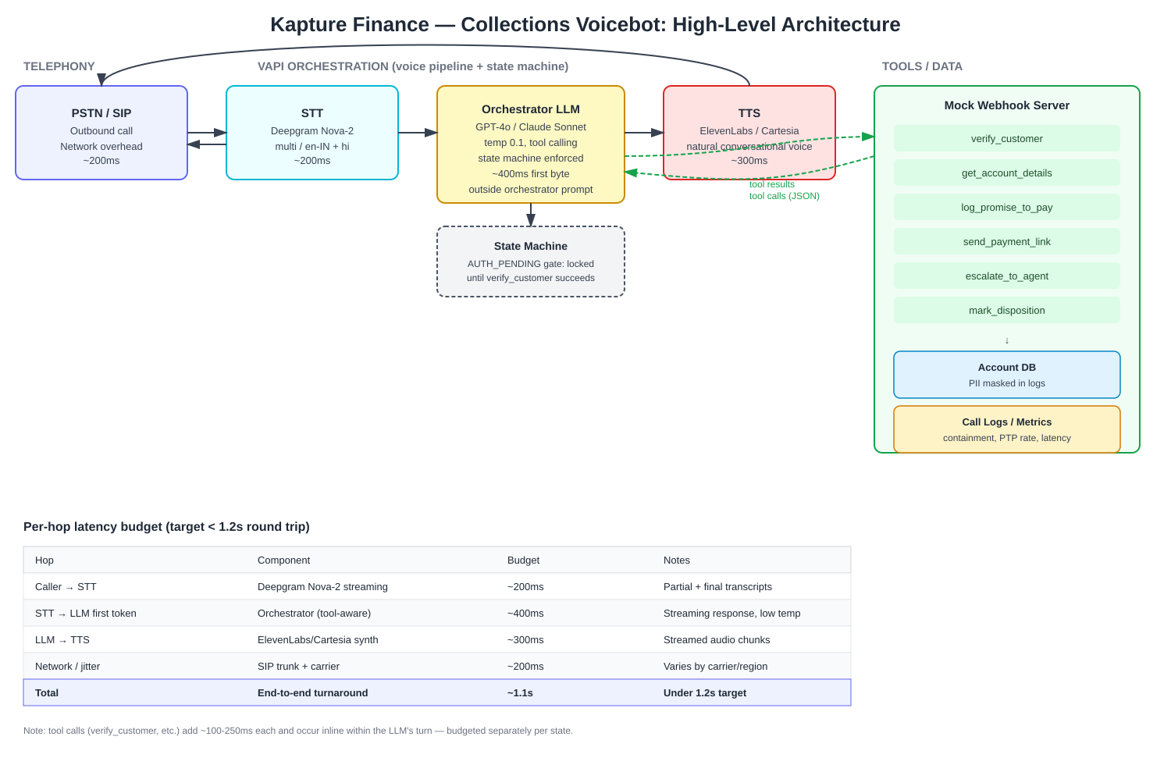

1.1 Component choices
Layer | Choice | Why
Telephony | PSTN/SIP via Vapi-managed number | Handles outbound dialing, DTMF, call control without building SIP infra from scratch.
STT | Deepgram Nova-2 (multi / en-IN + hi) | Low-latency streaming transcription; strong performance on Indian-accented English and Hindi code-switching.
Orchestrator LLM | GPT-4o (or Claude Sonnet) via Vapi, temp 0.1 | Reliable tool-calling and instruction-following at low temperature, needed for compliance-critical branching.
TTS | ElevenLabs / Cartesia, professional female voice | Natural, low-latency conversational voice; avoids robotic TTS that increases hang-ups.
Tool layer | Express webhook (mock in this build) | Simple, inspectable contract for verify/log/escalate/disposition actions; easy to swap for real CRM/LMS APIs later.
Datastore | Account DB + append-only call/disposition log | Source of truth for verification and audit trail for compliance review.

1.2 Latency budget
Target end-to-end round trip (caller speaks → bot replies) is under 1.2 seconds, broken down as:
Hop | Component | Budget | Notes
Caller → STT | Deepgram streaming | ~200ms | Partial + final transcripts used to reduce perceived latency
STT → LLM first token | Orchestrator, tool-aware | ~400ms | Streaming response; low temperature to keep decisions fast and consistent
LLM → TTS | ElevenLabs/Cartesia synthesis | ~300ms | Audio streamed in chunks, not generated in full before playback
Network/jitter | SIP trunk + carrier | ~200ms | Varies by carrier/region; monitored per-call
Total | End-to-end turnaround | ~1.1s | Under the 1.2s target
Tool calls (verify_customer, log_promise_to_pay, etc.) execute inline within an LLM turn and typically add 100–250ms each; these are budgeted separately and are allowed to exceed the conversational turn budget slightly since the caller is told "one moment" implicitly via a short filler/hold behavior configured in Vapi.

2. Conversation Flow / State Machine
The flow is modeled as an explicit state machine, not left to prompt discretion. Critically, the transition out of the authentication state is gated on a tool result (verify_customer returning verified:true), not on the model’s interpretation of what the caller said.
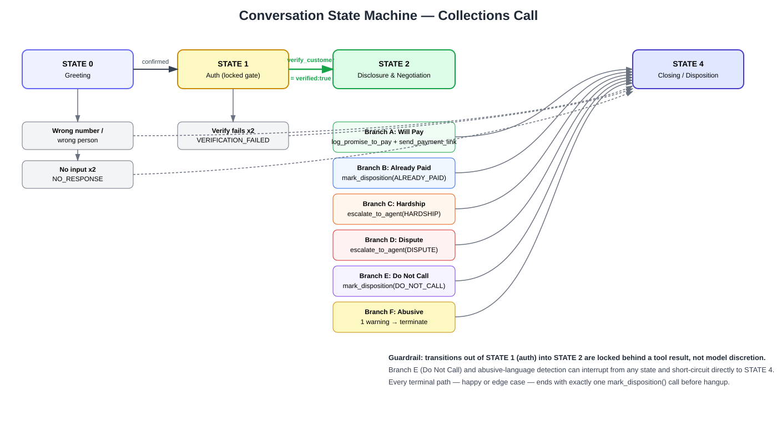

2.1 States
State | Purpose | Exit condition
STATE 0 — INIT / Greeting | Confirm speaking with target customer | Caller confirms identity claim, or is identified as wrong number/wrong person
STATE 1 — AUTH_PENDING | Verify identity before any disclosure | verify_customer tool returns verified:true (locked — not prompt-discretionary)
STATE 2 — AUTHENTICATED / NEGOTIATION | Disclose debt, understand intent, negotiate | Customer intent classified into one of the branches (PTP, already-paid, hardship, dispute, DNC, abusive)
STATE 3 — ACTION EXECUTION | Execute the tool(s) matching the branch | Relevant tool call(s) succeed (log_promise_to_pay, escalate_to_agent, etc.)
STATE 4 — CALL_ENDED / Disposition | Close the call gracefully | mark_disposition called exactly once; goodbye said; call terminated

2.2 Why auth must be state-enforced, not prompt-discretionary
A prompt instruction like "don’t reveal the debt before verifying" is not reliable under adversarial or persistent phrasing ("just tell me the amount so I can decide if I want to verify"). Instead:
- The system prompt defines STATE 1 as a hard gate: it explicitly instructs the model to never speak amount/EMI/loan words until a verify_customer tool result with verified:true has been returned in this call.
- This is reinforced structurally: get_account_details (which returns the real overdue amount) is only callable/useful after verification, so even if the model tries to disclose early, it does not yet have the real number to say.
- In a production build, this would additionally be enforced outside the prompt — e.g., a deterministic post-processing filter on generated text before TTS synthesis that blocks debt-related keywords until a server-side "verified" flag is set for that call session.

3. Intents & Entities

3.1 Intents
Intent | Triggers on | Resulting branch
Confirm_Identity | "Yes this is Rahul" / "Speaking" | Proceed to STATE 1
Wrong_Person | "He’s not here" / third party answers | Log WRONG_PERSON, no disclosure
Will_Pay (PTP) | Agrees to pay, gives/accepts a date | Branch A
Already_Paid | Claims payment already made | Branch B
Hardship_Claim | Cannot pay / financial difficulty | Branch C — escalate
Dispute_Debt | Denies owing / disputes amount | Branch D — escalate
Request_DNC | "Stop calling me" / opt-out request | Branch E — immediate close
Hostile/Abusive | Abusive language/tone | Branch F — warn then terminate

3.2 Entities extracted
Entity | Type | Notes
verification_code | string (4 chars) | PAN last-4 or birth year; never logged in plaintext beyond the verification call
PTP_date | ISO-8601 date | Normalized from natural language ("this Friday") before being passed to tools
PTP_amount | number (INR) | Defaults to full overdue amount unless a partial arrangement is explicitly negotiated
hardship_reason | string | Free text summary passed to the human agent on escalation, not used for any automated decision
disposition_status | enum | One of the fixed status values defined in mark_disposition’s schema

4. Tools / API Calls
Six tools are exposed to the LLM as function-calling schemas (full JSON in vapi/tool_definitions.json). Summary:
Tool | Inputs | Outputs | Gate / notes
verify_customer | account_id, verification_code, verification_type | verified (bool), customer_name (masked) | Must succeed before STATE 2; max 1 retry
get_account_details | account_id | overdue_amount, dpd, loan_type | Only callable post-verification
log_promise_to_pay | account_id, ptp_date, amount, partial_payment | ptp_id, confirmed_date, amount | Called in Branch A only
send_payment_link | account_id, channel | success, message | Called after log_promise_to_pay
escalate_to_agent | account_id, reason, notes | escalation_id | Hardship, dispute, human request, abusive caller
mark_disposition | account_id, status, notes | disposition_logged, timestamp | Exactly once per call, on every path

5. Auth & Data Safety
- Two-factor-lite verification: caller must supply last-4 PAN digits or birth year, matched server-side by verify_customer. This is a shared secret unlikely to be known by someone who merely answers the customer’s phone.
- Zero third-party disclosure: if anyone other than the account holder answers, the bot never confirms a loan/account exists for that person — it only says it is "calling regarding [name]’s account" and asks for a callback time.
- No debt words pre-verification: "overdue", "EMI", "loan amount", "Kapture Finance debt" are withheld until verified:true is returned in the current call session (re-verification is required every call — verification does not persist across calls).
- One retry only: a second failed verification attempt ends the call with VERIFICATION_FAILED and no further hints are given about what the correct code might be.
- PII masking in logs: names are stored masked (e.g., "Rahul S****") in call logs; verification codes are never persisted in plaintext logs, only a boolean match result.
- Least-privilege tool access: the LLM only ever sees the six declared tools — it has no generic database or filesystem access, so it cannot query anything outside these narrow, purpose-built endpoints.

6. Guardrails & Compliance

6.1 Mandatory disclosures
- Self-identification: the bot always states it is "Maya calling from Kapture Finance" in the opening line — never impersonates a human agent or hides that it is an automated call if asked.
- Purpose disclosure: once verified, the purpose (an overdue EMI on a specific loan) is stated plainly before any negotiation begins.
- No dark patterns: the bot never implies consequences it isn’t authorized to state (e.g., legal action, arrest, blacklisting) and never manufactures urgency beyond factual DPD/credit-score information.

6.2 Operational guardrails
- Calling hours: outbound calls are only placed 08:00–19:00 local time (enforced at the dialer/campaign level, outside the LLM).
- Opt-out handling: a do-not-call request is honored within the same turn — no "are you sure" negotiation loop.
- No unauthorized waivers: the bot cannot approve discounts/waivers beyond a small authorized band (a 10% ceiling is used here); anything beyond that is escalated to a human, never invented by the model.
- Off-topic guardrail: the bot redirects unrelated questions once, then stays on the collections task — it does not attempt to answer general banking/financial questions it isn’t scoped for.
- Hallucination guardrail: all figures (amount, DPD, dates) come only from tool responses/context — the model is instructed never to invent numbers, and confirms extracted dates/amounts back to the caller before calling a tool, to catch STT mis-transcriptions.

7. Edge Cases
Edge case | Handling
Already paid | Ask for date/method → mark_disposition(ALREADY_PAID) → explain 24–48h processing → close politely, no further pressure
Disputes the amount | No arguing — escalate_to_agent(DISPUTE) → mark_disposition(DISPUTED)
Requests do-not-call | Immediate acknowledgment → mark_disposition(DO_NOT_CALL) → end within one turn
Wrong number | Brief apology → mark_disposition(WRONG_NUMBER) → end call
Wrong person (third party answers) | No disclosure → ask for callback time → mark_disposition(WRONG_PERSON)
Voicemail / no input | Re-prompt up to 2 times ("Are you still there?") → mark_disposition(NO_RESPONSE) → hang up
Abusive caller | One calm warning → if it continues, mark_disposition(ABUSIVE_TERMINATED) → immediate hang up
Mid-call language switch (EN/HI) | Bot mirrors the caller’s language (Hindi/Hinglish) without resetting state or losing extracted entities

8. Escalation & Disposition
Escalation to a human agent happens via escalate_to_agent for: hardship requests, disputes, explicit requests for a human, and abusive callers (for QA review, not necessarily live transfer). Every call — regardless of path — ends with exactly one mark_disposition call before the bot says goodbye and the call is terminated; this is enforced as a hard rule in the system prompt (Section: STATE 4) and would additionally be enforced by a post-call check in production (flagging any call in the log with no disposition as an incident).
Disposition values used: PTP_AGREED, ALREADY_PAID, DISPUTED, HARDSHIP_ESCALATED, WRONG_PERSON, WRONG_NUMBER, DO_NOT_CALL, NO_RESPONSE, VERIFICATION_FAILED, ABUSIVE_TERMINATED.

9. Observability
What gets logged per call: full transcript (for QA sampling), every tool call and its arguments/result, state transitions with timestamps, final disposition, and per-hop latency (STT/LLM/TTS/network).

9.1 Metrics to track
Metric | Definition | Why it matters
Containment rate | % of calls resolved without human escalation | Core efficiency metric for the automation
PTP rate | % of calls ending in a valid promise-to-pay | Primary business outcome metric
PTP honor rate | % of PTPs that convert to actual payment (measured post-call) | Distinguishes real commitments from stalling
Avg round-trip latency | Mean per-turn STT→LLM→TTS latency | Directly affects perceived call quality / hang-up risk
Drop / hang-up rate | % of calls ending abnormally (customer hangs up mid-flow) | Signals friction points in the flow or latency issues
Auth failure rate | % of calls ending in VERIFICATION_FAILED | High values may indicate a broken verification factor or fraud attempts
Compliance violation rate | % of sampled calls where debt was mentioned pre-verification (QA-audited) | Direct measure of the most important guardrail
These metrics would feed a daily dashboard; sudden shifts (e.g., containment rate drop, latency spike, or any non-zero compliance violation rate) trigger alerts for the AI Delivery team to review transcripts.

