**Practical No.:-** 1

**Name:** Sattyam Sagar Chavan, AI&DS-B4 batch, Roll no: 73

**Input :-**

print("Name : Sattyam Sagar Chavan , Class : SE - AI&DS , Batch : B2 , Roll no : 73\n

OUTPUT :\n")

print("Enter values in the format : 'Name1 Name2 Name3 Name4 Name5 ...'")

a=input("Enter all cricket player's names with spaces: ")

b=input("Enter all badminton player's names with spaces: ")

c=input("Enter all football player's names with spaces: ")

grpA=a.split(" ")

grpB=b.split(" ")

grpC=c.split(" ")

print("\nCricket Players : ",grpA)

print("Badminton Players : ",grpB)

print("Football Players : ", grpC)

def Cricket_n_Badminton(grpA,grpB):

anb=[]

for i in grpA:

if i in grpB:

anb.append(i)

return(anb)

def Cricket_n_Badminton_ButNotBoth(grpA, grpB):

temp1=[]

temp2 = Cricket_n_Badminton(grpA,grpB)

for i in grpA:

if i not in temp2:

temp1.append(i)

for i in grpB:

if i not in temp2:

temp1.append(i)

return(temp1)

def Neither_Cricket_Nor_Badminton (grpA,grpB,grpC):

temp1 = []

temp2 = Cricket_n_Badminton(grpA,grpB)

temp3 = Cricket_n_Badminton_ButNotBoth(grpA, grpB)

temp2 = temp2+temp3

for i in grpC:

if i not in temp2:

temp1.append(i)

return(temp1)

def Cricket_n_Football (grpA, grpC):

anc=[]

for i in grpA:

if i in grpC:

anc.append(i)

return(anc)

def Cricket_and_Football_but_not_Badminton (grpA, grpB,grpC):

temp1 = []

intersection = Cricket_n_Football(grpA, grpC)

for i in intersection:

if i not in grpB:

temp1.append(i)

return(temp1)

print("\nThe players who play both cricket and badminton : ", Cricket_n_Badminton(grpA,grpB))

print("\nThe players who play either cricket or badminton but not both : ",

Cricket_n_Badminton_ButNotBoth (grpA,grpB))

print("\nThe players who play neither cricket nor badminton : ", Neither_Cricket_Nor_Badminton

(grpA,grpB, grpC))

print("No. of players who play neither cricket nor badminton : ",

len(Neither_Cricket_Nor_Badminton (grpA,grpB,grpC)))

print("\nThe players who play cricket and football but not badminton : ",

Cricket_and_Football_but_not_Badminton (grpA, grpB,grpC))

print("No. of players who play cricket and football but not badminton : ",

len(Cricket_and_Football_but_not_Badminton (grpA,grpB,grpC)))

print("\n")

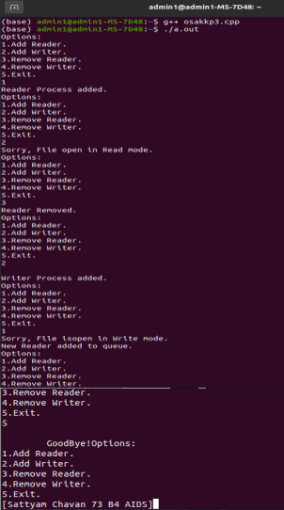**Output :**

