Practical no 11 : Write C++ program for simulating job queue. Write functions to add job and delete job from queue.

Class : SE B AIDS Roll no 73

#include <iostream> #define MAX 10 using namespace std;

struct queue {

int data[MAX]; int front, rear;

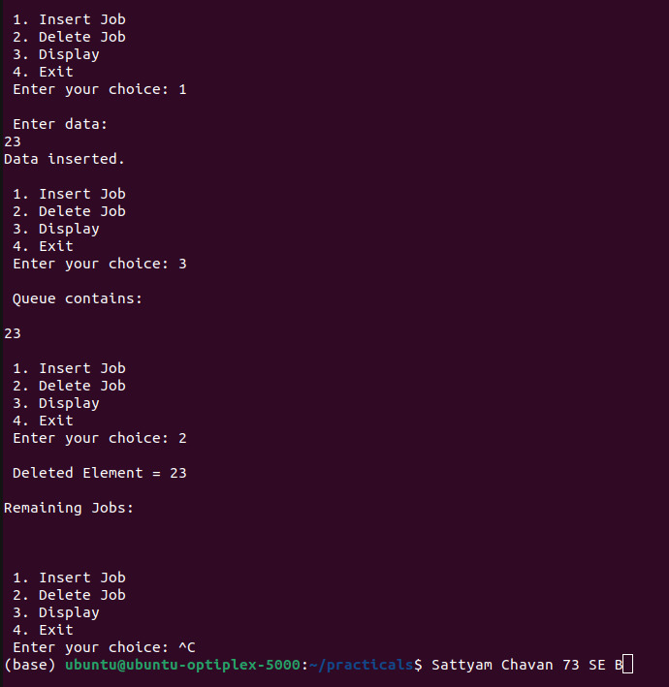};

class Queue { struct queue q;

public:

Queue() { q.front = q.rear = -1; } int isempty();

int isfull();

void enqueue(int); int delqueue(); void display();

};

int Queue::isempty() {

return (q.front == q.rear) ? 1 : 0;

}

int Queue::isfull() {

return (q.rear == MAX - 1) ? 1 : 0;

}

void Queue::enqueue(int x) { if (!isfull()) {

q.data[++q.rear] = x;

}

}

int Queue::delqueue() { if (!isempty()) {

return q.data[++q.front];

}

return -1; // Indicate an error (underflow)

}

void Queue::display() { int i;

cout << "\n";

for (i = q.front + 1; i <= q.rear; i++)

cout << q.data[i] << " "; cout << endl;

}

int main() { Queue obj; int ch, x;

cout << "\n\nName: Sattyam Sagar Chavan; Roll No: 73; Div: B\n\n";

do {

cout << "\n 1. Insert Job\n 2. Delete Job\n 3. Display\n 4. Exit\n Enter your choice: "; cin >> ch;

switch (ch) { case 1:

if (!obj.isfull()) {

cout << "\n Enter data: \n"; cin >> x;

obj.enqueue(x);

cout << "Data inserted." << endl;

} else {

cout << "Queue is overflow!!!\n\n";

}

break; case 2:

if (!obj.isempty()) {

cout << "\n Deleted Element = " << obj.delqueue() << endl;

} else {

cout << "\n Queue is underflow!!!\n\n";

}

cout << "\nRemaining Jobs: \n"; obj.display();

break; case 3:

if (!obj.isempty()) {

cout << "\n Queue contains: \n"; obj.display();

} else {

cout << "\n Queue is empty!!!\n\n";

}

break; case 4:

cout << "\n Exiting Program ";

break; default:

cout << "\n Invalid choice! Please try again.\n";

}

} while (ch != 4); return 0; }