ASSIGNMENT NO. 12 (Group E)

**Write C++ program to simulate deque with functions to add and delete elements from either end of the deque.**

Name : Sattyam Sagar Chavan Roll No : 73 Division : B Dept : SE (AI&DS)

#include <iostream> #define MAX 10 using namespace std;

struct que {

int arr[MAX]; int front, rear;

};

void init(struct que *q) { q->front = -1;

q->rear = -1;

}

void print(struct que q) { int i = q.front;

while (i != q.rear) {

cout << "\t" << q.arr[i]; i = (i + 1) % MAX;

}

cout << "\t" << q.arr[q.rear];

}

int isempty(struct que q) { return q.rear == -1 ? 1 : 0;

}

int isfull(struct que q) {

return (q.rear + 1) % MAX == q.front ? 1 : 0;

}

void addf(struct que *q, int data) { if (isempty(*q)) {

q->front = q->rear = 0; q->arr[q->front] = data;

} else {

q->front = (q->front - 1 + MAX) % MAX; q->arr[q->front] = data;

}}

void addr(struct que *q, int data) { if (isempty(*q)) {

q->front = q->rear = 0; q->arr[q->rear] = data;

} else {

q->rear = (q->rear + 1) % MAX; q->arr[q->rear] = data;

}

}

int delf(struct que *q) {

int data1 = q->arr[q->front]; if (q->front == q->rear) {

init(q);

} else {

q->front = (q->front + 1) % MAX;

}

return data1;

}

int delr(struct que *q) {

int data1 = q->arr[q->rear]; if (q->front == q->rear) {

init(q);

} else {

q->rear = (q->rear - 1 + MAX) % MAX;

}

return data1;

}

int main() {

cout << "\nName: Sattyam Sagar Chavan ; Roll No: SEBD23273; Division: B\n\n"; struct que q;

int data, ch; init(&q);

while (true) {

cout << "\t\n1. Insert front,"

<< "\t\n2. Insert rear,"

<< "\t\n3. Delete front,"

<< "\t\n4. Delete rear,"

<< "\t\n5. Print,"

<< "\t\n6. Exit";

cout << "\nEnter your choice:\t"; cin >> ch;

switch (ch) { case 1:

cout << "\nEnter data to insert front: "; cin >> data;

addf(&q, data); break;

case 2:

cout << "\nEnter the data to insert rear: "; cin >> data;

addr(&q, data); break;

case 3:

if (isempty(q)) {

cout << "\nDeque is empty ";

} else {

data = delf(&q);

cout << "\nDeleted data is " << data;

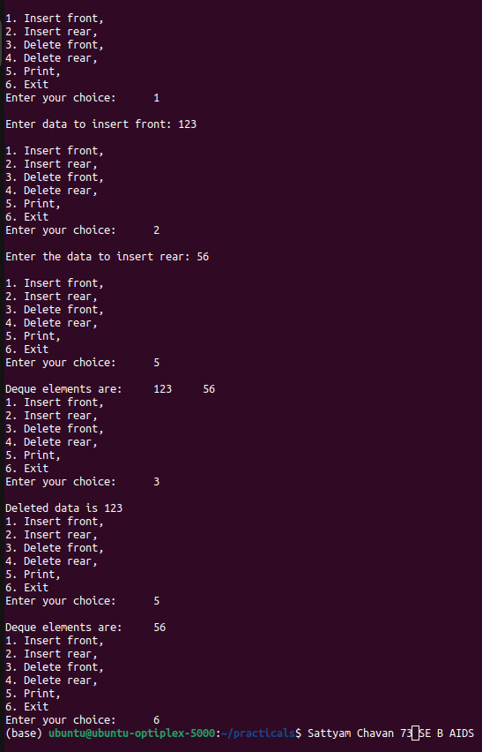}

break;

case 4:

if (isempty(q)) {

cout << "\nDeque is empty ";

} else {

data = delr(&q);

cout << "\nDeleted data is " << data;

}

break;

case 5:

if (isempty(q)) {

cout << "\nDeque is empty ";

} else {

cout << "\nDeque elements are: "; print(q);

}

break;

case 6:

return 0;

default:

cout << "\nInvalid choice. Please try

again.\n";

}

}

return 0;

}