**ASSIGNMENT NO. 9 (Group D)**

Name : Sattyam Sagar Chavan

Roll No : SEBD23273

Division : B

Dept : SE (AI&DS)

Subject : Data Structure Lab

Input:

#include<iostream>#include<string.h>#define max 50using namespace std;class STACK{private:char a[max];int top;public:STACK(){top=-1;}void push(char);void reverse();void convert(char[]);void palindrome();};void STACK::push(char c){top++;a[top] = c;a[top+1]='\0';cout<<endl<<c<<" is pushed on stack ...";}void STACK::reverse(){char str[max];cout<<"\n\nReverse string is : ";for(int i=top,j=0; i>=0; i--,j++){cout<<a[i];str[j]=a[i];}cout<<endl;}void STACK::convert(char str[]){int j,k,len = strlen(str);for(j=0, k=0; j<len; j++){if( ( (int)str[j] >= 97 && (int)str[j] <=122 ) || ( (int)str[j] >= 65 && (int)str[j] <=90 )){if( (int)str[j] <=90 ){str[k] = (char)( (int)str[j] + 32 );}else{str[k] = str[j];}k++;}}str[k]='\0';cout<<endl<<"Converted String : "<<str<<"\n";}void STACK::palindrome(){char str[max];int i,j;for(i=top,j=0; i>=0; i--,j++){str[j]=a[i];}str[j]='\0';if(strcmp(str,a) == 0)cout<<"\n\nString is palindrome...";elsecout<<"\n\nString is not palindrome...";}int main(){cout<<"Name: Samarth Ayodhyaprasad Kurmi ; Roll no: SEBD23212 ; Division: B";STACK stack;char str[max];int i=0;cout<<"\nEnter string to be reversed and check is it palindrome or not : \n\n";cin.getline(str , 50);stack.convert(str);while(str[i] != '\0'){stack.push(str[i]);i++;}stack.palindrome();stack.reverse();return 0;

}

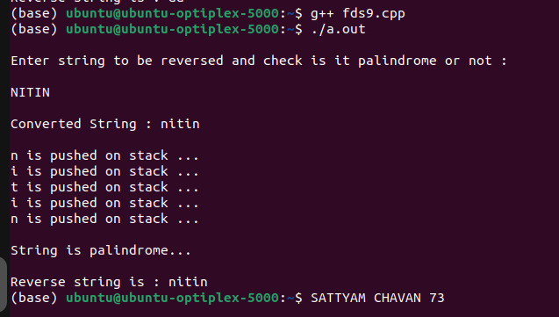**Output:**