Editkaro.in — Portfolio Website

Web Development Project Report

Prepared by: Riya Maurya
Date: June 20, 2026
Live URL: https://editkaro-portfolio-bay.vercel.app
Technologies: HTML5 • CSS3 • JavaScript
Deployment: Vercel

1. Project Overview
This report documents the design, development, and deployment of the portfolio website for Editkaro.in — a professional video editing and social media marketing agency. The website was built from scratch using HTML5, CSS3, and vanilla JavaScript, without any external frameworks, and was subsequently deployed on Vercel for global access.
The live website is accessible at: https://editkaro-portfolio-bay.vercel.app

2. Key Features
- Responsive dark-mode design using CSS Custom Properties (variables).
- Glassmorphism-style navigation bar with scroll-based background transitions.
- Animated hero section with a pulsing radial gradient background effect.
- Portfolio grid with category filter buttons (All, Reels & Shorts, Corporate, Vlogs, Commercials).
- Smooth card hover animations using CSS transitions and transforms.
- Services section with glassmorphism cards and hover lift effect.
- Contact form with JavaScript-powered submission feedback animation.
- Mobile-responsive hamburger menu with animated burger-to-X transformation.
- SEO meta tags and semantic HTML5 structure throughout.
- Deployed on Vercel CDN for fast, global access.

3. Website Screenshots

Hero Section


Portfolio Grid
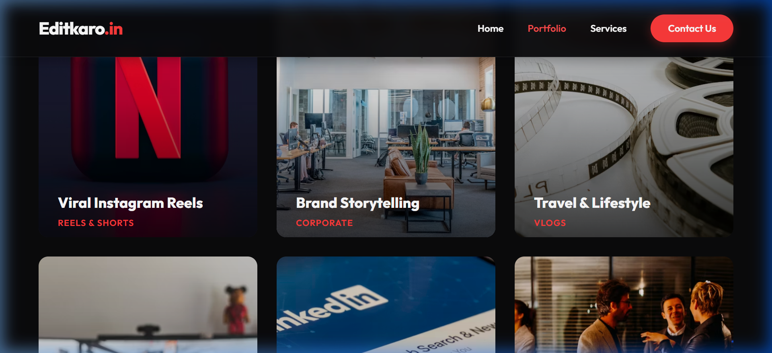

Services Section
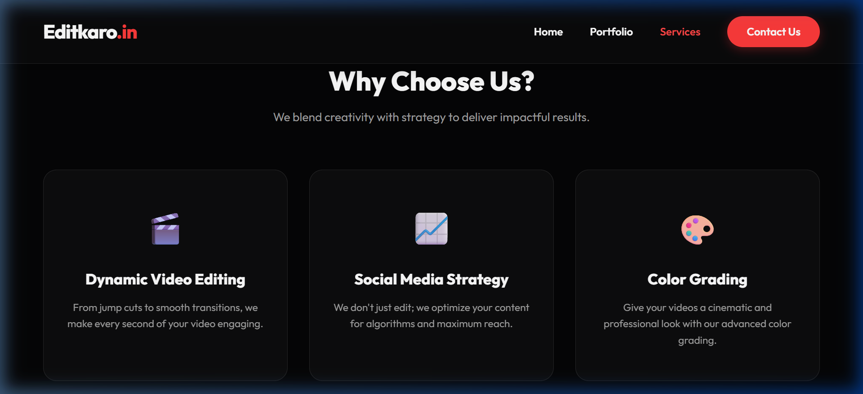

Contact & Footer
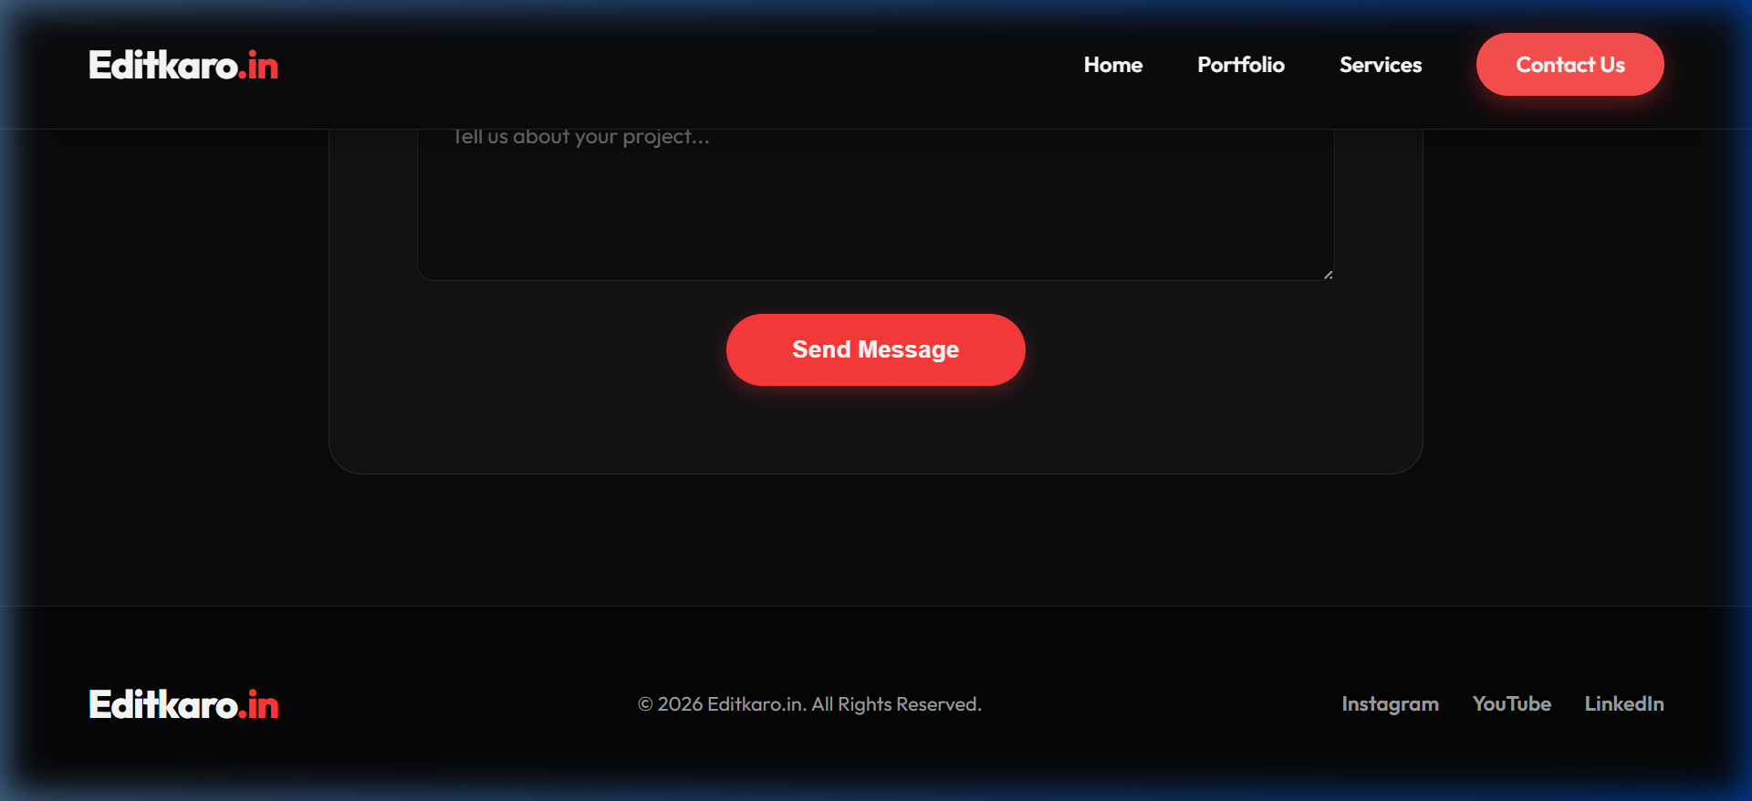

4. Source Code

index.html
<!DOCTYPE html>
<html lang="en">
<head>
<meta charset="UTF-8">
<meta name="viewport" content="width=device-width, initial-scale=1.0">
<title>Editkaro.in - Premium Video Editing & Social Media Marketing</title>
<meta name="description" content="Professional video editing and social media marketing agency.">
<link rel="preconnect" href="https://fonts.googleapis.com">
<link rel="preconnect" href="https://fonts.gstatic.com" crossorigin>
<link href="https://fonts.googleapis.com/css2?family=Outfit:wght@300;400;600;800&display=swap" rel="stylesheet">
<link rel="stylesheet" href="style.css">
</head>
<body>
<nav class="navbar">
<div class="logo">Editkaro<span>.in</span></div>
<ul class="nav-links">
<li><a href="#home">Home</a></li>
<li><a href="#portfolio">Portfolio</a></li>
<li><a href="#services">Services</a></li>
<li><a href="#contact" class="btn-primary">Contact Us</a></li>
</ul>
<div class="burger">
<div class="line1"></div>
<div class="line2"></div>
<div class="line3"></div>
</div>
</nav>

<header id="home" class="hero">
<div class="hero-content">
<h1 class="hero-title">Elevate Your <span>Visual</span> Storytelling</h1>
<p class="hero-subtitle">Premium video editing and social media marketing tailored to make your brand stand out in a noisy digital world.</p>
<div class="hero-cta">
<a href="#portfolio" class="btn-primary">View Our Work</a>
<a href="#contact" class="btn-secondary">Let's Talk</a>
</div>
</div>
<div class="hero-bg-anim"></div>
</header>

<section id="portfolio" class="portfolio">
<div class="section-header">
<h2>Our Masterpieces</h2>
<p>Explore our diverse range of video editing categories.</p>
</div>

<div class="filters">
<button class="filter-btn active" data-filter="all">All</button>
<button class="filter-btn" data-filter="reels">Reels & Shorts</button>
<button class="filter-btn" data-filter="corporate">Corporate</button>
<button class="filter-btn" data-filter="vlogs">Vlogs</button>
<button class="filter-btn" data-filter="commercial">Commercials</button>
</div>

<div class="portfolio-grid">
<!-- Portfolio Items -->
<div class="portfolio-item" data-category="reels">
<div class="item-overlay"></div>
<img src="https://images.unsplash.com/photo-1611162617474-5b21e879e113?ixlib=rb-4.0.3&auto=format&fit=crop&w=800&q=80" alt="Instagram Reels">
<div class="item-content">
<h3>Viral Instagram Reels</h3>
<p>Reels & Shorts</p>
</div>
</div>

<div class="portfolio-item" data-category="corporate">
<div class="item-overlay"></div>
<img src="https://images.unsplash.com/photo-1556761175-4b46a572b786?ixlib=rb-4.0.3&auto=format&fit=crop&w=800&q=80" alt="Corporate Video">
<div class="item-content">
<h3>Brand Storytelling</h3>
<p>Corporate</p>
</div>
</div>

<div class="portfolio-item" data-category="vlogs">
<div class="item-overlay"></div>
<img src="https://images.unsplash.com/photo-1542204165-65bf26472b9b?ixlib=rb-4.0.3&auto=format&fit=crop&w=800&q=80" alt="Travel Vlog">
<div class="item-content">
<h3>Travel & Lifestyle</h3>
<p>Vlogs</p>
</div>
</div>

<div class="portfolio-item" data-category="commercial">
<div class="item-overlay"></div>
<img src="https://images.unsplash.com/photo-1600861194942-f883de0dfe96?ixlib=rb-4.0.3&auto=format&fit=crop&w=800&q=80" alt="Product Commercial">
<div class="item-content">
<h3>Product Launch Ad</h3>
<p>Commercials</p>
</div>
</div>

<div class="portfolio-item" data-category="reels">
<div class="item-overlay"></div>
<img src="https://images.unsplash.com/photo-1616469829581-73993eb86b02?ixlib=rb-4.0.3&auto=format&fit=crop&w=800&q=80" alt="TikTok Edits">
<div class="item-content">
<h3>Engaging TikToks</h3>
<p>Reels & Shorts</p>
</div>
</div>

<div class="portfolio-item" data-category="corporate">
<div class="item-overlay"></div>
<img src="https://images.unsplash.com/photo-1515169067868-5387ec356754?ixlib=rb-4.0.3&auto=format&fit=crop&w=800&q=80" alt="Event Coverage">
<div class="item-content">
<h3>Annual Summit Coverage</h3>
<p>Corporate</p>
</div>
</div>
</div>
</section>

<section id="services" class="services">
<div class="section-header">
<h2>Why Choose Us?</h2>
<p>We blend creativity with strategy to deliver impactful results.</p>
</div>
<div class="services-grid">
<div class="service-card">
<div class="icon">🎬</div>
<h3>Dynamic Video Editing</h3>
<p>From jump cuts to smooth transitions, we make every second of your video engaging.</p>
</div>
<div class="service-card">
<div class="icon">📈</div>
<h3>Social Media Strategy</h3>
<p>We don't just edit; we optimize your content for algorithms and maximum reach.</p>
</div>
<div class="service-card">
<div class="icon">🎨</div>
<h3>Color Grading</h3>
<p>Give your videos a cinematic and professional look with our advanced color grading.</p>
</div>
</div>
</section>

<section id="contact" class="contact">
<div class="contact-box">
<h2>Ready to transform your content?</h2>
<p>Let's collaborate and bring your vision to life.</p>
<form id="contactForm">
<div class="input-group">
<input type="text" placeholder="Your Name" required>
<input type="email" placeholder="Your Email" required>
</div>
<textarea placeholder="Tell us about your project..." rows="5" required></textarea>
<button type="submit" class="btn-primary">Send Message</button>
</form>
</div>
</section>

<footer>
<div class="footer-content">
<div class="logo">Editkaro<span>.in</span></div>
<p>&copy; 2026 Editkaro.in. All Rights Reserved.</p>
<div class="socials">
<a href="#">Instagram</a>
<a href="#">YouTube</a>
<a href="#">LinkedIn</a>
</div>
</div>
</footer>

<script src="app.js"></script>
</body>
</html>

style.css
:root {
--bg-dark: #0a0a0c;
--bg-darker: #050506;
--accent: #ff3b3b;
--accent-hover: #ff5252;
--text-main: #ffffff;
--text-muted: #a0a0a0;
--card-bg: rgba(255, 255, 255, 0.03);
--border-light: rgba(255, 255, 255, 0.1);
}

* {
margin: 0;
padding: 0;
box-sizing: border-box;
}

html {
scroll-behavior: smooth;
}

body {
font-family: 'Outfit', sans-serif;
background-color: var(--bg-dark);
color: var(--text-main);
line-height: 1.6;
overflow-x: hidden;
}

/* Typography */
h1, h2, h3 {
font-weight: 800;
line-height: 1.2;
}

a {
text-decoration: none;
color: inherit;
transition: all 0.3s ease;
}

/* Navbar */
.navbar {
display: flex;
justify-content: space-between;
align-items: center;
padding: 1.5rem 5%;
position: fixed;
top: 0;
left: 0;
width: 100%;
z-index: 1000;
background: rgba(10, 10, 12, 0.8);
backdrop-filter: blur(10px);
border-bottom: 1px solid var(--border-light);
transition: all 0.3s ease;
}

.logo {
font-size: 1.8rem;
font-weight: 800;
letter-spacing: -1px;
}

.logo span {
color: var(--accent);
}

.nav-links {
display: flex;
list-style: none;
gap: 2.5rem;
align-items: center;
}

.nav-links a {
font-size: 1rem;
font-weight: 600;
}

.nav-links a:hover {
color: var(--accent);
}

.burger {
display: none;
cursor: pointer;
}

.burger div {
width: 25px;
height: 2px;
background-color: var(--text-main);
margin: 5px;
transition: all 0.3s ease;
}

/* Buttons */
.btn-primary {
background: var(--accent);
color: #fff !important;
padding: 0.8rem 1.8rem;
border-radius: 50px;
font-weight: 600;
border: none;
cursor: pointer;
box-shadow: 0 4px 15px rgba(255, 59, 59, 0.3);
}

.btn-primary:hover {
background: var(--accent-hover);
transform: translateY(-2px);
box-shadow: 0 6px 20px rgba(255, 59, 59, 0.4);
}

.btn-secondary {
background: transparent;
color: var(--text-main);
padding: 0.8rem 1.8rem;
border-radius: 50px;
font-weight: 600;
border: 1px solid var(--border-light);
cursor: pointer;
}

.btn-secondary:hover {
border-color: var(--text-main);
background: rgba(255, 255, 255, 0.05);
}

/* Hero Section */
.hero {
min-height: 100vh;
display: flex;
align-items: center;
justify-content: center;
text-align: center;
padding: 0 5%;
position: relative;
overflow: hidden;
}

.hero-content {
max-width: 800px;
z-index: 2;
animation: fadeInUp 1s ease forwards;
}

.hero-title {
font-size: 4.5rem;
margin-bottom: 1.5rem;
}

.hero-title span {
background: linear-gradient(45deg, var(--accent), #ff8a00);
-webkit-background-clip: text;
-webkit-text-fill-color: transparent;
}

.hero-subtitle {
font-size: 1.2rem;
color: var(--text-muted);
margin-bottom: 2.5rem;
max-width: 600px;
margin-inline: auto;
}

.hero-cta {
display: flex;
gap: 1rem;
justify-content: center;
}

.hero-bg-anim {
position: absolute;
top: 50%;
left: 50%;
transform: translate(-50%, -50%);
width: 600px;
height: 600px;
background: radial-gradient(circle, rgba(255,59,59,0.15) 0%, rgba(10,10,12,0) 70%);
z-index: 1;
border-radius: 50%;
filter: blur(50px);
animation: pulse 6s infinite alternate;
}

@keyframes pulse {
0% { transform: translate(-50%, -50%) scale(1); opacity: 0.8; }
100% { transform: translate(-50%, -50%) scale(1.2); opacity: 1; }
}

@keyframes fadeInUp {
from { opacity: 0; transform: translateY(30px); }
to { opacity: 1; transform: translateY(0); }
}

/* Common Section Styles */
section {
padding: 6rem 5%;
}

.section-header {
text-align: center;
margin-bottom: 4rem;
}

.section-header h2 {
font-size: 2.5rem;
margin-bottom: 1rem;
}

.section-header p {
color: var(--text-muted);
font-size: 1.1rem;
}

/* Portfolio Filters */
.filters {
display: flex;
justify-content: center;
flex-wrap: wrap;
gap: 1rem;
margin-bottom: 3rem;
}

.filter-btn {
background: transparent;
color: var(--text-muted);
border: 1px solid var(--border-light);
padding: 0.6rem 1.5rem;
border-radius: 30px;
cursor: pointer;
font-family: 'Outfit', sans-serif;
font-size: 0.95rem;
transition: all 0.3s ease;
}

.filter-btn:hover, .filter-btn.active {
background: var(--text-main);
color: var(--bg-dark);
border-color: var(--text-main);
}

/* Portfolio Grid */
.portfolio-grid {
display: grid;
grid-template-columns: repeat(auto-fill, minmax(320px, 1fr));
gap: 2rem;
}

.portfolio-item {
position: relative;
border-radius: 16px;
overflow: hidden;
aspect-ratio: 4/5;
cursor: pointer;
transform: scale(1);
transition: transform 0.4s cubic-bezier(0.165, 0.84, 0.44, 1);
}

.portfolio-item img {
width: 100%;
height: 100%;
object-fit: cover;
transition: transform 0.6s ease;
}

.item-overlay {
position: absolute;
inset: 0;
background: linear-gradient(to top, rgba(0,0,0,0.9) 0%, rgba(0,0,0,0.2) 50%, transparent 100%);
opacity: 0.8;
transition: opacity 0.4s ease;
z-index: 1;
}

.item-content {
position: absolute;
bottom: 0;
left: 0;
width: 100%;
padding: 2rem;
z-index: 2;
transform: translateY(20px);
transition: transform 0.4s ease;
}

.item-content h3 {
font-size: 1.5rem;
margin-bottom: 0.5rem;
}

.item-content p {
color: var(--accent);
font-weight: 600;
font-size: 0.9rem;
text-transform: uppercase;
letter-spacing: 1px;
}

.portfolio-item:hover {
transform: scale(1.02);
}

.portfolio-item:hover img {
transform: scale(1.08);
}

.portfolio-item:hover .item-overlay {
opacity: 1;
}

.portfolio-item:hover .item-content {
transform: translateY(0);
}

/* Services */
.services {
background-color: var(--bg-darker);
}

.services-grid {
display: grid;
grid-template-columns: repeat(auto-fit, minmax(280px, 1fr));
gap: 2rem;
}

.service-card {
background: var(--card-bg);
border: 1px solid var(--border-light);
padding: 3rem 2rem;
border-radius: 20px;
text-align: center;
transition: all 0.3s ease;
backdrop-filter: blur(10px);
}

.service-card:hover {
transform: translateY(-10px);
border-color: rgba(255, 59, 59, 0.3);
box-shadow: 0 10px 30px rgba(0,0,0,0.5);
}

.service-card .icon {
font-size: 3rem;
margin-bottom: 1.5rem;
}

.service-card h3 {
margin-bottom: 1rem;
font-size: 1.4rem;
}

.service-card p {
color: var(--text-muted);
font-size: 0.95rem;
}

/* Contact */
.contact-box {
max-width: 800px;
margin: 0 auto;
background: var(--card-bg);
border: 1px solid var(--border-light);
padding: 4rem;
border-radius: 24px;
text-align: center;
backdrop-filter: blur(10px);
}

.contact-box h2 {
font-size: 2.2rem;
margin-bottom: 0.5rem;
}

.contact-box p {
color: var(--text-muted);
margin-bottom: 2.5rem;
}

form {
display: flex;
flex-direction: column;
gap: 1.5rem;
}

.input-group {
display: flex;
gap: 1.5rem;
}

input, textarea {
width: 100%;
padding: 1rem 1.5rem;
background: rgba(0, 0, 0, 0.3);
border: 1px solid var(--border-light);
border-radius: 12px;
color: var(--text-main);
font-family: 'Outfit', sans-serif;
font-size: 1rem;
transition: border-color 0.3s ease;
}

input:focus, textarea:focus {
outline: none;
border-color: var(--accent);
}

form .btn-primary {
align-self: center;
padding: 1rem 3rem;
font-size: 1.1rem;
}

/* Footer */
footer {
background-color: var(--bg-darker);
padding: 3rem 5%;
border-top: 1px solid var(--border-light);
}

.footer-content {
display: flex;
justify-content: space-between;
align-items: center;
flex-wrap: wrap;
gap: 1.5rem;
}

.footer-content p {
color: var(--text-muted);
font-size: 0.9rem;
}

.socials {
display: flex;
gap: 1.5rem;
}

.socials a {
color: var(--text-muted);
font-size: 0.95rem;
font-weight: 600;
}

.socials a:hover {
color: var(--text-main);
}

/* Responsive */
@media screen and (max-width: 768px) {
.nav-links {
position: fixed;
right: -100%;
top: 70px;
flex-direction: column;
background: rgba(10, 10, 12, 0.95);
backdrop-filter: blur(15px);
width: 100%;
height: calc(100vh - 70px);
justify-content: center;
transition: right 0.4s ease;
}

.nav-links.nav-active {
right: 0;
}

.burger {
display: block;
}

.hero-title {
font-size: 3rem;
}

.input-group {
flex-direction: column;
}

.contact-box {
padding: 2rem;
}
}

app.js
// Navigation menu toggle for mobile
const burger = document.querySelector('.burger');
const nav = document.querySelector('.nav-links');
const navLinks = document.querySelectorAll('.nav-links li');

burger.addEventListener('click', () => {
// Toggle Nav
nav.classList.toggle('nav-active');

// Burger Animation
burger.classList.toggle('toggle');

// Animate lines if needed
const line1 = document.querySelector('.line1');
const line2 = document.querySelector('.line2');
const line3 = document.querySelector('.line3');

if (nav.classList.contains('nav-active')) {
line1.style.transform = 'rotate(-45deg) translate(-5px, 5px)';
line2.style.opacity = '0';
line3.style.transform = 'rotate(45deg) translate(-5px, -5px)';
} else {
line1.style.transform = 'none';
line2.style.opacity = '1';
line3.style.transform = 'none';
}
});

// Smooth scrolling for anchor links
document.querySelectorAll('a[href^="#"]').forEach(anchor => {
anchor.addEventListener('click', function (e) {
e.preventDefault();
nav.classList.remove('nav-active'); // Close mobile menu if open

// Reset burger
const line1 = document.querySelector('.line1');
const line2 = document.querySelector('.line2');
const line3 = document.querySelector('.line3');
line1.style.transform = 'none';
line2.style.opacity = '1';
line3.style.transform = 'none';

document.querySelector(this.getAttribute('href')).scrollIntoView({
behavior: 'smooth'
});
});
});

// Portfolio Filtering
const filterBtns = document.querySelectorAll('.filter-btn');
const portfolioItems = document.querySelectorAll('.portfolio-item');

filterBtns.forEach(btn => {
btn.addEventListener('click', () => {
// Remove active class from all buttons
filterBtns.forEach(b => b.classList.remove('active'));
// Add active class to clicked button
btn.classList.add('active');

const filterValue = btn.getAttribute('data-filter');

portfolioItems.forEach(item => {
const category = item.getAttribute('data-category');

if (filterValue === 'all' || filterValue === category) {
item.style.display = 'block';
setTimeout(() => {
item.style.opacity = '1';
item.style.transform = 'scale(1)';
}, 50);
} else {
item.style.opacity = '0';
item.style.transform = 'scale(0.8)';
setTimeout(() => {
item.style.display = 'none';
}, 400); // Matches transition duration
}
});
});
});

// Form Submission (Prevent Default for Demo)
document.getElementById('contactForm')?.addEventListener('submit', (e) => {
e.preventDefault();
const btn = e.target.querySelector('button');
const originalText = btn.innerText;

btn.innerText = 'Sending...';
btn.style.opacity = '0.8';

setTimeout(() => {
btn.innerText = 'Message Sent!';
btn.style.background = '#4CAF50';
e.target.reset();

setTimeout(() => {
btn.innerText = originalText;
btn.style.background = '';
btn.style.opacity = '1';
}, 3000);
}, 1500);
});

// Navbar background change on scroll
const navbar = document.querySelector('.navbar');
window.addEventListener('scroll', () => {
if (window.scrollY > 50) {
navbar.style.background = 'rgba(10, 10, 12, 0.95)';
navbar.style.boxShadow = '0 4px 20px rgba(0, 0, 0, 0.3)';
} else {
navbar.style.background = 'rgba(10, 10, 12, 0.8)';
navbar.style.boxShadow = 'none';
}
});

5. Deployment Details
Platform: Vercel
Project Name: editkaro-portfolio
Production URL: https://editkaro-portfolio-bay.vercel.app

Report prepared by: Riya Maurya

