Software Requirements Specification

for

Carpool

Version 1.0 approved

Prepared by Riya. S. Menon

3rd August 2024

Table of Contents

Table of Contents ii

Revision History ii

1. Introduction 1

1.1 Purpose 1

1.2 Document Conventions 1

1.3 Intended Audience and Reading Suggestions 1

1.4 Product Scope 1

1.5 References 2

2. Overall Description 2

2.1 Product Perspective 2

2.2 Product Functions 2

2.3 User Classes and Characteristics 2

2.4 Operating Environment 3

2.5 Design and Implementation Constraints 3

2.6 User Documentation 3

2.7 Assumptions and Dependencies 3

3. External Interface Requirements 3

3.1 User Interfaces 3

3.2 Hardware Interfaces 4

3.3 Software Interfaces 3

3.4 Communications Interfaces 3

4. System Features 4

4.1 Login 4

4.2 Register 5

4.3 Profile Management 5

4.4 Search 5

4.5 Book ride 6

4.6 Ride history 6

4.7 Transaction processing 7

4.8 Planning of routes with ggogle map integration 7

4.9 State diagram 8

5. Other Nonfunctional Requirements 9

5.1 Performance Requirements 9

5.2 Safety Requirements 9

5.3 Security Requirements 9

5.4 Software Quality Attributes 9

5.5 Business Rules 9

6. Other Requirements 10

Appendix A: Glossary 10

Appendix B: Analysis Models 10

Appendix C: To Be Determined List 10

Revision History

|  |  |  |  |
| --- | --- | --- | --- |
| **Name** | **Date** | **Reason For Changes** | **Version** |
|  |  |  |  |
|  |  |  |  |

# Introduction

## Purpose

The purpose of this document is to present a thorough description of the web application named “Carpool”. The document will explain the purpose, features, functionality, interfaces, interactions of the application and what it is intended to perform and under the bounds within it must perform. The document will serve as a guide for the developers and designers behind it and to the potential users and the stakeholders.

## Document Conventions

The document was framed based on the IEEE template for System Requirement Specification Documents.

The document used the following conventions:

1. **Bold Text:** Used for section headers and important terms
2. **Numbers:** Used for lists of features or items.
3. **Bullet points:** Used for lists of features or items.

## Intended Audience and Reading Suggestions

* Everyday users: everyday users like students, commuters and all the general passengers who look for a cheaper mode of their travel. These people will be benefitted by the application to look for a cost-effective ride from their source to their destination.
* Organizational groups: This groups include people belonging to the same offices, institutions and organization residing in the neighboring premises with one another who can use this application to promote a sense of together by travelling to their workplace together thereby having a lesser cheaper cost rides and reducing the impact towards environmental pollution.
* Drivers: Individuals who will to work as a driver can register themselves and manage their profile thereby, they can have an additional source of income through this web application.
* System administrators: People who work behind the application to ensure the application works smoothly and addresses the issues of the users.
* Programmers: People who are further more interested to work on the project and the improve the minor bugs if present.

Readers are requested to start reading from section 1 and then section 2; continuing the same way to the corresponding sections for a better understanding.

## Product Scope

Carpool is a platform that enables drivers and passengers to connect for a ride sharing. The application will enable the potential users to create their profiles, book their rides, register for the desired vehicles, view their travel history and deal with transactions for the specific rides. On the other hand, the application work as a source of employment for the people who wish to work as a driver by registering themselves with our platform. The foremost goal is to achieve an easy, convenient, cost effective and environment friendly mode of transportation.

## References

IEEE Template for System Requirement Specification Documents: <https://goo.gl/nsUFwy>

[Carpool - Wikipedia](https://en.wikipedia.org/wiki/Carpool)

[What is carpooling? | How it works & carpool benefits (driversnote.com)](https://www.driversnote.com/dictionary/carpooling)

[Google Maps Platform Documentation  |  Google for Developers](https://developers.google.com/maps/documentation)

# Overall Description

## Product Perspective

There are many people who go to the same location singlehandedly in their personal vehicles will at the end leads to more traffic, cost for the fuel and ultimately leads to environmental pollution. If those people commuting to the same destination spot for whatever reasons opt for carpool, it will lead for cost effective and efficient rides, less fuel consumption and lesser traffics leading to faster travels to their workplace, and leading to less environmental pollution.

Carpool was developed for people who look for a cost and environmentally friendly rides from source to their destination and it can be accessed by any web browsers.

It is not a follow up member of an existing project or a replacement of an already existing one.

## Product Functions

The carpool will provide the following functionalities:

* Login: a user has to login in order to book a cab and authentication
* Register: a user has to register himself in order to work as a driver
* Profile management for both passenger and driver
* Search: to search for their desired vehicles.
* Ride booking
* History: a user can go through with their old travel history
* Transaction processing
* Planning of routes with the integration of google maps

## User Classes and Characteristics

* Common Users: everyday users like students, commuters and all the general passengers who look for a cheaper mode of their travel. These people will be benefitted by the application to look for a cost-effective ride from their source to their destination.
* This groups include people belonging to the same offices, institutions and organization residing in the neighboring premises with one another who can use this application to promote a sense of together by travelling to their workplace together thereby having a lesser cheaper cost rides and reducing the impact towards environmental pollution.
* Drivers: Individuals who will to work as a driver can register themselves and manage their profile thereby, they can have an additional source of income through this web application.
* System administrators: People who work behind the application to ensure the application works smoothly and addresses the issues of the users.
* Programmers: People who are further more interested to work on the project and the improve the minor bugs if present.

## Operating Environment

The software will work on all laptops, desktops, mobile devices, and other devices with access to the internet and web browsers and in all operating systems.

## Design and Implementation Constraints

Carpool is a web application and for the frontend it is build using web technologies like-HTML, CSS, JavaScript and a backend framework like Node.js, Django.

The application involves the use of a relational database like MySQL.

Integration with google maps API for planning of the route and destination

The application will run on all operating systems and will be supported by all web browsers.

Various constraints:

Performance: The application must be able to handle heavy congestion and support a large number of transactions with quick responses.

Security: SECURE authentication, data protection through encryption and GDPR complied.

Device Compatibility: Should be compatible with main web browsers and all operating systems and should responsive as per the device it has to be opened on.

Integration Constraints: Payment gateway (gPay / Paypal ), Email & SMS service for notifications

## User Documentation

The below listed user documentation will be delivered:

1. User Manuals
2. Help guides
3. tutorials

## Assumptions and Dependencies

The application is a web-based platform and will be accessed and compatible with any web browsers at any time of the day but the users should have an active internet connection. The system will depend on third parties for payment processing and mapping.

# External Interface Requirements

## User Interfaces

On the home page or the main page, the user will be given the option to login as a user or a driver.

The registered user will be given the facility to manage their profiles, search for the desired cares, so see their old travel history and to process their payments. Thus, the user interface will be friendly so as to make sure any user with little knowledge of the web application even can access it.

## Hardware Interfaces

The application proposed does not have direct hardware interfaces, but it must be supported by all devices like mobile, laptops, desktops.

## Software Interfaces

The application will have the following software interfaces like:

Gpay or PayPal – payment gateway for payment processing.

Google maps API for integration of google maps within the project.

Email or SMS notification to alert the users about their rides.

## Communications Interfaces

The application will use HTTP/HTTPS protocols for web communications. Other communication facilities like email or SMS will follow their standard communication protocols.

# System Features

## Login

4.1.1 Description and Priority

The login option is provided on the right-hand side of the application. Only registered users can book a vehicle for carpool. Users can register themselves by clicking once on the login tab after which it will be redirected to the login page where the user can make their account for accessing the services. Its priority will be 1.

4.1.2 Stimulus/Response Sequences

Upon directed to the login page, the intended user has to provide with all the necessary information and set up their password. Upon next login, the user has to enter his/her username or the password and this two information will be cross verified with the one already stored in the database. Upon correct data entry the user will be directed to the home page again and if the data entry is wrong an error message will be displayed to user.

4.1.3 Functional Requirements

REQ-1: The application will allow users to register with their personal email id and a strong password.

REQ-2: then the system will authenticate the users based upon the provided credentials.

REQ-3: the application will send a confirmation mail upon their registration

REQ-4: the application will display error messages for failed login attempts.

## Register

4.2.1 Description and Priority

The register option is provided on the right-hand side of the application. Only registered drivers can ride a vehicle for carpool. Drivers can register themselves by clicking once on the register tab after which it will be redirected to the register page where the drivers can make their account. Its priority will be 1.

4.2.2 Stimulus/Response Sequences

Upon directed to the register page, the intended driver has to provide with all the necessary information and set up their password. Upon next login, the user has to enter his/her username or the password and this two information will be cross verified with the one already stored in the database. Upon correct data entry the user will be directed to the home page again and if the data entry is wrong an error message will be displayed to driver. Then the drivers can mark give information from what places they will be driving along with the vehicle details and the fare.

4.2.3 Functional Requirements

REQ-1: The application will allow people who wish to work as a driver to register with their personal email id and a strong password.

REQ-2: then the system will authenticate the users based upon the provided credentials.

REQ-3: the application will send a confirmation mail upon their registration where the drivers have to give all valid information.

REQ-4: the application will display error messages for failed login attempts.

## Profile Management

4.3.1 Description and Priority

Profile management allows the registered the users to update their personal information and for the drivers; let them update the vehicle information. It enables maintaining accurate information. Its priority will be 5.

4.3.2 Stimulus/Response Sequences

Users and the drivers can access their profile from the dashboard. Both can update the information accordingly and save the required changes. The entered information will be verified and updated in the database. Upon successful update a message will be display to the concerned person.

4.3.3 Functional Requirements

REQ-1: The application will allow users to update their profile by clicking on the profile icon.

REQ-2: after feeding their new data, the users can click on save

REQ-3: the new data will be saved on the database.

## Search

4.4.1 Description and Priority

Users can search for the available vehicles from the source to their destination. This feature is essential so that users can choose their vehicles based upon the number of people and their convenience. Its priority will be 3.

4.4.2 Stimulus/Response Sequences

Users give input date, time and their location as well as the number of people. Based upon the data entered the application will display a list of available vehicles which match the data entered by the users.

4.4.3 Functional Requirements

REQ-1: The application will allow users to search for different vehicles

REQ-2: the application will display a list of vehicles which match the users requirements like input date, time and their location as well as the number of people

REQ-3: based upon their choice users can book their vehicles.

## BOOK RIDE

4.5.1 Description and Priority

Search allows the registered users to check for the various vehicles routing towards their destination spot. After searching, users can book for their rides. This is he main aspect of the application. Its priority will be 2.

4.5.2 Stimulus/Response Sequences

Users can search different vehicles to their desired location and book for any of the vehicle going to that way.

4.5.3 Functional Requirements

REQ-1: The users shall book a ride after searching

REQ-2: the application sends a booking confirmation to the passenger and the driver.

## RIDE HISTORY

## 4.6.1 Description and Priority

Users can view their old carpooling travels detail. This help them to track their travel history and how much money has been saved by doing carpooling. Its priority will be 6.

4.6.2 Stimulus/Response Sequences

Users can navigate to their old travels in the history section to view their old travel details which indicated the date, the drivers’ details including the vehicle information and even the expense of the travel.

4.6.3 Functional Requirements

REQ-1: The application allows users to view their old travel details

REQ-2: the user if want can delete even the details as per their requirements.

## TRANSACTION PROCESSING

## 4.7.1 Description and Priority

Users can make payment for their ride and this is the most important function for complete booking. Its priority will be 2.

4.7.2 Stimulus/Response Sequences

Users can select a payment method of their choice and complete the transaction. The systems can process the payment and complete the carpooling.

4.7.3 Functional Requirements

REQ-1: The application allows users to select a payment method of their choice

REQ-2: the application securely processes the transactions and confirm it to the user and to the driver.

## PLANNING OF ROUTES WITH GOOGLE MAPS INTEGRATION

## 4.8.1 Description and Priority

Users can make payment for their ride and this is the most important function for complete booking. The application integrates with google maps to pan routes and book vehicles accordingly. Its priority will be 4.

4.8.2 Stimulus/Response Sequences

Users enter the starting and their destination locations. The application the uses google maps to calculate the optimal route to the user

4.8.3 Functional Requirements

REQ-1: The application integrates google maps API and make users enter the starting and their destination locations

REQ-2: the application then processes the information and present the optimal route to the passenger and to the driver

## STATE TRANSITION DIAGRAM

1. Context flow diagram

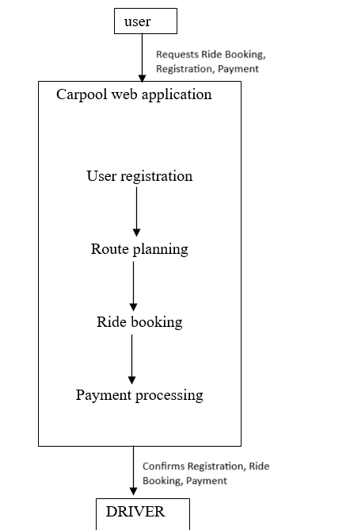

1. user registration

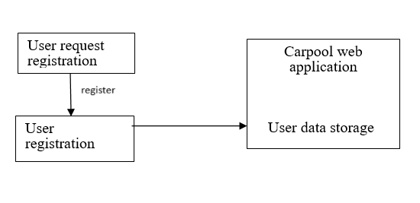

c)ride booking

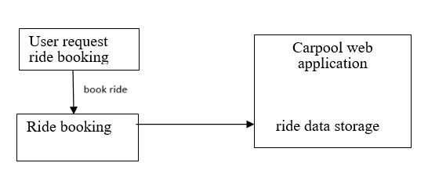

d)payment processing

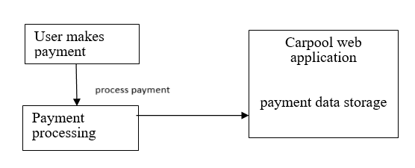

e)route planning

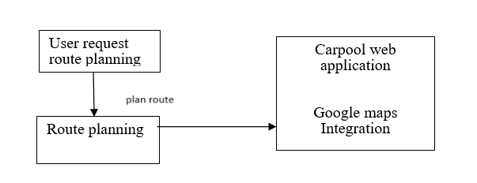

# Other Nonfunctional Requirements

## Performance Requirements

A proper internet connection is required for availing the services either as a passenger or as a driver while using the web application and the user should have basic knowledge for using web services and the interface should be friendly with the user.

## Safety Requirements

The application should ensure that neither the passenger details nor the registered drivers’ s details within them is lost during or anytime. There should be a mechanism in order to procure the details lost if in case and to prevent unauthorized access to the user data.

## Security Requirements

Each time the user has to login to the application with their username and the password in order to avail the services offered by the application. This is done to make sure so that security of the users is considered and none of the unauthorized users try to misuse the personal information of other users. Only the system administrator has the privilege to access the database and modify it to prevent unauthorized access. If the user forgets his/her password then he can request fir a password change and a mail will be sent to that intended person through nail.

## Software Quality Attributes

Availability: The website is accessible and available to use 24*7 with having a healthy internet connection.

Adaptability: The website is user friendly making all users to have an user friendly interaction with it so that people will little technology knowledge can even access it.

Flexibility: User can use the application from any of their gadgets and is very flexible to use.

## Business Rules

* Only registers users(passengers) can book their rides.
* Drivers must submit their valid and legal documents during their registration and upload legal documents about their vehicles.

# Other Requirements

* The application must have obesity atomicity, concurrency, integrity.
* License requirement: The usage of this application is possible only when the acquired the license to make it functional
* To maintain the integrity of the data and to be reliable to the maximum level.

Appendix A: Glossary

Carpool: Sharing rides with people who travel to the same destination which is cheaper and leads to less traffic and less environmental pollution.

* HTML: hypertext markup language used to build structure of the website
* CSS: used to apply style to the website

Appendix B: Analysis Models

Data flow diagram of ne one function or feature of the web application has been provided in section 4.9.