Correlation between New Zealand’s Temperatures against surrounding Ocean Surface Temperatures

# REGION & DOMAIN

# New Zealand (Oceania - Australasia)

# Weather and Climate, Land Vs Ocean surface temperatures, Environmental Indicators

# RESEARCH QUESTION

This project work looks into Oceanic Sea-Surface Temperatures surrounding New Zealand in correlation with New Zealand’s land temperatures. Whether the Ocean Surface temperatures surrounding New Zealand have developed a correlation to New Zealand’s Average Mean Temperatures using data obtained from the last 15 years?

# DATA LINKS

Four Datasets are being used to plot the correlation using the below links which provide the following data: the Antarctic Sea Water Surface temperatures, Tasman Sea Water Surface temperatures, New Zealand Water Surface temperatures and the Annual Average Mean New Zealand temperatures from 1990 – 2015.

<https://raw.githubusercontent.com/kellwyn/kellwyn.github.io/master/AntarcticSeawatersurface.csv>

<https://raw.githubusercontent.com/kellwyn/kellwyn.github.io/master/TasmanSeawatersurface.csv>

<https://raw.githubusercontent.com/kellwyn/kellwyn.github.io/master/watersurface.csv>

<https://raw.githubusercontent.com/kellwyn/kellwyn.github.io/master/AvgTemperature.csv>

The below additional link provides access to more information provided by the Government of New Zealand which was used as initial reference.

http://archive.stats.govt.nz/browse_for_stats/environment/environmental-reporting-series/environmental-indicators/Home/About.aspx#dataquality

**PLOTTED IMAGE USING PANDAS & MATPLOTLIB** 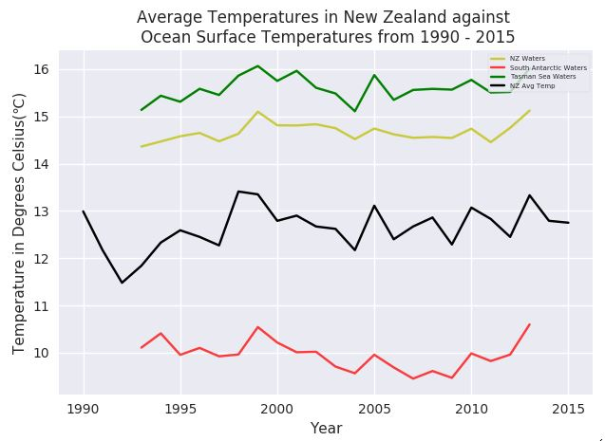

**PLOTTED IMAGE USING SEABORN – Correlation of Oceanic Sea Surface Water Temperatures surrounding New Zealand with NZ Average Annual Temperatures** 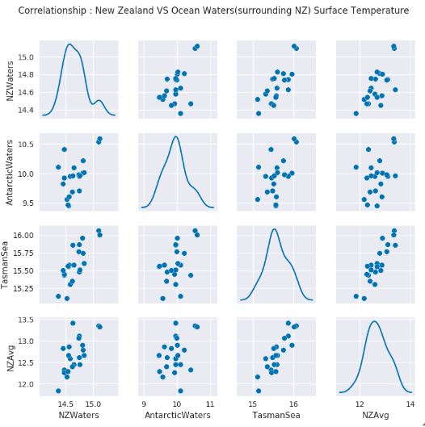

# Discussion

This visualization was concerned with answering the question of how New Zealand’s annual mean temperatures get affected by the Oceanic Surface Water temperatures. A correlation between them is plotted using the temperature data available for 15 years from the years 1990- 2015, to identify trends that could be determined using the available data. No sea-surface temperature trend could be determined for New Zealand’s oceanic, Antarctic waters and the Tasman Sea for 1993 to 2013. Trends were assessed at the 95 percent confidence level. The annual sea-surface temperatures varied up to 1.0-2.0 degrees Celsius. A steady similarity of temperatures rising with gradual descend after a peak in 2005, can be identified between the Tasman Sea temperatures and New Zealand’s annual temperatures. The possibility of identifying trends between New Zealand’s Ocean temperatures and annual temperatures is highly likely over longer timeframes.

In the visualization, Cairo’s principles were implemented by effective colour use by making the visual clean and easy to decipher. The visualization’s truthfulness is attained by providing high quality data from trusted government sources. A legend was provided which was clear and didn’t obstruct the visualization itself. The visualization was insightful providing an opportunity to gather an insight into the changes in sea water surface temperatures can affect the environment. The design of the data plotted was functional as it provides not only a correlation between New Zealand's annual temperatures and the Oceanic surface water temperatures but also the correlations inbetween the different oceanic waters as well.