CHAPTER 1
INTRODUCTION

1.1 OVERVIEW OF SMART TRANSPORTATION SYSTEM
In modern educational institutions, student transportation management plays a pivotal role in ensuring daily operational efficiency, campus safety, and parental peace of mind. Conventional institutional bus monitoring relies predominantly on manual logbooks, gatekeeper verification, or intermittent phone communications between drivers and administrative officers. These outdated methods introduce substantial administrative delays, human errors, unrecorded unauthorized vehicle excursions, and an acute lack of real-time visibility for students waiting at stops throughout urban regions such as Coimbatore.
To overcome these persistent logistical hurdles, the PULSE PLATE system introduces an end-to-end intelligent transportation and attendance architecture. By integrating edge-deployed Automatic Number Plate Recognition (ANPR), deep learning facial verification, real-time driver state analysis, and automated database synchronization, the system eliminates manual gatekeeping friction. The edge device accurately registers campus entry and departure timestamps while feeding comprehensive transport telemetry into dedicated administrative and student web applications.
1.1.1 Objectives of the Project
The core objective of PULSE PLATE is to formulate a self-updating, non-intrusive vehicle monitoring ecosystem tailored for institutional fleets. Key deliverables include autonomous license plate detection under diverse illumination conditions, driver identity authentication against registered biometric profiles, proactive driver safety monitoring including drowsiness and seat belt compliance, and instant real-time student notification distribution.
• To design and deploy high-accuracy edge camera nodes at campus entry and exit gates for instantaneous automated vehicle number plate identification.
• To incorporate computer vision algorithms for real-time facial verification of designated drivers and continuous monitoring of driver alertness.
• To provide role-based administrative portals for Administrative Officers (AO) and Transport Admins to streamline gate passes and route adjustments.
• To deliver responsive web and mobile interfaces for students offering live bus campus presence, stop arrival estimations, and push alerts.
1.2 PROBLEM STATEMENT
Educational campuses operating extensive bus networks face major logistical bottlenecks during peak morning and evening transit windows. Physical record-keeping at entrance gates causes severe vehicle queues, resulting in lost transit time and inaccurate recording of arrival schedules. Furthermore, administrators have no automated means of verifying whether the authorized driver is operating the vehicle or if a driver is fatigued, posing serious passenger safety hazards.
From the student perspective, missing a college bus due to lack of departure alerts or confusion regarding route alterations creates severe daily inconveniences. Existing GPS tracking modules are frequently prone to power disconnections, tampering, and high cellular recurring data expenses without offering gate-level physical verification. A centralized, camera-based AI infrastructure that delivers reliable digital attendance and safety verification is therefore an urgent institutional requirement.
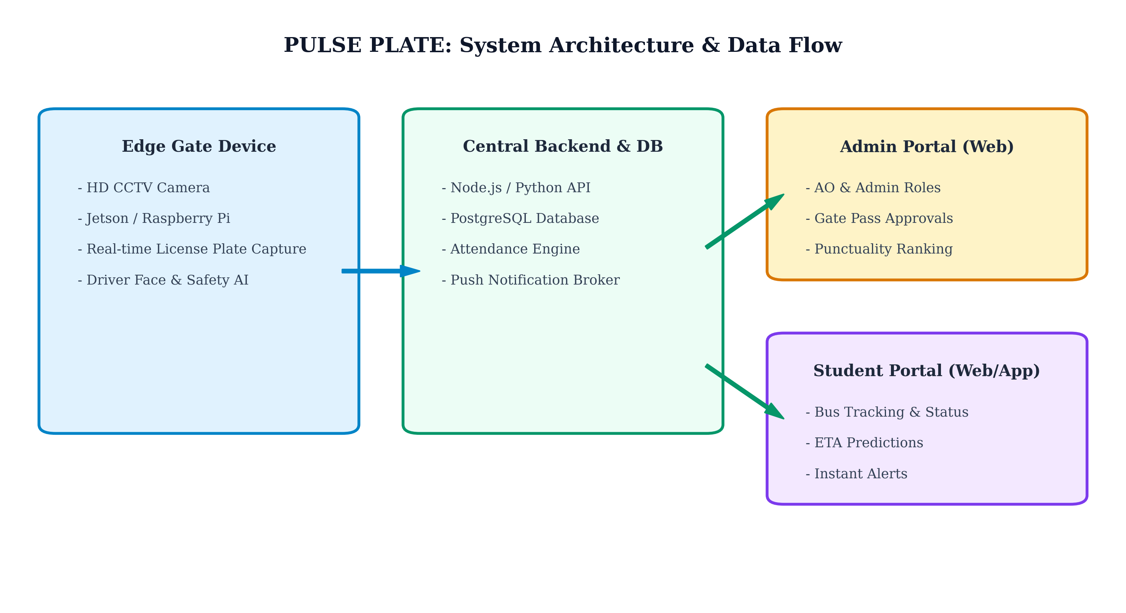
Figure 1.1 Architecture and System Overview of PULSE PLATE
As illustrated in Figure 1.1, the physical edge layer communicates bidirectionally with the centralized PostgreSQL backend to provide synchronized real-time attendance status. The operational parameters and hardware specifications deployed across the testing testbed are outlined in Table 1.1.
Table 1.1 Key System Specifications and Deployment Parameters
S. No | System Component | Hardware / Technology | Functional Specification
1 | Edge Controller | Raspberry Pi 4 / Jetson Nano | Quad-core ARM 1.5GHz, 4GB LPDDR4
2 | Vision Sensor | 1080p HD Industrial Camera | 30 FPS, IR Night Vision, Wide Angle
3 | Central Database | PostgreSQL Server | ACID Compliant Relational Storage
4 | Web Application | React.js & Node.js Engine | Role-based Access & Live Telemetry
5 | Mobile Client | Responsive PWA & Android | Push Notifications & Dynamic ETA

1.3 SCOPE AND SIGNIFICANCE
The scope of this project encompasses the engineering and practical deployment of an automated vehicle attendance and driver surveillance prototype at educational campus gates. The system handles full-day transit cycles, ranking institutional buses according to punctual arrival intervals (08:00 AM to 08:45 AM), generating dynamic digital gate passes, and alerting students immediately upon evening vehicle departures.
Significantly, the architecture eliminates recurring transponder hardware expenses associated with legacy RFID tags while establishing an incorruptible digital audit trail. The modular software stack ensures seamless scalability to multi-gate campuses, industrial enterprise fleets, and municipality-scale intelligent traffic management networks.
1.5 CHAPTER ORGANIZATION
CHAPTER 1 Discussed about the introduction to smart vehicle identification, background problem statement, system objectives, and overarching scope.
CHAPTER 2 Covers the literature survey, existing transportation monitoring limitations, advantages, and comparative disadvantages.
CHAPTER 3 Proposed Methodology detailing the ANPR pipeline, edge computer vision processing, dual-portal architecture, and safety monitoring modules.
CHAPTER 4 Result and Discussion presenting experimental detection accuracy, verification performance, latency metrics, and field deployment outcomes.
CHAPTER 5 Conclusion and Future work summarizing the complete system contributions and discussing scalable enhancements for future cloud and IoT integration.

