CHAPTER 3
PROPOSED METHODOLOGY

3.1 SYSTEM ARCHITECTURE AND HARDWARE DESIGN
The proposed PULSE PLATE system is architected as an intelligent distributed edge-cloud ecosystem engineered specifically for institutional transportation monitoring. The physical infrastructure centers on an industrial-grade edge computing node deployed at the campus gate, interfaced with high-definition vision sensors and power-backup modules. The edge pipeline executes real-time video stream ingestion, automated license plate recognition, driver biometric authentication, and safety policy enforcement.
The computational backend utilizes a high-throughput Node.js microservice connected to a robust PostgreSQL database engine. All captured image artifacts and telemetry vectors are ingested through secure RESTful endpoints, triggering instant WebSocket updates across the Administrative Web Portal and Student Mobile Client. This decoupled topology ensures low latency and fail-safe local edge processing during network disruptions.
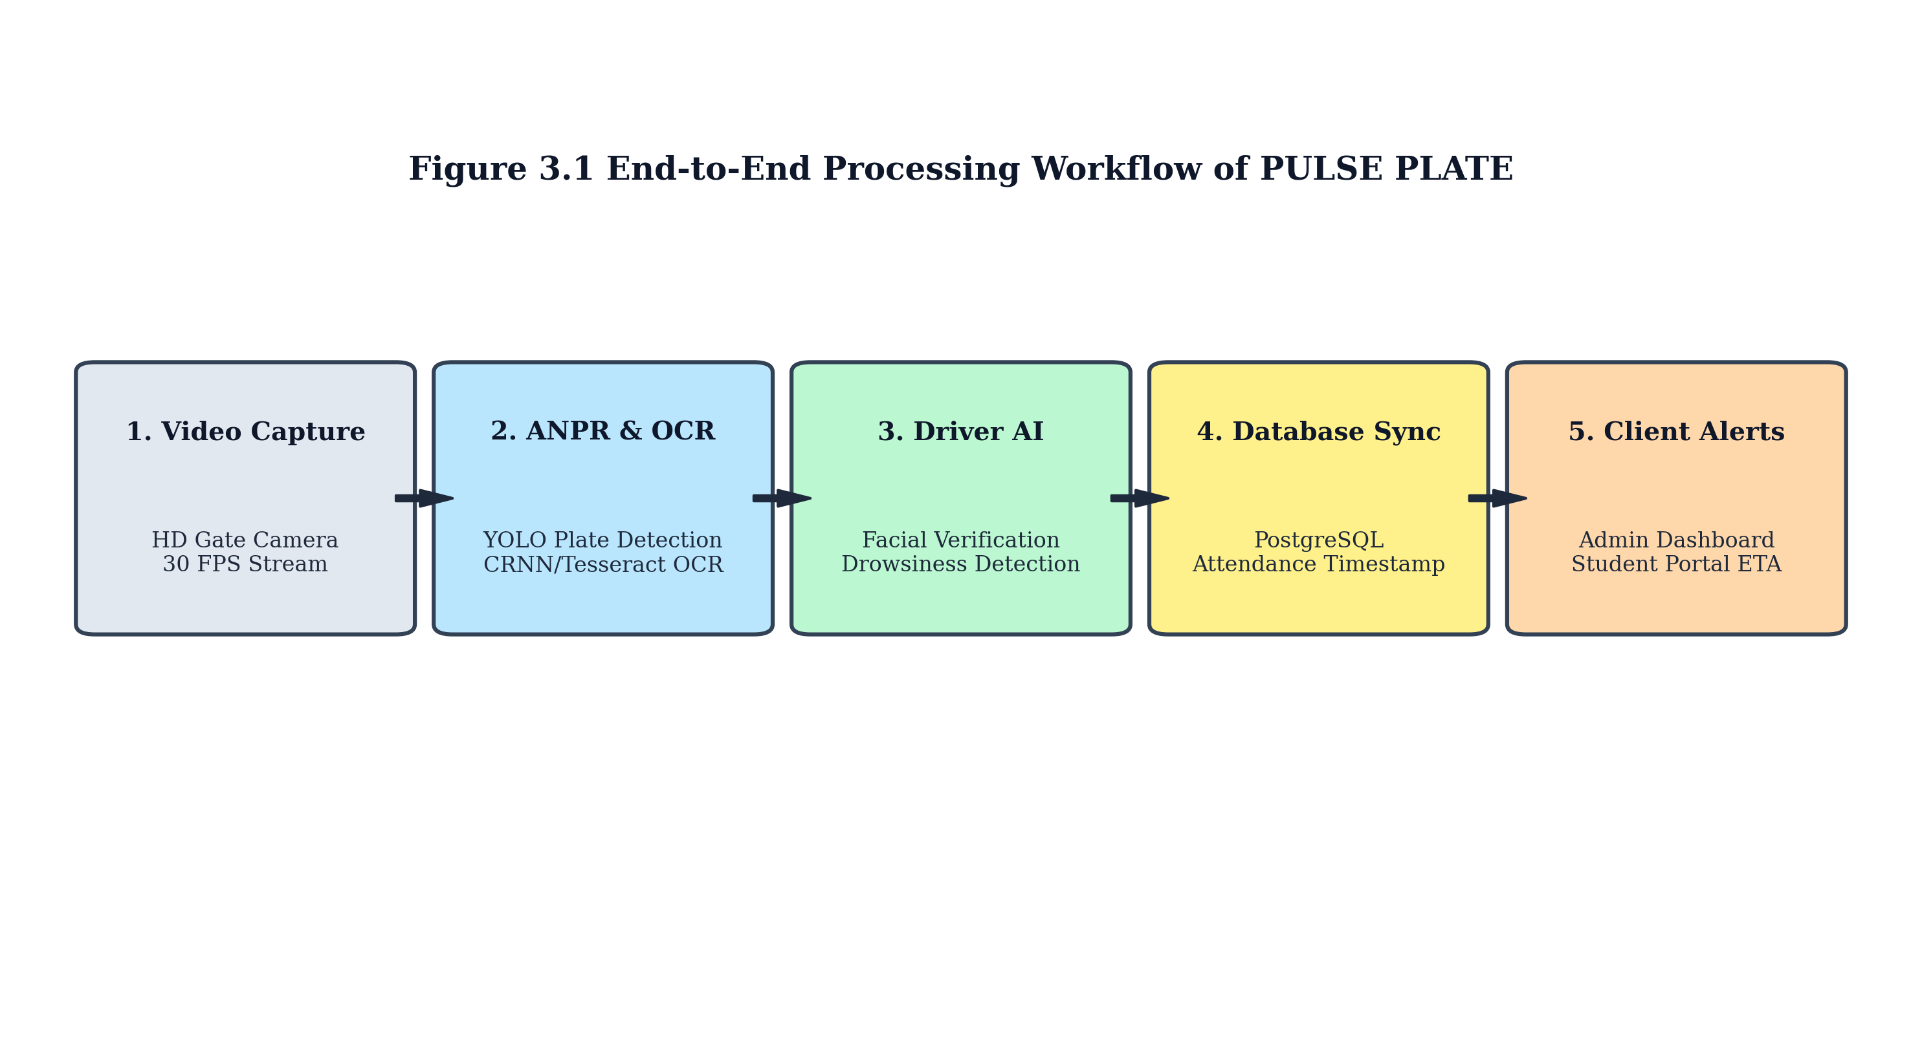
Figure 3.1 Complete Methodological Flowchart and Edge Pipeline
3.2 AI MODULES AND COMPUTER VISION PIPELINES
As detailed in Figure 3.1, the computer vision pipeline operates sequentially upon detecting an approaching vehicle within the camera frame. The first stage employs a customized YOLOv8 deep neural network optimized for vehicular license plate bounding box localization. Once the plate coordinates are extracted, perspective transformation and adaptive thresholding algorithms normalize the bounding region prior to OCR character transcription.
3.2.1 Driver Face Verification and Safety Monitoring
Simultaneously, a secondary ROI (Region of Interest) targeting the driver cabin is analyzed using a 68-point facial landmark detector. The extracted 128-dimensional facial embedding is compared against the institution's authorized driver registry using Euclidean cosine distance metrics. Furthermore, the driver monitoring engine evaluates eye aspect ratio (EAR) and mouth aspect ratio (MAR) across continuous frame windows to detect micro-sleep drowsiness patterns and monitor seat belt buckle engagement.
• YOLOv8 Plate Detection: Identifies license plate coordinates in under 18 milliseconds per frame.
• CRNN Alphanumeric OCR: Transcribes multi-line state registration codes with over 98% character confidence.
• FaceNet Biometric Matching: Compares driver facial embeddings with registered database profiles to prevent unauthorized substitutions.
• Driver Alertness & Seat Belt AI: Detects eyelid closure exceeding 1.5 seconds and flags non-compliance instantly to the administrative dashboard.
3.3 DATABASE ARCHITECTURE AND DUAL-PORTAL WORKFLOW
The database layer is constructed upon an ACID-compliant PostgreSQL schema optimized for fast spatial and temporal indexing. Table schemas maintain comprehensive relations encompassing Buses, Drivers, Students, Transit Routes, Gate Pass Requests, and Real-time Attendance Logs. Image data is saved efficiently on persistent object storage with relative references indexed in relational tables to maintain minimal database footprint.
Table 3.1 PostgreSQL Database Schema and Primary Field Definitions
Table Name | Primary Key | Foreign Keys | Key Fields and Attributes
buses | bus_id | driver_id, route_id | bus_number, registration_no, capacity, campus_status
drivers | driver_id | assigned_bus_id | name, license_no, phone_no, face_embedding, status
attendance_logs | log_id | bus_id, driver_id | entry_time, exit_time, punctuality_status, date
gate_passes | pass_id | driver_id, bus_id | reason, departure_time, approval_status, ao_remarks
route_changes | request_id | driver_id, route_id | original_route, requested_route, ao_approval

3.4 ROLE-BASED ADMINISTRATIVE AND STUDENT WORKFLOWS
The administrative portal provides granular role separation between the Administrative Officer (AO) and Transport Administrators. The AO holds exclusive authorization privileges for approving driver gate pass submissions, sanctioning emergency route alterations, and managing institutional fleet configurations. Transport Admins monitor daily punctuality rankings, inspect driver attendance statistics, and oversee fuel/service schedules.
The student application delivers an intuitive status interface displaying registered bus information, driver assignments, and live campus presence indicators (Green for inside campus, Red for departed). Upon evening bus departure, automated notifications are broadcast, enabling students to track arrival times across stops accurately throughout Coimbatore.
3.5 CHAPTER SUMMARY
This chapter presented the comprehensive technical methodology of the PULSE PLATE system, detailing the edge computing hardware, computer vision algorithms, database architecture, and dual-portal interfaces. The integration of high-speed ANPR with driver biometric authentication and safety telemetry establishes a robust foundation for institutional transport automation. The quantitative performance metrics of this methodology are evaluated in Chapter 4.

